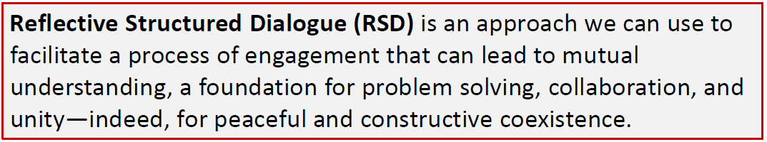
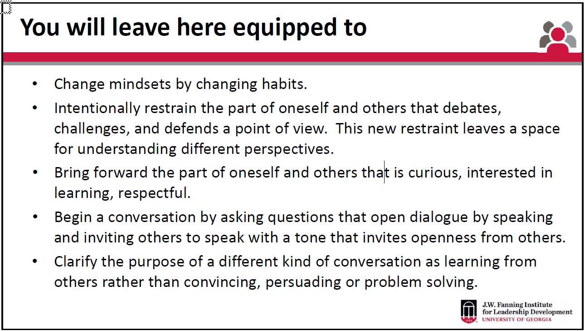
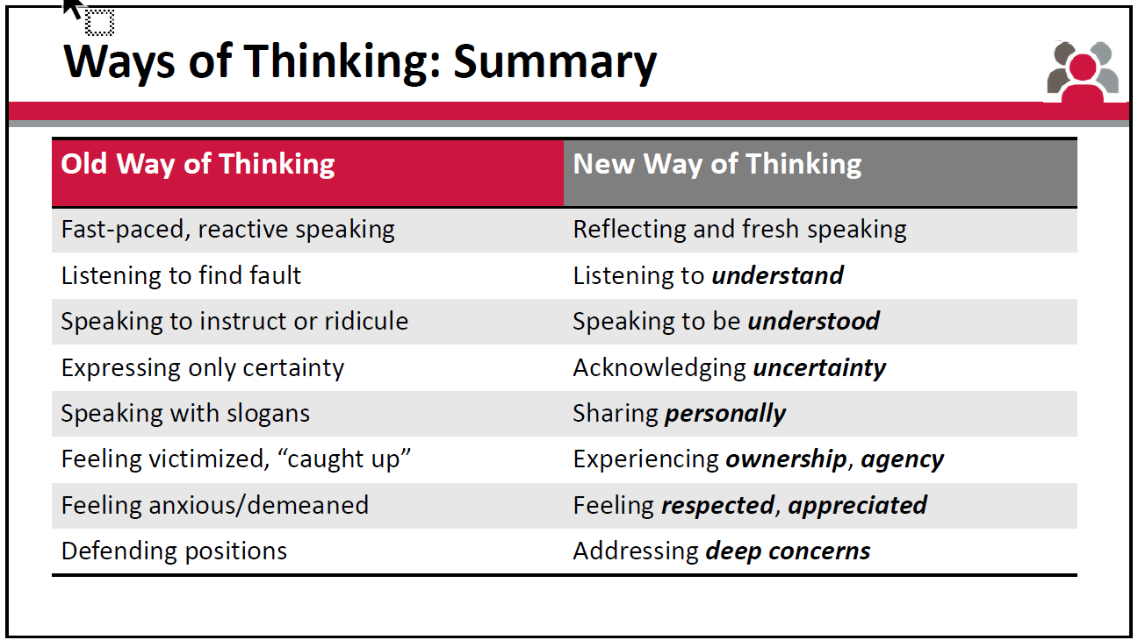
Questions to Open Dialogue Demonstration
Round One
Please share a story from your personal and or community life when a woman in leadership impacted your life.
Round Two
Around the issue of women’s leadership, what is at the heart of the matter for you? In other words, what are your values, hopes, fears and assumptions at the
center of your conviction.
Round Three
Within your overall perspective on this issue, what are some areas of uncertainty or internal value conflicts that you are willing to speak about?
And, if there are no internal conflicts to what do you attribute that?
