TEMPORARY PARKING PERMIT

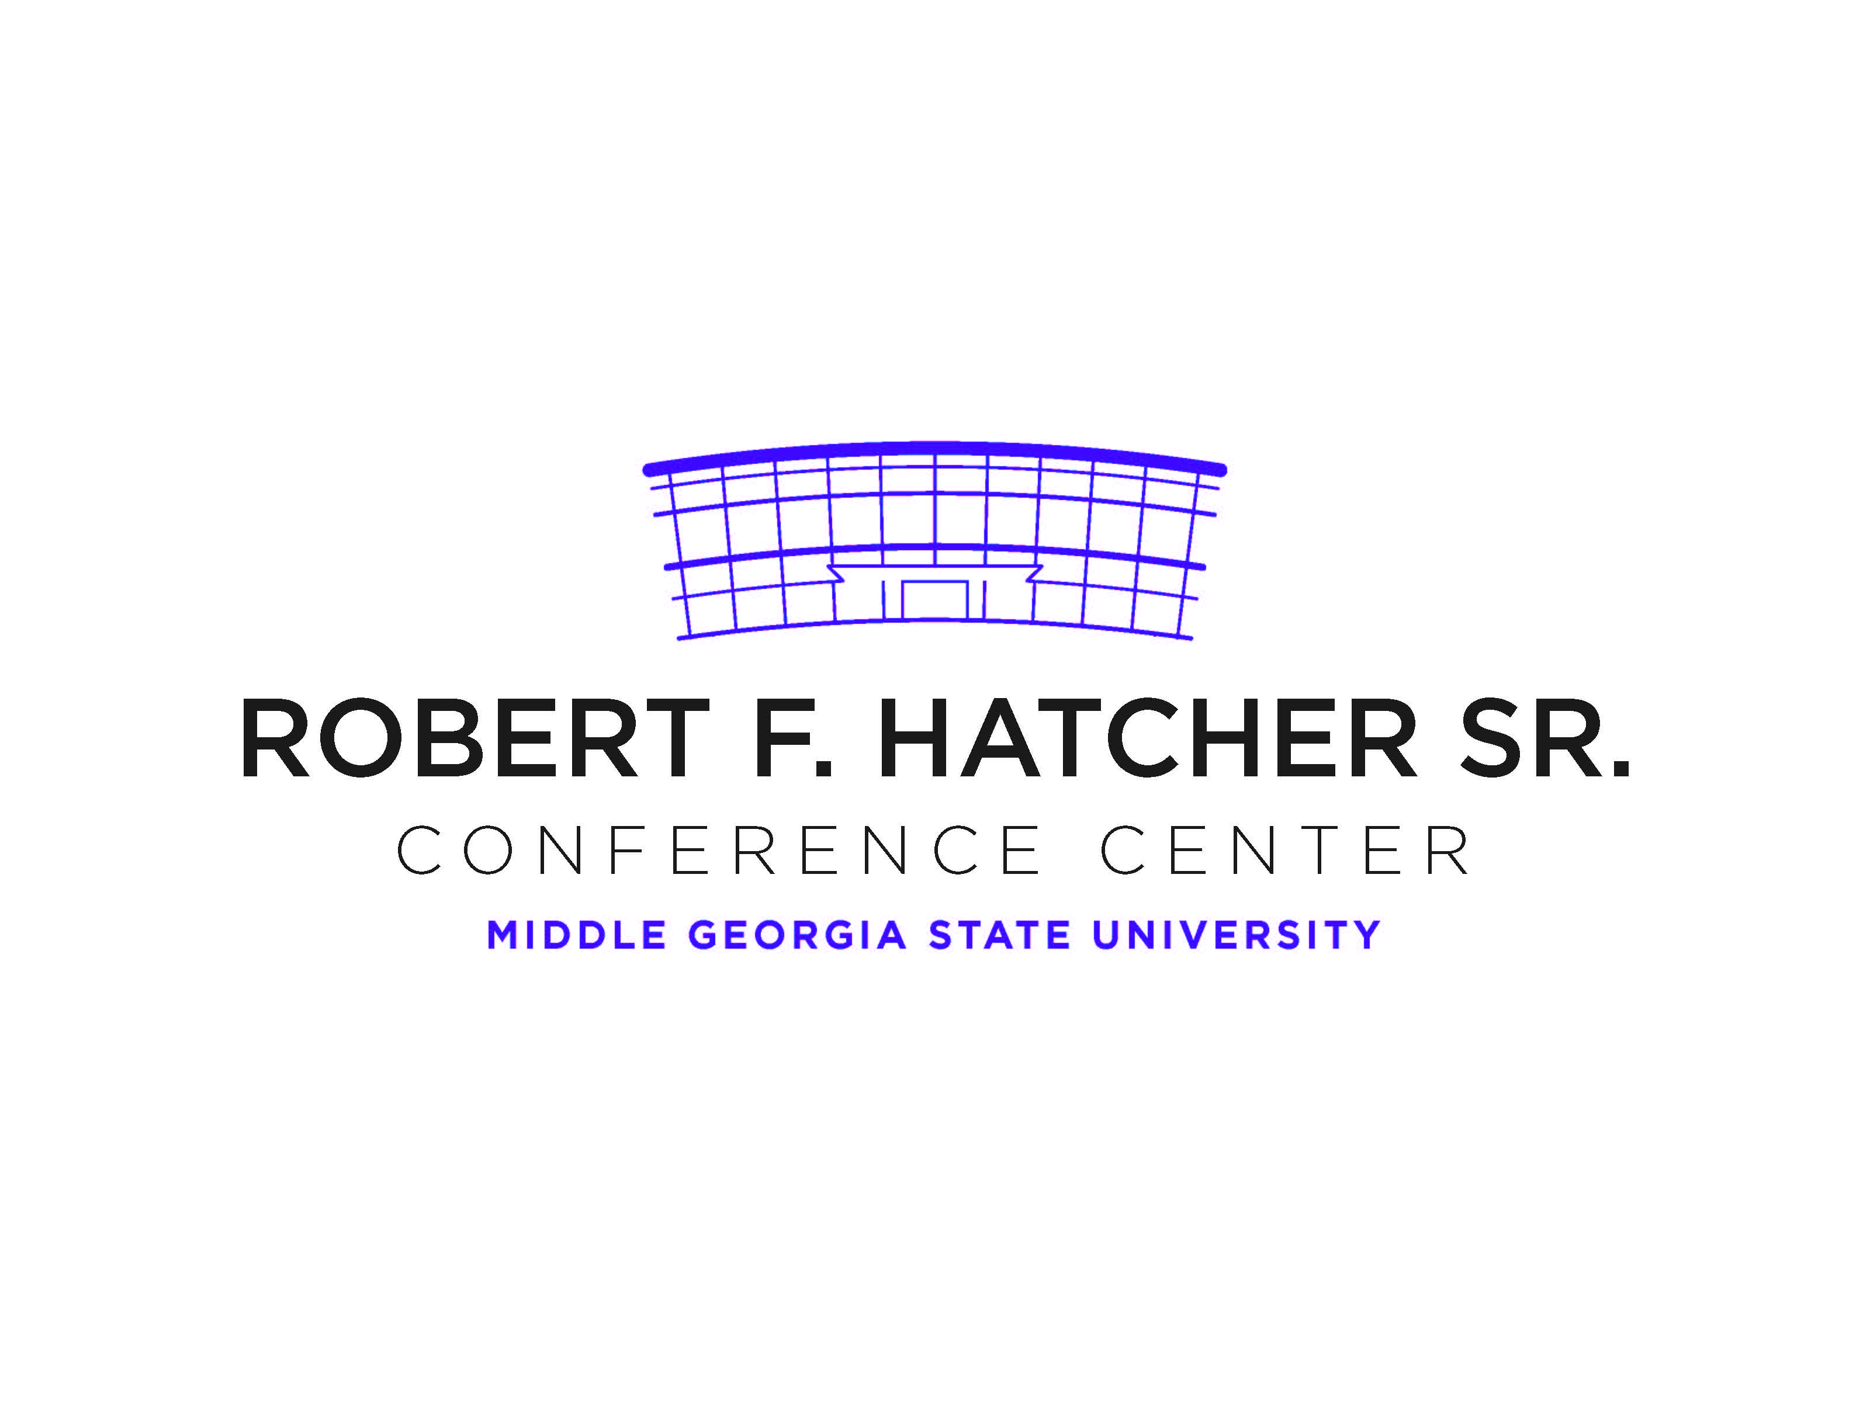

VALID DATE: October 28, 2022
Diversity and Inclusion Conference
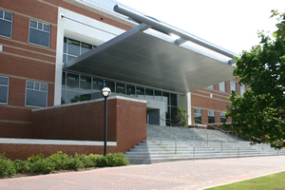 |  | 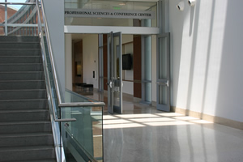
The Conference Center is located on the 2nd floor the Professional Sciences Center near the main entrance to the Jones Building |  | Entrance to Hatcher Conference Center from inside the Jones Building

DO NOT PARK IN FACULTY/STAFF PARKING AREAS
DO NOT BACK INTO PARKING SPACE
DISPLAY PERMIT ON DASHBOARD OR REAR WINDOW
Smoking is prohibited on campus

