eProcurement and GeorgiaFIRST Marketplace
User’s Guide
for
Buyers
Organization/Department

Table of Contents
Table of Contents 2
Introduction 5
Chapter 1: eProcurement and GeorgiaFIRST Marketplace Overview 6
What is eProcurement? 6
What is the GeorgiaFIRST Marketplace? 6
Types of Requisitions 6
Benefits of ePro and the GeorgiaFIRST Marketplace 7
Types of Roles Involved 7
Role Setup 8
How does PSFIN pass along user information to GeorgiaFIRST Marketplace? 11
Procure-to-Pay Process Flow 12
Chapter 2: Suppliers 13
GeorgiaFIRST Marketplace Suppliers 13
How to Use Catalog Suppliers 13
Chapter 3: eProcurement Approvals 15
How Do Approvals Work? 15
Approval Stages 15
Approver’s Worklist 19
Chapter 4: Approving and Denying Requisitions 20
Retrieving Your Worklist 20
Reviewing Your Worklist 21
Ad Hoc Approvers 29
Requisition Push Back 32
Chapter 5: Using the Manage Requisitions Page 36
Managing Requisitions 36
How To: Manage Requisitions 42
Available Actions to Take on the Manage Requisitions Page 43
Editing a Requisition 44
How To: Edit a Requisition 45
Delete a Requisition Line 46
How To: Delete a Requisition Line 47
Copying a Requisition 48
How To: Copy a Requisition 48
Canceling a Requisition 49
How To: Cancel a Requisition 49
Chapter 6: Budget Checking Requisitions 50
What is Budget Checking? 50
Budget Checking Requisitions 51
Manual Budget Checking 51
Batch Budget Checking 54
How To: Run Batch Budget Checking on Requisitions 55
Reviewing Budget Check Exceptions 57
Budget Checking Errors 62
Chapter 7: Sourcing Requisitions into Purchase Orders 64
Sourcing of GeorgiaFIRST Marketplace Requisitions 64
Sourcing of Special Request Requisitions 64
Expediting Requisitions 65
How To: Expedite Requisitions 66
Review Expedite Results through the Sourcing Workbench 68
How To: Use the Sourcing Workbench to Review Expedite Requisitions Results 71
Creating a Purchase Order by Copying a Requisition 72
Processing of Purchase Orders Sourced from Special Request Requisition 76
Chapter 8: Additional Requisition Maintenance 77
Purging Staging Tables 77
How To: Purge Staging Tables 79
Closing Requisitions 81
How To: Close Requisitions 85
Requester’s Workbench 86
Using the Workbench to Approve Requisitions 88
How To: Approve an Open Requisition through the Requisition Reconciliation Workbench 89
Using the Workbench to Cancel Requisitions 90
How To: Cancel Requisitions through the Requisition Reconciliation Workbench 91
Using the Workbench to Close Requisitions 92
How To: Close Requisitions through the Requisition Reconciliation Workbench 93
Chapter 9: Receiving Items 94
Desktop Receiving 94
How To: Create a Desktop Receipt 96
Receiving Through the Purchasing Menu 97
How To: Create a Purchasing Receipt 100
Receiving an Asset 100
How To: Create a Purchasing Receipt for an Asset 102
Chapter 10: ePro Inquiries, Queries and Reports 103
Review Requisition Activity 103
Review Requisition Accounting Entries 108
Review Requisition Document Status 110
BOR_REQ_OPEN_AMOUNT_BY_REQ Query 112
BOR_REQ_OPEN_AMOUNT_ALL Query 112
BOR_REQ_OPEN_PREENCS_KK Query 113
Requisition to PO Cross Reference Report (POX1100) 114
Requisition Print Report (PORQ010) 115
Requisition Budgetary Activity Report (POS8002) 116

Introduction
This User’s Guide is designed for Buyers who will be working with ePro requisitions and sourcing them into purchase orders. There are GeorgiaFIRST Marketplace requisitions, as well as Special Request Requisitions. Each type of requisition requires specific ways of handling them. This guide will detail how to work with both kinds of requisitions.
In this User’s Guide, you will find an overview of what the eProcurement module does, as well as what the function of the GeorgiaFIRST Marketplace is. You will also learn how to recognize Marketplace Suppliers, how to approve requisitions assigned to you, and how to process requisitions. You will also learn the primary role that the Buyer plays in the entire process.
Topics covered in this User’s Guide:
- Overview of eProcurement and the GeorgiaFIRST Marketplace
- Suppliers
- eProcurement Approvals
- Approving and Denying Requisitions
- Using the Manage Requisitions Page
- Budget Checking Requisitions
- Sourcing Requisitions into Purchase Orders
- Additional Requisition Maintenance
- Receiving Items
- ePro Inquiries, Queries and Reports

Chapter 1: eProcurement and GeorgiaFIRST Marketplace Overview
What is eProcurement?
eProcurement (ePro) is a module in PeopleSoft Financials that has a primary function of creating electronic requisitions and routing them for approval. In this PSFIN module, ePro is used to create requisitions for goods and services. A requisition is simply an official request to purchase goods and services.
Previously, you may have used paper requisitions, or some other format, to request an item to be purchased. That hardcopy requisition then had to be routed for approval signatures and sent to the Purchasing Office. The Purchasing Office then had to rekey the information into the system to create a Purchase Order to send to the Supplier.
With ePro, much of this is completely automated. A requisition is created within ePro and electronically routed for approval. The approval chain is dependent on the Department charged and item type, among other things. Finally, after the last electronic approval is made, the requisition can be copied or sourced into an official Purchase Order that is dispatched to a Supplier.
What is the GeorgiaFIRST Marketplace?
The GeorgiaFIRST Marketplace takes the use of ePro to another level. The GeorgiaFIRST Marketplace is an online shopping site that is accessed from PeopleSoft Financials. Through this online shopping site, users can shop online for contract items from a variety of state and institution approved Suppliers. Users can select items by placing them in an online shopping cart. They assign these shopping carts to a designated requester when ready, and the requester then turns their shopping cart into an ePro requisition.
Because users are shopping from approved Suppliers with contract prices, very little buyer intervention is required. After a requisition that is built from the GeorgiaFIRST Marketplace is approved, it is designed to be picked up for batch processing that will budget check it, source it into a purchase order, and then dispatch the purchase order. These batch processes are designed to run at different times throughout the day. As a Buyer, you may be responsible for monitoring these batch processes and resolving any errors. In addition, you will still be able to process these requisitions manually if needed.
Types of Requisitions
With the implementation of the GeorgiaFIRST Marketplace into the eProcurement module, there are now two types of requisitions: GeorgiaFIRST Marketplace requisitions and Special Request Requisitions.
- GeorgiaFIRST Marketplace Requisitions: Shoppers build these requisitions from items in the GeorgiaFIRST marketplace.
- Special Request Requisitions: Requesters build these requisitions by entering item descriptions directly onto the requisition and are not built from the contractually-approved items in the marketplace.
Within ePro, users will not be able to combine items from the GeorgiaFIRST Marketplace with items from a Special Request Requisition into one requisition. Each requisition must be completely from the marketplace (CAT) or from a Special Request Requisition (ONL).
Benefits of ePro and the GeorgiaFIRST Marketplace
With this new system of online shopping and electronic requisitioning, you will see some immediate benefits, including:
- Reduction in paper forms routing through different offices
- Online browsing and shopping for items
- Comparison shopping
- You only need one login to shop from multiple Suppliers
- You can request goods from multiple Suppliers through one shopping cart
- All items in the GeorgiaFIRST Marketplace are contractually approved items
- Faster routing for approvals
- Ability to save items as ‘favorites’ in the GeorgiaFIRST Marketplace
- Automatic batch processing of approved requisitions
Types of Roles Involved
In order for the ePro and GeorgiaFIRST Marketplace functionality to work properly, users are set up with specific roles and responsibilities. They include:
- Shoppers: These users are the ones who select items in the GeorgiaFIRST Marketplace.
- Browsers: Users without any GeorgiaFIRST Marketplace roles assigned will default to a Marketplace Browser. Browsers can view the items, contracts, and prices in the Marketplace but cannot shop or create requisitions.
- Requesters: These users take the shopping carts created by Shoppers and turn them into ePro Requisitions. Requesters can also build their own shopping carts, just like Shoppers.
- Approvers: These users are set up to approve ePro Requisitions.
- Buyers: These users are responsible for ensuring approved requisitions are sourced into a Purchase Order and dispatched to the Supplier.
- AP Personnel: The AP office processes the resulting invoice from the Supplier.
- ePro Administrator: This user monitors the approval workflow, to make sure requisitions are worked in a timely fashion
- Local Security Administrator: This user is responsible for setting up others users in their appropriate roles.
As a Buyer, you are primarily responsible for ensuring requisitions are budget checked, sourced into Purchase Orders, and then dispatching the Purchase Orders. GeorgiaFIRST Marketplace requisitions should require very little manual intervention, if any, for these processes to happen. Special Request Requisitions may need more interaction, since they are not built from contractually-approved items.
Role Setup
In order for PeopleSoft Financials and the GeorgiaFIRST Marketplace to know what you can and cannot do in the systems, each role has a specific setup. All setup is accomplished in the PeopleSoft Financials system and transfers to the GeorgiaFIRST Marketplace. In this section, we are going to discuss the setup involved. It includes Security Roles, Requester Assignment, and User Preferences.
Security Roles
Your Local Security Administrator assigns specific security roles to each user. These Security Roles enable you to access certain pages. This is why you may be able to see eProcurement in the menu, but not see Accounts Payable for example.
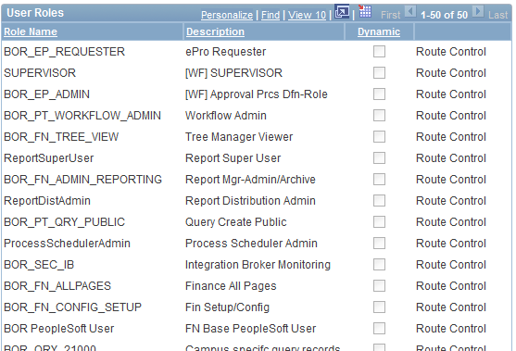

Buyer Assignment
To perform actions related to Purchase Orders, you must be set up as a “Buyer” in the system. Someone such as your Local Security Administrator or ePro Administrator will create you as a “Buyer”. It is through this Buyer Setup that the following Defaults are set:
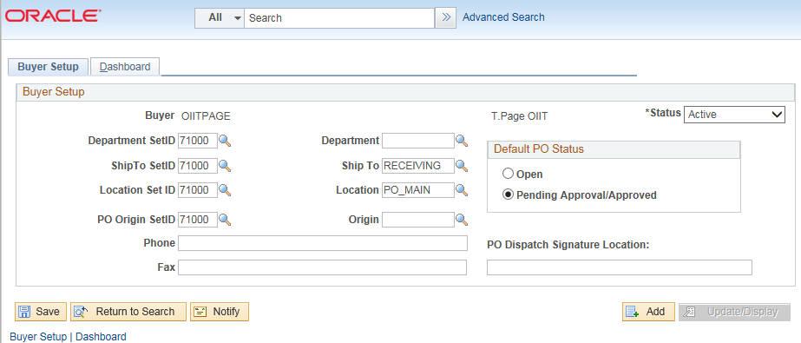
User Preferences
In addition to being created or setup as a Buyer in the system, that buyer must have their user preferences established prior to creating requisition. Through the User Preferences, allowable purchase order and requisition actions are set up, such as canceling or closing a requisition and/or purchase order. In addition, it is through the User Preferences that you are given the permission to work additional requisitions and purchase orders for other requesters and buyers.
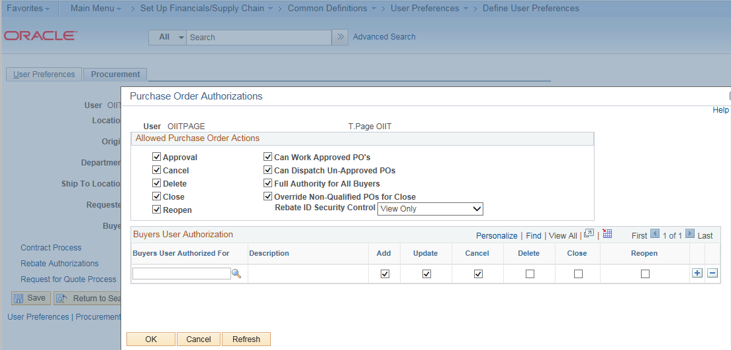
Process Flow
Now that you know all of the roles involved, below is the process flow beginning with Shoppers and ending with the Accounts Payable office.
Shoppers use the GeorgiaFIRST Marketplace to select goods they request to have purchased
Shoppers assign their completed shopping carts to their assigned Requester
The Requester is notified by email of this newly assigned cart
The Requester logs into the system and pulls the Shopper’s cart into a Requisition
The Requester finishes the requisition and submits it for approval
The Approvers (determined by various factors) either approve or deny the requisition lines
Once fully approved, the PeopleSoft Financials system automatically budget checks the requisition
Once the requisition has a valid budget check status, the PeopleSoft Financials system automatically sources the requisition into a purchase order and dispatches it to the Supplier
The Supplier fulfills the order and sends the item and invoice to the Institution
The institution receives the item/Receipt is created in PSFIN
The AP Office pays the invoice
If the process involves a Special Request Requisition, then the shopper is eliminated from this process flow and the requester enters the items directly onto the requisition.

How does PSFIN pass along user information to GeorgiaFIRST Marketplace?
Shoppers and Requesters access the GeorgiaFIRST Marketplace through the eProcurement module in PeopleSoft Financials. By using their PeopleSoft User ID and Password, they can access the PeopleSoft system. Once in PeopleSoft, they simply proceed to the GeorgiaFIRST Marketplace through a hyperlink.
By logging in through PeopleSoft, the system sends the user’s information to the GeorgiaFIRST Marketplace, allowing them to log in only once and shop from multiple Suppliers. In addition, their PeopleSoft User ID is used to store the Chartfields that should be charged for their requested goods.

Procure-to-Pay Process Flow
If your institution has not used requisitions in the past, it is helpful to understand where they fit into the Procure-to-Pay process flow.

Chapter 2: Suppliers
As a Buyer, you may or may not be responsible for setting up Suppliers in the PeopleSoft system. This is different at each institution. However, you do work with Suppliers through Purchase Orders. Due to the implementation of the GeorgiaFIRST Marketplace, there are some changes that have been to some of the Suppliers in your system.
GeorgiaFIRST Marketplace Suppliers
Most of the Suppliers that are now Marketplace Suppliers are ones that you have used in the past. Some of the Suppliers include Fischer Scientific, Staples, and Grainger. All Suppliers in the GeorgiaFIRST Marketplace are considered catalog Suppliers. These Suppliers are created under the “SHARE” SetID and are maintained centrally.
These catalog Suppliers will have a Supplier ID that begins with “CAT” (i.e., CAT0000001). The catalog Suppliers are synched to SciQuest, which is the company that hosts and maintains the GeorgiaFIRST Marketplace.
In PeopleSoft Financials, there is a custom process that copies this “SHARE” SetID Supplier and populates within each SetID. The Supplier ID will be the same, but you will be able to access the Supplier under your regular SetID.
These copied Suppliers under your institution’s SetID will be read-only. The only area that you can control is Supplier Pre-Noting and Pay Groups.
How to Use Catalog Suppliers
New Catalog Suppliers should be used for all procure-to-pay transactions. This includes any GeorgiaFIRST Marketplace Requisitions, Special Request Requisitions, and all Purchase Orders. Under AP the new Catalog Suppliers are to be used on all Vouchers as well.
After your institution goes live with eProcurement and the GeorgiaFIRST Marketplace, you should not use any old Supplier that has become a Catalog Supplier. For example, imagine that Staples is a Supplier that your institution routinely uses and the current Supplier ID for them under your SetID is 0000000107. Staples is now a Catalog Supplier that you can access through the GeorgiaFIRST Marketplace.
Under the SHARE SetID, the new Supplier ID for Staples is now CAT0000000201. Even though this Supplier ID is created and maintained under the SHARE SetID, it has been copied down to your institution’s SetID so that you can access it for all your purchasing documents.
If a GeorgiaFIRST Marketplace Requisition is created, the Supplier ID completes into the requisition automatically from the shopping cart. If a Special Request Requisition is created for an item from Staples, then the Requester should use the new “CAT0000000201” Supplier ID, even though it is not a Marketplace Requisition. The old Supplier ID should no longer be used.
Any current requisitions or purchase orders that are open with the old Supplier ID will still be able to be processed. The system will prevent you from creating any new documents with the old Supplier ID though.

Chapter 3: eProcurement Approvals
A critical component to the whole eProcurement process is the ability to submit requisitions for approval electronically. Because approvals are handled online within the PeopleSoft Financials system, each institution can customize the approval process to their own specifications.
How Do Approvals Work?
As mentioned earlier, a Requester builds a requisition in ePro. Each item on a requisition is actually placed on its own requisition line. Theoretically, each line in a requisition can be charged to a different set of Chartfields. Therefore, there may be different approval paths for each line on a requisition.
Once the Requester submits the requisition for approval, each line has its own approval path. This approval path is determined by a number of factors. At a minimum, each requisition line will go to the Department Manager and Project Manager (if a Project is to be charged). These are the managers that are tied into the Department and Project Chartfields on that requisition line.
Depending on how your institution has set up approvals for eProcurement, the requisition line may go to many additional approvers as well. This includes approvers for assets, IT items, and items above a certain amount. Below is a summary of all of the approval stages and paths available for eProcurement. To determine what stages and paths your institution is using, check with your Purchasing Department or Local Security Administrator.
Approval Stages
Overall, there are five approval stages that can be used for eProcurement requisitions. They include:
- Stage 1: Department and Project Approval
- Stage 2: Agency Fund Approval
- Stage 3: Amount Approval (for requisitions built from the GeorgiaFIRST Marketplace)
- Stage 4: Item-Type Based Approvals
- Stage 5: Buyer Approval (for requisitions not built from the GeorgiaFIRST Marketplace)
Here is a summary of each stage:
Stage 1: Department and Project Approval
This is a mandatory approval stage for all requisition lines. Each requisition line must be charged to a Department. In addition, requisition lines can be charged to a Project. The requisition line is routed to the Department Manager (as entered in PeopleSoft) for approval. If the Project Chartfield is used on the requisition line, the system also routes it to the Project Manager.

Stage 2: Agency Fund Approval
This approval stage is an optional one for institutions. It is set up so that any requisition line charged to an Agency Fund Code must go to an individual specified for Agency Fund Approvals. Agency funds are used to account for resources held by an institution as custodian or fiscal agent for individual students, faculty, staff members, or other organizations. Agency Fund Codes include 60000, 61000, and 62000.
If your institution chooses to employ this approval stage, there may be multiple Agency Fund Approvers. Each Agency Fund Approver will have the role BOR_AGENCY_FUND_APPR. The institution will determine whether all amount approvers must approve the requisition or if only one from the group of multiple approvers has to approve it. If an agency fund code is not used on a requisition line, the system bypasses this approval stage.
Stage 3: Amount Approval
The Amount Approval stage is also an optional one. This stage is for all requisitions that were built from the GeorgiaFIRST Marketplace and has a monetary amount of $10,000 or more. Again, your institution may set up multiple approvers to serve as the Amount Approver. Each Amount Approver will have the role BOR_CAT_AMOUNT_APPR. The institution will determine whether all amount approvers must approve the requisition or if only one from the group of multiple approvers has to approve it. The institution also does not have to use the $10,000 threshold and can edit this if needed.
If the requisition was not generated from the GeorgiaFIRST Marketplace, it will bypass this approval stage (this can be changed by the institution). If the requisition is below the set threshold and was generated from the GeorgiaFIRST Marketplace, it will also bypass this approval stage.
Stage 4: Item-Type Based Approvals
In Approval Stage 4, approvals are based upon the type of item being requested. Within this stage, there are seven potential approval paths. Each path is optional for the institutions.
- Stage 4, Path 1: Asset Approval
If the item on a Requisition line is an asset and charged to an Asset Account, it will be routed to the person set up as the Asset Approver. The accounts included in this path are 743200, 744200, and 800000 through 899999.

An Asset Approver must have the role “BOR_ASSET_APPR.” If your institution chooses to use the Asset Approver path, there can be multiple asset approvers. The institution will determine whether all asset approvers must approve the requisition or if only one from the group of multiple approvers has to approve it. In addition, institutions may identify additional account codes for asset approval, and they may add monetary amount criteria (i.e., item charged to Account 743200 and is greater than $5,000.).
- Stage 4, Path 2: Audio Visual Approver
This is an optional approval path and is for any item on a requisition line that contains an NIGP code related to Audio Visual items or services. NIGP stands for National Institute of Governmental Purchasings Commodity Services Code. The NIGP Code is a coding classification used primarily to classify products and services procured by state and local governments.

In PeopleSoft, the Category ID is tied into the NIGP Code. In the GeorgiaFIRST Marketplace, the NIGP code is already tied into item. For requisition line items not generated from the Marketplace, the Requester enters the proper Category ID. For those line items that have an NIGP Code related to Audio Visual items and services, the system will route the requisition line to the Audio Visual Approver.

An Audio Visual Approver must have the role “BOR_AUDIO_VIS_APPR”. If your institution chooses to use the Audio Visual (AV) Approver path, there can be multiple AV approvers. The institution will determine whether all AV approvers must approve the requisition or if only one from the group of multiple approvers has to approve it. In addition, institutions may identify additional NIGP codes for audio visual approval, and they may add monetary amount criteria (i.e., item has an NIGP code of 06400 and is greater than $1,000.).

- Stage 4, Path 3: Chemical Approver
This path is also an optional one, and is for any requisition line with an NIGP code associated with chemicals. If the NIGP code for the requisition line is associated with a chemical purchase, the line will route to the Chemical Approver.

A Chemical Approver must have the role “BOR_CHEMICAL_APPR”. If your institution chooses to use the Chemical Approver path, there can be multiple Chemical Approvers. The institution will determine whether all chemical approvers must approve the requisition, or of only one from the group of approvers must approve it. In addition, institutions may identify additional NIGP codes for chemical approval, and they may add monetary amount criteria.

- Stage 4, Path 4: Facilities Planning and Design Approver
This optional path is for any requisition line with an NIGP code associated with the facilities planning and design.

A Facilities Planning and Design Approver must have the role “BOR_FACILITIES_APPR”. If your institution chooses to use the Facilities Planning and Design Approver path, there can be multiple approvers in this path. The institution will determine whether all Facilities Planning and Design approvers must approve the requisition, or if only one from the group of approvers must approve it. In addition, institutions may identify additional NIGP codes for facilities planning and design approval, and they may add monetary amount criteria.

- Stage 4, Path 5: IT Approver
This approval path is for any IT hardware or software approvals, and is also optional. For any requisition line that is for an computer hardware or software purchase or service (based on NIGP Code), the system routes the line to the IT Approver.

An IT Approver must have the role “BOR_IT_APPR”. If your institution chooses to use the IT Approver path, there can be multiple approvers in this path. The institution will determine whether all IT Approvers must approve the requisition, or if only one from the group of approvers must approve it. In addition, institutions may identify additional NIGP codes for IT approval, and they may add monetary amount criteria.

- Stage 4, Path 6: University Relations Approver
The sixth approval path in stage 4 is also optional and is for the University Relations Approver. For any requisition line that relates to media contact, logo use or copyright items (based on NIGP code), the system routes it to the University Relations Approver.

The University Relations Approver must have the role “BOR_UNIVREL_APPR”. If your institution chooses to use the University Relations Approver path, there can be multiple approvers in this path. The institution will determine whether all University Relations Approvers must approve the requisition, or if only one from the group of approvers must approve it. In addition, institutions may identify additional NIGP codes for University Relations approval, and they may add monetary amount criteria.

- Stage 4, Path 7: Default NIGP Code – 00000
The seventh approval path in stage 4 will route to a Buyer Approver in the event that a GeorgiaFIRST Marketplace Requisition line does not have an NIGP code. If the line item does not have an NIGP code, it will default to the “00000” NIGP code. This requisition line will automatically route to a Buyer Approver for correction.
Stage 5: Buyer Approval
In Approval Stage 5, the system will route all special request requisitions (those requisitions not built from the GeorgiaFIRST Marketplace) to the person designated to give buyer approval. This stage is primarily used for Special Request Requisitions since they are not built from contract-approved catalogs. The Buyer Approver can then ensure the line item meets all procurement policies.
Institutions may choose to have multiple Buyer Approvers. In addition, the Institution can choose whether all Buyer Approvers must approve the requisition or if only one needs to act on it. Finally, the institution may choose to inactivate this stage or include it for all requisitions.
Approver’s Worklist
As a Buyer, you may have the responsibility of approving ePro requisitions. When it is routed to you, it will appear in your Worklist. You can approve the requisition through your Worklist.. The system will also notify you with an email indicating that you have a requisition awaiting your action.
The Worklist is a queue which holds items waiting for approval. Once an approver works a transaction, it is removed from their Worklist. Once a requisition has been placed in your Worklist, you have a limited time in which to act upon it. After three days of inactivity on a requisition, the system will send you a reminder notification that the requisition must be worked. After four days without approving or denying a requisition, that transaction will escalate to another level and be removed from your Worklist. The ePro Administrator will then need to reassign that transaction to another approver. Each institution can customize the notification and escalation time frames.
As you are reviewing a requisition, you have the ability to either approve or deny it. As the Buyer, you should be the last step in the approval path. After approving the requisition, the requisition status should change to “Approved”, and be available for budget checking. If you deny the requisition, the system will notify the Requester of this. The system will require you to input a comment before denying it so that the Requester will know why it was denied. Do not include any slashes (/) in your comments. If the requisition just needs to be adjusted, you can indicate this in the comments and then deny it. The Requester can make the necessary adjustments and resubmit it for approval.

Chapter 4: Approving and Denying Requisitions
In this chapter, we will walk you through the details of how to approve or deny a requisition line assigned to you. Remember, Special Request Requisitions include a Buyer in the approval chain to ensure that the requisition meets all necessary procurement policies and guidelines.
Retrieving Your Worklist
When a requisition line has been routed to you for approval, it will appear in your Worklist. You will also be notified via email that a requisition is awaiting your action. You can access your Worklist from the home page in PeopleSoft Financials Core system. Keep in mind, that to approve requisitions, you must be in the Core system and not the Self Service system (used for Expenses).
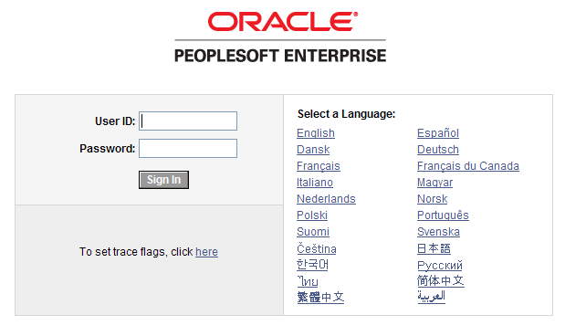
After entering your PeopleSoft User ID and Password, you can sign into the system. Remember, your User ID and Password are case sensitive. Also, if you attempt to sign-in five times with the incorrect login information, the system will lock you out. To unlock your account, notify your Local Security Administrator.
You can access the Worklist through either the link in the upper right corner of the page or in the Main Menu.
Reviewing Your Worklist
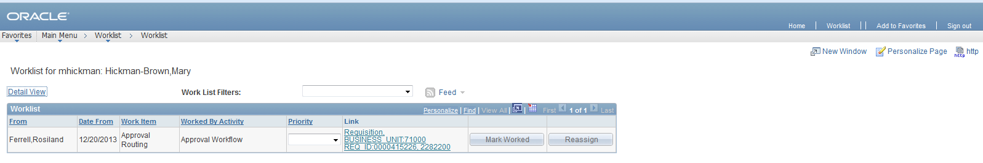
Your Worklist is separated into different columns. First, the person who submitted the requisition is listed in the “From” Column. The “Date From” column indicates when the requisition was submitted. The “Work Item” column indicates what action is required. The “Priority” column is not used. And the “Link” column displays the link to the Requisition needing approval. Note that the “Reassign” button has been inactivated on this page.
On your Worklist, you can sort the page by clicking on a column heading. For example, if you wanted to sort your Worklist by the Requester, you would click the “From” column heading.
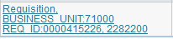
In each Requisition link, there are certain pieces of information used to identify it. First, the link begins with the term “Requisition” and is followed by your institution’s Business Unit. The Requisition ID is listed next. In the example above, the Requisition ID is 0000415226. To go to the Requisition Approval page, simply click on that Requisition link.
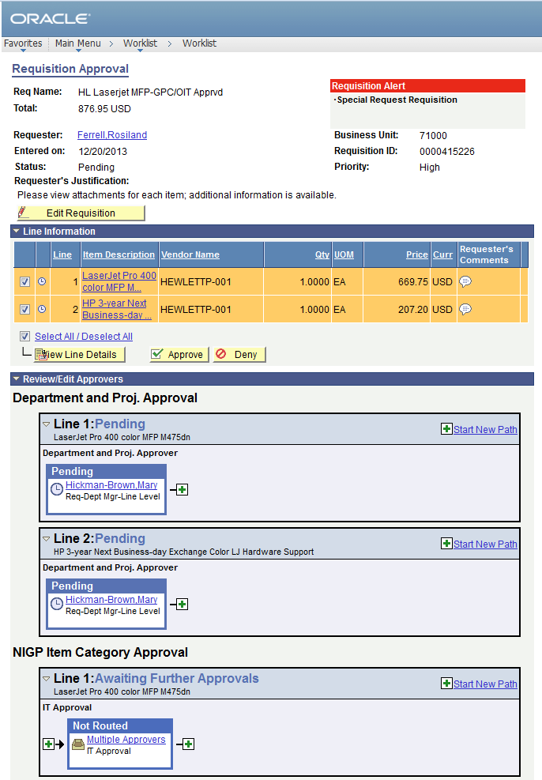
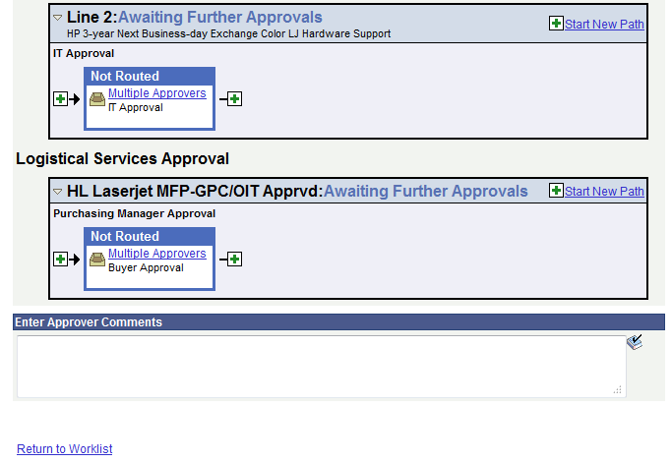
Here’s a brief description of what is on the Requisition Approval page:
- If the Requester gave the requisition a specific name, it will be listed. If not, the Requisition ID will be listed next to Req Name.
- The Requisition total amount is listed.
- The Requester is listed. If you select the Requester’s Name link, the system will display the Requester’s Name, Employee ID and Department.
- The date the Requisition was entered in the system is listed.
- The Requisition Status is listed.
  - Pending: The requisition is pending approval
- If the Requester entered any comments about the whole requisition, they will be listed next to Requester’s Justification.
- The Business Unit, Requisition ID, and Priority are also listed.
- For some approvers, the “Edit Requisition” button will be available above the Line Information section so that they can modify the requisition. After an approver modifies and saves the requisition, Workflow approvals may need to be restarted depending on their role action security.

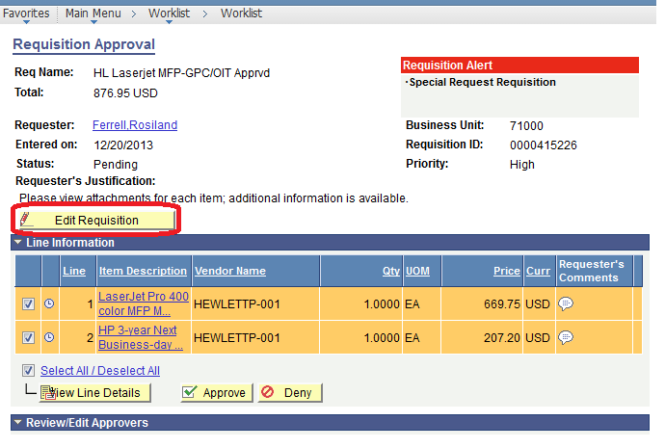

In the Line Information section, the system will display all requisition lines that you are required to act upon. The ‘clock’ icon indicates that the line is pending your approval.
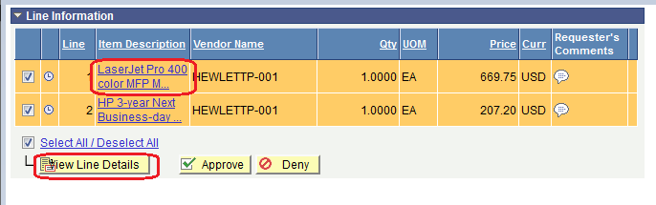
If you select the Item Description’s hyperlink in a line, the Item Description page is displayed.
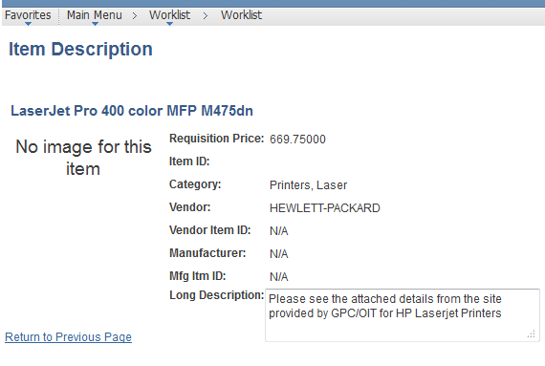
The Item Description page will list the item price, Category, and Supplier if listed. Select the “Return to Previous Page” link to return to the Requisition Approval page.
To see the line details, select the requisition line through its checkbox and then select the View Line Details button. You can select multiple lines at one time to view those line details simultaneously.
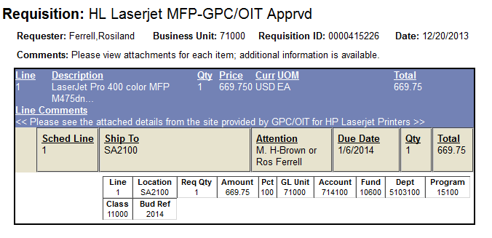
A new window will open and the shipping and distribution information will be displayed. You will be able to see the Chartfields that are charged for that requisition line. When you are done reviewing the line details, you can close the pop up window.
The “Requester’s Comments” call-out icon appears for those lines that have line comments or attachments. To review these comments, you can select the call-out icon.
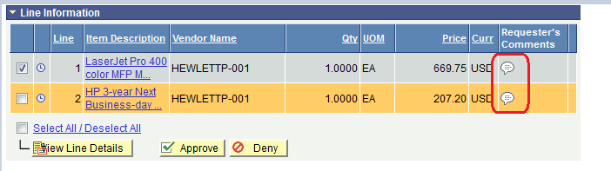

Here, you can review the line comments and attachments. To return to the line information, select the “Return to Previous Page” link.
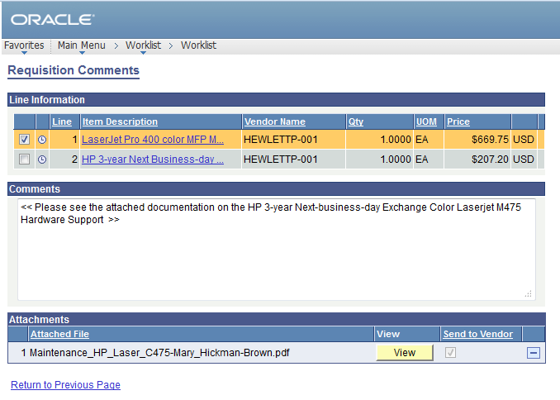
To see the approval path for a requisition, select the “expand” icon next to Review/Edit Approvers.
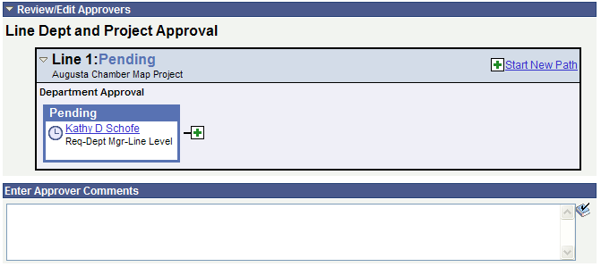
The Review/Edit Approvers section expands and lists all approvers that have acted or need to act on a requisition. In addition, there will be an approval path for each requisition line, since each line can have a different set of approvers depending on their Chartfields and item type.
Under the approval path, you can enter any comments that you wish to attach to the requisition. Do not include any slashes (/) in your comments.
When you are ready to act on the requisition, you can select your requisition lines and then click the Approve or Deny button.
Once approved, the Requisition Approval page should update indicating that you have completed your approval action.
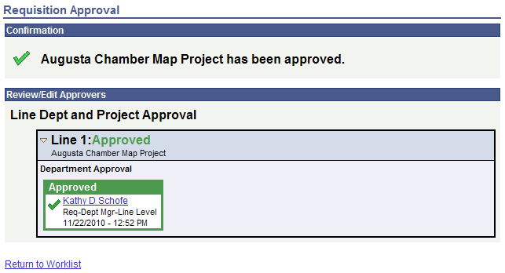
A requisition line will go to “approved” once all approvers have acted on it. Until then, the Requisition Status is still Pending.
To return to your Worklist to work another requisition, select the Return to Worklist link.

How To: Access your Worklist
- Log into PeopleSoft Financials Core System with your User ID and Password.
- Click the Worklist hyperlink in the upper right corner of the home page.
- Click a Requisition link under the “link” column to display a requisition.
How To: Approve a Requisition
- Select the requisition from your Worklist.
- Review each line item’s descriptions by clicking on the Item Description hyperlinks.
- Review each line item’s details by selecting them with a checkmark and clicking the View Line Details button.
- Review the approval path if desired. You can insert additional approvers if needed (see lesson #).
- Enter any comments you wish to add to the requisition. Do not include any slashes (/) in the comments field.
- Select the lines you want to approve with a checkmark and then click the Approve button.
- After receiving the approval confirmation, click the Return to Worklist link.
How To: Deny a Requisition
- Select the requisition from your Worklist.
- Review each line item’s descriptions by clicking on the Item Description hyperlinks.
- Review each line item’s details by selecting them with a checkmark and clicking the View Line Details button.
- Review the approval path if desired.
- Enter comments explaining why you are denying the requisition. Do not include any slashes (/) in your comments.
- Select the lines you want to deny with a checkmark and then click the Deny button.
- After receiving the denial confirmation, click the Return to Worklist link.

Ad Hoc Approvers
eProcurement gives you the ability to insert additional approvers if you feel it is necessary. After reviewing a requisition’s approval path, you can insert additional approvers if you have the BOR_AD_HOC_APPROVE security role.
While you are reviewing the approval path for a requisition, you can insert the ad hoc approver wherever you see a green plus sign (+).
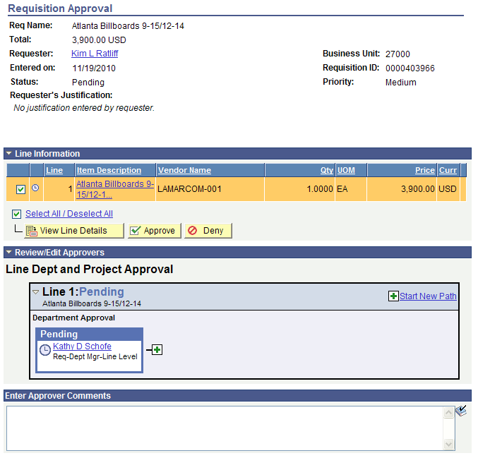
After clicking the green plus sign where you want to insert the additional approver, the system will display a pop-up box where you can select the ad hoc approver.
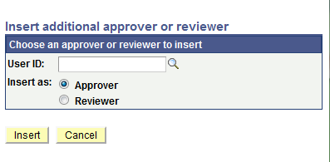
If you select the User ID look up icon, you will be able to search for the approver by User ID or by name. After selecting the additional approver, you can specify whether you want that approver to be inserted as an Approver or a Reviewer.
- Approver: If you select another person to be an approver, that person will be required to approve the requisition before it can move onto the next step.
- Reviewer: If you select another person to be a reviewer, that person will see the requisition in their Worklist, but they will not need to approve the requisition line.
If you have inserted an approver and then decide to remove them, you must do this before you approve the requisition.
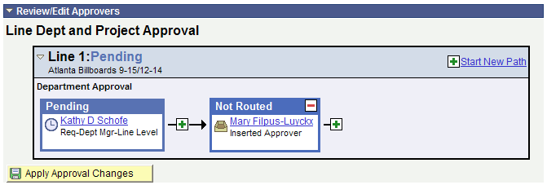
To remove a user you added as an Ad Hoc approver, select the red minus sign (-) in that person’s approval box.
When you insert another person in the approval path for a requisition, that user will need to proper ‘approver’ security setup in the system to work the requisition. If you unsure if the user has the correct security setup, contact that user and your Local Security Administrator.
How To: Insert Ad Hoc Approver
- Select the requisition from your Worklist.
- Review each line item’s descriptions by clicking on the Item Description hyperlinks.
- Review each line item’s details by selecting them with a checkmark and clicking the View Line Details button.
- Review the approval path.
- Click the green plus sign (+) where you want to insert the ad hoc approver.
- Click the User ID look up icon in the pop-up window.
- Search for the name or User ID of the approver you want to add. Click on that person’s name.
- Select either Approver or Reviewer.
- Click the Insert button.
- Click the Apply Approval Changes button.
- Enter any comments you wish to add to the requisition. Do not include any slashes (/) in the comments field.
- Select the lines you want to approve with a checkmark and then click the Approve button.
- After receiving the approval confirmation, click the Return to Worklist link.

Requisition Push Back
All approvers can approve or deny a requisition that is submitted to them. Some approvers also have the ability to push a requisition back to the previous approver. This may be necessary if an approver has additional questions about a requisition. Initial approvers for a requisition will be unable to push back a requisition since there are no previous approvers in the approval path. Project approvers and inserted ad hoc approvers can use the push back function.
When you push back a requisition, it places that requisition back into a Pending status for that approval step. If you receive a requisition that was pushed back, you will be required to approve it again or deny it.
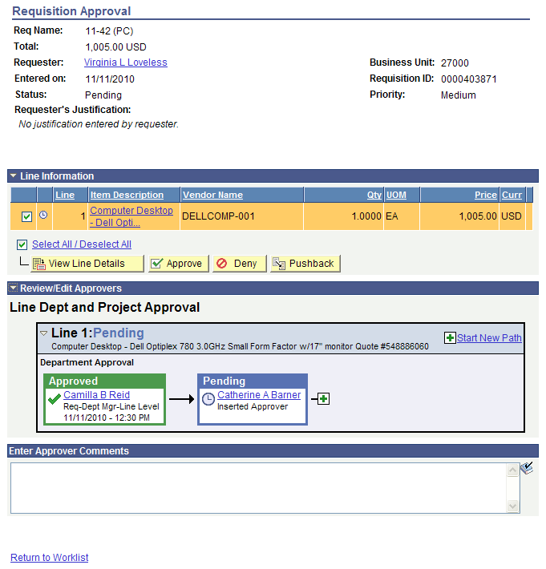
In the example above, you can see the Pushback button. As the approver Catherine Barner, you could push the requisition back to the first approver. When you push back a requisition, you will be required to enter comments explaining why you are pushing the requisition back. Do not include any slashes (/) in your comments. After pushing it back, you will receive confirmation the requisition has been pushed back to the previous approver.
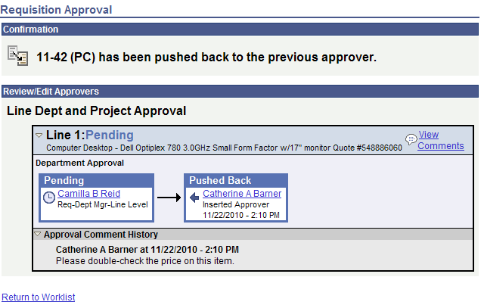
As the approver who receives a pushed back requisition, you will easily be able to see that it was pushed back and you can review the comments to determine why it was pushed back.
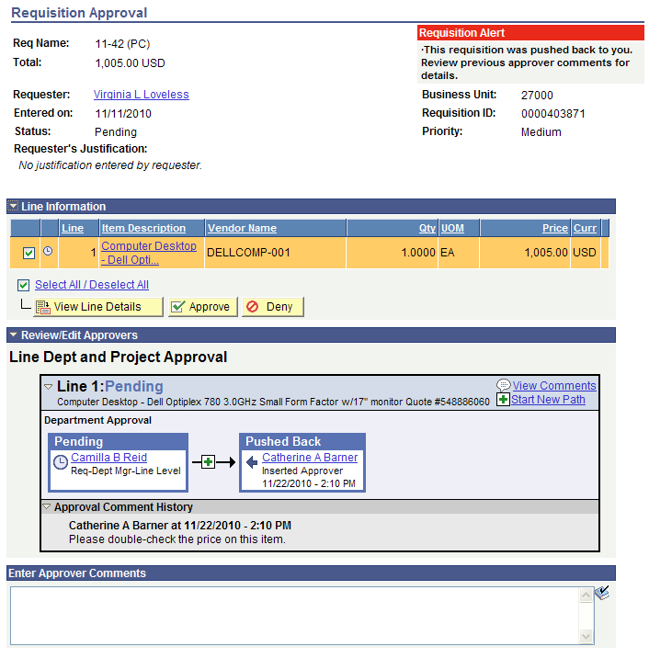
You can then perform the necessary actions and either approve or deny the requisition. If you approve it, it will proceed on the approval path.
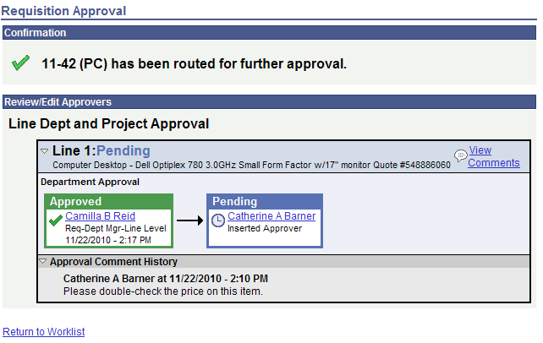
How To: Push Back a Requisition to the Previous Approver
- Select the requisition from your Worklist.
- Review each line item’s descriptions by clicking on the Item Description hyperlinks.
- Review each line item’s details by selecting them with a checkmark and clicking the View Line Details button.
- Review the approval path if desired.
- Enter comments as to why you are pushing the requisition back to the previous approver. Do not include any slashes (/) in your comments.
- Select the lines you want to push back with a checkmark and then click the Push Back button.
- After receiving the Push Back confirmation, click the Return to Worklist link.

Chapter 5: Using the Manage Requisitions Page
In the ePro Module, one of the most productive pages is the Manage Requisitions page. In this chapter, we will detail what the page looks like and explain the different tasks you can perform through the page.
Managing Requisitions
Once a Requester has saved a requisition, it is easy to track what stage it is in by using the Manage Requisitions page. From this page, you can see the requisition status, review requisition details, and edit requisitions if needed.
To use the Manage Requisitions page, you will first have to search for the requisitions. You can search through the following parameters (leave a field blank to return all values):
- Requisition ID
- Date From/Date To (when was the requisition created)
- Requester (this is the Requester entered on the Requisition)
- Requisition Name
- Request Status (this is the status of the requisition)
- Entered By
- Budget Status (this is the budget checking status)
- PO ID (if the requisition has been sourced to a PO, this is the corresponding PO ID)
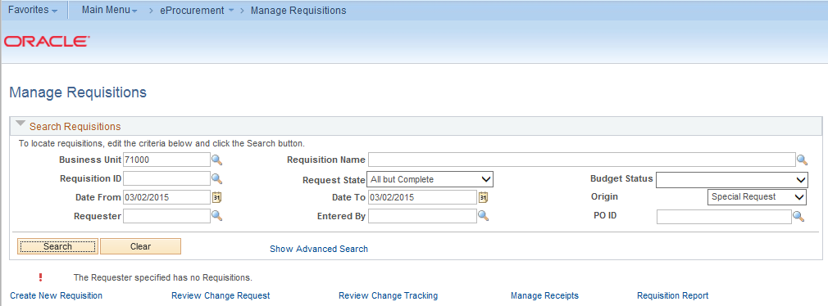

There are many statuses that a Requisition goes through during its lifecycle.
Requisition Status | Explanation
Open | The requisition has been entered and saved in the system, but it has not yet been submitted for approval.
Pending | The Requisition has been submitted and is awaiting approval.
Approved | The requisition has been fully approved and can become a PO.
Denied | The requisition was denied in the approval process.
Canceled | The requisition was entered and saved, but was canceled. A canceled requisition can be reopened within a certain number of days.
PO(s) Created | The requisition has been placed on a Purchase Order.
PO(s) Dispatched | The requisition has been placed on a Purchase Order, and the PO has been dispatched to the Supplier.
Received | The requisition has been placed on a PO. The PO has been dispatched to the Supplier, and the goods have been partially or fully received.
Complete | After the requisition is dispatched on a PO, the goods are received, and the Supplier is paid. A background process identifies the requisition status as Complete. Canceled requisitions are also identified as Complete.

After a requisition has been approved, it must then go through the Budget Checking process. The Budget Statuses include Not Checked, Error, and Valid.
Budget Status | Explanation
Not Chk’d | The requisition has not had budget checking run on it yet.
Error | The requisition has gone through budget checking and failed; the budget checking error must be corrected before the requisition can be sourced into a purchase order.
Valid | The requisition has passed budget checking and is available to be sourced into a purchase order.

The more search criteria that you enter, the more narrow your search results will be. In your list of search results, you will see the following for each Requisition:
- Requisition ID
- Requisition Name
- Business Unit
- Date
- Status
- Budget
- Total
- Action Drop Down box and Go button
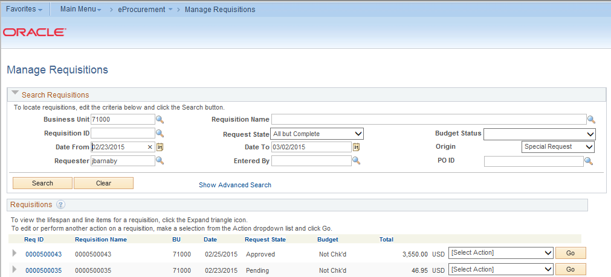
You can sort by a search result, such as Budget, by clicking on the column heading hyperlink. In the results, you can quickly see the status the requisition is in, as well as its budget checking status. To see the lifespan of the requisition, as well as its line item, you can expand the requisition.
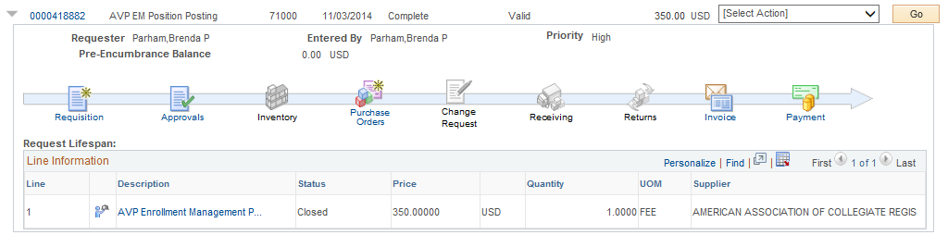
Once you have expanded a Requisition, you can see its lifecycle represented by the lifespan icons. If an icon is in color, that stage has been completed. In this example, you can see that the requisition was sourced into a Purchase Order and dispatched, and the requested items have been received. The items still need to be paid for.
From this page, there are many items that you can review. If you select the Requisition ID or the Requisition icon in the lifecycle, you will get a summary of the requisition details.
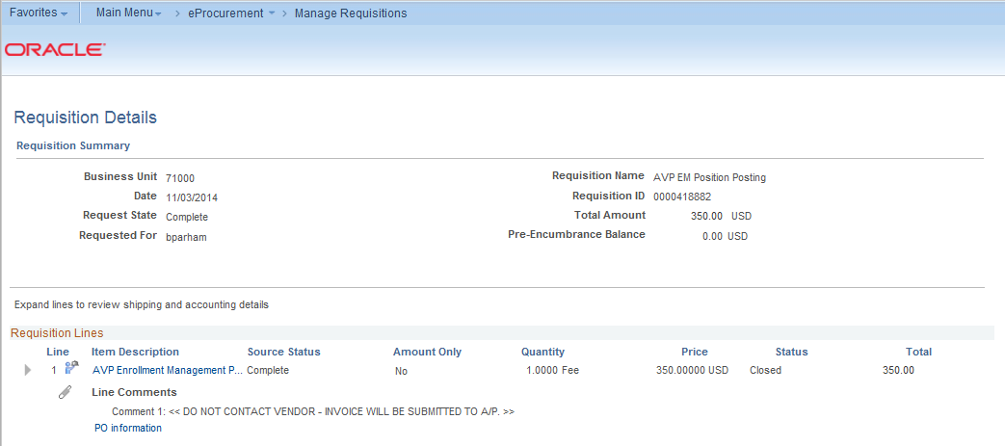
If the requisition has already been sourced to a PO, you will see a “PO Information” link. To get the PO Information for a sourced requisition line, you can click on this bar and see the PO number, receipt status, and PO line information.
If you want to see the requisition schedule and distribution information, you can expand the line from the Requisition Details page.
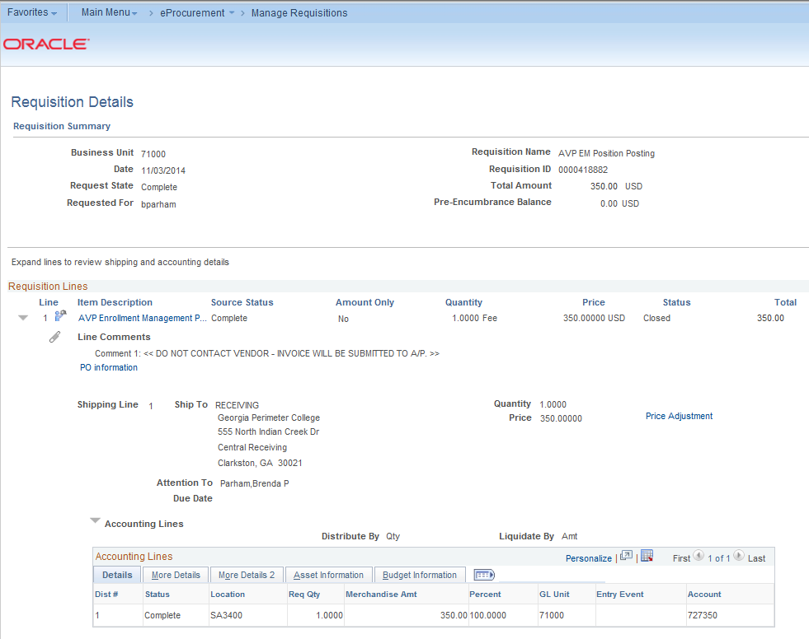
The Line section contains all of the line items on a requisition. The Shipping Line section displays shipping information for the item, such as where the item is being shipped, when it is due, the quantity, the price, and the total amount of the line.
The Accounting Lines section details the Chartfields and additional information. The Dist # displays the number the system assigned to the distribution. The system uses this numbering to distinguish between multiple distributions for a single requisition line. The distribution statuses include the following:
- Open: The distribution line is open
- Complete: the distribution line is closed
- Processed: the distribution line has been processed and is unavailable for sourcing
- Canceled: the distribution has been canceled
To get the detailed information for a requisition line, you can select the line hyperlink in the Description column under the lifespan or from the Requisition Schedule and Distribution page.
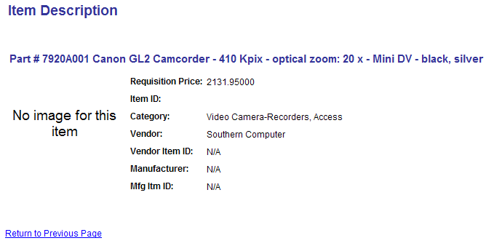

If you select the Approvals icon in the lifespan, you will see the approval status and path of the requisition lines.
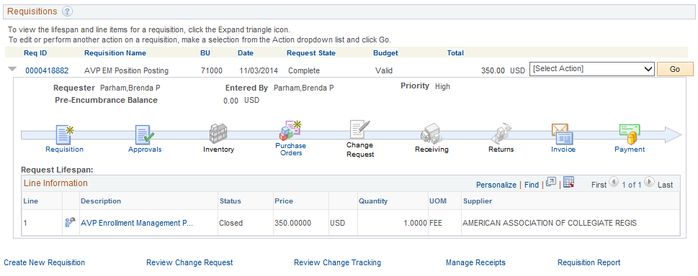
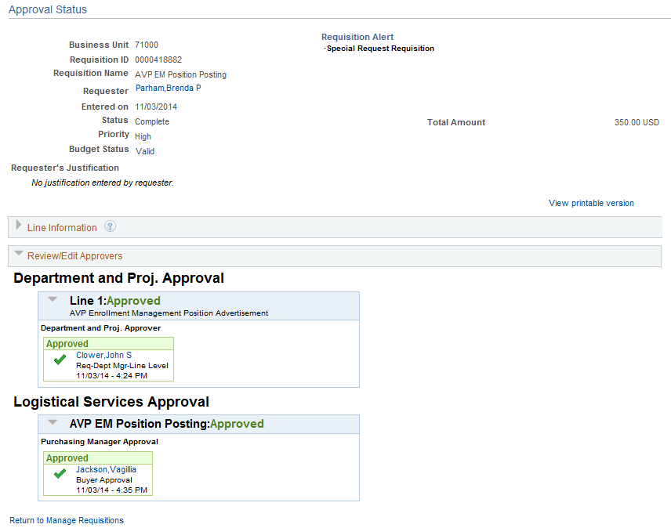
Finally, you can select the Purchase Orders, Receipts, Invoices, and Payments icons after they are enabled to get the information from those specific documents.
The choices in the Action drop down box for each requisition will be specific to the stage that requisition is in. The choices most often used are “Edit Requisition” and “Cancel Requisition”. We will talk more about these choices later in this chapter.
How To: Manage Requisitions
- In PeopleSoft Financials Core system, select eProcurement in the menu.
- Select Manage Requisitions.
- Enter search criteria for your requisitions.
- Click the Search button.
- To see a requisition’s lifespan, click its expand button.
- To see details about a completed stage in the lifespan, click on the lifespan icon.
- To see the approval path for a requisition, click on the Approvals lifespan icon.
- To see requisition line information, click on the line description.
- To see requisition shipping/schedule and accounting/distribution information, click on the Requisition lifespan icon and then expand the line.
Available Actions to Take on the Manage Requisitions Page
Depending on the status of the requisition, there are various actions that you can take through the Manage Requisitions Page. This includes:
- Budget Checking a Requisition
- Edit a Requisition
- View Approvals
- Copy a Requisition
- Cancel a Requisition

Editing a Requisition
There will be times when you need to edit a requisition. This includes those requisitions that you have created and saved, but not yet submitted, as well as requisitions that have been denied and may need to be corrected. And, there may be a few occasions when you need to edit a requisition that has already been submitted for approval.
In order to edit a requisition, you can go through the Manage Requisitions page and search for the requisition in need of editing. When it is displayed in your search results, there will be the option of “Edit Requisition” in its action drop down list. If the requisition is no longer available for editing, that option will not appear in the drop down list. For example, once a PO is created from a requisition, that requisition can no longer be edited.
Once you select the choice of “Edit Requisition” and click Go, the system will take you to the Edit Requisition page. This page is the same type of page used when creating a requisition. From the Review and Submit page, to edit a line, click on the line description. This will bring up the page where you can edit the price, category, unit of measure, etc.
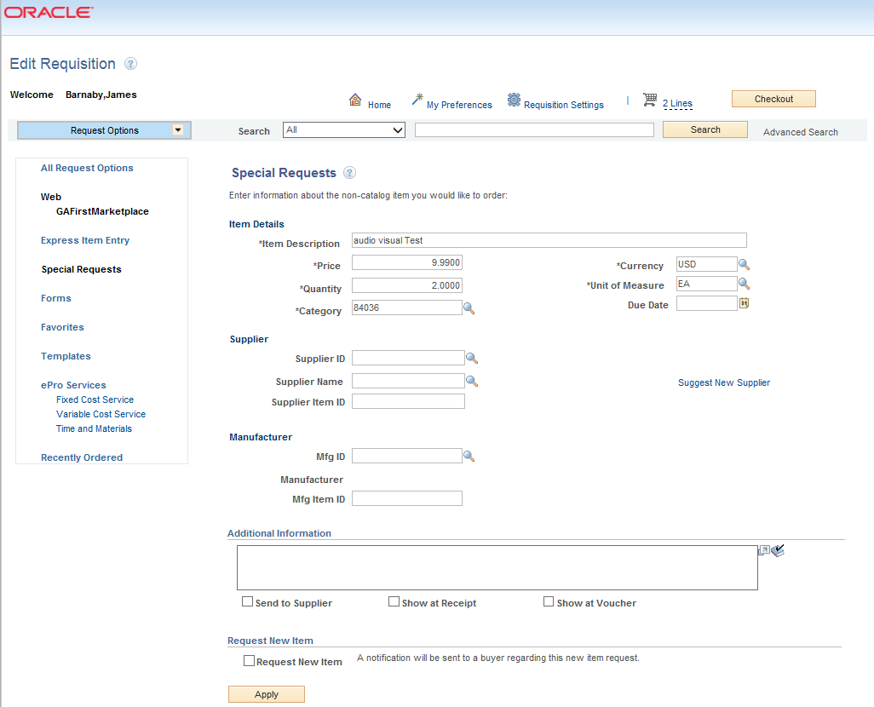
To edit a requisition line’s accounting/distribution and shipping/schedule information navigate back to the Checkout – Review and Submit page and click on the expand icon for that line. The shipping information can be updated, and the Chartfields can be updated if necessary. After making all of your edits, you can select the Save & Submit button. If you have made changes to a requisition that is already in the approval process, when you submit the edited requisition, it will reinitiate the approval process, unless you have special role action roles that prevent Workflow from being restarted after you submit a requisition that is currently undergoing approvals. Therefore, it may be helpful to add a comment explaining why an approver may be seeing the same requisition again. After previewing approvals, you can then submit the requisition.
How To: Edit a Requisition
- In PeopleSoft Financials Core system, select eProcurement in the menu.
- Select Manage Requisitions.
- In the search field, enter the Requisition ID that needs to be edited (you may need to clear some of the search fields).
- Click the Search button.
- In the Requisition ID’s action drop-down list, select Edit Requisition.
- Click the Go button.
- To update the requisition line information, select the link under Description. Make the necessary changes and then select the Checkout button.
- To update an individual requisition line Chartfield information, click its expand button. Make the necessary changes.
- To update multiple requisition lines at one time, select the lines to be edited and the select the Mass Change button. Make the necessary edits.
- Select the Save & Submit button.
- If reinitiating the approval process, consider adding a comment to inform your approvers of this. Do not include any slashes (/) in your comments.
- Insert any ad hoc approvers if necessary.
- Click the Apply Approval Changes button.
Delete a Requisition Line
You can delete a requisition line if needed, as long as the requisition line has not been budget checked. To delete a requisition line, you will again go through the Manage Requisitions page and select “Edit Requisition.” From the “Edit Requisition – Review and Submit” page, you can select the line to be deleted by placing a checkmark in its select box. You can select multiple lines at one time if needed. To delete the selected lines, simply click the Delete button. The system will ask you to confirm the deletion before proceeding. Since you have modified the overall requisition, you will need to Save and Submit the requisition again.
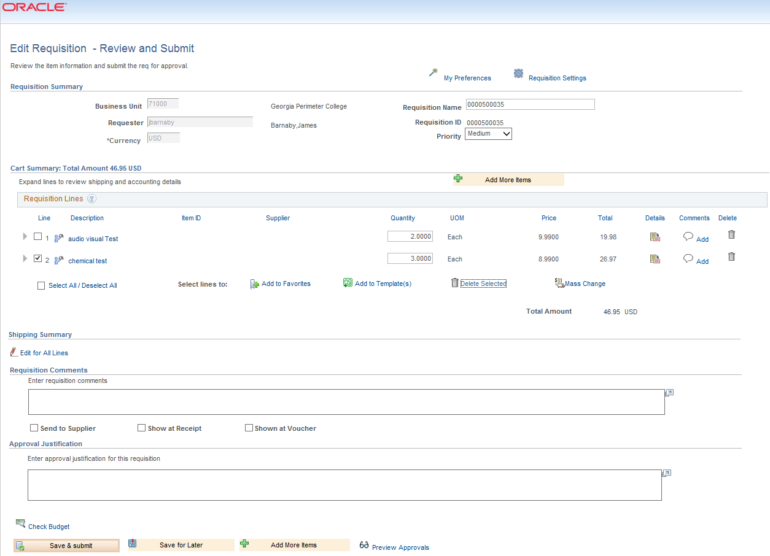
How To: Delete a Requisition Line
- From the PeopleSoft Financials Core system, select eProcurement in the menu.
- Select Manage Requisitions.
- Enter the Requisition ID in the Search Criteria (you may need to clear some of the search fields).
- Click the Search button.
- In the Requisition ID’s action drop-down list, select Edit Requisition.
- Click the Go button.
- Select the line(s) you want to delete.
- Click the Delete button.
- To confirm the deletion, click the OK button.
- Click the Save and Submit button.

Copying a Requisition
Need description
How To: Copy a Requisition
- From the PeopleSoft Financials Core system, select eProcurement in the menu.
- Select Manage Requisitions.
- Enter the Requisition ID in the Search Criteria (you may need to clear some of the search fields).
- Click the Search button.
- In the Requisition ID’s action drop-down list, select Copy.
- Click the Go button.
- Select Yes when notified that the ‘copied defaults will remain unchanged – do you want to copy?’.
- To update the requisition line information, select the link under Description. Make the necessary changes and then select the Checkout button.
- On the Checkout – Review and Submit page, you can make changes to the Quantity, Shipping, and Accounting/Distribution information.
- Click the Save and Submit button.

Canceling a Requisition
On occasion, you may find the need to cancel a requisition. If you need to cancel a requisition, you can do so as long as the requisition has not been sourced into a Purchase Order. Once it has been sourced into a purchase order, the requisition can no longer be canceled and you will have to work with the purchase order. To cancel a requisition, you will go through the Manage Requisitions page.
How To: Cancel a Requisition
- From the PeopleSoft Financials Core system, select eProcurement in the menu.
- Select Manage Requisitions.
- Enter the Requisition ID in the Search Criteria (you may need to clear some of the search fields).
- Click the Search button.
- In the Requisition ID’s action drop-down list, select Cancel Requisition.
- Click the Go button.
- On the Requisition Details page, select the Cancel Requisition button.
- On the Manage Requisitions page, the requisition state should change to Canceled.

Chapter 6: Budget Checking Requisitions
Budget Checking is the process to determine if there are enough funds in a budget to cover the purchase. In this chapter we are going to discuss how budget checking works, how to perform budget checking, and how to review budget checking errors.
What is Budget Checking?
Budget Checking is the comparison of a pending transaction amount against the budget it is set to be charged to. This ensures that a budget has been adequately set up and that there are sufficient funds to post the pending transaction, before the transaction is actually posted. The Commitment Control (KK) module of PeopleSoft is used to budget check transactions against Appropriation, Organization, Revenue Estimate, Grant, and Project budgets.
Based on a number of factors, Commitment Control is able to distinguish if a particular Chartfield combination has sufficient funding available in order to validate the transaction amount or whether an exception should be issued. Budget exceptions are the result of transactions that have failed the budget checking process for one of the following reasons:
- Exceeds Control Budget
- No Budget Exists
- Budget is Closed
- Budget Date Out of Bounds
Other errors exist, but these are the most common.
Budget exceptions can fall into two categories: warnings and errors. Warnings are exceptions that do not conform to the rules of the control budget, but have been passed along and update the Commitment Control ledgers nonetheless. Errors are exceptions that have failed budget checking because they do not conform to the rules established for that control budget. Transactions with errors are not allowed by the system to update the Commitment Control budget ledgers.
When Requisitions are budget checked and receive a “Valid” budget checking status, the system creates a pre-encumbrance. A pre-encumbrance is a Commitment Control ledger type for an amount that you expect to expend, but which you have no legal obligation to expend.
After a Requisition is sourced into a Purchase Order, that Purchase Order is also budget checked. If the Purchase Order passes budget checking, the system relieves the pre-encumbrance from the Requisition and creates an encumbrance for the Purchase Order. An encumbrance is a Commitment Control ledger type for an amount that you are legally obligated to spend.
After the goods on the Purchase Order and received and the Supplier sends the invoice, the Voucher is created. When the Voucher is budget checked, the system relieves the encumbrance from the Purchase Order and creates the expenditure for the Voucher.
Budget Checking Requisitions
After a Requisition is fully through the approval process, it is available for Budget Checking. You can budget check requisitions in batch or manually. In addition, the system has automatic budget checking batch processes run periodically throughout the day. So, if anything is ready to be budget checked, the system automatically runs the process on it.
This scheduled budget checking job is a part of the overall “SCIQUEST” scheduled batch job. This SCIQUEST batch job includes budget checking requisitions, sourcing Marketplace Requisitions into Purchase Orders, budget checking purchase orders, running document tolerance on purchase orders, and dispatching purchase orders.
The automatic batch budget checking process runs at the following times:
- 10:00 a.m.
- 12:00 p.m.
- 2:00 p.m.
- 4:00 p.m.
- 6:00 p.m.
Manual Budget Checking
You can manually budget check a fully approved requisition on the Manage Requisitions page. There are a couple of things to keep in mind when manually budget checking a requisition. When you initiate budget checking for this page, you should not leave the page while it is processing. In addition, manual budget checking tends to take longer than batch budget checking, and it can put extra demands on all processing in the system.
However, at times, you may find it necessary to perform manual budget checking. If so, you should select the “Check Budget” option in the drop down list for that requisition. Note that only approved requisitions will actually budget check. If a requisition is not yet fully approved, the system will not budget check it. All requisition lines need to be approved for budget checking. The system then processes this action. If the budget check is successful, the budget status will be “Valid.” Depending on your initial search criteria, you may need to change your criteria to see the requisition again on this page.
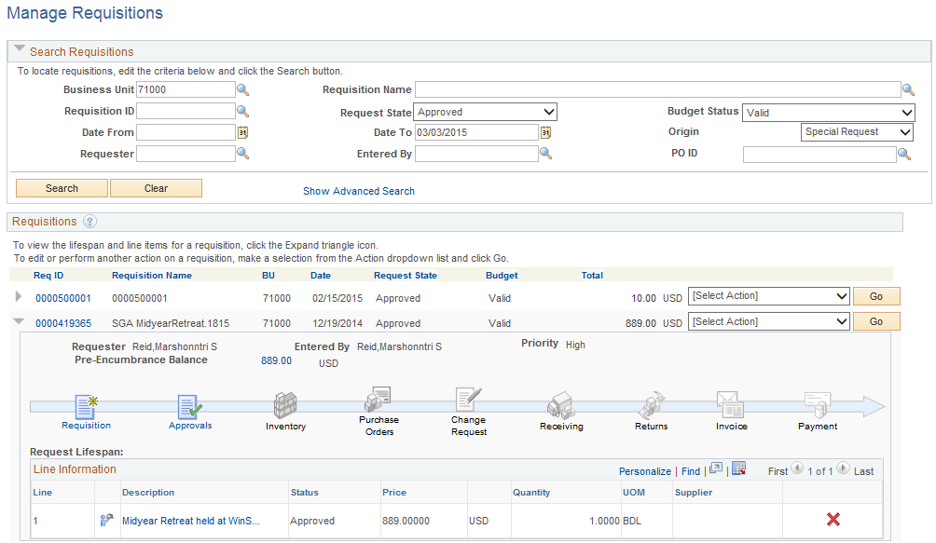

How To: Manually Budget Check a Requisition
- In PeopleSoft Financials, select eProcurement in the menu.
- Select Manage Requisitions.
- Locate the requisition you want to manually budget check through the search section.
- In the requisition’s action drop down list, select Check Budget.
- Click the Go button.
- Remain on this page while the system is processing your request.
- Review the budget checking status by bringing up that requisition in the search results again.

Batch Budget Checking
In addition to manually budget checking a requisition on the Manage Requisitions page, you can also initiate budget checking batch, outside of the normally set automatic batch processing. When budget checking requisitions in batch, you can process all requisitions that are waiting to be budget checked, or just select ones according to their Requisition ID, Date, Requester, Origin or Status.
To run budget checking in batch on requisitions, you will have to go to the Purchasing menu in PeopleSoft.
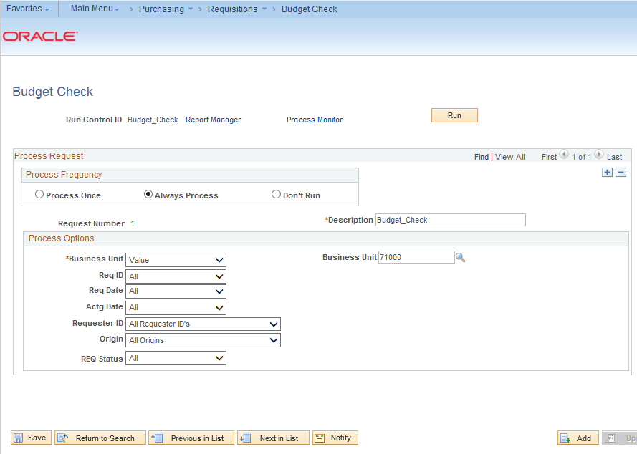
When running batch budget checking on your requisitions, you can run it on all requisitions, a range of requisitions, or just one requisition. In addition, you can select requisitions by date, requester, origin, and status. After inputting your process parameters, you can run the process and monitor the status of the process through the Process Monitor.

After the process successfully completes and the results are posted, you can view the results through the View Log/Trace link or through the Message Log link. By looking at the Message Log, you can see that the number of documents processed, and how many have a budget error or budget warning.
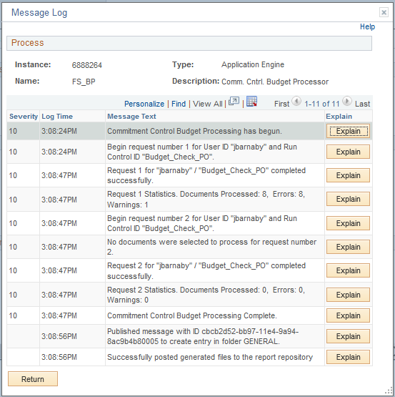
How To: Run Batch Budget Checking on Requisitions
- In PeopleSoft Financials, select Purchasing in the menu.
- Select Requisitions.
- Select Budget Check.
- Enter or select a Run Control ID (add a new one if necessary)
- Select a Process Frequency of Always.
- Enter a Description.
- Ensure your business unit is listed in the Process Options.
- Using the additional process option drop down lists, select which requisitions you want the budget checking process to run on.
- Click the Run button.
- On the Process Scheduler Request page, click the OK button.
- To view the process results, note your process instance number and then select the Process Monitor link.
- Locate your process instance in the Process List. Periodically click the Refresh button until your Run Status shows “Success” and your Distribution Status shows “Posted.”
- Click the Details link.
- Click the Message Log link.
- Review the results of the batch process. It will indicate how many requisitions were processed, as well as how many had a budget checking error or budget checking warning.
- Click the Return button.
- Click the OK button.

Reviewing Budget Check Exceptions
If your budget check process (either manual or batch) results in a budget checking exception, you can review what those exceptions are through the Commitment Control module. Remember, a budget check exception will either be a warning or an error. Warnings are still processed. Errors cannot be processed until they are resolved. The system will also send periodic notifications to requesters that their requisitions have failed budget checking.
When searching for budget check exceptions, you can search by the Commitment Control Transaction ID or Date, the Requisition ID, the Process Instance or Process Status. For example, if the routine budget check process was run at 4:00 p.m., you can find that process instance number and enter it on the search page to review any budget check exceptions during that batch process.
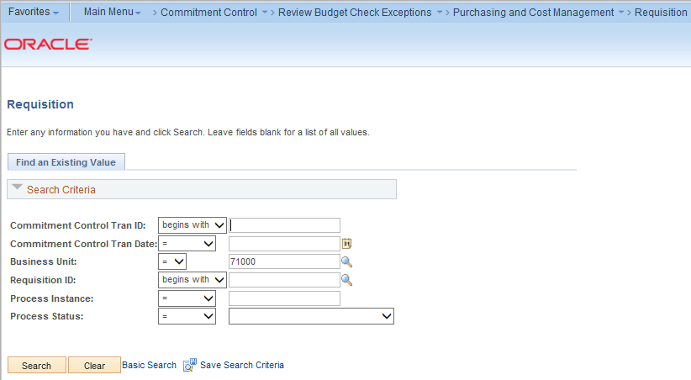
If there are multiple results, they will be listed on the page. If a transaction has a process status of “Warning”, it has been posted to Commitment Control and the transaction requires no further action. If a transaction has a process status of “In Process,” the transaction is stuck and will be ignored by the budget checking status. Users must use the online reset process to change the process status back to “none.” If a transaction has a process status of “Error,” the transaction has failed budget checking and must be corrected before it will post to Commitment Control ledgers and the general ledger.
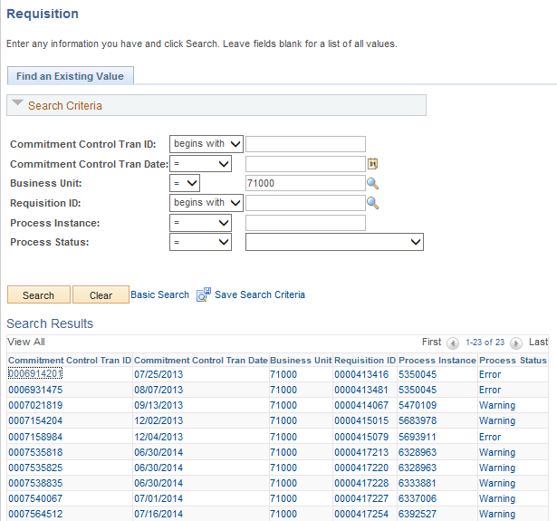
On the Review Exceptions page, the exception type is listed for that requisition. In addition, the actual exception is listed in the Budget Override tab. The possible exceptions are:
- Exceeds Control Budget
- No Budget Exists
- Exceeds Non-Cntrl Budget
- Budget is Closed
- Budget Date Out of Bounds
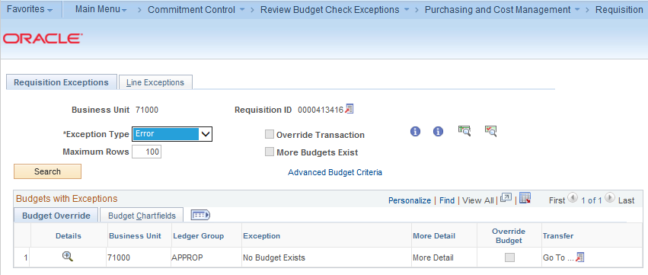
On the Budget Chartfields tab, you can review the Chartfields that are in error. To see the Budget Override tab combined with the Budget Chartfields tab, select the “Show all Columns” button.
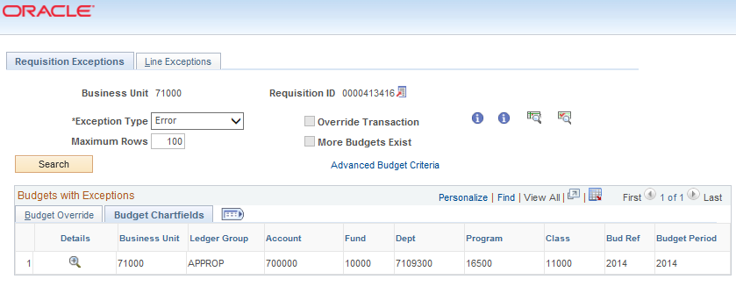
Back on the Budget Override tab, there is an “Override Transaction” checkbox. If you have the proper security authority and the circumstances are appropriate, you may be able to override the budget error. If you don’t have the authority to override the error, or if the error cannot be overridden, this checkbox will be grayed out.
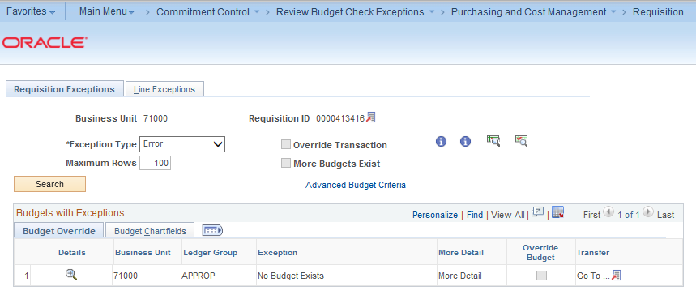
Also on the Budget Override tab, you can transfer to the Budget Exceptions or Budget Inquiry page by selecting the “View Related Links” icon.
The Budget Exceptions page allows you to see the detailed Chartfields that are in error.
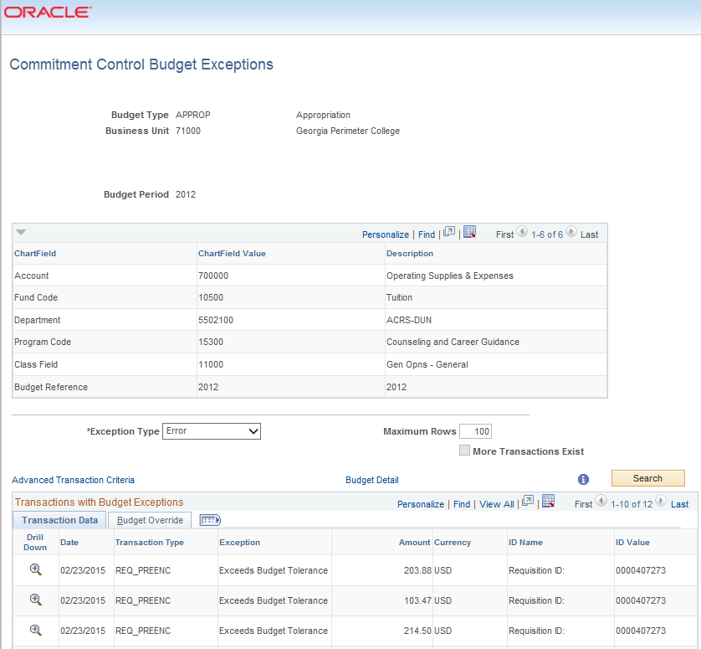

The Budget Inquiry criteria page displays and the Chartfields must be entered into the appropriate fields. After selecting Search, select the View Details link. The Budgeted, Expensed, Encumbered, Pre-Encumbered, and available budget for the Chartfield combination used on the requisition will display. This page will not display if the budget exception is that “No Budget Exists.”
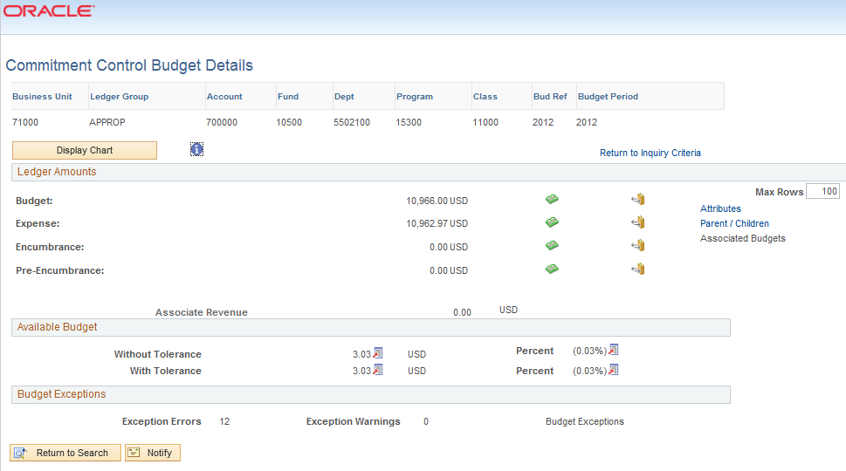
How To: Review Budget Checking Exceptions for Requisitions
- In PeopleSoft Financials, select Commitment Control in the menu.
- Select Review Budget Check Exceptions.
- Select Purchasing and Cost Management.
- Select Requisition.
- On the Find an Existing Value page, enter the Requisition ID, Process Instance number, or process status.
- Select the Search button.
- Locate the exception you wish to review and select a link in that line.
- Review the Budget Override tab to determine the actual exception.
- Review the Budget Chartfields tab to determine the Chartfields causing the exception.

Budget Checking Errors
As we mentioned earlier, budget checking errors will prevent a requisition from moving forward to be sourced into a purchase order. Budget Checking errors must be cleared up first. The responsibility of clearing up budget checking errors differs at each institution. This section will briefly explain how budget checking errors may be cleared up for requisitions.
Exceeds Control Budget/Exceeds Budget Tolerance: This error means that there is not sufficient funding to allow a transaction to post to Commitment Control. In most instances, this means that the APPROP or one of the Project ledgers is under-funded. The most common corrective action are to:
- Perform a budget transfer and increase the funding
- Spread the charges over multiple budget years by changing the budget date
- Override the budget (depending on security)
- Change the Chartfields to charge another cost center
After completing the corrective action, the requisition must be re-budget checked.
No Budget Exists: This error occurs when the Chartfield/Budget Year combination does not exist in Commitment Control. The most common corrective actions are to:
- Create a budget adjustment to include the new budget Chartfield combination
- Change the Chartfields to charge another cost center
The No Budget Exists error must be corrected and cannot be overridden. After completing the corrective action, the requisition must be re-budget checked.
Budget is Closed: This error occurs when a Chartfield value or string is set to close via budget attributes or the ledger control Chartfield definition. Most likely, the error will occur on a project/grant definition when spending occurs outside of the sponsor’s start and end dates. To correct this error, perform one of the following:
- Change the ending date of the project (in adherence with the sponsor’s agreement) and run the Project Sync process
- Change the budget date on the requisition (dependent on security)
- Charge another Chartfield string
The Budget is Closed error must be corrected and cannot be overridden. After completing the corrective action, the requisition must be re-budget checked.
Budget Date Out of Bounds: This error occurs when a budget is still open, but the budget date is outside the ending date of the budget attributes or the ledger control Chartfield definition. Most likely, this error will occur on a project/grant definition, when spending occurs outside of the sponsor’s start and end dates. To correct the issue, perform one of the following:
- Change the ending date of the project (in adherence with the sponsor’s agreement) and run the Project Sync process
- Change the budget date on the requisition (dependent on security)
- Charge another Chartfield string
The Budget Date Out of Bounds error must be corrected and cannot be overridden. After completing the corrective action, the requisition must be re-budget checked.
After taking corrective action for a budget checking error, that requisition must be re-budget checked. If the budget checking error was overridden, it must also be re-budget checked. You can perform the budget checking on that requisition through the different means mentioned earlier in this lesson, or you can perform it directly on the Requisition Exceptions page.
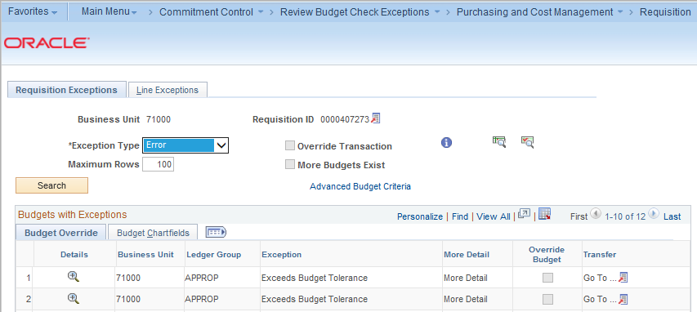
Select the Budget Check icon to re-initiate budget checking on just this transaction. If the budget checking exception remains, you can use the same process to review the exception.

Chapter 7: Sourcing Requisitions into Purchase Orders
Once a requisition has been fully approved and has a Valid budget checking status, the next step is to source it into a Purchase Order. There are many ways a requisition can be sourced into a purchase order. First, we will discuss how GeorgiaFIRST Marketplace requisitions are typically sourced into Purchase Orders. Then, we will discuss how you can source Special Request Requisitions into Purchase Orders.
Sourcing of GeorgiaFIRST Marketplace Requisitions
GeorgiaFIRST Marketplace requisitions are designed to require minimal buyer intervention. Because the items are selected through the marketplace catalogs, the Supplier Information is already completed on the requisition. In addition, because the catalog items are all contractually approved, adherence to purchasing polices is built into the process.
Ideally, after a GeorgiaFIRST Marketplace Requisition is fully approved and has received a Valid budget check, it is then available for the auto-sourcing process. This automatic process runs at different times throughout the day to source these requisitions into purchase orders. The auto-source job is a part of the overall “SCIQUEST” batch job.
The SCIQUEST batch job runs at 10:00 a.m., 12:00 p.m., 2:00 p.m., 4:00 p.m., and 6:00 p.m. In addition to auto-sourcing Marketplace Requisitions, the SCIQUEST batch job includes batch budget checking of requisitions, batch budget checking of purchase orders, batch document tolerance checking of purchase orders, and dispatching purchase orders.
Once a Marketplace Requisition has been fully approved, it can proceed through all steps of the SCIQUEST scheduled batch job during the same batch run, unless it encounters an error during one of the jobs (i.e., fails budget checking). If there is an error, once it has been corrected, it is then available to be picked up by the next available SCIQUEST batch jobs. During the dispatch job, Marketplace Requisition/Purchase Orders are automatically sent back to SciQuest, who then transfers it automatically to the Supplier.
Sourcing of Special Request Requisitions
In PeopleSoft Financials, there are a couple of ways to source a requisition into a purchase order. You can expedite requisitions, allowing you to process multiple requisitions at one time. Or you can copy a requisition into a purchase order. Using the Expedite Requisitions process is the preferred method, however, we will discuss both.

Expediting Requisitions
By using the Expedite Requisitions page, you can manually review and process requisition lines. Your first step will be to search for the requisition lines. You can specify one requisition or display all approved and budget checked requisitions. In addition, you can also include requisition lines that have not been assigned a Supplier yet. If you want to display all requisition lines ready to be sourced from a specific Requester, you can do that as well.
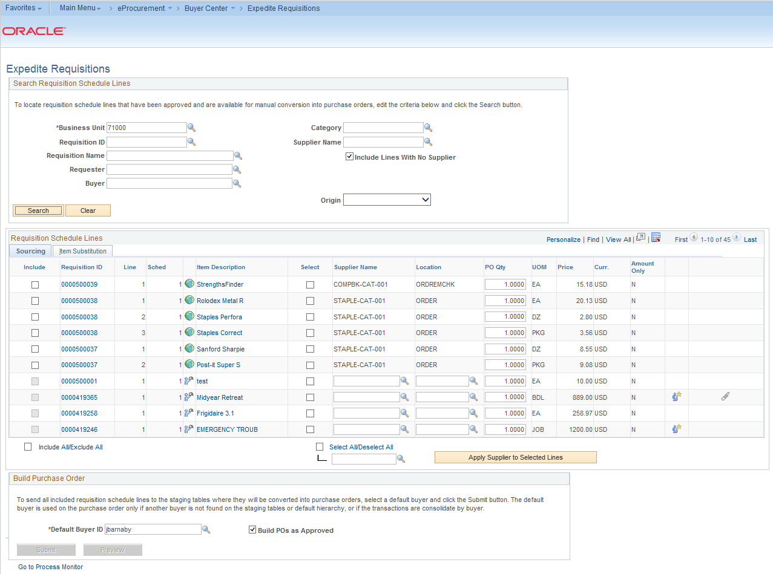
There are certain conditions that a requisition line must meet before it will show up on this page, ready to be sourced. This includes being fully approved and having a Valid budget checking status. If a requisition line is not ready to be sourced, according to the system, it will not display on this page.
If you select the Requisition ID link, the system will open a new window and provide the details regarding the requisition, including a link to the requisition schedule and distribution. If you select the Item Description link, you will see the basic description for the line item.
In the Supplier Name field, you can change a Supplier listed, or add a Supplier if it is missing. Keep in mind that you should not change any Suppliers on the Expedite Requisitions page for GeorgiaFIRST Marketplace requisitions. If the Supplier Name field is blank for a requisition line, you will not be able to expedite it. Also, if you have multiple lines that you want to include the same Supplier for, enter/select that Supplier’s name in the last Supplier name field on the page. Then, you can select the requisition lines you want to apply the Supplier to. Next, select the “Apply Supplier to Selected Lines” button.
The Location field is default Supplier location.
In the PO Qty field, you should see the quantity requested for that line item on the requisition. You can choose to source a partial quantity if needed. To do this, change the quantity listed. Use the Default Buyer ID field to enter the name of the buyer to use on the resulting purchase orders. The default buyer is used on the purchase order only if another buyer is not found on the staging tables or default hierarchy.
To have Purchase Orders created with an “Approved” status, select the “Build POs as Approved” checkbox. If selected, the expedite process examines auto approval criteria set at the business unit level. If the auto approval criteria are met, the status is set to “Approved.” If the auto approval criteria are not met, the status is set to “Pending Approval.” If you do not select this checkbox, the Purchase Order is created with a status of “Open.”
When you are ready to expedite the requisitions, select the requisitions that you want to source into Purchase Orders by checking their “Include” checkbox. You can select the “Preview” button to display a preview of the purchase order before it is actually staged. Before previewing the purchase order, you must select it. Also, once you select a requisition line, you are then unable to change the Supplier name, location, and PO quantity.
When you are ready to build your purchase orders, select the “Submit” button. The Submit feature stages the items and launches the PO Calculations process (PO_POCALC) and Create Purchase Order process (PO_CREATE). The Purchase Orders are generated in the background. You can monitor the process of PO generation by going to the Process Monitor. Once the process has successfully completed and posted, you can review the results through the Sourcing Workbench.
How To: Expedite Requisitions
- In PeopleSoft Financials, select eProcurement in the menu.
- Select Buyer Center.
- Select Expedite Requisitions.
- Enter search criteria for the requisitions you want to source.
- If you also want to see all requisitions (that meet your search criteria) that do not have a Supplier assigned yet, check the “Include Lines With No Supplier” checkbox.
- Click the Search button.
- To review information about the requisition, select the Requisition ID link or the Item Description link.
- To change or add a Supplier for a requisition line, continue. Otherwise, go to step 9.
  - On the Requisition Line that needs a Supplier, select the Supplier Name look up icon.
  - Search for the Supplier by either using its Supplier ID or Short Supplier Name.
  - Select the Supplier you want applied to that requisition line.
- To change or add a Supplier for multiple requisition lines, continue. Otherwise, go to step 10.
  - Select the requisition lines you want to apply the same Supplier to by clicking in their Select checkboxes, next to the Supplier Name field.
  - Click the Look Up icon for the last Supplier Name field, under the “Select All/Deselect All” link.
  - Search for the Supplier by either using its Supplier ID or Short Supplier Name.
  - Select the Supplier you want applied to the selected requisition lines.
  - Click the Apply Supplier to Selected Lines button.
- Update any PO quantities if you do not want to source the requested quantity.
- Select the lines you want to source to purchase orders by clicking in their “Include” checkboxes.
- If needed, update the User ID in the Default Buyer ID field.
- Select the Build POs as Approved checkbox.
- Click the Preview button to see how the PO will be built. When finished, click the Return to Expedite Requisitions link.
- Click the Submit button to initiate the process.
- Select the Process Monitor link to review the status of the PV_PO_CREATE process.
- Periodically click the Refresh button until the Run Status is Success and the Distribution Status is Posted.
- Click the Details link.
- Click the Message Log link.
- On the message log, you should see how many source documents were processed, and how many were completed without error.

Review Expedite Results through the Sourcing Workbench
After running the Expedite Requisitions process, you can review the results through the Sourcing Workbench. When using the Sourcing Workbench, you can review the results by a variety of criteria, including Buyer, Requisition ID, Stage Status, or Process Instance. If you search by Process Instance, you should use the Process Instance from the Expedite Requisitions process previously run.
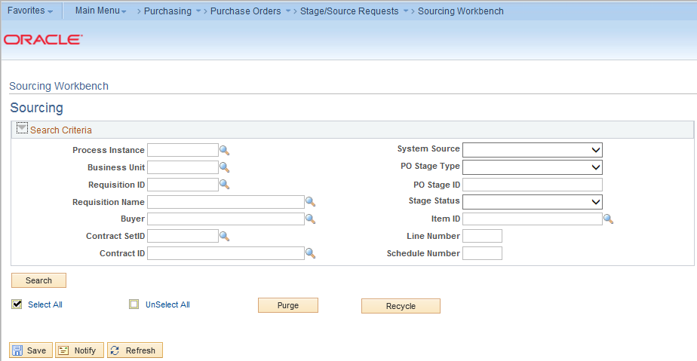
In the results, there will be two tabs. There is a Selected Items tab, with the Process instance, Stage Status, Supplier ID, Requisition ID, and Purchase Order ID.
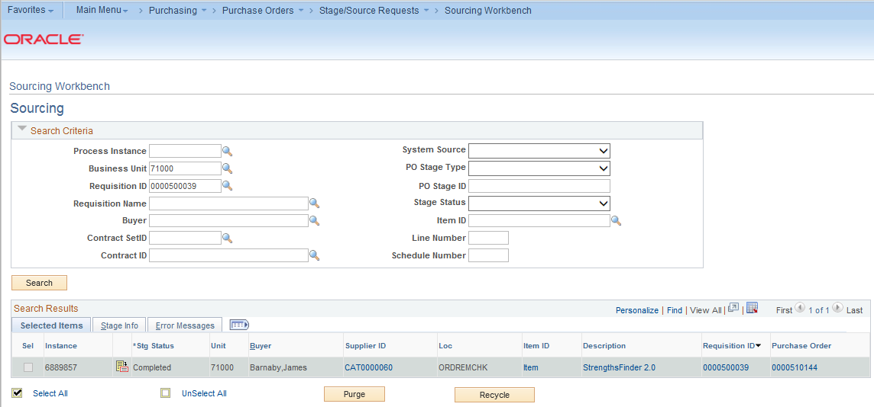
The second tab is the Stage Info tab. This tab contains the staging information for the requisition and purchase order.
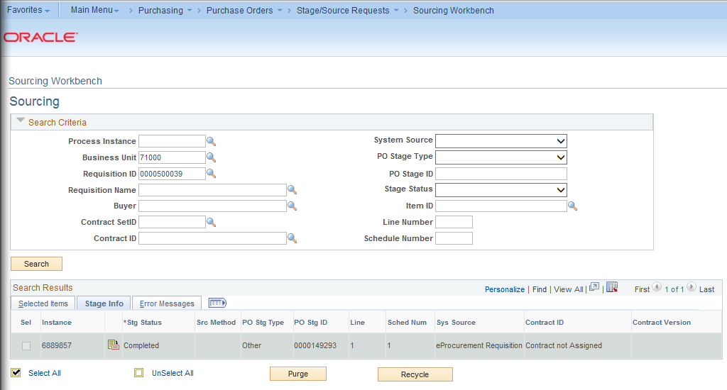
On the Selected Items tab, you will see an icon for Sourcing Details. The Sourcing Details page will provide the Purchase Order ID, the Requisition ID, where the item is being shipped to, the quantity, and the price.
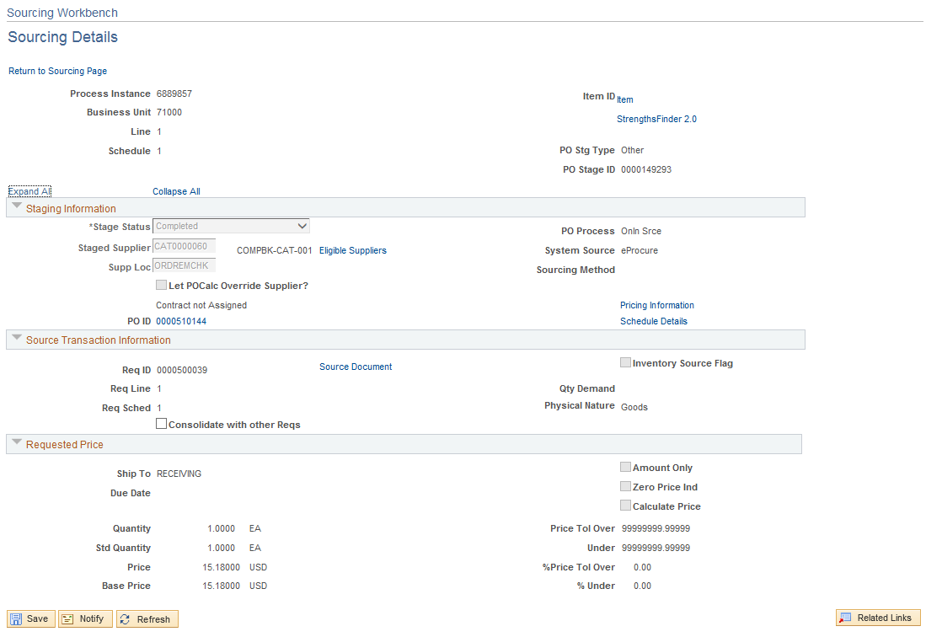
To see the resulting purchase order, you can select the link from the Purchase Order ID column on the Selected Items tab. The system will open a new window for the Purchase Order page.
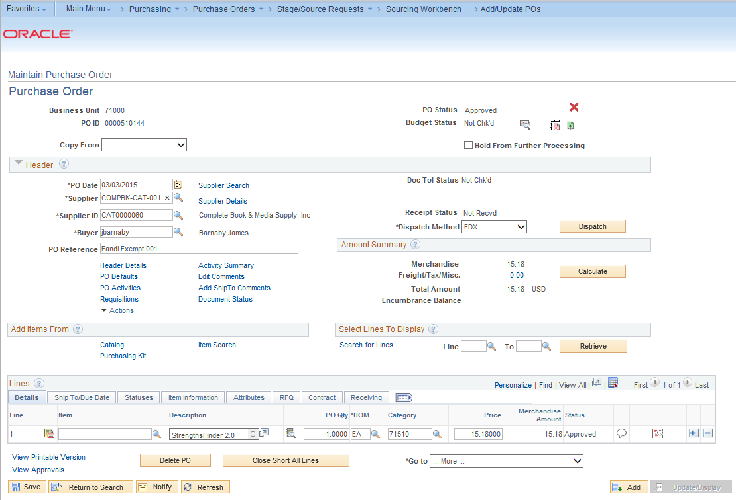
Once the Purchase Order has been created, continue with the processing of that purchase order. If you selected the checkbox “Build POs as Approved”, then your next step should be budget checking the Purchase Order and then dispatching it.
How To: Use the Sourcing Workbench to Review Expedite Requisitions Results
- In PeopleSoft Financials Core system, select Purchasing in the menu.
- Select Purchase Orders.
- Select Stage/Source Requests.
- Select Sourcing Workbench.
- Enter the Process Instance from the Expedite Requisitions process.
- Enter/Select your Business unit.
- Click the Search button.
- To review a resulting purchase order, select its link.

Creating a Purchase Order by Copying a Requisition
You can manually create a purchase order by copying in a requisition. This should only be done if the requisition is a Special Request Requisition. You should not copy a GeorgiaFIRST Marketplace Requisition into a Purchase Order.
When creating a new Purchase Order from a Requisition through the Add/Update POs menu selection, you must first select a Supplier ID before doing anything else. Once you have selected the Supplier ID, you can then choose to copy from a requisition.
After choosing to copy from a requisition, the system will display the “Copy Purchase Order from Requisition” page, where you can select for the actual requisition to copy. First, you need to enter your requisition selection criteria. If you know the actual Requisition ID, enter that. If not, you can search using other criteria available.
Make sure that you adjust the Max Rows field if you know that your requisition has many lines. This field defaults to 20 rows. You can update it if needed though.
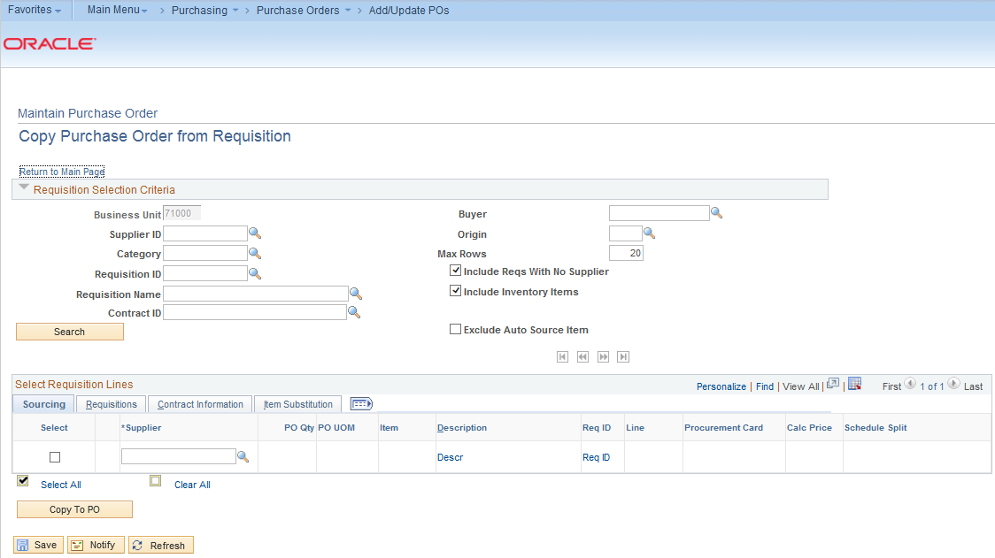
After entering your search criteria and selecting the Search button, you should see the resulting requisition lines.
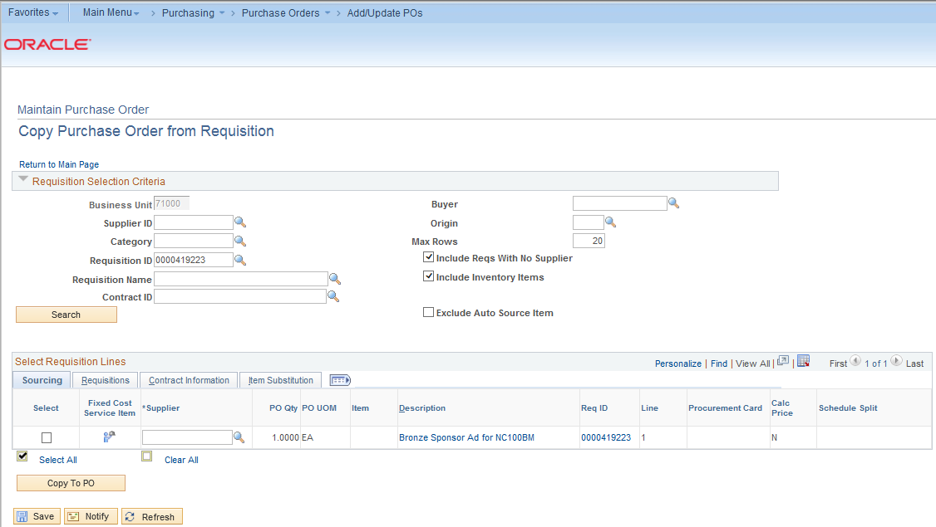
On both the Sourcing tab and the Requisitions tab, you can see links for the item description and for the requisition details (Req ID). To select a Requisition line item to copy over to the purchase order, select it with a checkmark in its Select box. Then, you can use the Copy to PO button.
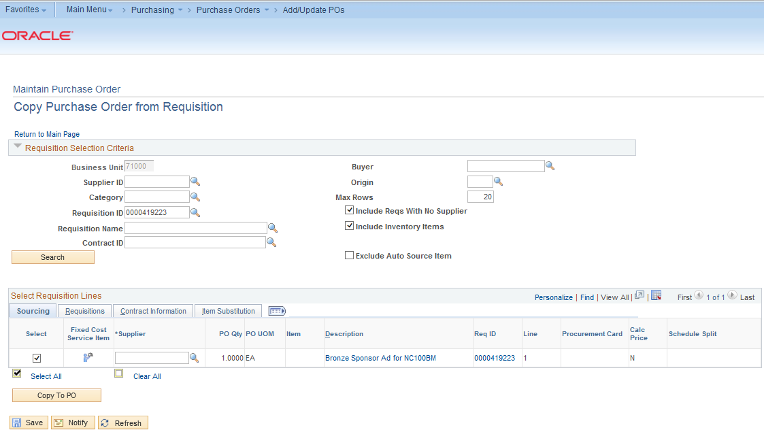
Once the requisition lines have been copied over to the Purchase Order, you can process it as you would any other purchase order. You can manually enter the Contract Number into the PO Reference field if you desire.
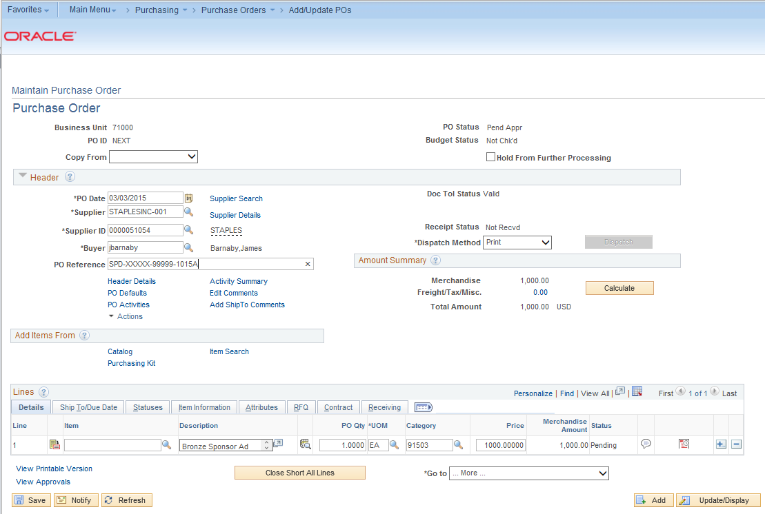
How To: Create a PO by Copying a Requisition
- In PeopleSoft Financials core system, select Purchasing in the menu.
- Select Purchase Orders.
- Select Add/Update POs.
- Click OK to add a new purchase order (NEXT should be in the PO ID field).
- In the PO Header, enter/select the Supplier ID for the Purchase Order.
- In the Copy From drop down list, select Requisition.
- In the Requisition Selection Criteria group box, enter the search criteria to locate the requisition you want to copy (i.e., Requisition ID).
- Click the Search button.
- Select the requisition lines you want to copy to the PO by checking its Select box.
- Click the Copy to PO button.
- Continue to process the Purchase Order as you would any other purchase order.

Processing of Purchase Orders Sourced from Special Request Requisition
After a Special Request Requisition has been sourced to a Purchase Order (through the Expedite process or Copy to PO process), it is then available for further processing. The scheduled batch SCIQUEST job will NOT pick up these purchase orders for budget checking, document tolerance checking, and dispatching, unless you request ITS to include them. The dispatching portion of the SCIQUEST batch job only flips the flag for PO dispatch. If you normally send a PO to a Supplier via fax, you will still need to fax the PO. You will still physically issue the purchase order to the appropriate Supplier.

Chapter 8: Additional Requisition Maintenance
When working with requisitions, there are some additional tasks that you will need to complete on a periodic basis. This includes purging the staging tables, reviewing requisition status, and closing requisitions.
Purging Staging Tables
There are numerous staging tables used for sourcing requisitions into Purchase Orders. These tables include:
- PO_ITM_STG
This core staging table provides line and schedule level information from the requisition destined for the purchase order.
- PO_DISTRIB_STG
This table provides distribution information. One row is placed here for each distribution destined for the purchase order. For requisitions, the information in this table comes directly from the requisition.
- PO_HDR_STG
This table is used for manually consolidated requisitions to specify information destined for the Purchase Order Header table.
The Purge Stage Tables process purges entries on the PeopleSoft Purchasing staging tables. Only rows in Completed (C), Error (E), or Ready to Purge (X) status are eligible for purging. It is recommended that your institution run this process at least weekly. At very busy institutions, you should consider running the Purge Staging Tables process daily. If you do not run the Purge Stage Tables process regularly, the staging tables retain old data, which negatively affects performance of processes that act on the tables.
Before purging error rows, the Purge Stage Tables process removes the “In Process” status on the requisition line and sets the source status on the requisition line to “Available” (A). Requisitions in error status are identified as “In Process,” while they are in the staging tables. In Process requisitions cannot be updated. Running the Purge Stage Tables process on error rows frees up requisitions for error correction.
If you run purge on a requisition in “Error” status on the Sourcing Workbench – Sourcing Details page, it frees the requisition and set the stage status on the stage tables to “X”, so it can be purged in this process. If you recycle an error, it has no effect on the requisition, but it sets the stage status on the stage tables to R, so the row can be picked up and processed again.
You can view the contents of the staging tables by going to the Sourcing Workbench. Again, the purge process removes rows that are in a completed, error, or ready to purge status.
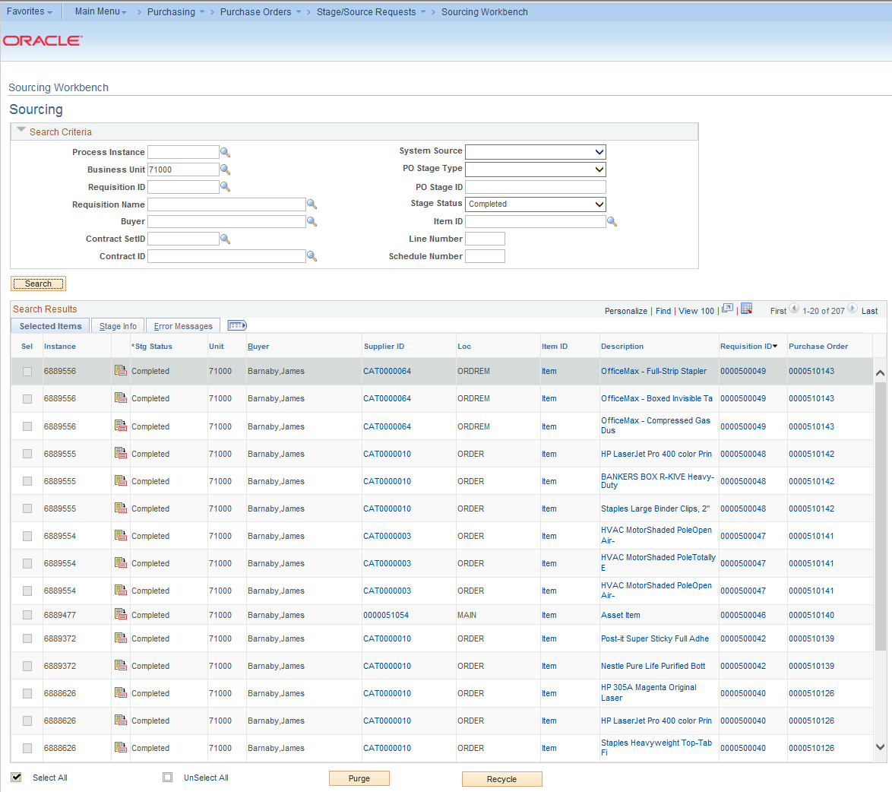
Once the purchase order has been created from the requisition, the Stage Status becomes “Complete” and it can be removed from the staging tables to make them work more efficiently.
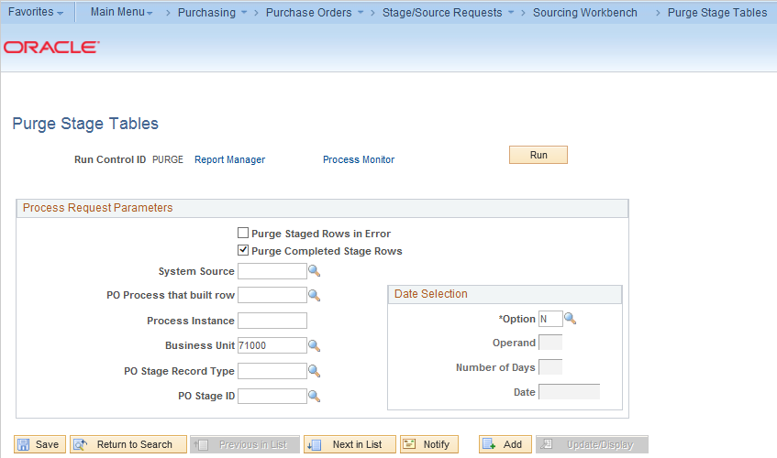
When running the Purge Tables process, you can choose to prevent the processing from running on rows with an error status. Also, you should input your Business Unit. You can leave the date selection field set to “N”, which means No Selection by Date.
After running the process, you should return to the Sourcing Workbench and see the results of the purge process. If you choose to purge all rows in a “Completed” stage status, then there should be no remaining results with that status until another requisition is successfully sourced into a purchase order.
How To: Purge Staging Tables
- In PeopleSoft Financials Core system, select Purchasing in the menu.
- Select Purchase Orders.
- Select Stage/Source Requests.
- Select Sourcing Workbench.
- Search by Stage Status the rows you want to purge (i.e., Completed).
- Review the rows that will be purged.
- In the menu, select Purge Stage Tables.
- Select or add a new run control ID.
- In the Process Request Parameters, choose which rows to purge.
- Select/Enter your business unit.
- Select the Run button.
- On the Process Scheduler Request page, click the OK button.
- Select the Process Monitor link.
- Periodically click the Refresh button until the PO_POSTGPRG process has a Run Status of Success and a Distribution Status of Posted.
- Select the Sourcing Workbench link in the menu.
- Search by Stage Status the rows you just purged.
- There should be no results if the rows were purged, and you left the date selection field set to “N.”

Closing Requisitions
The Close Requisitions process is used to close requisitions that are fully canceled or fully sourced, and no longer need to be modified. When this process is run, the Requisition status changes to “Completed”, or C. The benefit of this status change is that completed requisitions no longer appear in your list of available requisitions when you access requisition pages in update or display mode. These completed requisitions are also removed from the view in many other situations in which the available options have been set to exclude completed or canceled requisitions. Removing these requisitions from these prompts improves system performance and decreases the time required to find requisitions that you must modify.
Also, the Close Requisitions process also sets the budget header and line statuses, the KK_CLOSE_FLAG option, and PROCESS_MANUAL_CLOSE option accordingly so that the Commitment Control Budget Processor process (FS_BP) can liquidate pre-encumbrance budget amounts for outstanding requisitions.
Although the Close Requisitions process is optional and you can run it at any time, you should run the process at the end of each month to help improve the efficiency of your requisitioning process. If you remember the Procure-to-Pay process flow, requisitions are closed after the accompanying purchase order is closed and the requisition is reconciled.
There are certain criteria a requisition must meet in order to be closed:
- PO Status: The Close Requisitions process verifies that the Purchase Orders to which the Requisition lines are sourced have a “Completed” Status.
- Distribution Line Status: The Close Requisitions process verifies that the requisition distribution line status is set to X (Canceled) or P (Processed). A requisition has a status of P after it is sourced to a purchase order.
The Close Requisitions process closes a requisition if any one of the following is true:
- The Requisition Status is “Canceled” (PS_REQ_HDR.REQ_STATUS = X).
- The Requisition has been sourced to a Purchase Order (PS_REQ_LN_DISTRIB.DISTRIB_LN_STATUS = P) and the Purchase Order status is completed.
You can view requisition header information (PS_REQ_HDR) and requisition distribution information (PS_REQ_LN_DISTRIB) by accessing the requisition online or by querying these tables.
A requisition’s distribution lines, schedules, lines, and header can be closed in intervals by the Close Requisitions process. Distribution lines come first, followed by the schedules, lines, and header. Therefore, it is possible to have a distribution line close before the rest of the requisition. For example, imagine that a requisition contains 20 lines, each with two schedules. When the necessary distributions close, the schedule qualifies for closure. Once the two schedules close for a line, the line closes. When the 20 lines close, the requisition closes.
When you run the Close Requisitions process, it changes the status of all requisitions that meet closure criteria as shown in these tables:
Requisition Distribution Line | Updated Status
DISTRIB_LN_STATUS | C (completed) unless the distribution line was canceled, in which case the status remains X (canceled)
PROCESS_MANUAL_CLOSE | Y (Yes)
PC_DISTRIB_STATUS | N (None)
BUDGET_LINE_STATUS | N (not checked)
KK_CLOSE_FLAG | Y (yes)
KK_TRAN_OVER_FLAG | N (no)

Requisition Schedule Line | Updated Status
CURR_STATUS | C (closed) unless the schedule was canceled, in which case the status remains X

Requisition Line | Updated Status
CURR_STATUS | C (closed) unless the line was canceled, in which case the status remains X

Requisition Header | Updated Status
REQ_STATUS | C (completed)
ACTIVITY_DATE | Run Date
BUDGET_HDR_STATUS | N (not checked)
IN_PROCESS_FLG | N (no)

You can close requisitions through the Close Requisitions process (either manually or scheduled through the Process Scheduler), or you can close requisitions by using the Requester’s Workbench (next section).
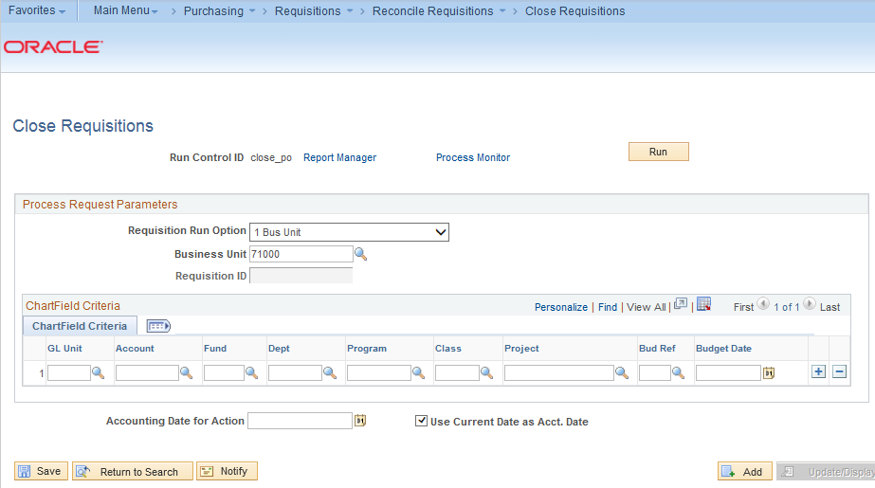
When running the Close Requisitions process, you can run it for your entire business unit or on a particular Requisition. When running it on your business unit, it will reconcile all qualified requisitions. You can also use the Chartfield criteria group box to select requisitions for processing based on Chartfield values.
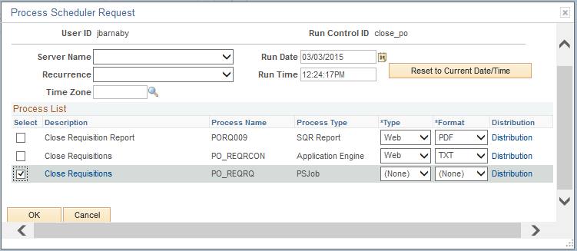
Once you click the Run button and proceed to the Process Scheduler Request page, you need to select the PS Job for PO_REQRQ – Close Requisitions. After starting the process, go to the Process Monitor to view the statuses for the PO_REQRQ PS Job. Once the process successfully completes, select the PO_REQRQ link.
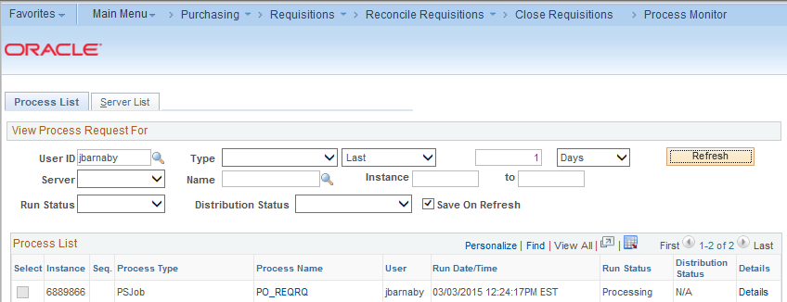
On the Process Detail page, select the link for PORQ009.
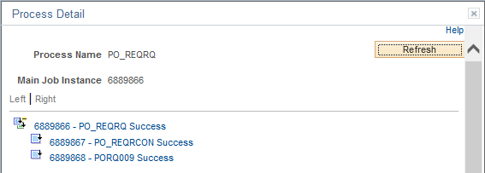
And then, select the link for View Log/Trace. On the View Log/Trace page, select the porq009 PDF link. The result is the Requisition Reconciliation Report. This report lists what requisition lines were successfully closed.
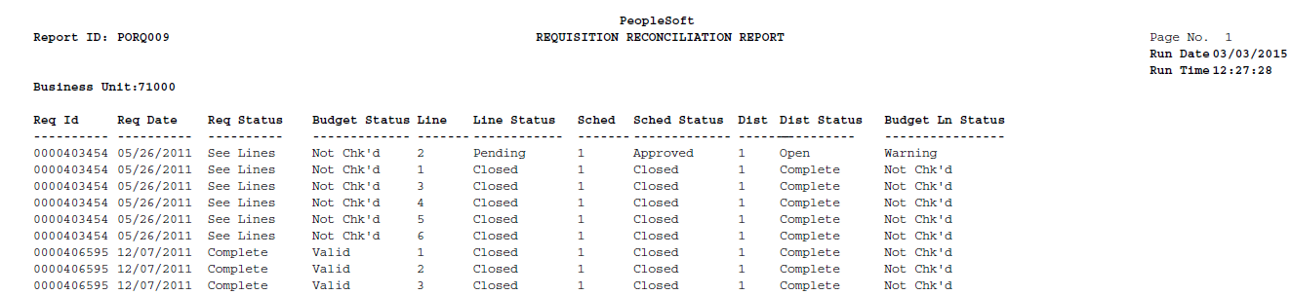
In the above example, you can see that for Requisition 0000403454, lines 1 and 3 through 6 have been closed. Line 2 is not closed, as it is Pending Approval. Since all of the lines have not been closed, the entire requisition has not been closed. The requisition can be budget checked in order to liquidate any remaining pre-encumbrances for lines 1 and 3 through 6.
How To: Close Requisitions
- In the PeopleSoft Financials Core system, select Purchasing in the menu.
- Select Requisitions.
- Select Reconcile Requisitions.
- Select Close Requisitions.
- Select or Enter a Run Control ID.
- In the Process Request Parameters, choose to run the process on 1 Business Unit or 1 Document.
- Enter/Select your business unit.
- If running the process on one requisition, enter the Requisition ID.
- Select the Run button.
- Select the Close Requisitions – PO_REQRQ – PS Job in the process list.
- Click OK.
- Select the Process Monitor link.
- Locate the PO_REQRQ process. Periodically click the Refresh button until the Run Status is Success and the Distribution Status is Posted.
- Click the PO_REQRQ link.
- Click the PORQ009 Success link.
- Click the View Log/Trace link.
- Click the porq009_XXXX.PDF link.
- Review the resulting Requisition Reconciliation Report.

Requester’s Workbench
The Requester’s Workbench is a tool that you can use to retrieve, review, and modify multiple requisitions. Institutions should view the Workbench on a daily basis to ensure there are no errors or Requisitions in Error status.
When using the Requester’s Workbench, you first have to search for the requisitions. You can do this through multiple criteria on the filter options page.
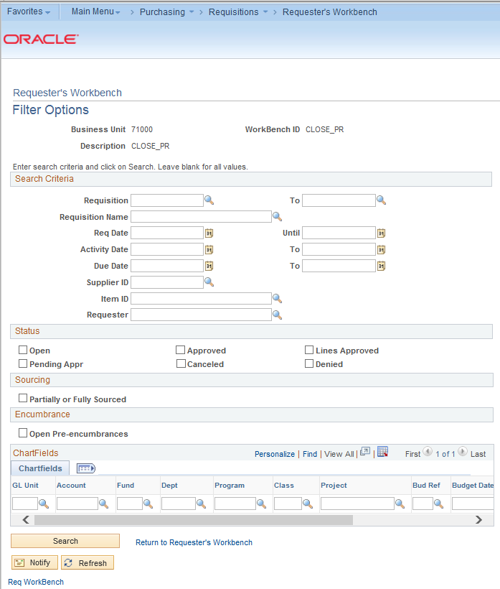
When searching for requisitions, it is advised that you enter some selection criteria to reduce the number of records retrieved. Whatever you enter in you search criteria, you can save and reuse. If needed, you can search for all requisitions from a particular requester. You can search by requisition status and whether it has been sourced. You can also use the Open Pre-Encumbrances checkbox as a search parameter. This check box enables you to search for requisitions that are tied to purchase orders with an open balance. Finally, you can enter multiple Chartfield combinations as search criteria. Once you enter all of your search criteria, click the Search button to review the Requester’s Workbench page.
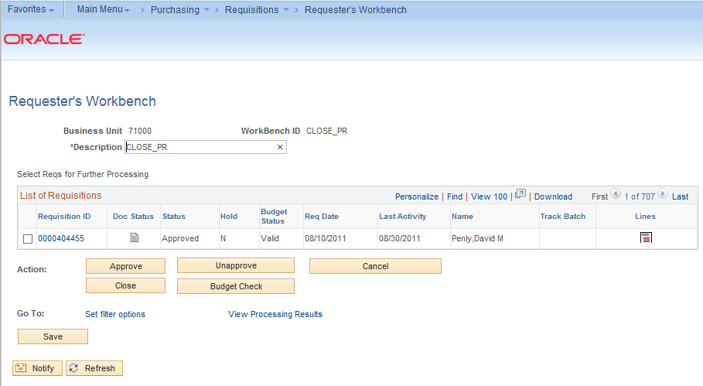
On the Requester’s Workbench page, you should enter a description. This enables you to save your search parameters. If you select a Requisition ID link, the system will open a new window to take you to the corresponding requisition inquiry page. You can use the Document Status icon to access the requisition document status inquiry page. You can select the Lines icon to access the Reconciliation Workbench – Requisition Lines page.
The actions that you can take on the Requester’s Workbench including approving open requisitions to become “Pending Approval” requisitions (in order to start the Workflow process), canceling requisitions, or closing requisitions. To process a requisition using one of these actions, you first select it and then click the appropriate button. (GeorgiaFIRST Institutions do not use the “Unapprove” function.)
You can return to the search criteria by selecting the “Set filter options” link.

Using the Workbench to Approve Requisitions
The approve action for requisitions does not mean that the requisition will bypass Workflow approvals. This approve action takes an open requisition and makes it “Pending” so that it can begin the workflow approval process. To perform this action, you can search for all open requisitions.
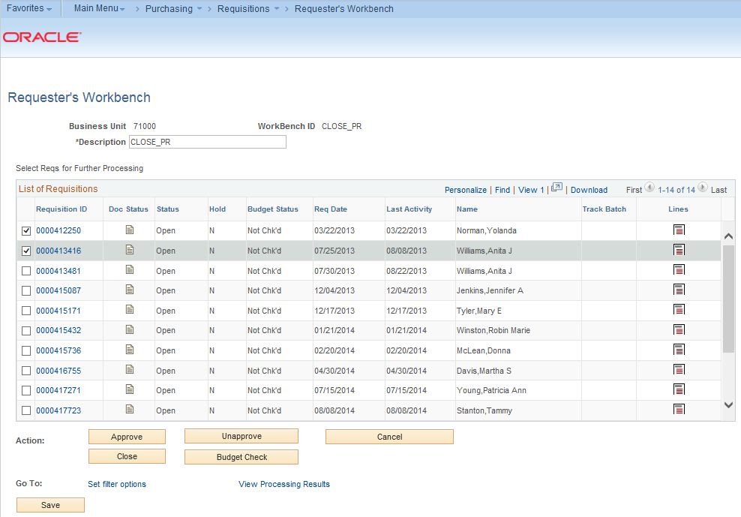
Once you have selected the requisition or requisitions that you want to approve, you can select the “Approve” button. Then the system will list which of those requisitions are qualified to be approved.
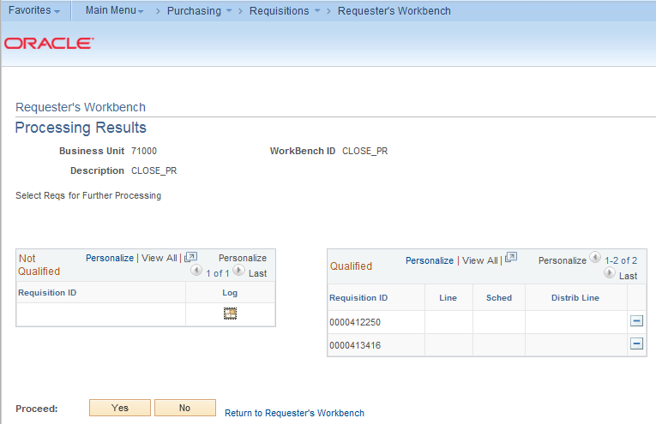
To remove a requisition from the list to approve, select its Delete button. To proceed with the approval, select the Yes button. To cancel the approval action on all selected requisitions, select the Delete button. Once the system processes the requisition approval, that requisition’s status should change from Open to Pending. It will now begin the Workflow approval process.
How To: Approve an Open Requisition through the Requisition Reconciliation Workbench
- In PeopleSoft Financials core system, select Purchasing in the menu.
- Select Requisitions.
- Select Requester’s Workbench.
- Go to the Add a New Value tab.
- Enter a Workbench ID (i.e. Approve).
- Enter your search criteria (i.e., Status = Open)
- Select the Search button.
- Enter a Description (i.e., Approve Open Reqs)
- Select the requisitions you want to move from Open to Pending with a checkmark.
- Click the Approve button.
- If any requisitions are not qualified to be approved, review the log for that requisition to determine the issue.
- To approve all requisitions that are qualified, click the Yes button.
- Confirm the approval action.
- Verify the requisition status for the selected requisitions are now “Pending.”
- Click the Save button.

Using the Workbench to Cancel Requisitions
You can also use the Requester’s Workbench to cancel requisitions. A requisition can be canceled as long as no part of the requisition has been sourced into a Purchase Order. Once it has been sourced, you will not be able to cancel the requisition and you will have to work with its corresponding Purchase Order.
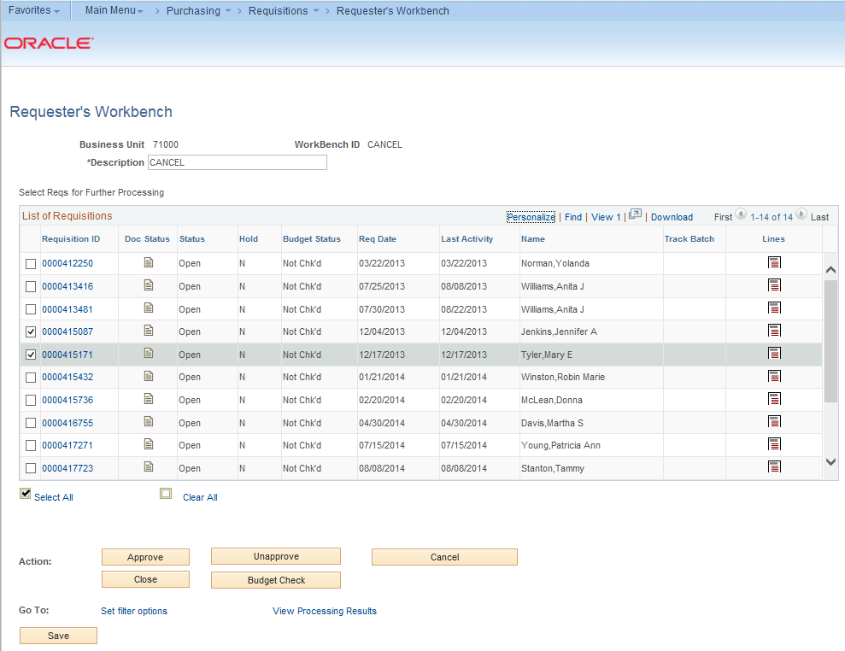
After selecting the requisitions you wish to cancel, select the Cancel button. The Processing Results page will list which requisitions are qualified to be canceled. If a requisition is not qualified, you can check its log to determine why it is not qualified.
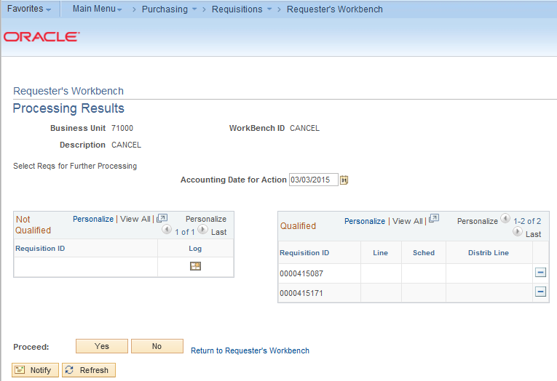
To cancel the qualified requisitions, you can proceed by clicking the Yes button and confirming your decision. The status for these requisitions will change to Canceled.
How To: Cancel Requisitions through the Requisition Reconciliation Workbench
- In PeopleSoft Financials core system, select Purchasing in the menu.
- Select Requisitions.
- Select Requester’s Workbench.
- Go to the Add a New Value tab.
- Enter a Workbench ID (i.e. Cancel).
- Enter your search criteria.
- Select the Search button.
- Enter a Description (i.e., Cancel Reqs)
- Select the requisitions you want to cancel with a checkmark.
- Click the Cancel button.
- If any requisitions are not qualified to be canceled, review the log for that requisition to determine the issue.
- To cancel all requisitions that are qualified, click the Yes button.
- Confirm the cancellation.
- Verify the requisition status for the selected requisitions are now “Canceled.”
- Click the Save button.

Using the Workbench to Close Requisitions
Finally, you can use the Requester’s Workbench to close requisitions. While you can use either the Close Requisitions process or the Workbench to close requisitions, it is suggested that you at least use the Workbench to see which requisitions are qualified for closure. For a requisition to be closed, it must have been sourced to a PO that is now complete or it must be canceled. By closing qualified requisitions, the system performance improves. In addition, closing qualified requisitions enables Commitment Control to liquidate any pre-encumbered budget amounts for outstanding Requisitions.
After searching for the requisitions, select them as you previously have and then click the Close button. The resulting Non-qualified and qualified requisitions will appear.
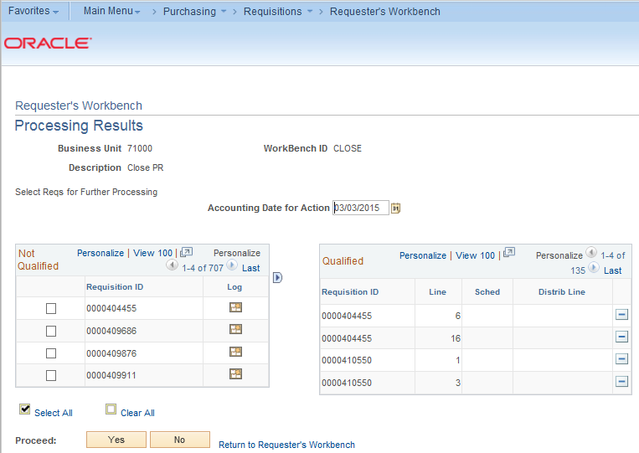
Many times, a requisition cannot be closed is because the corresponding purchase order has not been closed yet. In addition, if a requisition is on hold, it cannot be closed. Other times, it cannot be closed due to an unchecked or error budget line status. Requisitions with an unchecked budget status or a budget error should not be overridden and forced to close. You will need to address the budget issues before proceeding.
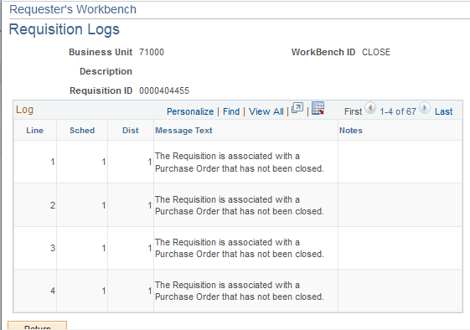
After closing the qualified requisitions, the requisition status will change to “Complete,” and the Budget Status will change to “Not Checked.” Then, these requisitions will need to be re-budget checked to return the pre-encumbrance to the budget. The next budget checking batch job should pick these requisitions up for processing.
How To: Close Requisitions through the Requisition Reconciliation Workbench
- In PeopleSoft Financials core system, select Purchasing in the menu.
- Select Requisitions.
- Select Requester’s Workbench.
- Go to the Add a New Value tab.
- Enter a Workbench ID (i.e. Close).
- Enter your search criteria.
- Select the Search button.
- Enter a Description (i.e., Close Reqs)
- Select the requisitions you want to close with a checkmark.
- Click the Close button.
- If any requisitions are not qualified to be closed, review the log for that requisition to determine the issue.
- To close all requisitions that are qualified, click the Yes button.
- Confirm the close action.
- Verify the requisition status for the selected requisitions are now “Complete” and the Budget Status is “Not Checked.”
- Click the Save button.
- Ensure these completed requisitions are budget checked.

Chapter 9: Receiving Items
For many items that are purchased, a receipt will be required before payment is issued by your Accounts Payable department. The receiving requirement is set on the actual requisition that is approved and turned into a purchase order. By creating a receipt in the system, your Accounts Payable Department can be sure that they are issuing payment for goods that have been received.
Some requesters will have the responsibility of performing Desktop Receiving, which is creating a receipt in the system. This receipt is tied into the Requisition, Purchase Order, and Invoice so that payment can be issued. Without the receipt, the payment cannot be issued.
Not all requesters will have this responsibility. Some shoppers may be responsible for their own desktop receiving. Check with your institution for your applicable business processes. If you do have the Desktop Receiving responsibility, continue with this chapter to learn how to create receipts in the PeopleSoft system.
Desktop Receiving
Desktop Receiving is a function within the eProcurement module. It is a simplified version of what your Central Receiving department does on campus. Your Central Receiving Department will still be responsible for creating receipts in the PeopleSoft system for assets and other items that need to be inventoried. However, this eProcurement Desktop Receiving function will enable you to receive many of the goods you order through the GeorgiaFIRST Marketplace. You will need to proper security setup to perform desktop receiving.
Desktop receiving is done through the PeopleSoft Core system, in the eProcurement module. On the Receive Items page, all of your requisitions that have not been fully received will be listed. Through the Receive Items page, you will be able to indicate whether you have received the full quantity requested, or just a partial quantity.
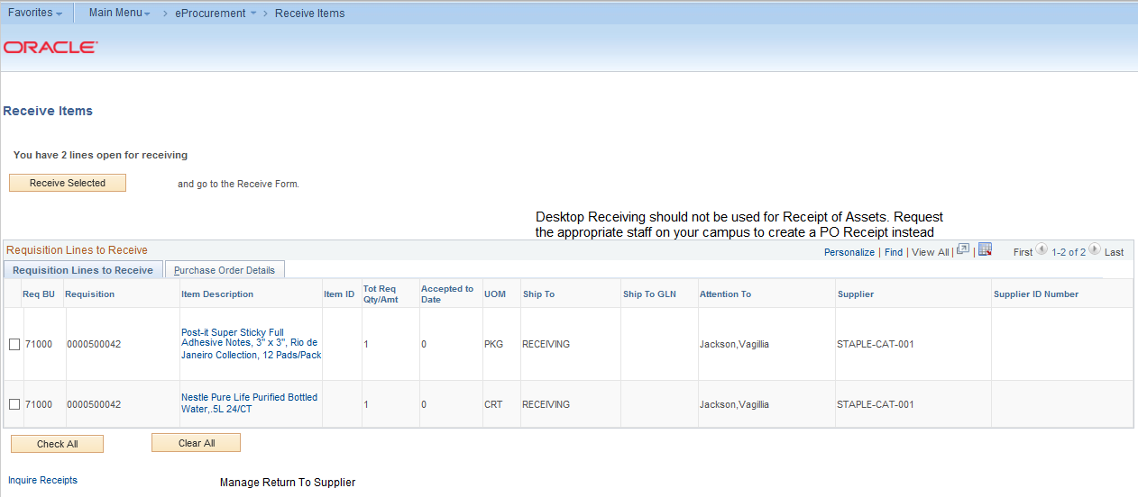
On the Receive Form, you will indicate the Receipt Date and how many you received.
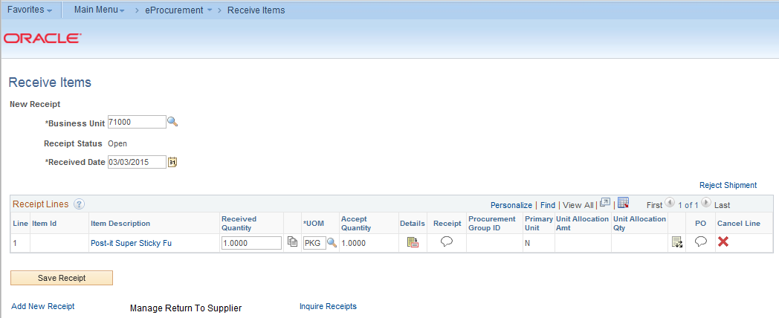
Once you save your receipt, the system will generate a Receipt Number. This Receipt Number will be tied into the Requisition number, Purchase Order number, and Voucher number.
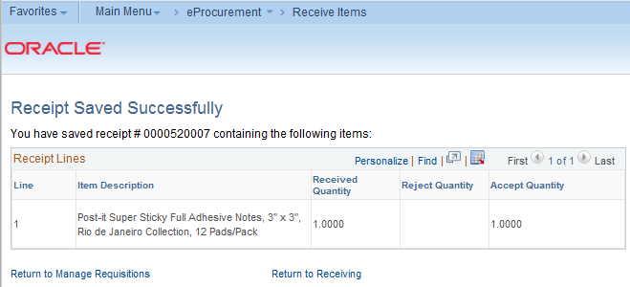
How To: Create a Desktop Receipt
- Log into the PeopleSoft Core system.
- Select eProcurement in the menu.
- Select Receive Items in the menu.
- Location the Requisition Line Item you need to receive.
- Select the requisition by placing a checkmark in its Select box (or to receive all line items, choose the Check All button).
- Select the Receive Selected button.
- If needed, change the Received Date. By default, the current date will be listed.
- In the Received Qty field, enter the quantity received.
- To review details about the actual purchase order, select the Details… icon.
- To attach comments to the Receipt, select the Comments icon.
  - Here you can indicate the condition and input a comment if needed.
  - Do not include any slashes in your comments.
- Click the Save Receipt button.
- Your Receipt Number will be listed on the “Receipt Saved Successfully” page.
If you have a Requisition line item that you previously received a partial quantity for, you will still be able to go back to this same page and receive additional quantities.
An alternate way to receive items is through the Manage Requisitions page. As a Buyer, you can receive items on behalf of a requester through this page. You would use the Action drop down box and select the option of “Receive Order”. In order to use this function, the status must indicate “PO(s) Dispatched”.

Receiving Through the Purchasing Menu
Receipts for requested items can be created through Desktop Receiving or through the Receiving menu option in the Purchasing Menu. When receiving in this manner, you create receipts through the corresponding purchase orders. Therefore, you don’t need to be the requester who created the requisition to create the receipt. However, receipts should only be created for items that you have physically received.
When adding a receipt, first, you need to select the purchase order. You can do this using a variety of criteria.
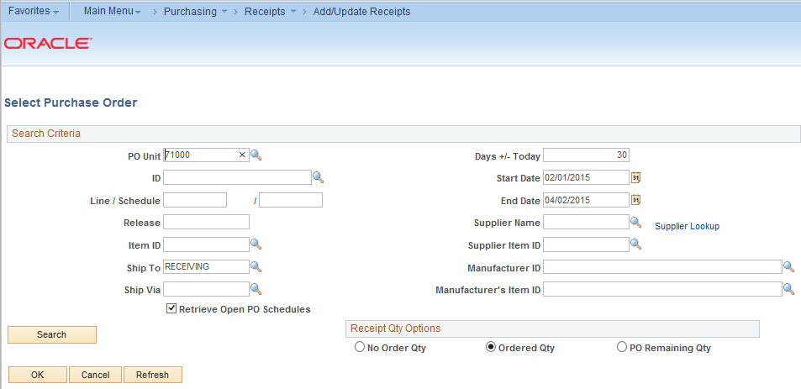
You can search by the purchase order ID (ID field), as well as the line and schedule number. You can also search for POs according to their Ship To location. You can search with a date range or by Supplier. If you select the Retrieve Open PO Schedules checkbox, you will only retrieve purchase order schedules that haven’t been fully received. If you do not select this checkbox, purchase orders that have been fully received appear in the search, as well as purchase order schedules that haven’t been fully received.
The Receipt Quantity options specify quantities to transfer to the receipt. Accessibility to these fields is set up in the User Preferences. There are three options to choose from to determine the receipt quantity to appear.
- No Order Quantity: Select this option to signify that the receiver must enter the actual quantity received. This selection requires a live count of the items prior to receipt in the system. If selected, the copy function does not transfer order quantities to the receipt. You will need to manually enter all receipt quantities.
- Ordered Quantity: Select this option to automatically make the received quantity the purchase order quantity. This selection changes the purchase order quantity regardless of any prior receipt quantity.
- PO Remaining Quantity: Select this option to have the receipt display the numeric difference between the quantity ordered and the current quantity received. Selecting this option replaces the received quantity with the quantity that has not yet been received.
Once you have entered all of the search criteria, you must hit the Search button (not the OK button). The Purchase Order lines that still need to be received will be listed in the results.
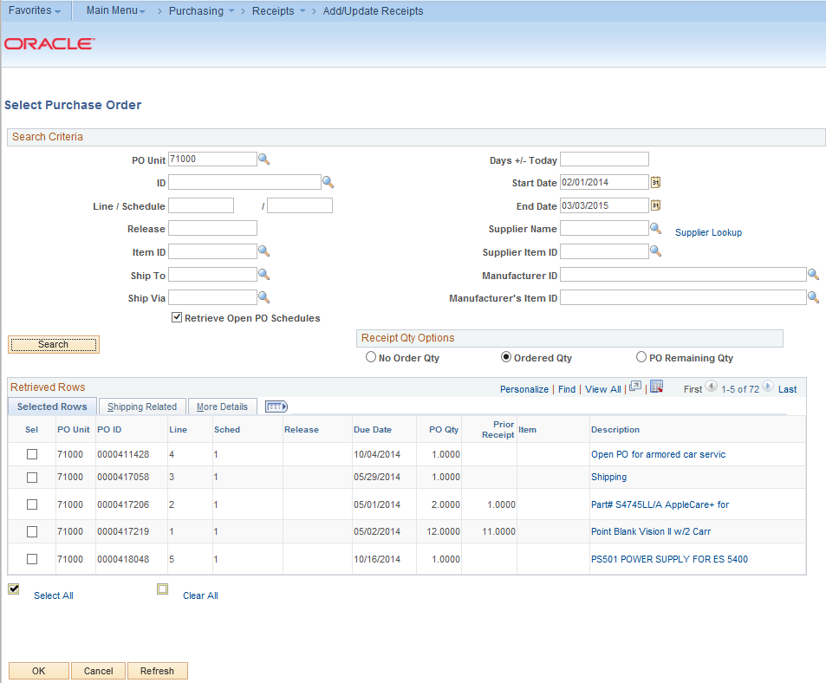
In the retrieved rows, you select each PO line that you want to create a receipt for. After selecting the Purchase Order lines, click the OK button.
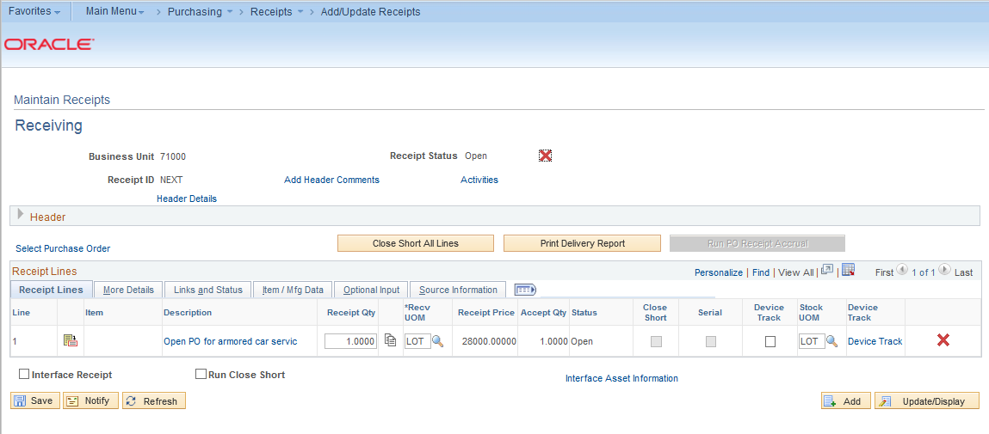
On the Receiving page, there are a number of items. Until you save this receipt, the Receipt ID will indicate “Next.” The following are the receipt header statuses:
- Closed – Receipt is closed
- Hold – Hold Receipt
- Moved – Moved to destination
- Open – Open
- Received – Fully Received
- Canceled – Canceled
If you need to cancel this receipt, you can click the Cancel Receipt button in the header to cancel the entire receipt. Canceling the transaction cannot be reversed. You can also add comments to the receipt through the Add Comments link. Do not include any slashes (/) in your comments.
If you need to select additional Purchase Order lines, you can do so through the link in the Header for “Select Purchase Order.”
In the Receipt Lines section are the PO lines that you indicated you want to create a receipt for. For each receipt line, you will see the following:
- Details Icon: Select this icon to access the Receipt Line Details for Line page, where you can view details about the receipt. This page formats the information you see here and on the subsequent tabs in a single long-page format.
- Description: This is the description from the Purchase Order line (which should be the same as the Requisition line).
- Receipt Qty and Recv UOM: This is the receipt quantity and received unit of measure. Here, you will enter the quantity delivered and the unit of measure in which it was received. When you enter the receipt quantity for a line, the Accept Qty value is calculated by subtracting the rejected quantity from the receipt quantity.
- Price: This is the line item’s purchase order price.
- Status: This is the status of the receipt line
  - Closed (closed schedule)
  - Hold (hold schedule)
  - Open (open schedule)
  - Received (received schedule)
  - Canceled (canceled schedule)
How To: Create a Purchasing Receipt
- In the PeopleSoft Financials Core system, select Purchasing in the menu.
- Select Receipts.
- Select Add/Update Receipts.
- On the Add a New Value page, ensure the PO Receipt box is checked and click the Add button.
- In the Search Criteria, enter the selection criteria for your Purchase Order lines you want to receive.
- Select the checkbox for Retrieve Open PO Schedules.
- Click the Search button.
- Select the PO lines you want to receive.
- Click the OK button.
- Update the Receipt Quantity if necessary.
- Click the Save button.
Receiving an Asset
If the receipt line item is for an asset, there are addition steps you need to take. If an item is marked as an asset on the requisition and purchase order, the Receipt Line will have an additional “AM Status” column.
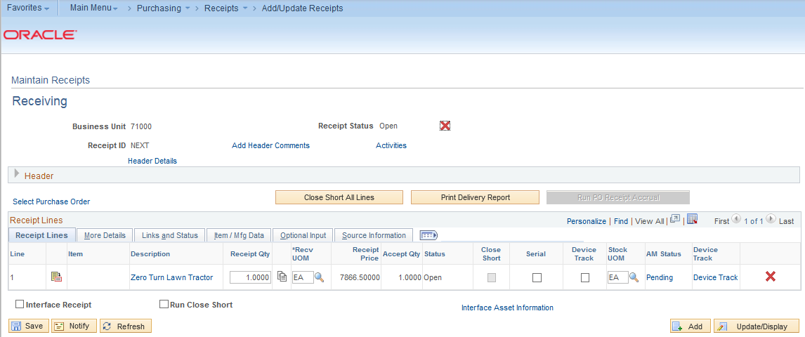
The AM Status is the status of the item data in relation to PeopleSoft Asset Management. The values include:
- Pending: This indicates that the receipt line is asset-related and is pending interface with PeopleSoft Asset Management.
- Moved: Indicates that the receipt line has been interfaced to PeopleSoft Asset Management.
When receiving a PO line that is an asset, you first need to select the Serial checkbox. Then, you can select the Pending link under AM Status. On the Asset Management Information page, you must input the Serial number for the asset at a minimum.
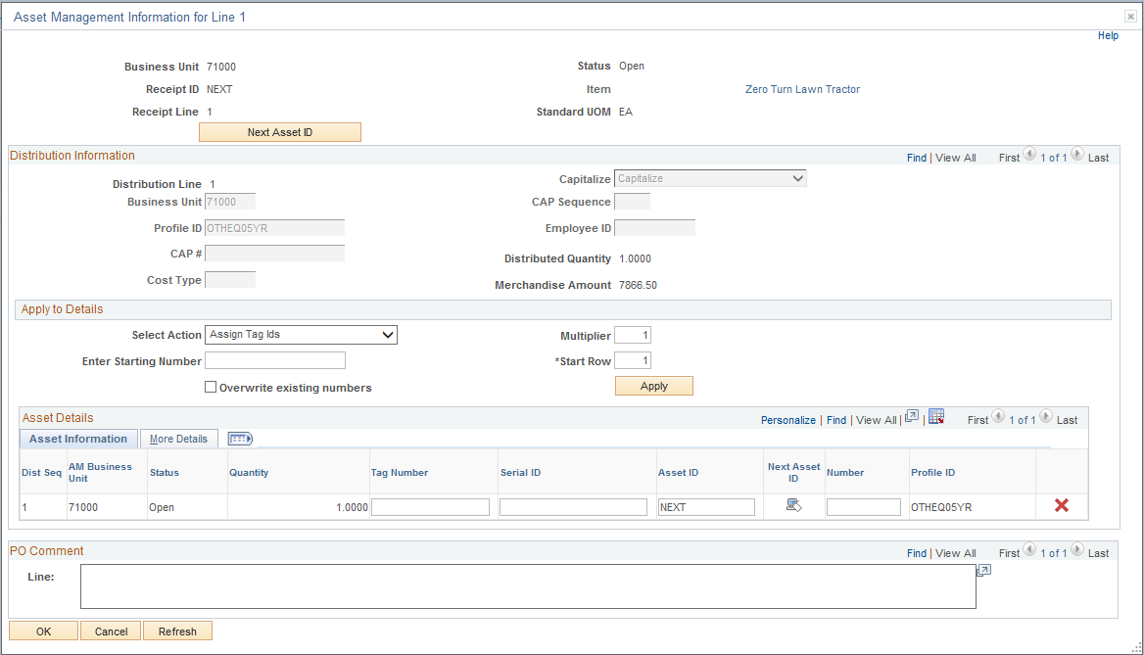
If you already have the asset’s tag number, you can fill that in as well. On the More Details tab, you can input the asset’s Custodian, Location and Manufacturer information if you want. When you are finished entering the required information, you can save the receipt. The Receipt is then ready to be interfaced into the Asset Management module.
How To: Create a Purchasing Receipt for an Asset
- In the PeopleSoft Financials Core system, select Purchasing in the menu.
- Select Receipts.
- Select Add/Update Receipts.
- On the Add a New Value page, ensure the PO Receipt box is checked and click the Add button.
- In the Search Criteria, enter the selection criteria for your Purchase Order lines you want to receive.
- Select the checkbox for Retrieve Open PO Schedules.
- Click the Search button.
- Select the PO lines you want to receive.
- Click the OK button.
- Update the Receipt Quantity if necessary.
- Select the Serial checkbox.
- Click on the Pending link under AM Status.
- Enter the asset’s Serial ID.
- If desired, enter the asset’s tag number, custodian, location, and manufacturer information.
- Click OK.
- Click the Save button.

Chapter 10: ePro Inquiries, Queries and Reports
There are some PeopleSoft inquiries, queries and reports that you can use to review information concerning requisitions.
Review Requisition Activity
You can use the Requisition Activity Inquiry to review requisition information in five stages. These inquiry pages provide information for a requisition and its associated documents. The navigation to the Requisition Activity Inquiry is Purchasing > Requisitions > Review Requisition Information > Requisitions.
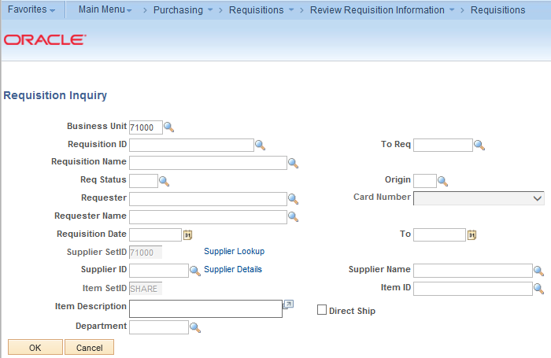
You can search for requisitions by requisition status, origin, requester ID or name, requisition date, Supplier ID, and Department.
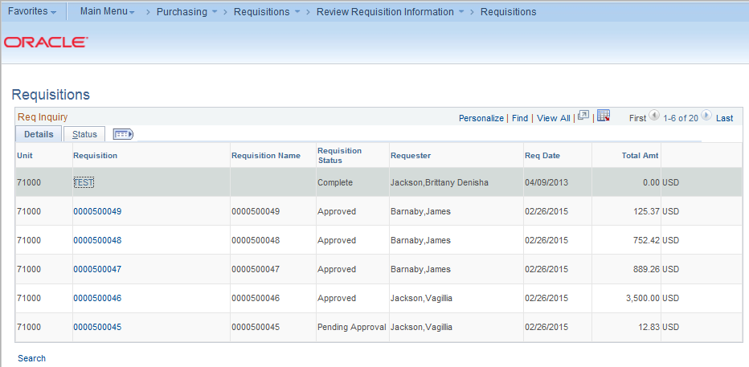
On the Req Inquiry page, the requisitions that meet your search criteria will be displayed. On the Details page, you will see the Requisition ID, its Status, the Requester, the Requisition Date, and the total amount of the requisition. If you click on the Requisition ID link, the system will display that requisition’s line details.
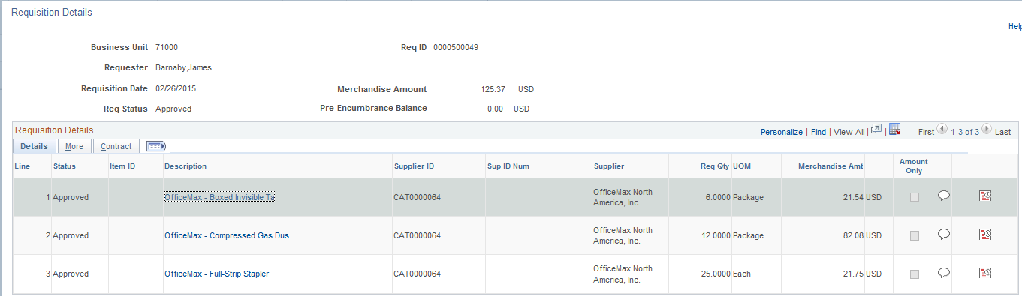
From here, you can see the line item descriptions, Suppliers, requested quantity, and amount. The description link will bring up the detailed item description. The callout icon displays the line comments. The Schedule icon displays the Due Date, Ship To location, and a link to the distribution information that includes the Chartfields and any asset information.
Back on the Requisition Inquiry page, there is also a Status tab.
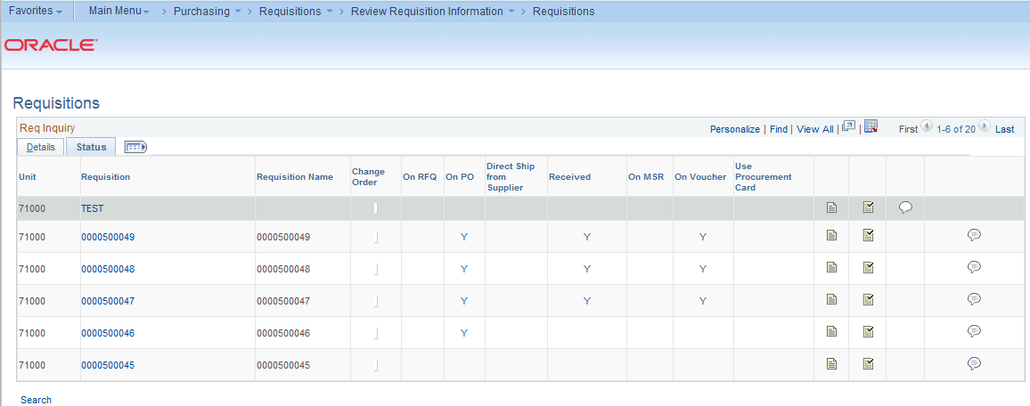
Again, you will see the Requisition ID, which when opened, will display the same information as it did through the Details tab. You will also see columns for “On PO,” “Received,” and “On Voucher.”
For the “On PO” column, this indicates whether the requisition has been sourced to a purchase order. “Y” means that all requisition lines appear on purchase orders. “P” means that some lines appear on purchase orders. You can select either link to display the purchase order information.
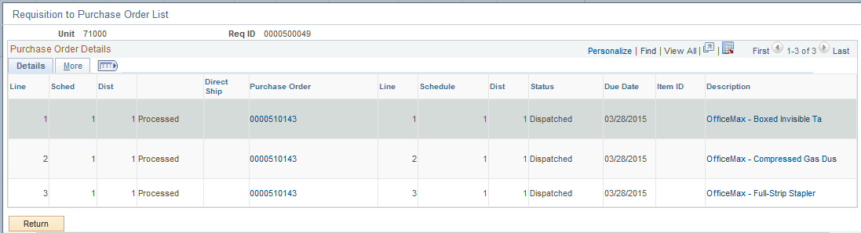
Selecting either link under the “On PO” column will display the Requisition to Purchase Order list, which will display the requisitions lines that have been sourced to a PO. Through this page, you can display the Purchase Order and see its status.
Back on the Requisition Inquiry – Status page, the “Received” column indicates whether any of the requisition lines have been received. Again, “Y” means that all lines appear on receipts, and “P” means that some lines appear on receipts.
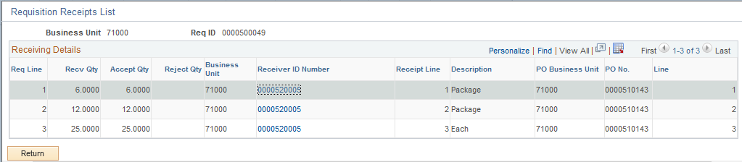
The Requisition Receipts list displays the requisition lines that have been received, along with the Receipt ID. By selecting the Receipt ID link, the system displays the receipt information.
The “On Voucher” column displays similar information. Once the requested goods have been received and placed on a voucher, an entry will display in this column. “Y” indicates that all requisition lines have been vouchered, while “P” indicates that only some of the requisition lines have been vouchered.
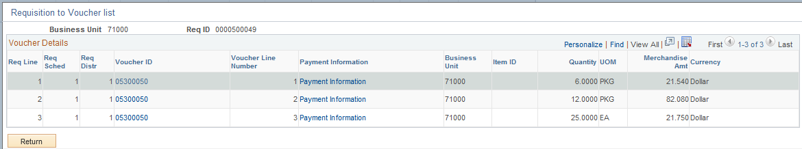
Also on the Requisition Inquiry – Status page, there are icons for Document Status and Approval Status. By selecting the Document Status icon, the system displays a new window for the Document Status Inquiry. We will review this inquiry later in this chapter.
The Approval Status icon displays the approval history of the requisition, including when it was approved.
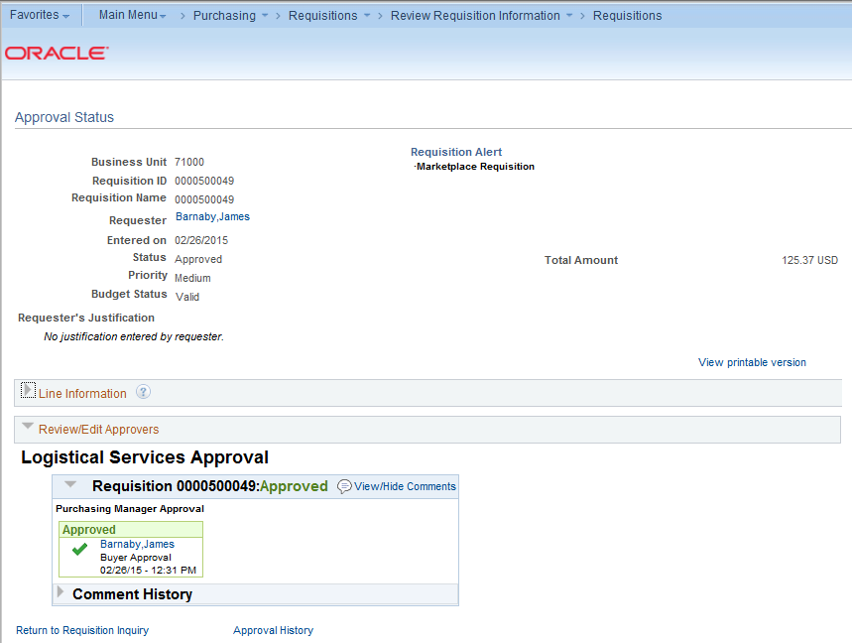

Review Requisition Accounting Entries
In addition to reviewing requisition activity, you may also find it necessary to review requisition accounting entries. This inquiry shows you the transaction type, Purchase Order associated with the reversal accounting entry lines, and additional accounting details related to the requisition. The navigation to the Requisition Accounting Entries Inquiry is Purchasing > Requisitions > Review Requisition Information > Accounting Entries.
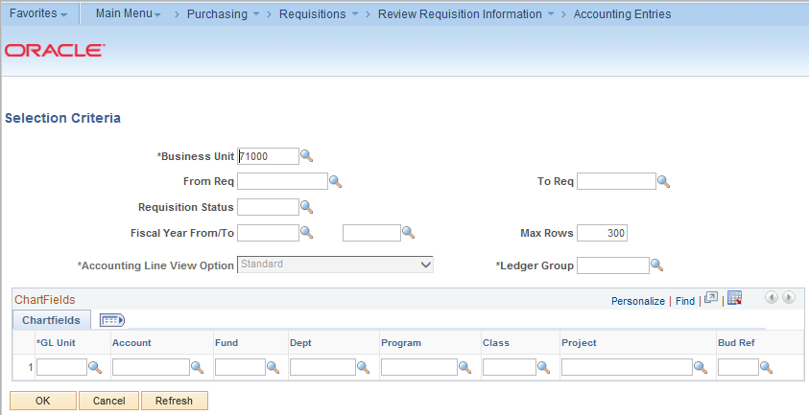
For the selection criteria, you can search by Requisition ID, requisition status, Fiscal Year, and Chartfields.
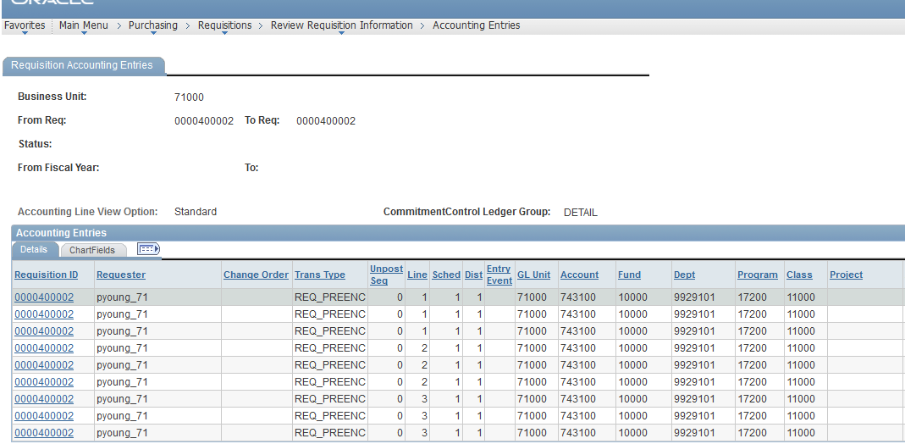
On the Accounting Entries Details tab, the Requisition ID will take you to the Requisition Activity Inquiry (as detailed earlier in this chapter). The Details tab also lists the transaction type, i.e., REQ_PREENC for pre-encumbrance. The Chartfields the pre-encumbrance was charged to are listed.
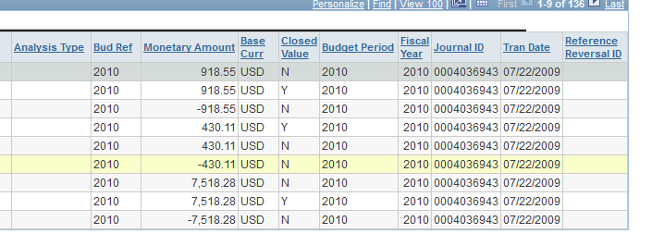
The second half of the page lists the budget reference, amount, journal ID, and transaction date. If the transaction is a Reversal (PO Encumbrance to relieve the pre-encumbrance), then the Purchase Order ID will be listed in the Reference Reversal ID column. Also on this second half of the page is the Closed Value column. This column indicates whether the transaction has been closed. “Y” means that is has closed, and “N” means that it is still open. When a transaction is closed, the Budget Processor liquidates all of its remaining un-liquidated commitment control ledger amounts.
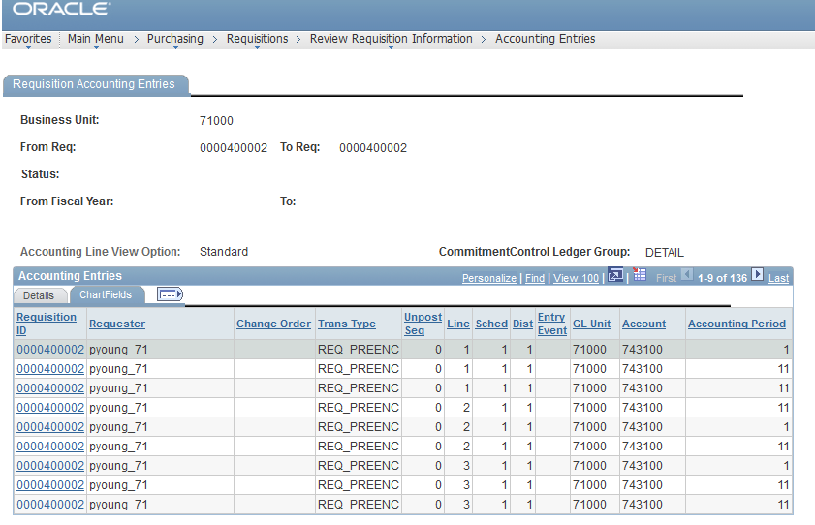
The Chartfields tab lists some of the same information, but includes the accounting period as well.

Review Requisition Document Status
You can use the Requisition Document Status Inquiry to review all documents associated with a requisition. This includes Purchase Order, Receipt, and Voucher. The navigation to the Requisition Document Status Inquiry is Purchasing > Requisitions > Review Requisition Information > Document Status.
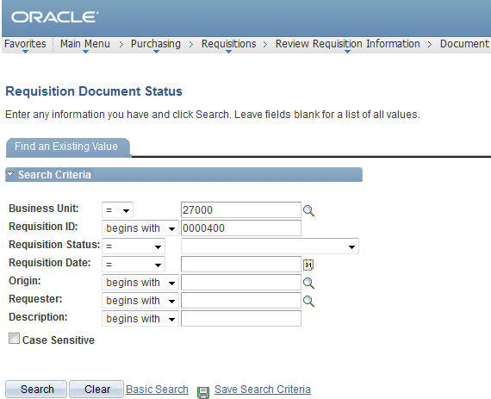
You can search for a requisition by Requisition ID, Status, Date, Origin, Requester or Description.
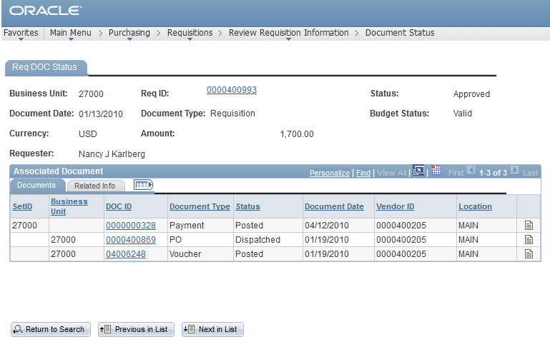
On the Requisition Document Status page, the system displays the requisition ID, date, status, and budget status. The Requester and total amount is also listed. In the Associated Document section, every document that has been created in association with the requisition will be listed. In the example above, you can see that the Purchase Order was created and is complete, the Receipt was created, the voucher was created and posted, and the payment has been sent and was posted. You can see the date each document was created as well.
If you click on a document ID link, the system will open a new window and will take you to that document’s inquiry page.
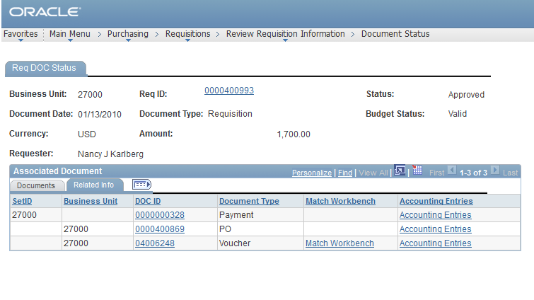
On the Document Status – Related Info tab, you will see the document ID’s again, which takes you to the inquiry page for that particular document. In addition, there is a link to the Accounting Entries for that document. This takes you to the accounting entries for that particular document.

Queries
There are numerous queries that you can use to review requisition information as well. To run these queries, go to Reporting Tools > Query > Query Manager (or Query Viewer) and enter the query name.
BOR_REQ_OPEN_AMOUNT_BY_REQ Query
This query is designed to return all open pre-encumbrance amounts for a specified requisition ID. The parameters for this query include the business unit and requisition ID.
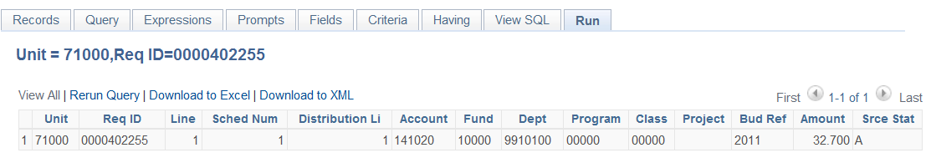
BOR_REQ_OPEN_AMOUNT_ALL Query
This query pulls all requisitions that have an open pre-encumbrance in Commitment Control, per the KK_LIQUIDATION table for a given business unit. The parameter of this query is the Business Unit.
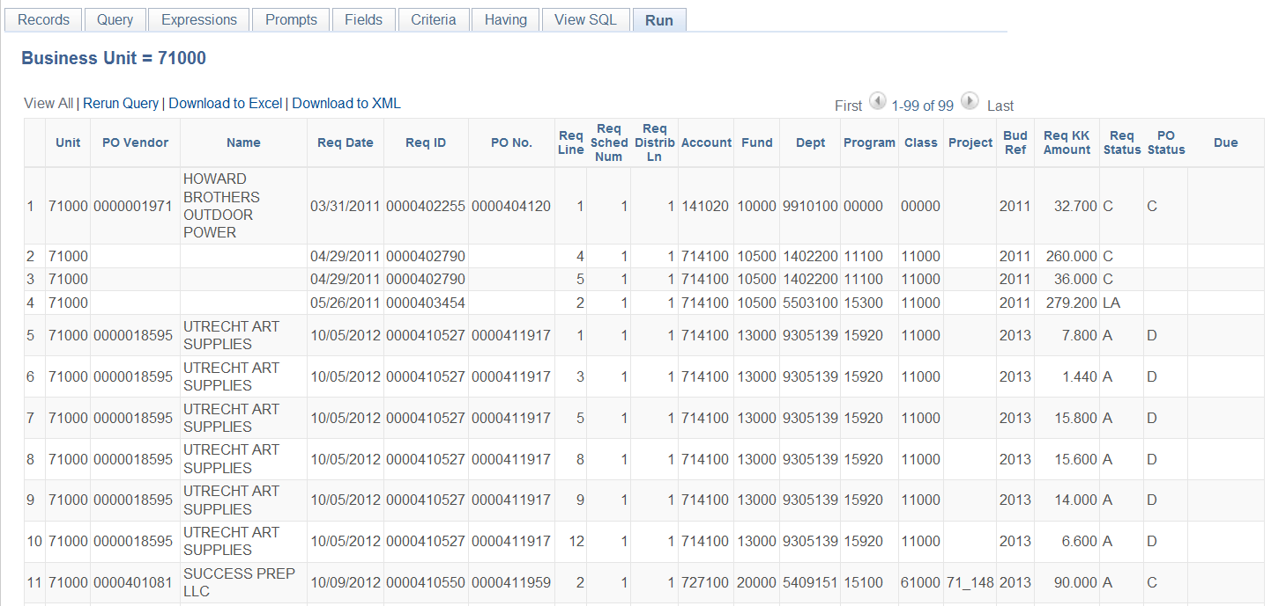

BOR_REQ_OPEN_PREENCS_KK Query
This query lists all requisition lines with an open pre-encumbrance balance in Commitment Control, along with any associated Purchase Order ID. This query is the Commitment Control equivalent of the BOR_REQ_OPEN_AMOUNT_ALL query that returns the open pre-encumbrance balance within the Purchasing module.
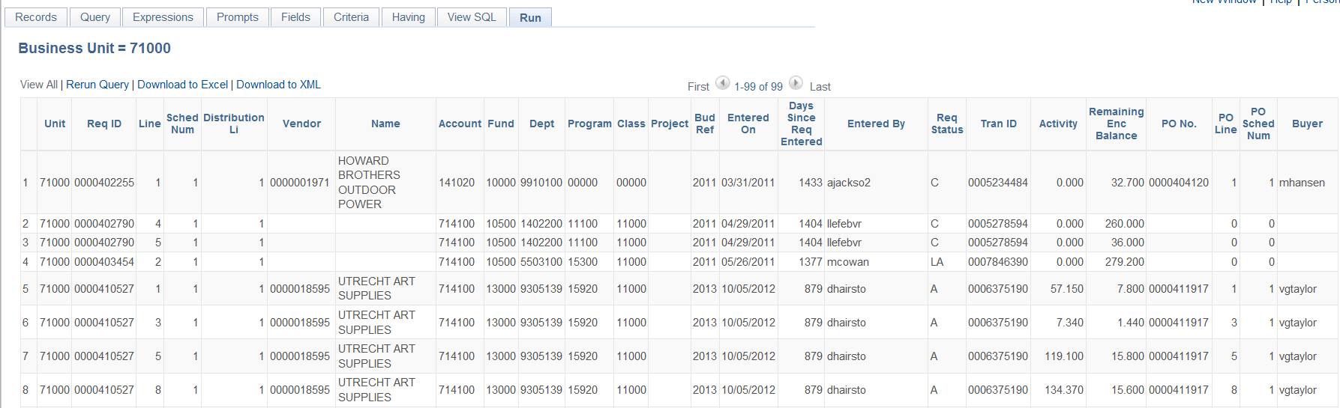

Requisition Reports
Just like queries, there are many reports that deal with requisitions that you can generate in the system.
Requisition to PO Cross Reference Report (POX1100)
The Req to PO Cross Reference Report lists the cross reference between requisitions and associated purchase orders. The parameters for this report are the From/To Dates and the Business Unit. The navigation to run this report is eProcurement > Reports > Requisition to PO Xref. The navigation to retrieve the report is Reporting Tools > Report Manager > Administration tab.
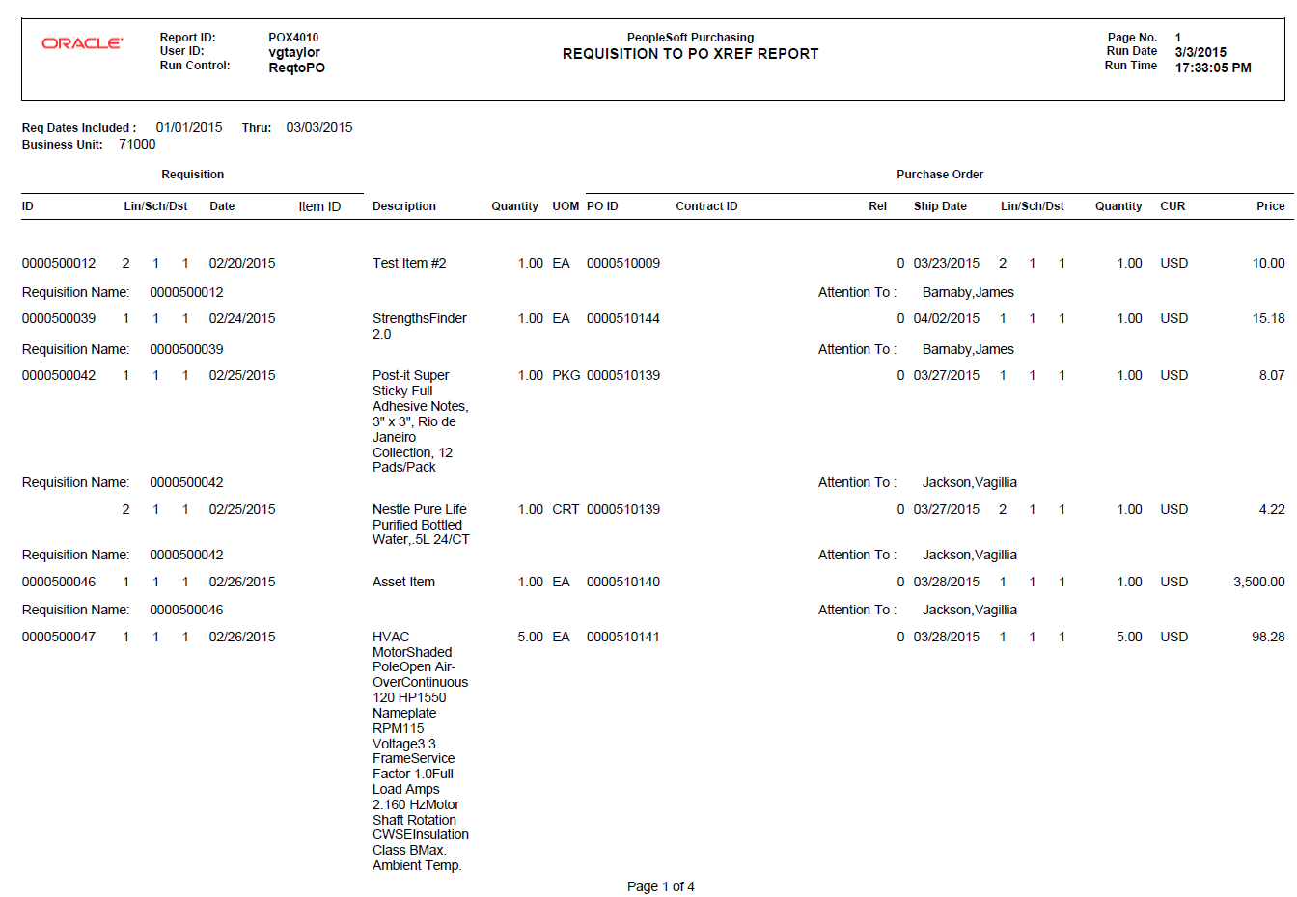

Requisition Print Report (PORQ010)
This report is a hardcopy of a requisition. You can print according to Requisition ID, Date range, and Requester. When running this, select all requisition statuses to ensure your requisition prints. The navigation to this report is Purchasing > Requisitions > Reports > Print Requisition.
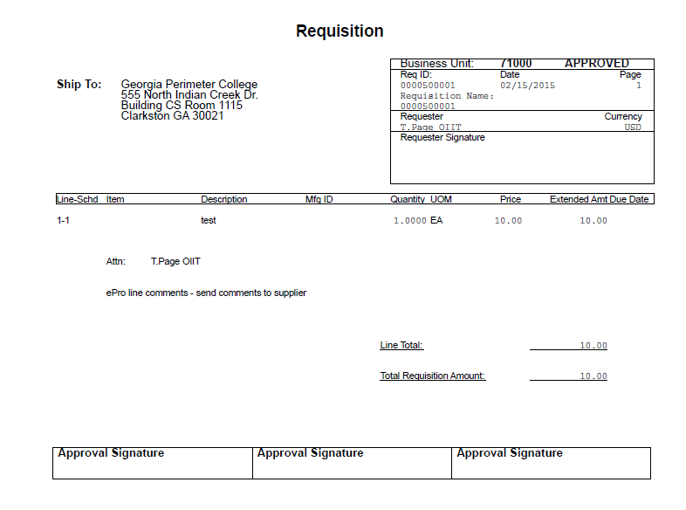

Requisition Budgetary Activity Report (POS8002)
The Requisition Budgetary Activity report provides budgetary amount information for requisitions according to the parameters you input. The navigation to this report is Purchasing > Purchase Orders > Reports > Req and PO Budgetary Activity. The parameters for this report include Business Unit and Date range. You can also specify to return only data with a specific amount remaining open. You can also include specific Chartfield ranges as well.
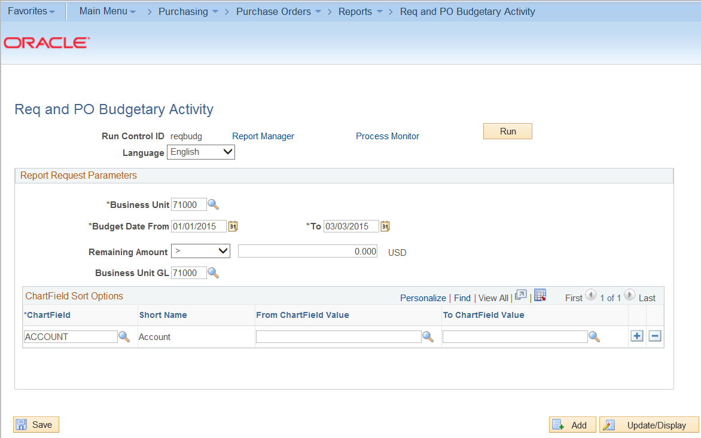
After inputting your parameters, you will need to select Requisition Budgetary Activity – POS8002 on the Process Scheduler Request page.
