eProcurement and GeorgiaFIRST Marketplace
User’s Guide
for
eProcurement Administrator

This page left blank for printing purposes.

Table of Contents

Table of Contents 3
Introduction 4
Chapter 1: eProcurement and GeorgiaFIRST Marketplace Overview 5
What is eProcurement? 5
What is the GeorgiaFIRST Marketplace? 5
Types of Requisitions 5
Benefits of ePro and the GeorgiaFIRST Marketplace 6
Types of Roles Involved 6
Process Flow 7
Chapter 2: eProcurement Approvals 8
How Do Approvals Work? 8
Approval Stages 8
Approval Time Limits 13
Chapter 3: ePro Monitoring and Maintenance 14
Updating a User’s Email Address for Notifications 14
How to: Update a User’s Email Address 14
Monitor ePro Requisition Workflow 15
How to Reassign Requisitions Routed to ePro Admin 19
Assigning an Alternate Approver 20
How to Assign an Alternate Approver 21

Introduction
This User’s Guide is designed for eProcurement Administrators who will be supporting the implementation and maintenance of the PeopleSoft Financials module eProcurement, or ePro, at their institution. Along with the implementation of ePro, the GeorgiaFIRST Marketplace is being implemented as well.
In this User’s Guide, you will find an overview of what the eProcurement module does, as well as what the function of the GeorgiaFIRST Marketplace is. You will also learn the primary role that the ePro Administrator plays in the entire process.
Topics included in this user guide:
- Overview of eProcurement and GeorgiaFIRST Marketplace
- eProcurement approvals
- Updating a user’s email address for notifications
- Monitoring workflow
- Reassigning requisitions
- Assigning alternate Approvers

Chapter 1: eProcurement and GeorgiaFIRST Marketplace Overview
What is eProcurement?
eProcurement (ePro) is a module in PeopleSoft Financials that has a primary function of creating electronic requisitions and routing them for approval. In this PSFIN module, ePro is used to create requisitions for goods and services; a requisition is simply an official request to purchase goods and services.
Previously, your institution may have used paper requisitions, or some other format, to request an item to be purchased. That hard copy requisition had to be routed for approval signatures and then sent to the purchasing department. The purchasing department had to re-key the information into the system to create a purchase order to send to the supplier.
With ePro, much of this process is automated. A requisition is created within ePro and electronically routed for approval. The approval workflow is dependent on the department charged and item type, among other things. Finally, after the last electronic approval is made, the requisition can be sourced into an official purchase order that is dispatched to a supplier.
What is the GeorgiaFIRST Marketplace?
The GeorgiaFIRST Marketplace takes the use of ePro to another level. The GeorgiaFIRST Marketplace is an online shopping site accessed from PeopleSoft Financials. Through this online shopping site, users can shop online for contract items from a variety of state- and institution-approved suppliers. Users can select items by placing them in an online shopping cart. They assign these shopping carts to a designated requester when ready, and the requester then turns their shopping cart into an ePro requisition.
Because users are shopping from approved suppliers with contract prices, very little buyer intervention is required. After a requisition built from the GeorgiaFIRST Marketplace is approved, it is designed to be picked up for batch processing, which will budget check it, source it into a purchase order, and dispatch that purchase order. These batch processes are designed to run at different times throughout the day.
Types of Requisitions
With the implementation of the GeorgiaFIRST Marketplace into the eProcurement module, there are now two types of requisitions: GeorgiaFIRST Marketplace requisitions and Special Request Requisitions.
- GeorgiaFIRST Marketplace Requisition (CAT Origin requisition): Shoppers build a requisition from items in the GeorgiaFIRST marketplace.
- Special Request Requisition (ONL Origin requisition): Requesters build a requisition by manually entering items directly into the requisition. This type of requisition is not built from the contractually-approved items in the Marketplace.
Within ePro, users will not be able to combine items from the GeorgiaFIRST Marketplace with items from a Special Request Requisition into one requisition. Each requisition must be completely either from the Marketplace (CAT) or from a Special Request Requisition (ONL).
Benefits of ePro and the GeorgiaFIRST Marketplace
With this system of online shopping and electronic requisitioning, you will see some immediate benefits, including:
- Reduction in paper forms routing through different offices
- Online browsing and shopping for items
- Comparison shopping
- Request goods from multiple suppliers through one shopping cart
- Items in the GeorgiaFIRST Marketplace are contractually approved items
- Faster routing for approvals
- Ability to save items as ‘favorites’ in the GeorgiaFIRST Marketplace
- Automatic batch processing of approved requisitions
Types of Roles Involved
In order for the ePro and GeorgiaFIRST Marketplace functionality to work properly, users are set up with specific roles and responsibilities. They include:
- Marketplace Browser: User without any GeorgiaFIRST Marketplace roles assigned will default to a Marketplace Browser. A Browser can view items, contracts, and pricing in the Marketplace but cannot add items to a cart or create requisitions.
- Shopper: User can select items to purchase, add them to a cart, and assign that cart to a Requester for further processing. This type of user cannot create a requisition in PeopleSoft.
- Requester: User can perform all functions that a Shopper can, with the added permissions to be able to create the actual requisition in PeopleSoft.
- Approver: User with the permissions and roles necessary to approve ePro requisitions.
- Buyer: User responsible for ensuring approved requisitions are sourced into a purchase order and dispatched to the supplier.
- Accounts Payable: Responsible for building electronic invoices that are sent from GeorgiaFIRST Marketplace suppliers.
- ePro Administrator: User monitors approval workflow to ensure requisitions are worked in a timely fashion.
- Local Security Administrator: Responsible for setting up other users with the appropriate roles, permissions, and user preferences. Please see the Local Security Administrator User’s Guide for more on the responsibilities of this user.
As the ePro Administrator, you are primarily responsible for monitoring ePro workflow and reassigning requisitions as needed. In addition, you will need to work with the Local Security Administrator on occasion to perform maintenance on ePro users. Since workflow is such a critical piece of ePro, the resolution of any requisition workflow issues is very important.
Process Flow
Now that you have identified all of the roles involved, it is helpful to understand the eProcurement and GeorgiaFIRST Marketplace process flow, beginning with Shoppers and ending with your accounts payable department.
Shoppers use the GeorgiaFIRST Marketplace to select goods they request to have purchased
Shoppers assign their completed shopping carts to their assigned Requester
The Requester is notified by email of this newly assigned cart
The Requester logs into the system and pulls the Shopper’s cart into a requisition
The Requester finishes the requisition and submits it for approval
The Approver(s) (determined by various factors) either approve or deny the requisition lines
Once fully approved, the PeopleSoft Financials system automatically budget checks the requisition
Once the requisition has a valid budget check status, the PeopleSoft Financials system automatically sources the requisition into a purchase order and dispatches it to the vendor
The supplier fulfills the order and sends the item and invoice to the Institution
The institution receives the item; receipt is created in PSFIN
The AP department pays the invoice
If the process involves a Special Request Requisition, then the Shopper is eliminated from this process flow and the Requester enters the items directly onto the requisition.

Chapter 2: eProcurement Approvals
A critical component of the eProcurement process is the ability to submit requisitions for approval electronically. Because approvals are handled online within the PeopleSoft Financials system, each institution can customize the approval process to their own specifications. In this chapter, we will outline the possible approval stages from which your institution may choose.
How Do Approvals Work?
As mentioned earlier, a Requester creates a requisition in ePro. Each item on a requisition is placed on its own requisition line. Each distribution line on a requisition may be charged to a different set of ChartFields. Therefore, there may be different approval paths for each line on a requisition depending on a variety of elements.
Once the Requester submits the requisition for approval, each line has its own approval path. This approval path is determined by a number of factors. At a minimum, each requisition line will go to the Department Manager and Project Manager (if a Project is to be charged). These are the managers who are tied into the Department and Project ChartFields on that requisition line.
Depending on how your institution has set up approvals for eProcurement, the requisition line may go to many additional approvers as well. This includes approvers for assets, IT items, and items above a certain amount, if desired. Below is a summary of all of the approval stages and paths available for eProcurement. To determine which stages and paths your institution is currently using, check with your purchasing department or Local Security Administrator.
Approval Stages
Overall, there are five approval stages that can be used for eProcurement requisitions. They include:
- Stage 1: Department and Project Approval
- Stage 2: Fund Approvals (Agency, Grant, Technology Fee)
- Stage 3: Amount Approval (for requisitions built from the GeorgiaFIRST Marketplace)
- Stage 4: Item Type-Based Approvals
- Stage 5: Buyer Approval (for requisitions not built from the GeorgiaFIRST Marketplace)

Here is a summary of each stage:
Stage 1: Department and Project Approval
This is a mandatory approval stage for all requisition lines. Each requisition line must be charged to a Department. In addition, requisition lines can be charged to a Project. The requisition line is routed to the Department Manager (as entered in PeopleSoft) for approval. If the Project ChartField is used on the requisition line, the system also routes it to the Project Manager.
Stage 2: Fund Approval
This approval stage is optional.
Agency Fund Approval:
Agency Fund Approval is set up so that any requisition line charged to an Agency Fund Code must go to an individual specified for Agency Fund Approvals. Agency funds are used to account for resources held by an institution as custodian or fiscal agent for individual students, faculty, staff members, or other organizations. Agency Fund Codes include 60000, 61000, and 62000.
Grant Fund Approval:
Grant Fund Approval is set up so that any requisition line charged to fund 20000 must go to an individual specified for Grant Fund Approvals.
Tech Fee Fund Approval:
Tech Fee Fund Approval is set up so that any requisition line charged to fund 16000 must go to an individual specified for Tech Fee Fund Approvals.
If your institution chooses to employ the Fund Approval stage, there may be multiple Agency Fund Approvers, Grant Fund Approvers, and Tech Fee Fund Approvers. Each Agency Fund Approver will have the role BOR_AGENCY_FUND_APPR, each Grant Fund Approver will have the role BOR_GRANT_APPR, and each Tech Fee Fund Approver will have the role BOR_TECH_FEE_APPR. The institution will determine whether all fund approvers must approve the requisition or whether only one from the group of multiple approvers has to approve it. If any of the above-mentioned fund codes are not used on a requisition line, the system bypasses this approval stage.
Stage 3: Amount Approval
The Amount Approval stage is also an optional one. This stage is for all requisitions that were built from the GeorgiaFIRST Marketplace, although you may choose to have it implemented for your Special Request requisitions as well. Institutions may select one of the options below when using Amount Approval:
- If the monetary amount is $10,000 or more per line, route to Amount Approver.
- If the total monetary amount of the requisition is $10,000 or more, route to Amount Approver and have a monetary amount of $10,000 or more per line.
Again, your institution may set up multiple approvers to serve as the Amount Approver. Each Amount Approver will have the role BOR_EP_CAT_AMOUNT_APPR. The institution will determine whether all amount approvers must approve the requisition or whether only one from a group of multiple approvers has to approve it. The institution does not have to use the $10,000 threshold and can edit this if needed.
If the requisition was not generated from the GeorgiaFIRST Marketplace, it will bypass this approval stage (this can be changed by the institution). If the requisition is below the set threshold and was generated from the GeorgiaFIRST Marketplace, it will also bypass this approval stage.
Stage 4: Item Type-Based Approvals
In Approval Stage 4, approvals are based upon the type of item being requested. Within this stage, there are seven potential approval paths. Each path is optional for the institutions.
- Stage 4, Path 1: Asset Approval
If the item on a Requisition line is an asset and charged to an Asset Account, it will be routed to the person set up as the Asset Approver. The accounts included in this path are 743200, 744200, and 800000 through 899999.

An Asset Approver must have the role “BOR_ASSET_APPR.” If your institution chooses to use the Asset Approver path, there can be multiple asset approvers. The institution will determine whether all asset approvers must approve the requisition or whether only one from the group of multiple approvers has to approve it. In addition, institutions may identify additional account codes for asset approval, and they may add monetary amount criteria (i.e., asset item unit price greater than $5,000).

- Stage 4, Path 2: Audio Visual Approver
This is an optional approval path and is for any item on a requisition line that contains an NIGP code related to Audio Visual items or services. An NIGP code is the National Institute of Governmental Purchasing’s coding classification used primarily to classify products and services procured by state and local governments.

In PeopleSoft, the Category ID is tied into the NIGP Code. In the GeorgiaFIRST Marketplace, the NIGP code is already tied into items. For requisition line items not generated from the Marketplace, the Requester enters the proper Category ID. For those line items that have an NIGP Code related to Audio Visual items and services, the system will route the requisition line to the Audio Visual Approver.

An Audio Visual Approver must have the role “BOR_AUDIO_VIS_APPR”. If your institution chooses to use the Audio Visual (AV) Approver path, there can be multiple AV approvers. The institution will determine whether all AV approvers must approve the requisition or whether only one from the group of multiple approvers has to approve it. In addition, institutions may identify additional NIGP codes for audio visual approval, and they may add monetary amount criteria (i.e., item has an NIGP code of 06400 and is greater than $1,000).
- Stage 4, Path 3: Chemical Approver
This path is also an optional one and is for any requisition line with an NIGP code associated with chemicals. If the NIGP code for the requisition line is associated with a chemical purchase, the line will route to the Chemical Approver.

A Chemical Approver must have the role “BOR_CHEMICAL_APPR”. If your institution chooses to use the Chemical Approver path, there can be multiple Chemical Approvers. The institution will determine whether all chemical approvers must approve the requisition or whether only one from the group of approvers must approve it. In addition, institutions may identify additional NIGP codes for chemical approval, and they may add monetary amount criteria.

- Stage 4, Path 4: Facilities Planning and Design Approver
This optional path is for any requisition line with an NIGP code associated with facilities planning and design.

A Facilities Planning and Design Approver must have the role “BOR_FACILITIES_APPR”. If your institution chooses to use the Facilities Planning and Design Approver path, there can be multiple approvers in this path. The institution will determine whether all Facilities Planning and Design approvers must approve the requisition, or whether only one from the group of approvers must approve it. In addition, institutions may identify additional NIGP codes for facilities planning and design approval, and they may add monetary amount criteria.

- Stage 4, Path 5: IT Approver
This approval path is for any IT hardware or software approvals and is also optional. For any requisition line that is for a computer hardware or software purchase or service (based on NIGP code), the system routes the line to the IT Approver.

An IT Approver must have the role “BOR_IT_APPR”. If your institution chooses to use the IT Approver path, there can be multiple approvers in this path. The institution will determine whether all IT Approvers must approve the requisition or whether only one from the group of approvers must approve it. In addition, institutions may identify additional NIGP codes for IT approval, and they may add monetary amount criteria.

- Stage 4, Path 6: University Relations Approver
The sixth approval path in Stage 4 is also optional and is for the University Relations Approver. For any requisition line that relates to media contact, logo use or copyright items (based on NIGP code), the system routes it to the University Relations Approver.

The University Relations Approver must have the role “BOR_UNIVREL_APPR”. If your institution chooses to use the University Relations Approver path, there can be multiple approvers in this path. The institution will determine whether all University Relations Approvers must approve the requisition or whether only one from the group of approvers must approve it. In addition, institutions may identify additional NIGP codes for University Relations approval, and they may add monetary amount criteria.
- Stage 4, Path 7: Default NIGP Code – 00000
The seventh approval path in Stage 4 will route to a Buyer Approver in the event that a GeorgiaFIRST Marketplace Requisition line does not have an NIGP code. If the line item does not have an NIGP code, it will default to the “00000” NIGP code. This requisition line will automatically route to a Buyer Approver for correction.

- Stage 4, Path 8: Furniture Approver
This path is optional. The Furniture Approver must have the role “BOR_FURNITURE_APPR”. If your institution chooses to use the Furniture Approver path, there can be multiple approvers in this path. The institution will determine whether all Furniture Approvers must approve the requisition, or if only one from the group of approvers must approve it. In addition, institutions may identify additional NIGP codes for Furniture approval, and they may add monetary amount criteria.

- Stage 4, Path 9: Human Resource Approver
This path is optional. The Human Resource Approver must have the role “BOR_HR_APPR”. If your institution chooses to use the Human Resource Approver path, there can be multiple approvers in this path. The institution will determine whether all Human Resource Approvers must approve the requisition, or if only one from the group of approvers must approve it. In addition, institutions may identify additional NIGP codes for Human Resource approval, and they may add monetary amount criteria.

- Stage 4, Path 10: Pharmaceutical Drug Approver
This optional path is for any requisition line with an NIGP code associated with pharmaceutical drugs. The Pharmaceutical Drug Approver must have the role “BOR_PHARM_DRUG_APPR”. If your institution chooses to use the Pharmaceutical Drug Approver path, there can be multiple approvers in this path. The institution will determine whether all Pharmaceutical Drug Approvers must approve the requisition, or if only one from the group of approvers must approve it. In addition, institutions may identify additional NIGP codes for Pharmaceutical Drug approval, and they may add monetary amount criteria.
- Stage 4, Path 11: Budget Reference Approver
This optional path of approval will route to a Budget Reference approver for any requisition line where the Budget Reference does not equal the Fiscal Year. The Budget Reference approver must have the role “BOR_EP_BUD_REF_APPR”. If your institution chooses to use the Budget Reference Approver path, there can be multiple approvers in this path. The institution will determine whether all Budget Reference Approvers must approve the requisition, or if only one from the group of approvers must approve it.

Stage 5: Buyer Approval
In Approval Stage 5, the system will route all Special Request Requisitions (those requisitions not built from the GeorgiaFIRST Marketplace) to the person designated to give buyer approval. This stage is primarily used for Special Request Requisitions since they are not built from contract-approved catalogs. The Buyer Approver can then ensure the line item meets all procurement policies.
Institutions may choose to have multiple Buyer Approvers. In addition, the institution can choose whether all Buyer Approvers must approve the requisition or whether only one needs to act on it. Finally, the institution may choose to inactivate this stage or include it for all requisitions.
Approval Time Limits
Within the system, there are built-in time limits that an Approver has to act on the requisition. This ensures that ePro requisitions do not sit around waiting for an Approver for an indefinite amount of time.
When a requisition is submitted for approval, the system sends it to the first Approver’s Worklist within PeopleSoft Financials. The Worklist is a queue which holds items waiting for approval. Once an Approver works a transaction, it is removed from the Worklist.
Once the requisition hits an Approver’s Worklist, that Approver has three days to either approve or deny it before they receive a reminder notification from the system. If the requisition sits in an Approver’s Worklist for four days without being approved or denied, the system removes the requisition from that Approver’s Worklist, and you as the ePro Administrator will need to reassign the transaction to another Approver. After the Approver has approved the requisition, the system automatically moves it onto the next Approver’s Worklist. If an Approver denies a requisition, the system returns it to the Requester. Denied requisition lines can be edited and resubmitted for approval.
If an Approver will be out of the office for an extended period of time and will be unable to work the requisitions in their Worklist, they have the ability to assign an alternate to serve in their place. This way, their Worklist does not build up while they are out of the office, and requisition approval is not delayed. As the ePro Administrator, you will also have this ability if you need to assign an alternate approver.
Each institution is able to customize the number of days as to when the system will send reminder emails and escalates a requisition.

Chapter 3: ePro Monitoring and Maintenance
In Chapter 2, you learned the various ePro Workflow approval stages and paths. Your institution can choose which stages and paths they want to implement. Timely requisition approvals are critical to the ePro functionality. The tasks in this chapter detail how you will need to maintain Workflow and ePro users.
Updating a User’s Email Address for Notifications
There may be times when a user informs you that they are not receiving ePro notifications. These notifications may include when a requisition has been created for a Shopper, when a requisition has been approved or denied, and when requisition items need to be received. If a user is not receiving notifications, you will need to work with the Local Security Admin to correct the user’s email address in that user’s profile.
You can verify and update a user’s email address through the Distributed User Profile pages. You can also add multiple email addresses for a user. However, one must be selected as a primary address. The system sends notifications to the primary email address.
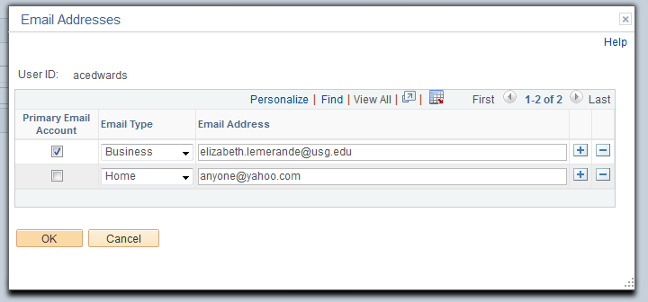
How to: Update a User’s Email Address
- In the menu, select PeopleTools.
- Select Security.
- Select User Profiles.
- Select Distributed User Profiles.
- On the Find an Existing Value tab, enter the User ID.
- Click the Search button.
- On the General tab, select the Edit Email Addresses link.
- Make any necessary updates to the existing email address.
- To add another email address, click the Add a new row button.
  - Select the email type.
  - Enter the email address.
- Ensure the Primary Email Account is selected.
- Click the OK button.
- Click the Save button.

Monitor ePro Requisition Workflow
As the ePro Admin, you will need to monitor workflow. The requisitions that cannot be successfully routed because of a missing or invalid user ID for Department and Project approvers will be sent to you. In addition, if your institution has chosen to use a particular workflow stage and path (i.e., Chemical Approvers), but no one has that security role, the transaction will route to you.
You will need to manually reassign transactions that cannot be successfully routed to the correct approver. You may also have to work with the Local Security Admin to resolve security role issues that are preventing the approval request from reaching the assigned approver.
Requisition approvals that cannot be sent to the correct approver and are then routed to the ePro Administrator are noted in the workflow routing. Below is a screenshot of a requisition routed to the ePro Administrator because no IT Approver had been assigned.
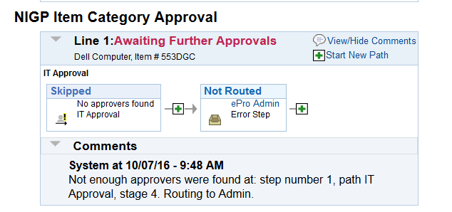
This is what the Requester will see after they submit the requisition. As the ePro Administrator, you will use the Monitor Approvals page to see which transactions you need to resolve. You will enter criteria to look for Requisitions in the Approval Process for your ePro Admin User ID.
In the search results, you need to look for requisitions that are in a Pending status. This means that the requisition needs approval.
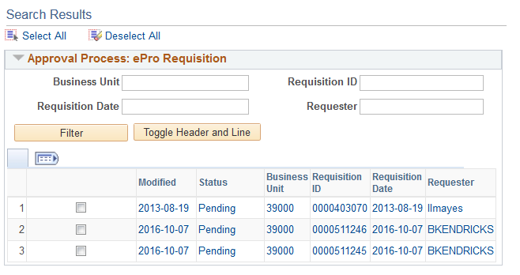
If you select the requisition ID of the transaction in a Pending status, the system will take you to another page where you can reassign the transaction. A row with a “Terminated” status indicates that the transaction was initiated but was eventually stopped. There is nothing you need to do with a row in a Terminated status on this page.
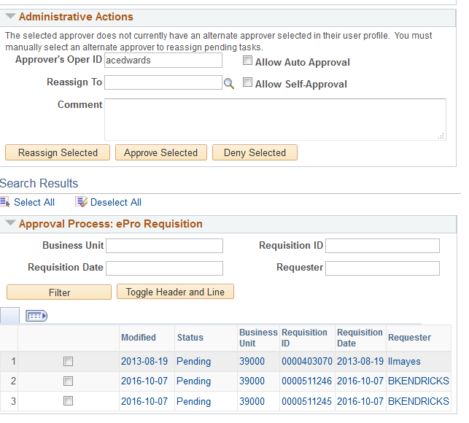
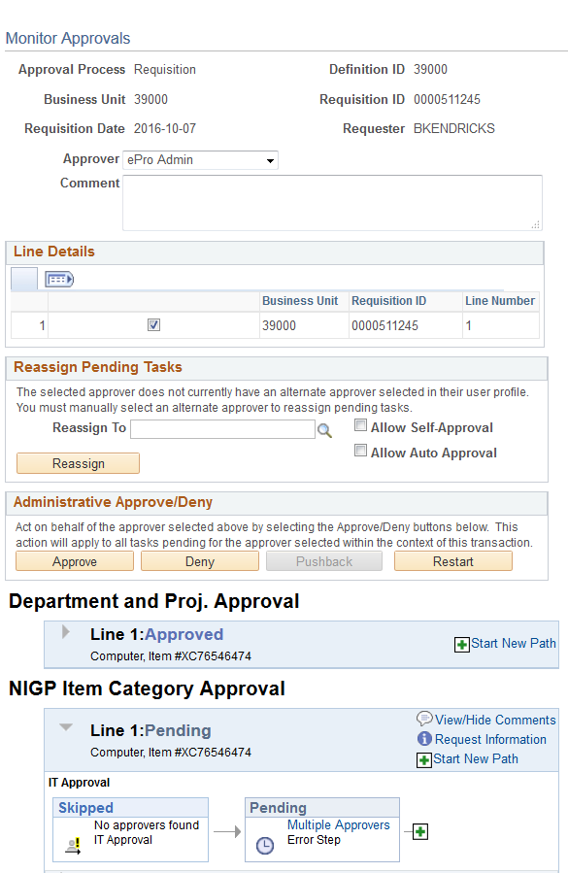
In the “Reassign To” field, enter or select the user ID of the Approver who should receive the requisition. You may need to work with your Local Security Admin and Purchasing Department to make sure the Approver is properly set up in the system, including security roles and Department or Project ChartField value setup if necessary.
After reassigning the requisition, the approval path should show the new approver in the Pending step.
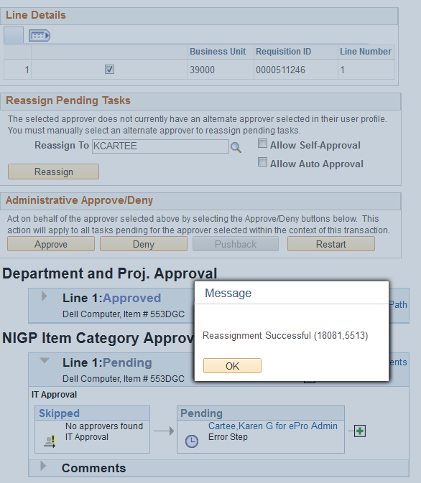

The newly assigned approver should be able to see the requisition in their Worklist. In the Approval Comment History section, the history of the ePro Admin reassigning the requisition is captured.
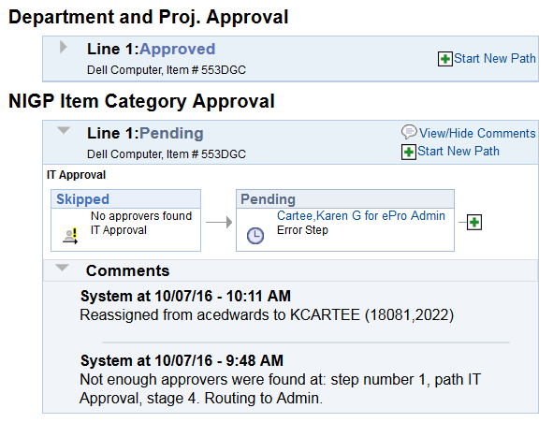
Monitoring ePro workflow to ensure that requisitions are properly routed is an activity that must be performed daily.
How to Reassign Requisitions Routed to ePro Admin
- In the menu, select Enterprise Components.
- Select Approvals.
- Select Approvals.
- Select Monitor Approvals.
- In the Approval Process field, enter/select Requisition.
- In the Definition ID field, enter your business unit.
- In the Approver field, enter/select the ePro Administrator’s user ID.
- Click the Search button.
- In the Search Results, locate any rows with a “Pending” Status. You will need to reassign any transactions in a pending status.
- Select the Requisition ID link for a row with a Pending status.
- Review where the requisition skipped approval and the reason why it skipped approval in the “Line Dept and Project Approval” section. You may need to work with your Local Security Admin and purchasing department to determine whether the correct approver has the appropriate roles and setup.
- Once you have resolved why the approver level was skipped, you can reassign the requisition. In the Reassign To field, enter/select the Approver you want to reassign the requisition to in the Reassign Pending Tasks group box.
- Click the Reassign button.
- You can search for the requisition again on the Monitor Approvals page to verify that it is no longer assigned to the ePro Admin.
Assigning an Alternate Approver
Approvers have been given instructions on how to set up an alternate approver for their requisitions when they will be away from the office and unable to work requisitions. There may be occasions when they will not be able to do this, and you will need to set up an alternate approver for them.
When you assign an alternate approver, you specify the appropriate date range. For example, if you received word that Approver “A” had to take emergency leave and will be out of the office for the next two weeks, you set up an alternate approver for those two weeks.
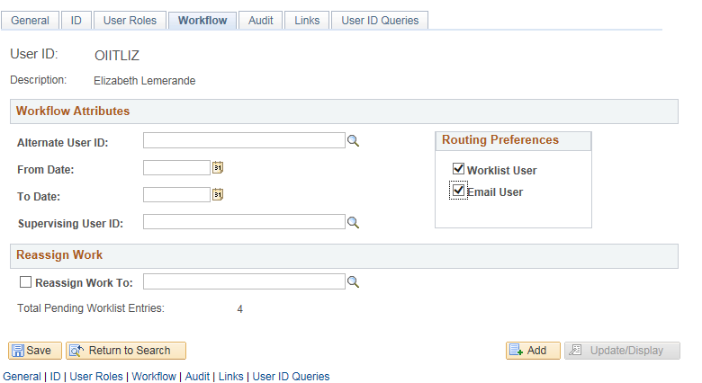
Assigning an alternate approver will only affect future requisitions. If there are currently requisitions in the original approver’s Worklist, they will not be affected. You should not use the “Reassign Work” section of this page. Instead, you can use the procedure for reassigning requisitions (page 19). Rather than searching for requisitions for the ePro Admin, you can search for requisitions for this approver.
The dates that you enter for the alternate approver mean that at 12:00 a.m. on the “From Date”, any new requisitions assigned to the original approver will automatically be sent to the alternate approver’s Worklist. New requisitions will continue to be sent to the alternate approver until 11:59 p.m. on the “To Date”. After that, the system will resume routing any new requisitions to the original approver.
When you assign an alternate approver, you must first ensure that the alternate has the appropriate security approval roles assigned to them. You will need to work with your Local Security Admin to do this.

How to Assign an Alternate Approver
- In the menu, select PeopleTools.
- Select Security.
- Select User Profiles.
- Select Distributed User Profiles.
- In the User ID field, enter the User ID of the approver who will be unable to work requisitions for a specific period of time.
- Click the Search button.
- Select the Workflow tab.
- In the Alternate User ID field, enter/select the User ID of the alternate approver that you are assigning.
- In the From Date field, enter/select the beginning date that requisitions should route to the alternate approver.
- In the To Date field, enter/select the ending date that requisitions should route to the alternate approver.
- Click the Save button.

