Navigating in the GeorgiaFIRST Marketplace
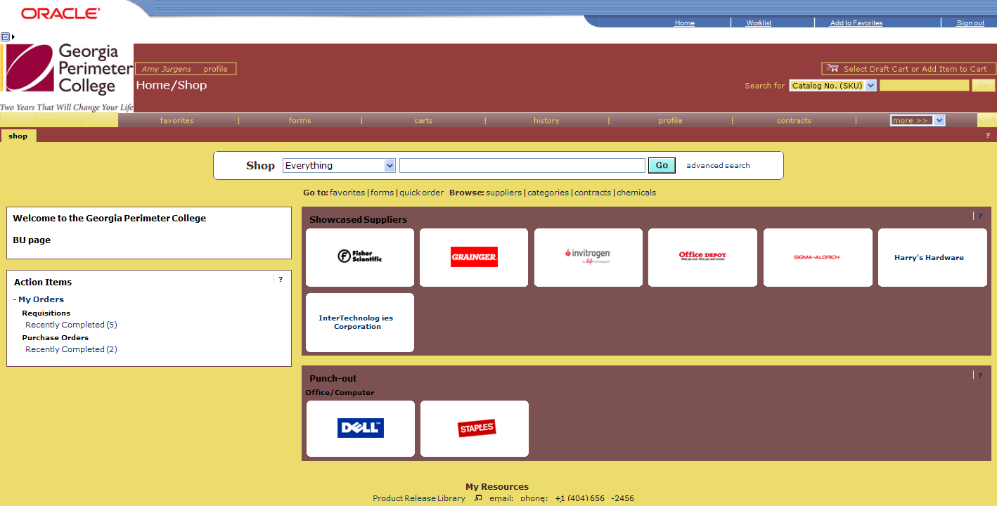
1
2
3
4
5
6
7
8
9
10
11
12
The first step in using the GeorgiaFIRST Marketplace is knowing where things are located, and how to navigate the home page. Whenever you wish to return to the home page, simply click the home/shop tab and select the shop sub-tab. Or you can click your school logo in the upper left corner to return to the home page.

- User Information: Your name and a link to your user profile
- Screen Title: Title of the current page that you are on
- Cart Summary: In the Cart Summary is the cart name, the number of items in the cart, and the total cart amount. Click this shortcut to go directly to the shopping cart page to review, update, and process your active shopping cart.
- Quick Search: This quick search feature allows for a variety of searches to be executed anywhere in the marketplace. To use this feature, a search option must be selected and search criteria must be keyed in. Clicking the “Go” button executes the quick search and displays the results in the appropriate search results screen.
- Navigation Tabs: Across the top of the GeorgiaFIRST Marketplace are the primary navigation tabs. By clicking on a tab, the screen refreshes to display sub-tabs for the topics or functions covered in that particular part of the Marketplace. The tabs that you see are dependent on your permissions. You may change the order of these tabs in your User Profile > User Settings > Navigation Setup.
  - Home/Shop: This tab is used for shopping and provides quick access to other parts of the application.
  - Favorites: Use this tab to create and define personal favorites folders and items, as well as shared (depending on permissions).
  - Carts: View and modify the current shopping cart, create new carts, delete existing carts, and prepare an active cart for processing.
  - History: Contains a repository of various documents within the application.
  - Profile: Used to review and update personal user information.
- Navigation Sub-Tabs: Once you select a tab, additional sub-tabs may be available and will be located beneath the primary navigation tabs.
- Shop at the Top/Shop Quick Search: You can access simple and advanced search from this feature. This is the primary area to perform item searches.
- Action Items Box: Contains quick links to important information for the user logged in. Depending on your role, the information displayed will vary.
- Organization Message: This box is an important tool system administrators use to communicate with the GeorgiaFIRST Marketplace community. This message box is available to all users and is a common way to communicate important upcoming dates, information about new suppliers, links to training, and more.
- Purchasing Showcase: The Purchasing Showcase is used to highlight suppliers recommended by your institution’s Procurement Department.
- Punch-Out: A “Punch-out” supplier is a site maintained by the actual supplier. Catalogs in punch-out sites can still be customized for an individual institution. Punch-out suppliers can be accessed from this area of the screen.
- Online Help: Online Help is accessed by clicking on the question mark anywhere in the application or by clicking on hyperlink text. Text with associated Help is indicated by text that changes colors when mousing-over the text. Much of the text in the application can be selected and a secondary Help window displays.

