eProcurement and GeorgiaFIRST Marketplace
User’s Guide
for
Approvers
Organization/Department

Table of Contents
Table of Contents 2
Introduction 3
Chapter 1: eProcurement and GeorgiaFIRST Marketplace Overview 4
What are eProcurement and the GeorgiaFIRST Marketplace? 4
Benefits of ePro and the GeorgiaFIRST Marketplace 4
Types of Roles Involved 5
Process Flow 6
Chapter 2: eProcurement Approvals 7
How Do Approvals Work? 7
Approval Stages 7
Approver’s Worklist 12
Chapter 3: Approving and Denying Requisitions 14
Retrieving Your Worklist 14
Reviewing Your Worklist 15
How To: Access your Worklist 22
How To: Approve a Requisition 22
How To: Deny a Requisition 22
Ad Hoc Approvers 23
How To: Insert Ad Hoc Approver 25
Requisition Push Back 26
How To: Push Back a Requisition to the Previous Approver 29
Chapter 4: Worklist Maintenance 30
Assigning an Alternate Approver 30
How To: Assign an Alternate Approver 31
Chapter 5: Contract Types 32

Introduction
This User’s Guide is designed for Approvers who will be responsible for approving Requisitions coming from the eProcurement module in PeopleSoft Financials.
In this User’s Guide, you will find an overview of what the eProcurement module does, as well as what the function of the GeorgiaFIRST Marketplace is. You will also learn the responsibilities you have as an Approver.
Topics Covered in this User’s Guide Include:
- Overview of eProcurement and the GeorgiaFIRST Marketplace
- Approving and Denying Requisitions in your Worklist
- Setting up an Alternate Approver
- Basic Procurement Policies

Chapter 1: eProcurement and GeorgiaFIRST Marketplace Overview
What are eProcurement and the GeorgiaFIRST Marketplace?
eProcurement (ePro) is a module in PeopleSoft Financials that has a primary function of creating electronic requisitions and routing them for approval. In this PSFIN module, ePro is used to create requisitions for goods and services. A requisition is simply an official request to purchase goods and services.
Previously, your institution may have used paper requisitions, or some other format, to request an item to be purchased. That hardcopy requisition then had to be routed for approval signatures and sent to the Purchasing Office. The Purchasing Office then rekeyed the information into the system to create a Purchase Order to send to the vendor.
With ePro, much of this is completely automated. A requisition is created within ePro and electronically routed for approval. The approval chain is dependent on the department charged and item type, among other things. Finally, after the last electronic approval is made, the requisition can be copied into or sourced into an official Purchase Order that is dispatched to a vendor.
The GeorgiaFIRST Marketplace takes the use of ePro to another level. The GeorgiaFIRST Marketplace is an online shopping site that is accessed from PeopleSoft Financials. Through this online shopping site, users can shop online for contract items from a variety of state and institution approved vendors. Users can select items by placing them in an online shopping cart. They assign these shopping carts to a designated requester when ready, and the requester then turns their shopping cart into an ePro requisition.
Benefits of ePro and the GeorgiaFIRST Marketplace
With this new system of online shopping and electronic requisitioning, you will see some immediate benefits, including:
- Reduction in paper forms routing through different offices
- Online browsing and shopping for items
- Comparison shopping
- One login to shop from multiple vendors
- Request for goods from multiple vendors through one shopping cart
- All items contractually approved when using GeorgiaFIRST Marketplace
- Faster routing for approvals
Types of Roles Involved
In order for the ePro and GeorgiaFIRST Marketplace functionality to work properly, users are set up with specific roles and responsibilities. They include:
- Shoppers: These users are the ones who select items in the GeorgiaFIRST Marketplace.
- Browsers: Users without any GeorgiaFIRST Marketplace roles assigned will default to a Marketplace Browser. Browsers can view the items, contracts, and prices in the Marketplace but cannot shop or create requisitions.
- Requesters: These users take the shopping carts created by Shoppers and turn them into ePro Requisitions. Requesters can also build their own shopping carts, just like Shoppers.
- Approvers: These users are set up to approve ePro Requisitions.
- Buyers: These users are responsible for ensuring approved requisitions are sourced into a Purchase Order and dispatched to the vendor.
- AP Personnel: The AP office processes the resulting invoice from the vendor.
- ePro Administrator: This user monitors the approval workflow, to make sure requisitions are worked in a timely fashion
- Local Security Administrator: This user is responsible for setting up others users in their appropriate roles.
As an Approver, you are primarily responsible for approving or denying ePro requisition lines that are assigned to you. For items that are purchased from the GeorgiaFIRST Marketplace (called Marketplace Requisitions), you can be assured that they come from approved pricing lists and contracts. For items that are not purchased from the GeorgiaFIRST Marketplace (called Special Request Requisitions), the Purchasing Office will be the final approver to ensure that the requested goods meet all purchasing requirements.

Process Flow
Now that you know all of the roles involved, below is the process flow beginning with Shoppers and ending with the Accounts Payable office.
Shoppers use the GeorgiaFIRST Marketplace to select goods they request to have purchased
Shoppers assign their completed shopping carts to their assigned Requester
The Requester is notified by email of this newly assigned cart
The Requester logs into the system and pulls the Shopper’s cart into a Requisition
The Requester finishes the requisition and submits it for approval
The Approvers (determined by various factors) either approve or deny the requisition lines
Once fully approved, the PeopleSoft Financials system automatically budget checks the requisition
Once the requisition has a valid budget check status, the PeopleSoft Financials system automatically sources the requisition into a purchase order and dispatches it to the vendor
The vendor fulfills the order and sends the item and invoice to the Institution
The institution receives the item/Receipt is created in PSFIN
The AP Office pays the invoice

Chapter 2: eProcurement Approvals
A critical component to the whole eProcurement process is the ability to submit requisitions for approval electronically. Because approvals are handled online within the PeopleSoft Financials system, each institution can customize the approval process to their own specifications.
How Do Approvals Work?
As mentioned earlier, a Requester builds a requisition in ePro. Each item on a requisition is actually placed on its own requisition line. Theoretically, each line in a requisition can be charged to a different set of Chartfields (though, as a best practice, these scenarios should be limited). Therefore, there may be different approval paths for each line on a requisition.
Once the Requester submits the requisition for approval, each line has its own approval path. This approval path is determined by a number of factors. At a minimum, each requisition line will go to the Department Manager and Project Manager (if a Project is to be charged). These are the managers that are tied into the Department and Project Chartfields on that requisition line.
Depending on how your institution has set up approvals for eProcurement, the requisition line may go to many additional approvers as well. This includes approvers for assets, IT items, and items above a certain amount. Below is a summary of all of the approval stages and paths available for eProcurement. To determine what stages and paths your institution is using, check with your Purchasing Department or Local Security Administrator.
Approval Stages
Overall, there are five approval stages that can be used for eProcurement requisitions. They include:
- Stage 1: Department and Project Approval
- Stage 2: Fund Approval (Agency, Grant, Technology Fee)
- Stage 3: Amount Approval (for requisitions built from the GeorgiaFIRST Marketplace)
- Stage 4: Item Type Based Approvals
- Stage 5: Buyer Approval (for requisitions not built from the GeorgiaFIRST Marketplace)
Here is a summary of each stage:
Stage 1: Department and Project Approval
This is a mandatory approval stage for all requisition lines. Each requisition line must be charged to a Department. In addition, requisition lines can be charged to a Project. The requisition line is routed to the Department Manager (as entered in PeopleSoft) for approval. If the Project Chartfield is used on the requisition line, the system also routes it to the Project Manager.
Stage 2: Fund Approval
This approval stage is an optional one for institutions.
Agency Fund Approval:
Agency Fund Approval is set up so that any requisition line charged to an Agency Fund Code must go to an individual specified for Agency Fund Approvals. Agency funds are used to account for resources held by an institution as custodian or fiscal agent for individual students, faculty, staff members, or other organizations. Agency Fund Codes include 60000, 61000, and 62000.
Grant Fund Approval:
Grant Fund Approval is set up so that any requisition line charged to fund 20000 must go to an individual specified for Grant Fund Approvals.
Tech Fee Fund Approval:
Tech Fee Fund Approval is set up so that any requisition line charged to fund 16000 must go to an individual specified for Tech Fee Fund Approvals.
If your institution chooses to employ the Fund Approval stage, there may be multiple Agency Fund Approvers, Grant Fund Approvers, and Tech Fee Fund Approvers. Each Agency Fund Approver will have the role BOR_AGENCY_FUND_APPR, each Grant Fund Approver will have the role BOR_GRANT_APPR, and each Tech Fee Fund Approver will have the role BOR_TECH_FEE_APPR. The institution will determine whether all fund approvers must approve the requisition or if only one from the group of multiple approvers has to approve it. If any of the above mentioned fund codes are not used on a requisition line, the system bypasses this approval stage.
Stage 3: Amount Approval
The Amount Approval stage is also an optional one. This stage is for all requisitions that were built from the GeorgiaFIRST Marketplace, although you can choose to have it implemented for your Special Request requisitions as well. Institutions have the following options when using Amount Approval and may select either option or both:
- If the monetary amount is $10,000 or more per line, route to Amount Approver.
- If the total monetary amount of the requisition is $10,000 or more, route to Amount Approver and have a monetary amount of $10,000 or more per line.
Again, your institution may set up multiple approvers to serve as the Amount Approver. Each Amount Approver will have the role BOR_CAT_AMOUNT_APPR. The institution will determine whether all amount approvers must approve the requisition or whether only one from a group of multiple approvers has to approve it. The institution does not have to use the $10,000 threshold and can edit this if needed.
If the requisition was not generated from the GeorgiaFIRST Marketplace, it will bypass this approval stage (this can be changed by the institution). If the requisition is below the set threshold and was generated from the GeorgiaFIRST Marketplace, it will also bypass this approval stage.
Stage 4: Item-Type Based Approvals
In Approval Stage 4, approvals are based upon the type of item being requested. Within this stage, there are eleven potential approval paths. Each path is optional for the institutions.
- Stage 4, Path 1: Asset Approval
If the item on a Requisition line is an asset and charged to an Asset Account, it will be routed to the person set up as the Asset Approver. The accounts included in this path are 743200, 744200, and 800000 through 899999.

An Asset Approver must have the role “BOR_ASSET_APPR”. If your institution chooses to use the Asset Approver path, there can be multiple asset approvers. The institution will determine whether all asset approvers must approve the requisition or whether only one from the group of multiple approvers has to approve it. In addition, institutions may identify additional account codes for asset approval, and they may add monetary amount criteria (i.e., asset item unit price greater than $5,000).

- Stage 4, Path 2: Audio Visual Approver
This is an optional approval path and is for any item on a requisition line that contains an NIGP code related to Audio Visual items or services. NIGP stands for National Institute of Governmental Purchasings Commodity Services Code. The NIGP Code is a coding classification used primarily to classify products and services procured by state and local governments.

In PeopleSoft, the Category ID is tied into the NIGP Code. In the GeorgiaFIRST Marketplace, the NIGP code is already tied into items. For requisition line items not generated from the Marketplace, the Requester enters the proper Category ID. For those line items that have an NIGP Code related to Audio Visual items and services, the system will route the requisition line to the Audio Visual Approver.

An Audio Visual Approver must have the role “BOR_AUDIO_VIS_APPR”. If your institution chooses to use the Audio Visual (AV) Approver path, there can be multiple AV approvers. The institution will determine whether all AV approvers must approve the requisition or whether only one from the group of multiple approvers has to approve it. In addition, institutions may identify additional NIGP codes for audio visual approval, and they may add monetary amount criteria (i.e., item has an NIGP code of 06400 and is greater than $1,000).

- Stage 4, Path 3: Chemical Approver
This path is also an optional one and is for any requisition line with an NIGP code associated with chemicals. If the NIGP code for the requisition line is associated with a chemical purchase, the line will route to the Chemical Approver.

A Chemical Approver must have the role “BOR_CHEMICAL_APPR”. If your institution chooses to use the Chemical Approver path, there can be multiple Chemical Approvers. The institution will determine whether all chemical approvers must approve the requisition or whether only one from the group of approvers must approve it. In addition, institutions may identify additional NIGP codes for chemical approval, and they may add monetary amount criteria.

- Stage 4, Path 4: Facilities Planning and Design Approver
This optional path is for any requisition line with an NIGP code associated with facilities planning and design.

A Facilities Planning and Design Approver must have the role “BOR_FACILITIES_APPR”. If your institution chooses to use the Facilities Planning and Design Approver path, there can be multiple approvers in this path. The institution will determine whether all Facilities Planning and Design approvers must approve the requisition or whether only one from the group of approvers must approve it. In addition, institutions may identify additional NIGP codes for facilities planning and design approval, and they may add monetary amount criteria.

- Stage 4, Path 5: IT Approver
This approval path is for any IT hardware or software approvals and is also optional. For any requisition line that is for a computer hardware or software purchase or service (based on NIGP Code), the system routes the line to the IT Approver.

An IT Approver must have the role “BOR_IT_APPR”. If your institution chooses to use the IT Approver path, there can be multiple approvers in this path. The institution will determine whether all IT Approvers must approve the requisition or whether only one from the group of approvers must approve it. In addition, institutions may identify additional NIGP codes for IT approval, and they may add monetary amount criteria.

- Stage 4, Path 6: University Relations Approver
The sixth approval path in stage 4 is also optional and is for the University Relations Approver. For any requisition line that relates to media contact, logo use or copyright items (based on NIGP code), the system routes it to the University Relations Approver.

The University Relations Approver must have the role “BOR_UNIVREL_APPR”. If your institution chooses to use the University Relations Approver path, there can be multiple approvers in this path. The institution will determine whether all University Relations Approvers must approve the requisition or whether only one from the group of approvers must approve it. In addition, institutions may identify additional NIGP codes for University Relations approval, and they may add monetary amount criteria.

- Stage 4, Path 7: Default NIGP Code – 00000
The seventh approval path in stage 4 will route to a Buyer Approver in the event that a GeorgiaFIRST Marketplace Requisition line does not have an NIGP code. If the line item does not have an NIGP code, it will default to the “00000” NIGP code. This requisition line will automatically route to a Buyer Approver for correction.

- Stage 4, Path 8: Furniture Approver
This path is optional. The Furniture Approver must have the role “BOR_FURNITURE_APPR”. If your institution chooses to use the Furniture Approver path, there can be multiple approvers in this path. The institution will determine whether all Furniture Approvers must approve the requisition or whether only one from the group of approvers must approve it. In addition, institutions may identify additional NIGP codes for Furniture approval, and they may add monetary amount criteria.

- Stage 4, Path 9: Human Resource Approver
This path is optional. The Human Resource Approver must have the role “BOR_Human_RES_APPR”. If your institution chooses to use the Human Resource Approver path, there can be multiple approvers in this path. The institution will determine whether all Human Resource Approvers must approve the requisition or whether only one from the group of approvers must approve it. In addition, institutions may identify additional NIGP codes for Human Resource approval, and they may add monetary amount criteria.

- Stage 4, Path 10: Pharmaceutical Drug Approver
This optional path is for any requisition line with an NIGP code associated with pharmaceutical drugs. The Pharmaceutical Drug Approver must have the role “BOR_PHARM_DRUG_APPR”. If your institution chooses to use the Pharmaceutical Drug Approver path, there can be multiple approvers in this path. The institution will determine whether all Pharmaceutical Drug Approvers must approve the requisition or whether only one from the group of approvers must approve it. In addition, institutions may identify additional NIGP codes for Pharmaceutical Drug approval, and they may add monetary amount criteria.
- Stage 4, Path 11: Budget Reference Approver
This optional path of approval will route to a Budget Reference approver for any requisition line where the Budget Reference does not equal the Fiscal Year. The Budget Reference approver must have the role “BOR_EP_BUD_REF_APPR”.

If your institution chooses to use the Budget Reference Approver path, there can be multiple approvers in this path. The institution will determine whether all Budget Reference Approvers must approve the requisition or whether only one from the group of approvers must approve it.

Stage 5: Buyer Approval
In Approval Stage 5, the system will route all special request requisitions (those requisitions not built from the GeorgiaFIRST Marketplace) to the person designated to give buyer approval. This stage is primarily used for Special Request Requisitions since they are not built from contract-approved catalogs. The Buyer Approver can then ensure the line item meets all procurement policies.
Institutions may choose to have multiple Buyer Approvers. In addition, the Institution can choose whether all Buyer Approvers must approve the requisition or if only one needs to act on it. Finally, the institution may choose to inactivate this stage or include it for all requisitions.
Approver’s Worklist
As an approver, when a requisition is routed to you for approval, it will appear in your Worklist in PeopleSoft Financials. You must access the PeopleSoft Financials Core system to work requisitions in your Worklist. The system will also notify you with an email indicating that you have a requisition awaiting your action. This email will contain a hyperlink to the approval page. If you are not signed into PeopleSoft, you will first be required to sign into the system.
The Worklist is a queue which holds items waiting for approval. Once an approver works a transaction, it is removed from their Worklist. Once a requisition has been placed in your Worklist, you have a limited time in which to act upon it. After three days of inactivity on a requisition, the system will send you a reminder notification that the requisition must be worked. After four days without approving or denying a requisition, that transaction will escalate to another level and be removed from your Worklist. The ePro Administrator will then need to reassign that transaction to another approver. Individual institutions can customize the number of days before escalating or reassignment to the ePro Admin.
After approving or denying a requisition line, the system removes it from your Worklist. However on rare occasions, a requisition line may be distributed to multiple Chartfields. If you feel that a requisition that you have already worked should have left your Worklist and still remains, contact your ePro Admin for assistance.
As you are reviewing a requisition, you have the ability to either approve or deny it. When you approve it, it moves onto the next approver. If you are the last approver for a requisition, it will then be made available for budget checking and processing into a purchase order. If you deny the requisition, the system will notify the Requester of this. The system will require you to input a comment before denying it so that the Requester will know why it was denied. If the requisition just needs to be adjusted, you can indicate this in the comments and then deny it. The Requester can make the necessary adjustments and resubmit it for approval.

Chapter 3: Approving and Denying Requisitions
In this lesson, we will walk you through the details of how to approve or deny a requisition line assigned to you.
Retrieving Your Worklist
When a requisition line has been routed to you for approval, it will appear in your Worklist. You will also be notified via email that a requisition is awaiting your action. You can access your Worklist from the home page in PeopleSoft Financials Core system. Keep in mind that to approve requisitions, you must be in the Core system and not the Self Service system (used for Expenses).
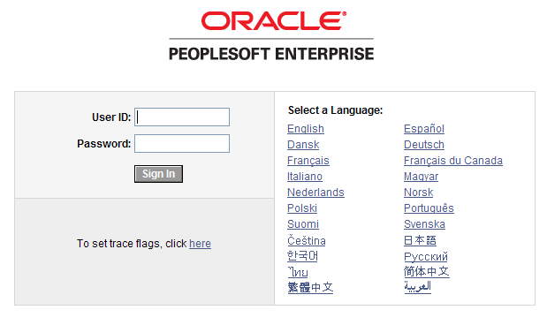
After entering your PeopleSoft User ID and Password, you can sign into the system. Remember, your User ID and Password are case sensitive. Also, if you attempt to sign-in five times with the incorrect login information, the system will lock you out. To unlock your account, notify your Local Security Administrator.
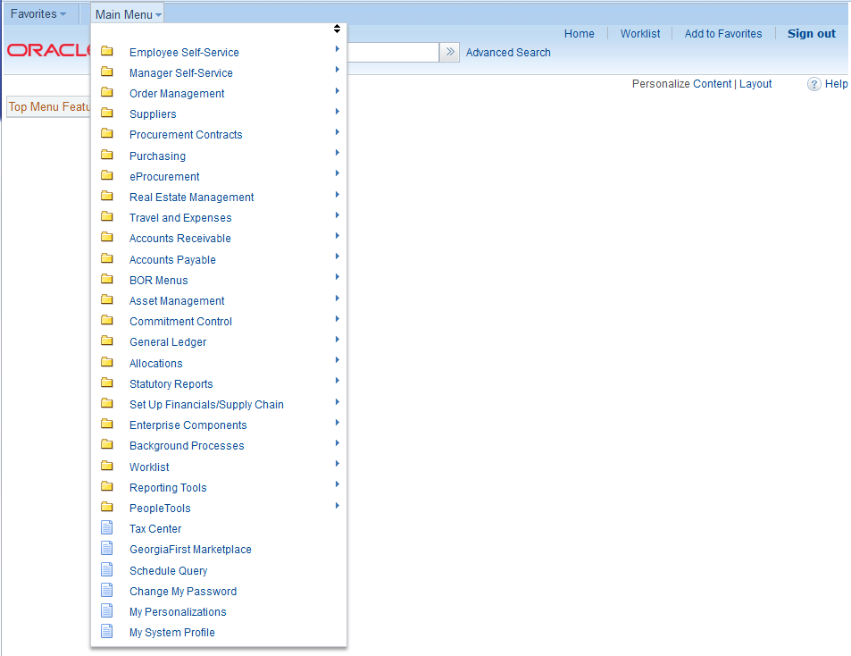
You can access the Worklist through either the link in the upper right corner of the page or in the Main Menu.
Reviewing Your Worklist
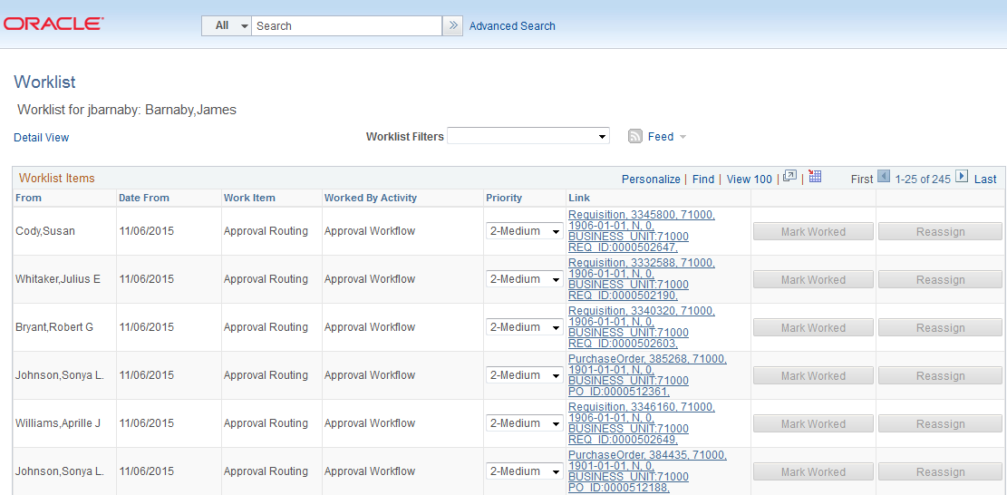
Your Worklist is separated into different columns. First, the person who submitted the requisition is listed in the “From” Column. The “Date From” column indicates when the requisition was submitted. The “Work Item” column indicates what action is required. The “Priority” column is not used. And the “Link” column displays the link to the Requisition needing approval. Note that the “Reassign” button has been inactivated on this page.
On your Worklist, you can sort the page by clicking on a column heading. For example, if you wanted to sort your Worklist by the Requester, you would click the “From” column heading.
In each Requisition link, there are certain pieces of information used to identify it. The link begins with the type of transaction needing approval, “Requisition” in the example below. Your institution’s Business Unit and the transaction ID is also listed. In the example, the Requisition ID is 0000502647. To go to the Requisition Approval page, simply click on that Requisition link.
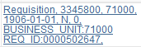
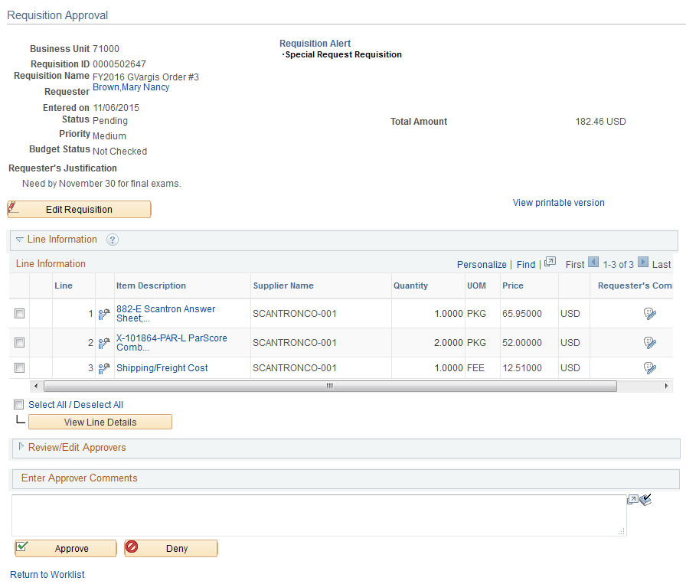
Here’s a brief description of what is on the Requisition Approval page:
- If the Requester gave the requisition a specific name, it will be listed. If not, the Requisition ID will be listed next to Req Name.
- The Requisition total amount is listed.
- The Requester is listed. If you select the Requester’s Name link, the system will display the Requester’s Name, Employee ID and Department.
- The date the Requisition was entered in the system is listed.
- The Requisition Status is listed.
  - Pending: The requisition is pending approval
- If the Requester entered any comments about the whole requisition, they will be listed next to Requester’s Justification.
- The Business Unit, Requisition ID, and Priority are also listed.
- For some approvers, the “Edit Requisition” button will be available above the Line Information section so that they can modify the requisition. After an approver modifies and saves the requisition, Workflow approvals may need to be restarted, depending on their role action security.
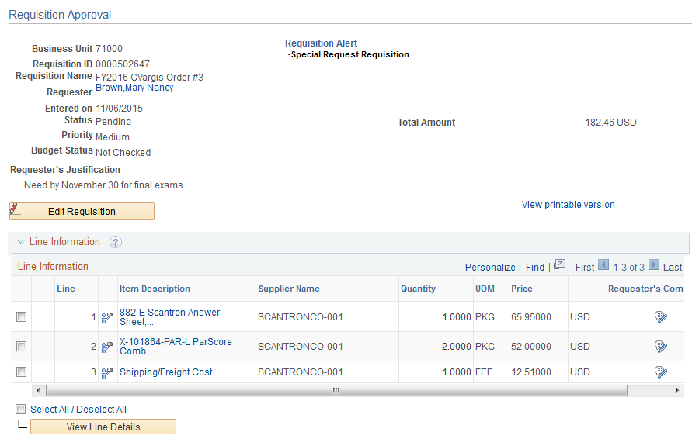
In the Line Information section, the system will display all requisition lines that you are required to act upon. The ‘clock’ icon indicates that the line is pending your approval.
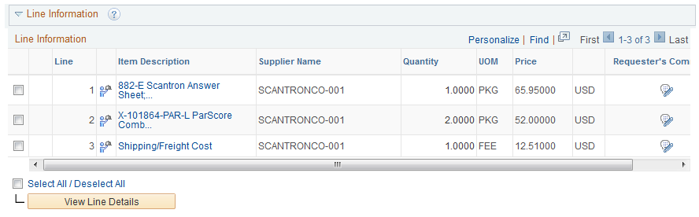
If you select the Item Description’s hyperlink in a line, the Item Description page is displayed.
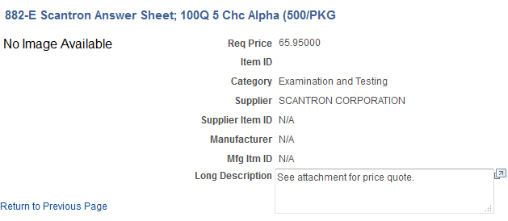
The Item Description page will list the item price, category, and supplier if listed. Select the “Return to Previous Page” link to return to the Requisition Approval page.
To see the line details, select the requisition line through its checkbox and then select the View Line Details button. You can select multiple lines at one time to view those line details simultaneously.
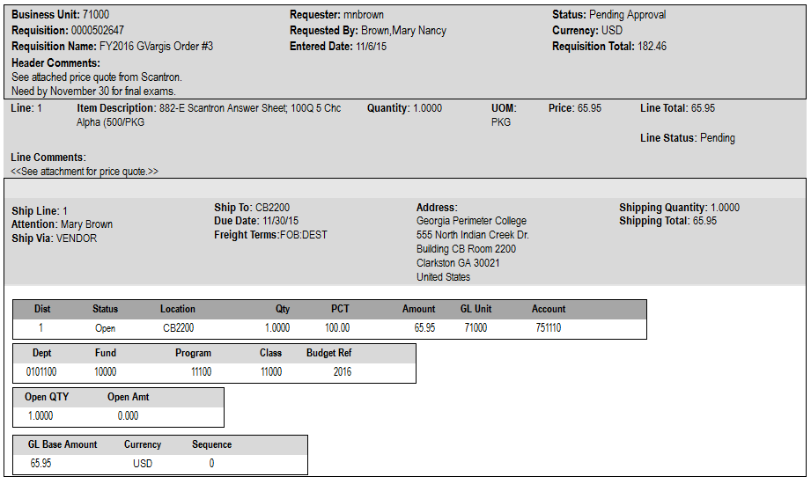
A new window will open and the shipping and distribution information will be displayed. You will be able to see the Chartfields that are charged for that requisition line. When you are done reviewing the line details, you can close the pop-up window.

The “Requester’s Comments” call-out icon appears for those lines that have line comments or attachments. To review these comments, you can select the call-out icon.
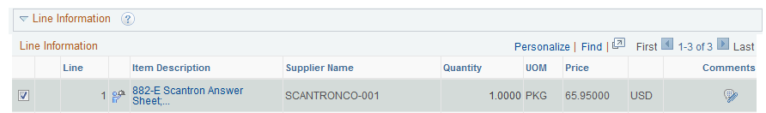
Here, you can review the line comments and attachments. To return to the line information, select the “Return to Previous Page” link.
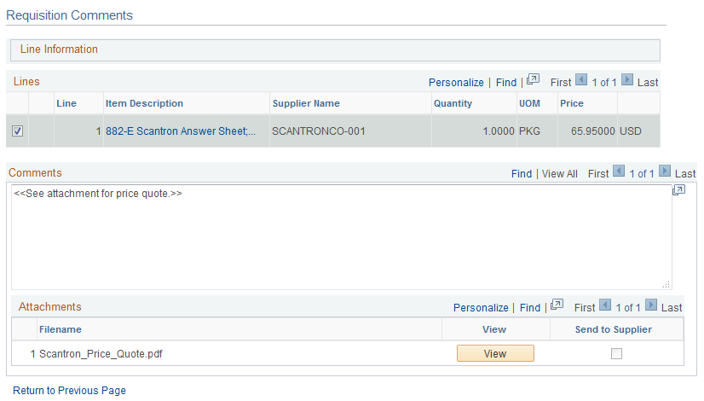
To see the approval path for a requisition, select the “expand” icon next to Review/Edit Approvers.
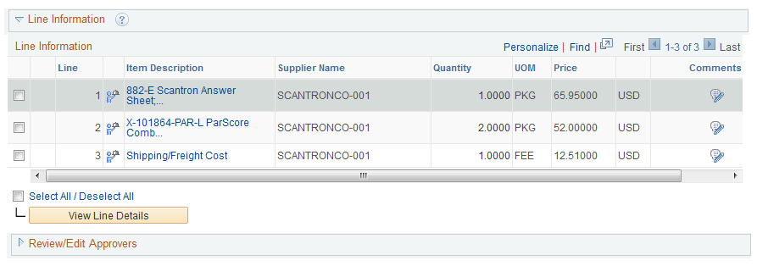
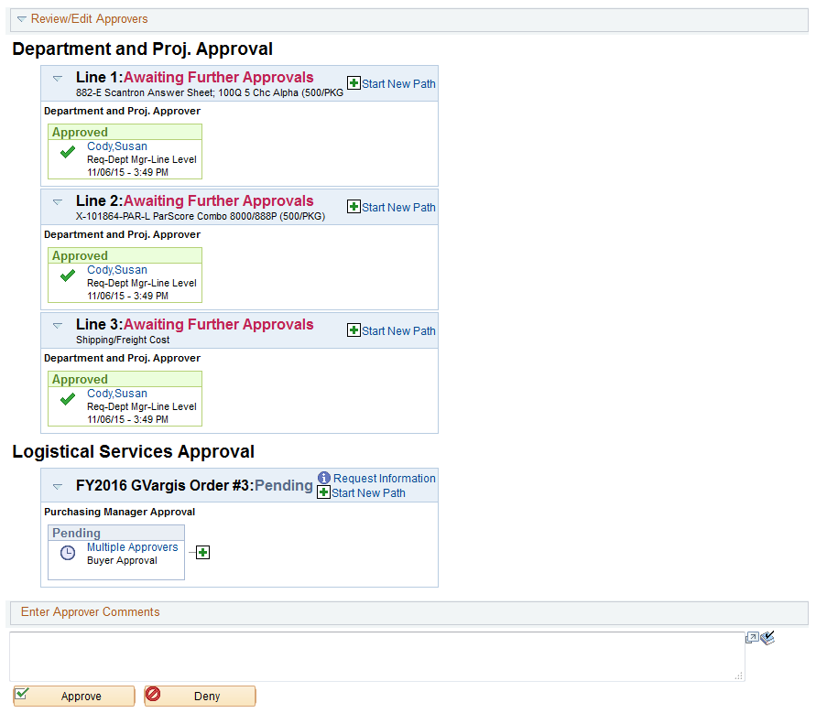
The Review/Edit Approvers section expands and lists all approvers that have acted or need to act on a requisition. In addition, there will be an approval path for each requisition line, since each line can have a different set of approvers depending on their Chartfields and item type.
Under the approval path, you can enter any comments that you wish to attach to the requisition. Do not include any slashes (/) in your comments.
When you are ready to act on the requisition, you can select your requisition lines and then click the Approve or Deny button.
Once approved, the Requisition Approval page should update indicating that you have completed your approval action.
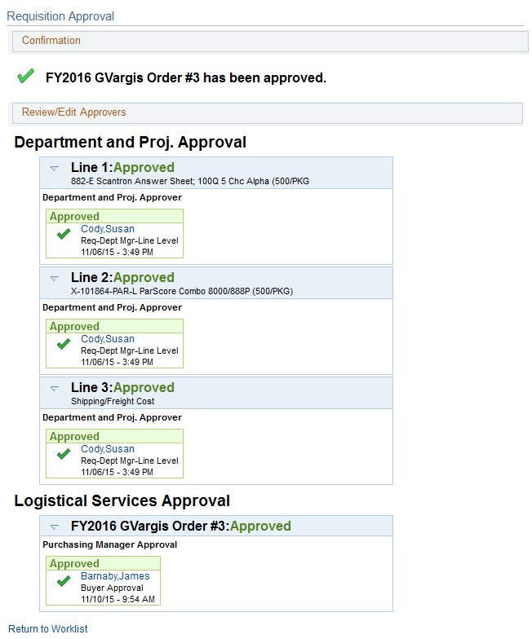
A requisition line will go to “approved” once all approvers have acted on it. Until then, the Requisition Status is still Pending.
To return to your Worklist to work another requisition, select the Return to Worklist link.

How to Access your Worklist
- Log into PeopleSoft Financials Core System with your User ID and Password.
- Click the Worklist hyperlink in the upper right corner of the home page.
- Click a Requisition link under the “link” column to display a requisition.
How to Approve a Requisition
- Select the requisition from your Worklist.
- Review each line item’s descriptions by clicking on the Item Description hyperlinks.
- Review each line item’s details by selecting them with a checkmark and clicking the View Line Details button.
- Review the approval path if desired. You can insert additional approvers if needed (see lesson #).
- Enter any comments you wish to add to the requisition. Do not include any slashes (/) in the comments field.
- Select the lines you want to approve with a checkmark and then click the Approve button.
- After receiving the approval confirmation, click the Return to Worklist link.
How to Deny a Requisition
- Select the requisition from your Worklist.
- Review each line item’s descriptions by clicking on the Item Description hyperlinks.
- Review each line item’s details by selecting them with a checkmark and clicking the View Line Details button.
- Review the approval path if desired.
- Enter comments explaining why you are denying the requisition. Do not include any slashes (/) in the comments field.
- Select the lines you want to deny with a checkmark and then click the Deny button.
- After receiving the denial confirmation, click the Return to Worklist link.

Ad Hoc Approvers
eProcurement gives you the ability to insert additional approvers if you feel it is necessary. After reviewing a requisition’s approval path, you can insert additional approvers if you have the BOR_AD_HOC_APPROVE security role.
While you are reviewing the approval path for a requisition, you can insert the ad hoc approver wherever you see a green plus sign (+).
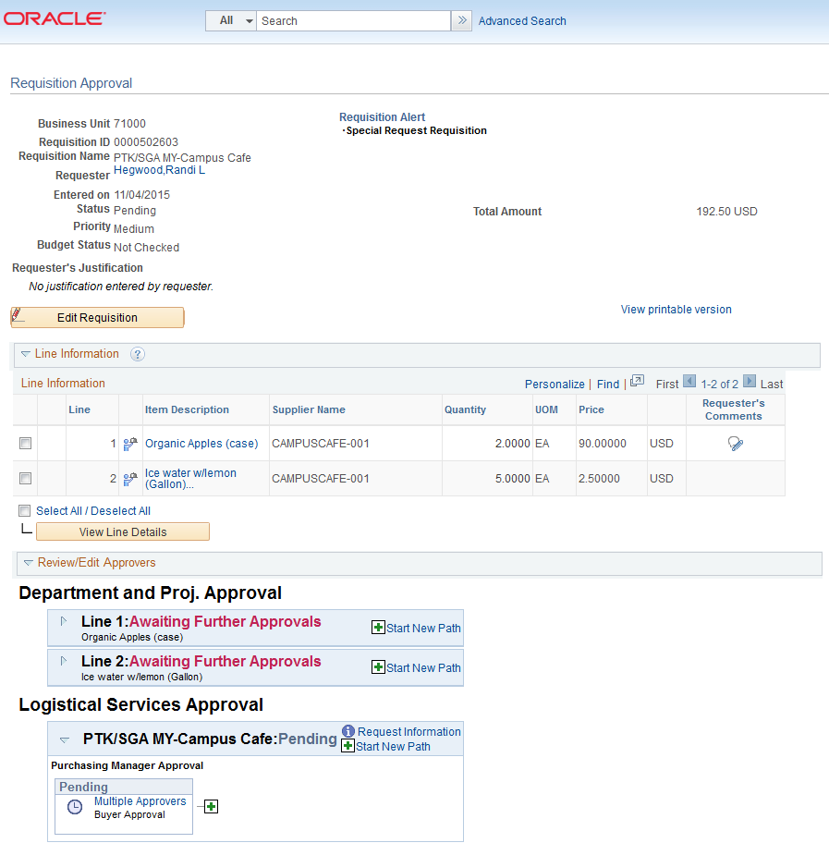
After clicking the green plus sign where you want to insert the additional approver, the system will display a pop-up box where you can select the ad hoc approver.
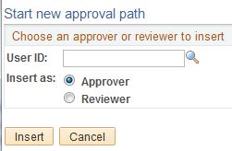
If you select the User ID look up icon, you will be able to search for the approver by User ID or by name. After selecting the additional approver, you can specify whether you want that approver to be inserted as an Approver or a Reviewer.
- Approver: If you select another person to be an approver, that person will be required to approve the requisition before it can move onto the next step.
- Reviewer: If you select another person to be a reviewer, that person will see the requisition in their Worklist, but they will not need to approve the requisition line.
If you have inserted an approver and then decide to remove them, you must do this before you approve the requisition.
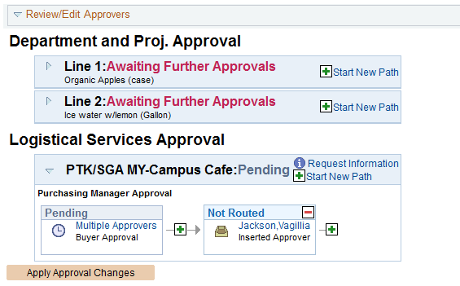
To remove a user you added as an Ad Hoc approver, select the red minus sign (-) in that person’s approval box.
When you insert another person in the approval path for a requisition, that user will need to proper ‘approver’ security setup in the system to work the requisition. If you unsure if the user has the correct security setup, contact that user and your Local Security Administrator.
How to Insert Ad Hoc Approver
- Select the requisition from your Worklist.
- Review each line item’s descriptions by clicking on the Item Description hyperlinks.
- Review each line item’s details by selecting them with a checkmark and clicking the View Line Details button.
- Review the approval path.
- Click the green plus sign (+) where you want to insert the ad hoc approver.
- Click the User ID look up icon in the pop-up window.
- Search for the name or User ID of the approver you want to add. Click on that person’s name.
- Select either Approver or Reviewer.
- Click the Insert button.
- Click the Apply Approval Changes button.
- Enter any comments you wish to add to the requisition. Do not include any slashes (/) in the comments field.
- Select the lines you want to approve with a checkmark and then click the Approve button.
- After receiving the approval confirmation, click the Return to Worklist link.

Requisition Push Back
All approvers can approve or deny a requisition that is submitted to them. Some approvers also have the ability to push a requisition back to the previous approver. This may be necessary if an approver has additional questions about a requisition. Initial approvers for a requisition will be unable to push back a requisition since there are no previous approvers in the approval path. Project approvers and inserted ad hoc approvers can use the push back function.
When you push back a requisition, it places that requisition back into a Pending status for that approval step. If you receive a requisition that was pushed back, you will be required to approve it again or deny it.
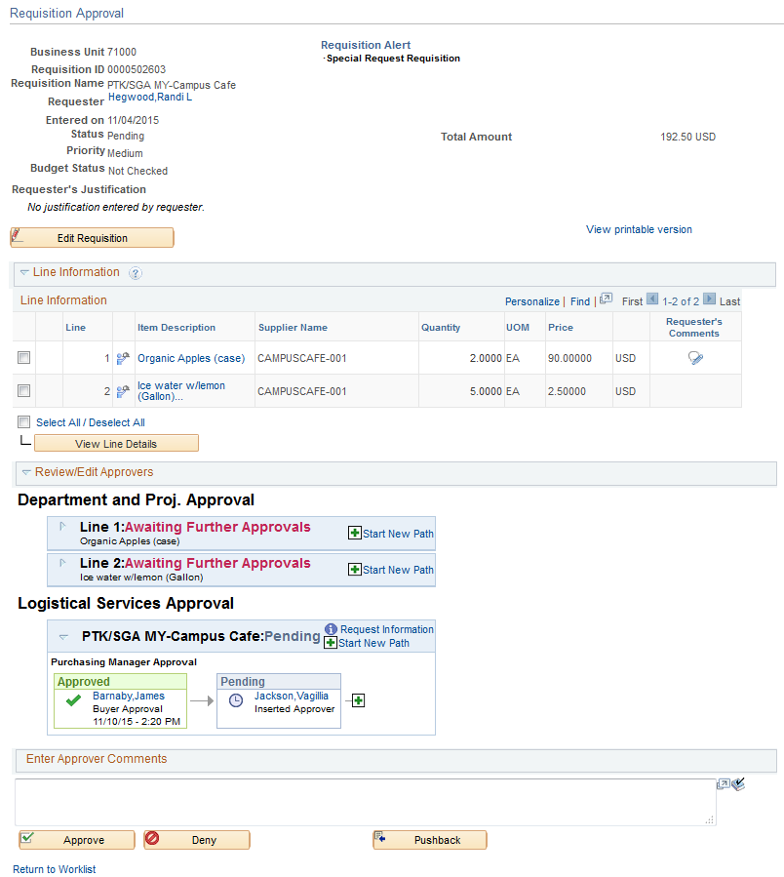
In the example above, you can see the Pushback button. As the approver Vagillia Jackson, you could push the requisition back to the first approver. When you push back a requisition, you will be required to enter comments explaining why you are pushing the requisition back. Do not include any slashes ( / ) in the comments field. After pushing it back, you will receive confirmation the requisition has been pushed back to the previous approver.
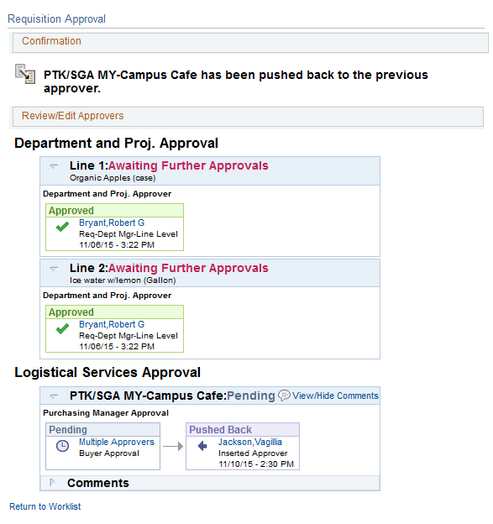
As the approver who receives a pushed back requisition, you will easily be able to see that it was pushed back and you can review the comments to determine why it was pushed back.
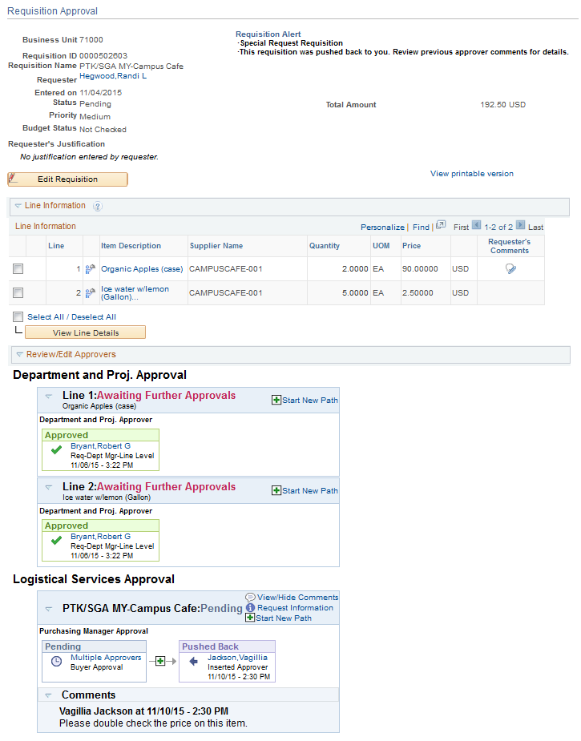
You can then perform the necessary actions and either approve or deny the requisition. If you approve it, it will proceed on the approval path.
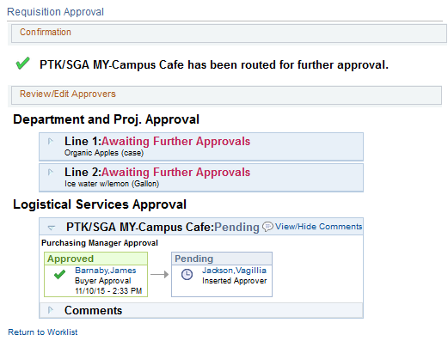
How to Push Back a Requisition to the Previous Approver
- Select the requisition from your Worklist.
- Review each line item’s descriptions by clicking on the Item Description hyperlinks.
- Review each line item’s details by selecting them with a checkmark and clicking the View Line Details button.
- Review the approval path if desired.
- Enter comments as to why you are pushing the requisition back to the previous approver. Do not include any slashes (/) in the comments field.
- Select the lines you want to push back with a checkmark and then click the Push Back button.
- After receiving the Push Back confirmation, click the Return to Worklist link.

Chapter 4: Worklist Maintenance
As a requisition approver, you are responsible for approving the purchase of items. If you are unable to perform this task due to the fact you may be out of the office on leave or out of town, you can assign an alternate approver while you are away.
Assigning an Alternate Approver
When you assign an alternate approver, you are telling the system that whenever your Worklist receives new requisitions to work, you want them routed to the alternate approver during the time frame specified. The system will then automatically forward any new Worklist items to your Alternate User during that specified time. You will not be able to reassign the items already in your Worklist.
When you specify the start and end dates for your alternate approver, the times that those dates go into effect begin at midnight. For example, imagine that you set up an alternate approver to take your requisitions from May 2, 2015 through May 7, 2015. Any new requisitions after 12:00 a.m. on May 2nd will automatically be routed to your alternate approver’s worklist. This will continue for all requisitions until 11:59 p.m. on May 7th. After that, the new requisitions will again route to your worklist.
You will need to work with your Local Security Administrator to ensure that the alternate approver you wish to assign has the proper security setup needed to work the requisitions. They will need the same approval authority that you have. Otherwise, they will not be able to access the requisition.
You set up your alternate approver through eProcurement > My Profile.
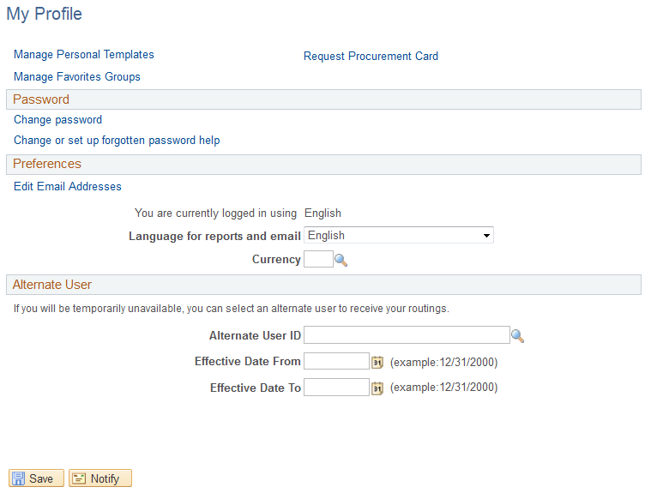
How to Assign an Alternate Approver
- In PeopleSoft Financials Core System, select eProcurement in the menu.
- Select My Profile.
- Select the Alternate User ID look up icon.
- Search for your alternate user by either User ID or name (Description).
- Select your alternate user by clicking on their User ID.
- Enter the Effective Date From.
- Enter the Effective Date To.
- Click the Save button.

Chapter 5: Contract Types
Even though the suppliers and items in the GeorgiaFIRST Marketplace are all contractually approved, it is helpful to know what the contract types are. There are six types of contracts in the GeorgiaFIRST Marketplace. These contract types are automatically mapped to a Purchase Order Type in PeopleSoft Financials.
If a single Purchase Order includes two contract types, the PO type is sent to “MUL” for multiple.
Contract Type | Custom Catalog Attribute | Order of Precedence | Purchase Order Type | Contract Number
Intergovernmental Agreement | Intergovernmental | 0 | IGA | Goes to the PO Line Item
Mandatory State Contract | Mandatory State Contract | 1 | SWCM | Goes to the PO Line Item
Agency Contract | Agency Contract | 2 | AC | Goes to the PO Line Item
Statutory Mandatory | Statutory Mandatory | 3 | MAN | Goes to the PO Line Item
Convenience State Contract | Convenience State Contract | 4a | SWCC | Goes to the PO Line Item
Statutory Preferred | Statutory Preferred | 4b | PRF | Goes to the PO Line Item

