USG Faculty Council Fall Meeting
October 26-27, 2023
Gordon State College

Parking – Attendees may park in Lot S-6 on the side of the Nursing and Allied Health Building (Building 46 on map). No parking permit needed. Additional parking in visitors lot V-1 across Spencer Street.

Meeting Location - Nursing and Allied Health Building Room 123.

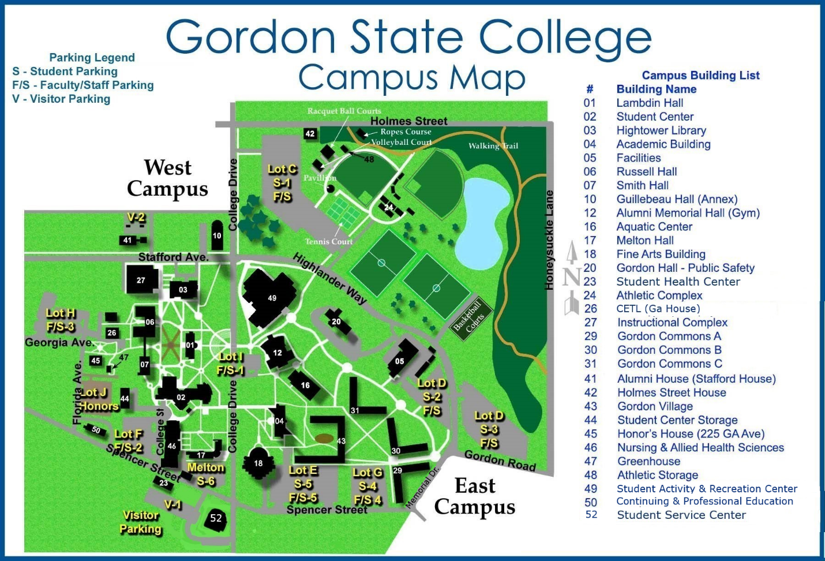

Link to interactive campus map

Lodging – Holiday Inn Express Forsyth – (478) 994 9697 Block of rooms reserved for USG Faculty Council at $104/night. Please make reservations at least one week prior to our meeting. Exit 186 off of I-75 – Immediately off interstate to the west. Approximately a 22 minute drive to campus (No traffic) via US HWY 41 to College Drive. Left on College. Right on Spencer, then one block to parking area and Nursing and Allied Health Building on the right.
Additional lodging at La Quinta Forsyth.

