**Corequisite Learning Support Manual**

**The University System of Georgia**

**May 18, 2023**

**Table of Contents**

1. Learning Support in the USG 3
2. Requirements for Institutions 17
3. Learning Support Coordinator 18
4. Corequisite Learning Support 19
5. Numbering of Corequisite Learning Support Courses 21
6. Mathematics Pathways and Aligned Mathematics Courses 24
7. Placement 25
8. Next-Generation Accuplacer Placement Tests 31
9. Differentiating Corequisite Learning Support Instruction for Diverse Students 33
10. Special Considerations for Corequisite Instruction in English 35
11. Special Considerations for Corequisite Instruction in Mathematics 40
12. Scheduling Considerations and Models 44
13. Class Sizes 49
14. Corequisite Course Setup in Banner 50
15. Other Banner Considerations 51
16. Entering Next-Generation Accuplacer Test Scores in Banner 51
17. Scheduling Two Sections in One Classroom 52
18. Restricting Enrollment in Corequisite Learning Support Sections to

Students with Corequisite Learning Support Requirements 54

1. Corequisite Learning Support Rules, Placement, and Documentation in Banner 55
2. Setting up Learning Support Sections in Banner 56
3. Setting up Learning Support Prerequisites for Collegiate Courses

in Banner 57

1. Data Collection 59
2. USG Policy on Learning Support 61
3. Academic and Student Affairs Handbook Guidelines on Learning Support 62
4. USG Policy on Students with Disabilities 63
5. Academic and Student Affairs Handbook Guidelines on Students with Mathematics Disabilities 64

Appendix 1 Fundamental Features of Corequisite Learning Support 65

Appendix 2 Banner 9 Quick Guide for Corequisite Courses 74

Updates and Corrections 84

**1.** **Learning Support in the University System of Georgia**

Learning Support is a generic term for programs designed for students who may need assistance to be successful in entry-level collegiate courses in English (reading and writing) and mathematics. As used in the University System of Georgia (USG), Learning Support is synonymous with what is often called developmental education, developmental studies, remediation, or remedial studies in other states and systems.

As it is currently conceived in the USG, Learning Support courses are “corequisite” courses that are paired with ENGL 1101 College Composition I, MATH 1001 Quantitative Reasoning, MATH 1101 Introduction to Mathematical Modeling, MATH/STAT 1401 Elementary Statistics, or MATH 1111 College Algebra.

Corequisite Learning Support offers the advantage that all students are enrolled in credit-bearing collegiate courses upon matriculation. Therefore, all students are immediately on a pathway to degree completion and are able to maintain their momentum as they progress toward graduation. Corequisite Learning Support will also save money for most students by not requiring them to take multiple levels of developmental (Learning Support) courses that do not count toward graduation.

The decision to mandate an exclusively corequisite approach to Learning Support was based on a number of factors. The first of these factors is what is sometimes referred to as “**chained attrition**.” Basically, the more courses in a sequence, the fewer students will make it through that sequence.

The USG used to offer Learning Support exclusively in prerequisite format, meaning that students had to complete these Learning Support courses before being allowed to take the collegiate courses in the same area. For students who enrolled in fall 2010, when Learning Support was offered almost exclusively through a prerequisite model, only 21% of students starting with Learning Support requirements passed their gateway collegiate courses in English and mathematics within 2 years.

Starting in 2015, the USG required that most students with Learning Support requirements begin with enrollment in Corequisite Learning Support courses while also enrolling in collegiate courses in the same area. At that time, however, institutions were still allowed to enroll their less-well-prepared students in prerequisite Learning Support courses, called “Foundations” courses. After completing the Foundations courses students were required to enroll in Corequisite Learning Support courses and collegiate courses in the same area.

Starting at the Foundations level, students encountered four potential attrition points:

1. Students who were told that they would have to enroll in Foundations Learning Support courses might decide not to enroll in college at all.
2. Students who enrolled in Foundations Learning Support might not pass that course.
3. Students who successfully completed Foundations Learning Support might not enroll in Corequisite Learning Support paired with a collegiate course.
4. Students who enrolled Corequisite Learning Support paired with a collegiate course might not pass the collegiate course, which is required to satisfy their Learning Support requirement.

Starting at the Corequisite level, students encounter only two potential attrition points:

1. Students who were told that they would have to enroll in Corequisite Learning Support courses while taking entry-level collegiate courses might decide not to enroll in college at all.
2. Students who enrolled in a Corequisite Learning Support course paired with a collegiate course might not pass the collegiate course, which is required to satisfy their Learning Support requirement.

**Chained Attrition**

Below are two illustrations (English and mathematics) of how chained attrition affects student persistence using USG data from students who first enrolled in fall 2016.

English

In fall 2016, 1387 students in the USG enrolled in Foundations Learning Support in English (ENGL 0989) and 1726 students enrolled in Corequisite Learning Support (ENGL 0999) while taking ENGL 1101.

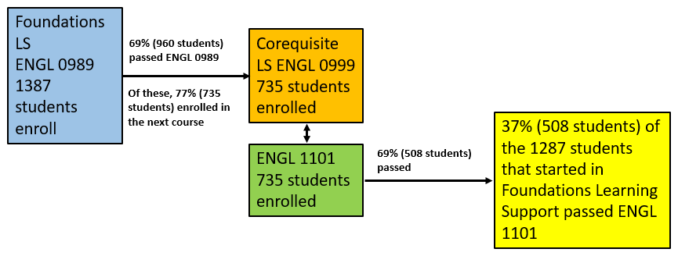

**652 students (47%) lost**

We do not know how many students decided not to enroll in a USG institution after being placed in Foundations-level Learning Support.

Of the 1387 students enrolled in Foundations-level English (ENGL 0989), 69% (960 students) passed ENGL 0989.

Of the 960 students who passed ENGL 0989, 77% (735 students) enrolled in ENGL 1101 with Corequisite Support in ENGL 0999 within a year of admission

Of the 735 students who enrolled in ENGL 1101 with Corequisite Learning Support, 69% (508 students) passed ENGL 1101 with a grade of “C” or higher within a year of admission.

Thus, of the 1387 students who enrolled in Foundations-level English in fall 2016, **37%** (508 students) passed ENGL 1101 within a year of admission, a cumulative attrition rate of nearly 3 out of 5 students.

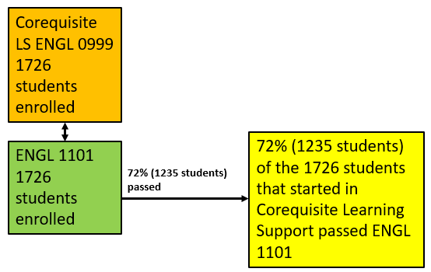

We do not know how many students decided not to enroll in a USG institution after being placed in ENGL 1101 with Corequisite Learning Support.

Of the 1726 students who enrolled in ENGL 1101 with Corequisite Learning Support in fall 2016, **72%** (1235 students) passed ENGL 1101 with a grade of “C” or higher within a year of admission.

Mathematics

In fall 2016 3585 students in the USG enrolled in Foundations Learning Support in mathematics (MATH 0987, 0988, or 0989) and 3490 students enrolled in Corequisite Learning Support (MATH 0997, 0998 or 0999) while taking entry-level collegiate math (MATH 1001, 1101, or 1111).

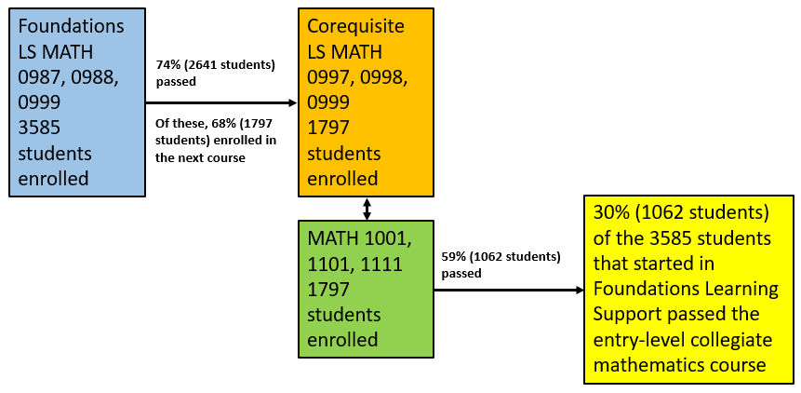

**1788 (50%) lost**

We do not know how many students decided not to enroll in a USG institution after being placed in Foundations-level Learning Support.

Of the 3585 students enrolled in Foundations-level mathematics (MATH 0987, 0988, or 0989), 74% (2641 students) passed the Foundations-level course.

Of the 2641 students who passed the Foundations course, 68% (1797 students) enrolled in MATH 1001, 1101, or 1111 with Corequisite Learning Support.

Of the 1797 students who enrolled in MATH 1001, 1101, or 1111 with Corequisite Learning Support, 59% (1062 students) passed the collegiate mathematics course with a grade of “C” or higher within a year of admission.

Of the 3585 students who enrolled in Foundations-level mathematics in fall 2016, **30%** (1062 students) passed entry-level collegiate mathematics within a year.

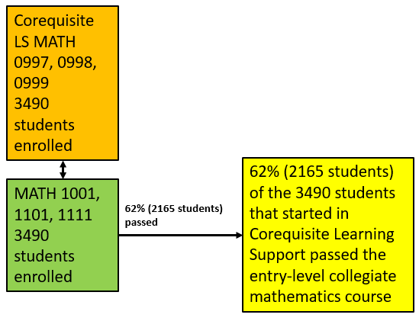

We do not know how many students decided not to enroll in a USG institution after being placed in an entry-level collegiate mathematics course with Corequisite Learning Support.

Of the 3490 students who enrolled in an entry-level mathematics course with Corequisite Learning Support in fall 2016, **62%** (2165) passed the collegiate mathematics course with a grade of “C” or higher within a year of admission.

Based on the data comparing collegiate course completion rates for students who started in Foundations-level Learning Support and students who started in a collegiate course with Corequisite Learning Support, a decision was made that Learning Support would only be offered as corequisite courses taken concurrently with collegiate courses in the same area starting in fall 2018.

Even if our success rates dipped somewhat by putting all students directly into Corequisite Learning Support and a collegiate course, they would have to drop a very long way to be as low as experienced with prerequisite Learning Support as a starting point.

Corequisite Learning Support was implemented “at scale” (meaning that most students requiring Learning Support had to be placed in Corequisite Learning Support) in fall 2015. Success rates in collegiate gateway courses for students with Corequisite Learning Support requirements were nearly as high as success rates for students without Learning Support requirements.

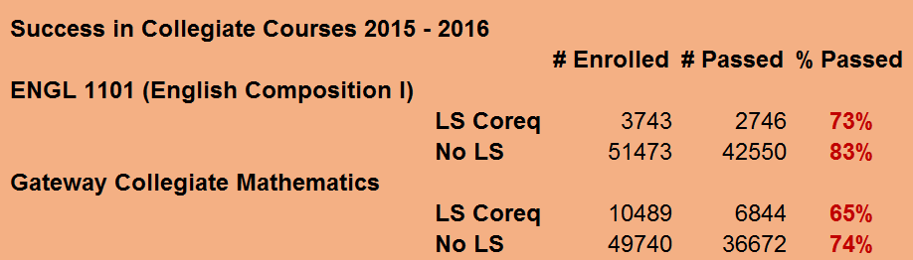

While the higher success rate of students starting in Corequisite Learning Support could be a result of these students starting out more prepared than the students who started in Foundations Learning Support, USG data showed that students at all levels of preparation were more likely to complete and pass a Gateway Collegiate course (ENGL 1101, MATH 1001, 1101, or 1111) if they started in Corequisite Learning Support than if they started in Foundations-level Learning Support. Regardless of the measure used to determine student preparation -- SAT scores, ACT scores, or high school grade point average -- the results were similar for both English and mathematics.

**Success in Gateway Courses by Academic Preparation as Defined by SAT Scores**

**English**

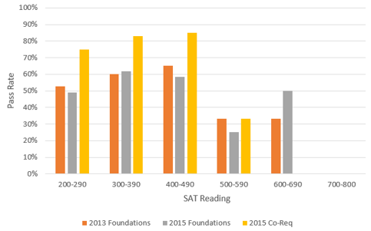

**Mathematics**

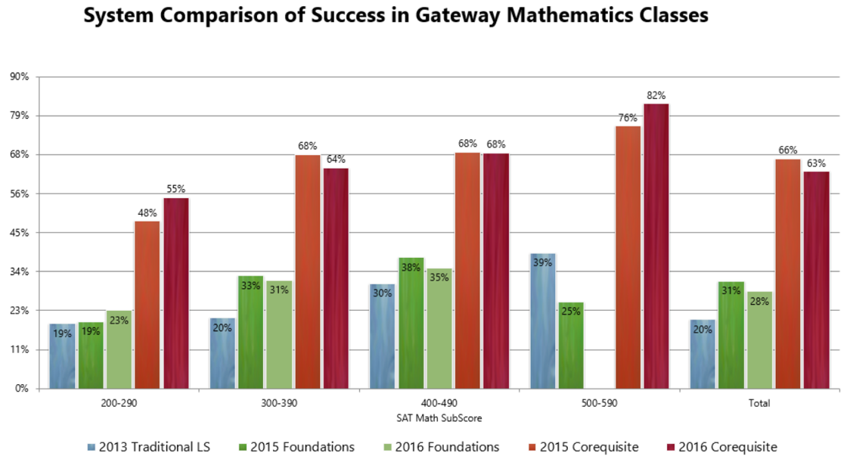

**Success in Gateway Courses by Academic Preparation as Defined by ACT Scores**

**English**

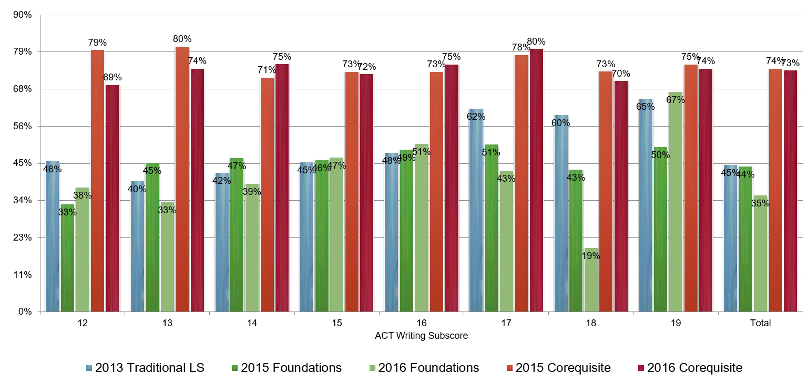

**Mathematics**

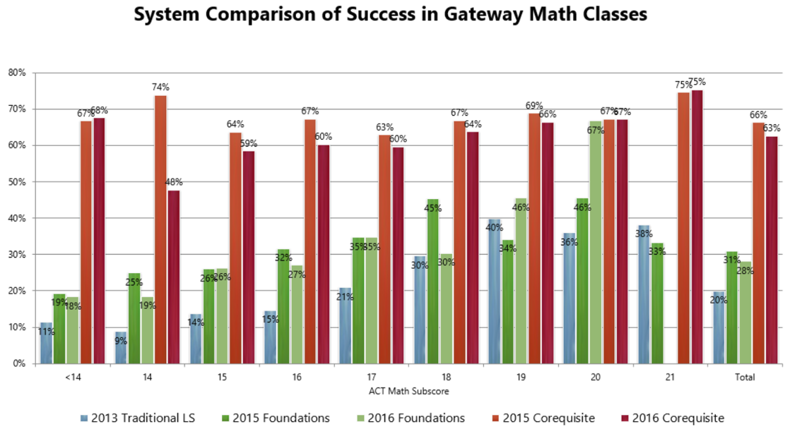

**Success in Gateway Courses by Academic Preparation as Defined by High School Grade Point Average**

**English**

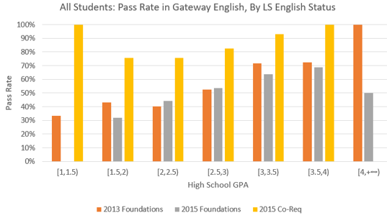

**Mathematics**

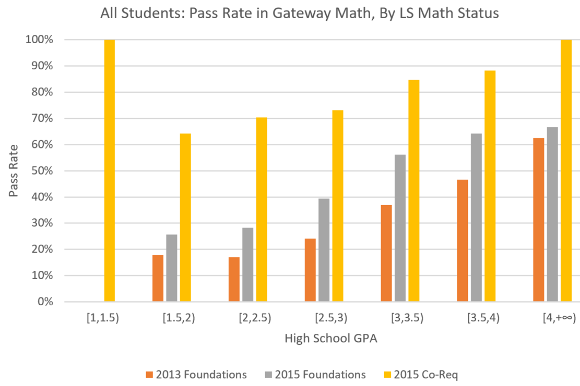

**Move to Fully Corequisite Learning Support – Fall 2018**

Beginning in fall 2018, USG institutions only offered Learning Support courses in a corequisite format. This meant that the less prepared students who had previously been placed in Foundations-level Learning Support were now placed in Corequisite Support sections.

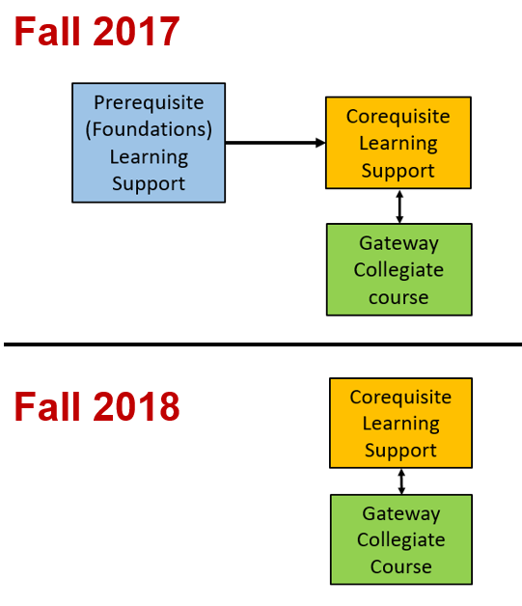

As a result of this shift, it was expected that success rates in the paired collegiate courses would dip. They did not. Success rates in paired collegiate courses in fall 2018 equalled or exceeded success rates in fall 2017, when the less prepared students were placed in Foundations courses.

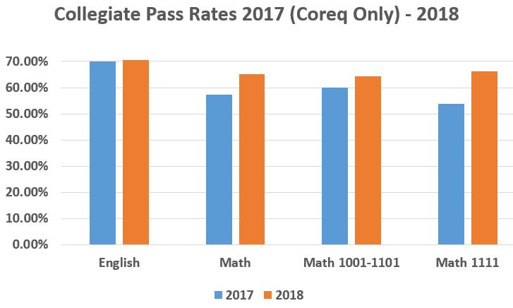

Students enrolled in corequisite support at all levels of preparation succeeded in their collegiate English and mathematics courses in fall 2018 at rates comparable to those before the shift to fully-scaled corequisite instruction.

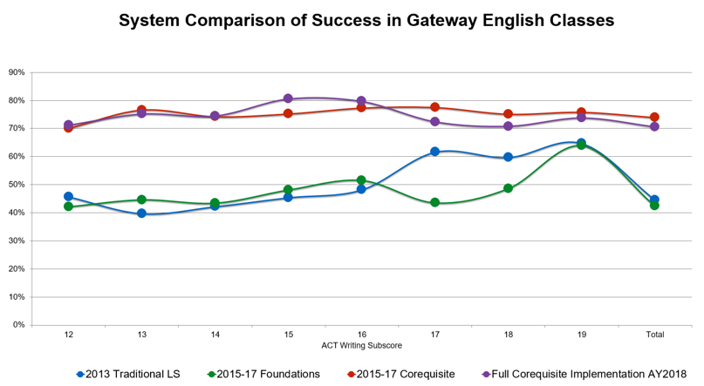

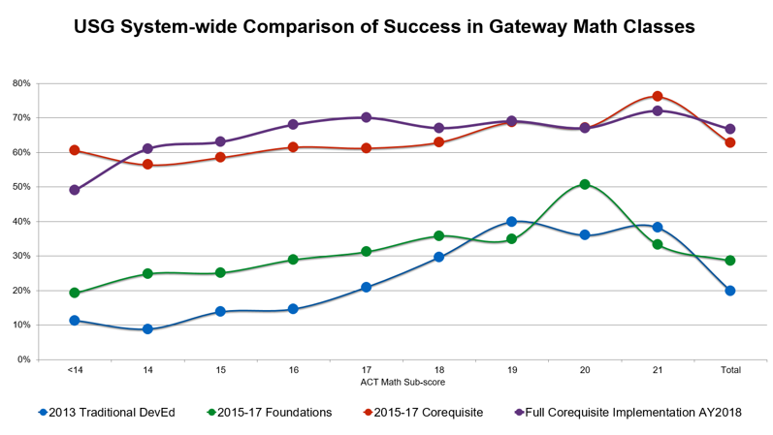

**Equity**

Do students from all racial groups benefit from the move to fully corequisite Learning Support? The answer appears to be “yes.” The next two graphs show the system-wide comparison of success in gateway English and mathematics courses for students enrolled in Corequisite Support at all levels of preparation disaggregated by race and ethnicity.

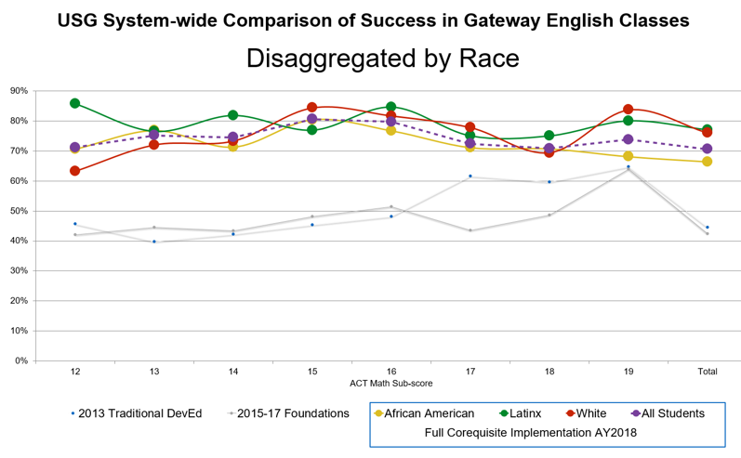

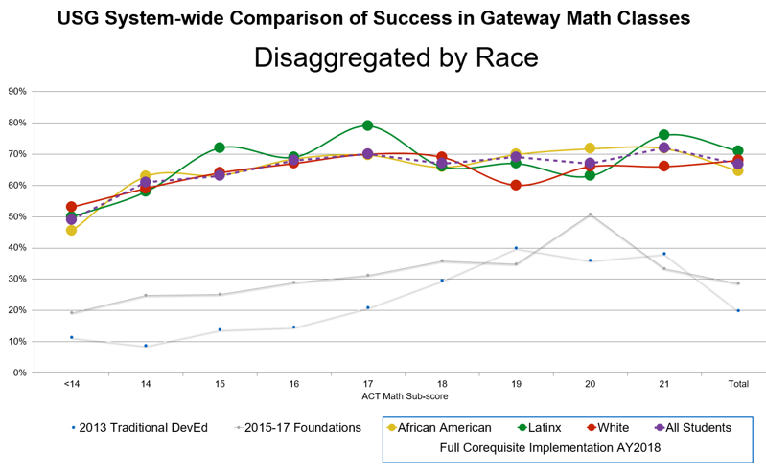

**Analysis of Student Success in “Follow-on” Courses**

Analysis of student success in “follow-on” collegiate courses also demonstrates the efficacy of the Corequisite Learning Support model in supporting and sustaining student success. Follow-on courses are courses that students take after completing the entry-level collegiate courses in English or mathematics and are an important component of progression toward degree completion.

For English, the follow-on course for ENGL 1101 is ENGL 1102. The percentages of student passing ENGL 1102 with grades of A, B, or C were compared for students who took ENGL 1101 with and without Corequisite Learning Support. For the cohort of students admitted in fall 2016, the ENGL 1102 pass rates for students who took ENGL 1101 with Corequisite Learning Support were close to those of students who took ENGL 1101 without Corequisite Learning Support, although slightly lower.

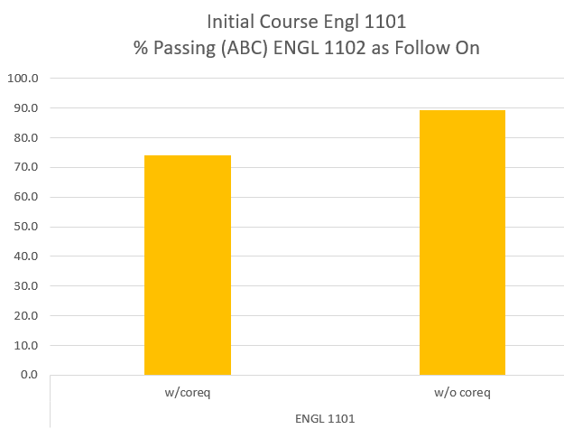

In mathematics, the entry-level collegiate courses were MATH 1001, 1101, and 1111 and the possible follow-on courses are MATH 1111 (for students entering in MATH 1001 or 1101), 1113 (for students entering in MATH 1111), or statistics.

The percentages of students passing MATH 1111 or statistics (as follow-on courses) with grades of A, B, or C were compared for students who took MATH 1001 or 1101 (combined) with and without Corequisite Learning Support. For the cohort of students admitted in fall 2016, the pass rates in the follow-on mathematics courses for students who took MATH 1001 or 1101 with Corequisite Learning Support were lower than, but close to those of students who took these courses without Corequisite Learning Support.

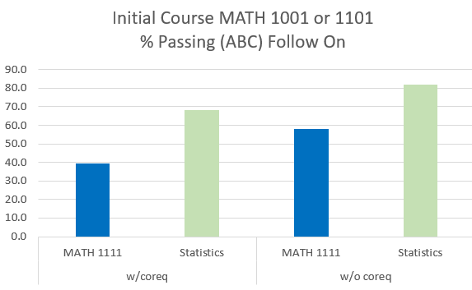

The percentages of students passing MATH 1113 or statistics (as follow-on courses) with grades of A, B, or C were compared for students who took MATH 1111 with and without Corequisite Learning Support. For the cohort of students admitted in fall 2016, the pass rates in the follow-on mathematics courses for students who took MATH 1111 with Corequisite Learning Support were lower than, but close to those of students who took these courses without Corequisite Learning Support.

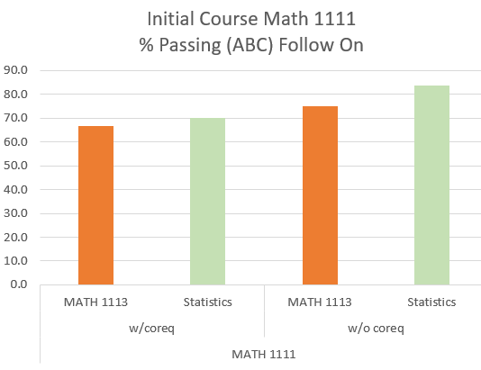

**2.** **Requirements for Institutions**

## Institutions that admit students with high school grade point averages (HSGPA) or standardized test scores indicating that they will require additional support to succeed in collegiate English or mathematics courses must offer Corequisite Learning Support courses in these areas.

## Institutions that admit students requiring Learning Support in English or mathematics must designate a Learning Support Coordinator.

## Institutions must use A, B, C, F grading in the Corequisite Learning Support courses.

**3.** **Learning Support Coordinator**

Institutions that admit students requiring Learning Support in English or mathematics must designate a Learning Support Coordinator.

## The duties of the Learning Support Coordinator must include (but are not limited to):

## Ensuring that appropriate Corequisite Learning Support courses are provided for all students requiring Learning Support.

## Coordinating with institutional admissions, the testing center, and academic departments as needed regarding placement, and ensuring that all students are appropriately placed.

## Ensuring that Learning Support placement and progress are accurately recorded and tracked in Banner.

## Ensuring that the fundamental features of Corequisite Learning Support are fully implemented at the institution.

## Ensuring that Corequisite Learning Support courses are carefully and appropriately aligned with the college level courses they are intended to support.

## Providing or coordinating training of institutional faculty, staff, and administrators as needed to ensure appropriate implementation of the Corequisite Learning Support model.

**4.** **Corequisite Learning Support**

## Learning Support courses are to be offered exclusively in “corequisite” format. The corequisite format means that students requiring Learning Support will enroll in both a collegiate course (ENGL 1101, MATH 1001, MATH 1101, MATH/STAT 1401, or MATH 1111) and a Corequisite Support course that is designed to support mastery of the skills and concepts needed to pass the collegiate course in a “just-in-time” manner.

Each Corequisite Learning Support course will be a required course that is aligned with and offered alongside the appropriate college-level course and should be designed specifically to help students master the skills and knowledge required for success in the linked college-level course. Institutions must ensure that Corequisite Learning Support sections are designed to meet the needs of students in the collegiate course and provide more than study hall, homework help, or tutoring.

The college-level and Corequisite Learning Support sections must be carefully coordinated. In particular, the college-level and Corequisite Learning Support sections must cover the same topics in the same order at the same time. In practical terms, this may mean that institutions will have to specify the order and timing of topic coverage for ALL Corequisite Learning Support sections and ALL college-level sections that include students with Learning Support requirements.

## Students will exit Learning Support (LS) requirements in English and/or mathematics by passing the college-level course in the Learning Support area with a grade that satisfies the minimum grade requirement for the collegiate course at that institution (typically a “C” or higher). Students must enroll in both the Corequisite Learning Support course and the collegiate course every semester until they pass the collegiate course, even if they have passed the Corequisite Learning Support course one or more times.

Paired college-level course sections may have only students with LS requirements (cohort model) or a mix of students with and without LS requirements (comingled model). When a college-level course section contains only students with LS requirements (cohort model), care should be taken to ensure that the section adheres to the same academic standards as sections containing a mix of students with and without LS requirements or sections containing only students without LS requirements.

Institutions must establish consistent standards for sections of ENGL 1101, MATH 1001, MATH 1101, MATH/STAT 1401, and MATH 1111. The college-level course sections that students with LS requirements enroll in must be identical to those taken by students who do not have LS requirements. **No elements of the Corequisite Learning Support experience will contribute to the grade earned in the college-level course.**

Although exit from LS requirements is determined by the grade earned in the collegiate course, institutions should make every effort to ensure that students attend the Corequisite Learning Support course and take the work of the Corequisite Support course seriously.

Students wishing to drop or withdraw from either the Corequisite Learning Support or linked college-level courses will be required to drop or withdraw from BOTH courses.

Students requiring Learning Support in both English and mathematics may defer enrollment in Corequisite Learning Support and the paired collegiate course in one or the other area but must be continuously enrolled in one or both pairs until the college-level courses have been passed. In cases where students cannot take courses in both Learning Support areas simultaneously, enrollment in ENGL 1101 with Corequisite Learning Support should take priority. All Area A requirements for collegiate English and mathematics and Corequisite Learning Support English and mathematics courses must be completed by the time students have completed 30 collegiate credit hours. Hours in Corequisite Learning Support courses do not count toward the 30 collegiate credit hours.

**5.** **Numbering of Corequisite Learning Support Courses**

Institutions must use the standard prefixes, numbers, titles, and course descriptions as listed below for the Corequisite Learning Support courses.

**ENGL 0999** Support for English Composition (1-3 institutional credit hours)

**Prerequisites:** None

**Corequisite:** ENGL 1101 English Composition I

**Description:** This Learning Support course provides corequisite support in reading and writing for students enrolled in ENGL 1101 – English Composition I. Topics will parallel those being studied in ENGL 1101 and the course will provide support for the essential reading and writing skills needed to be successful in ENGL 1101. Taken with ENGL 1101, this is a composition course focusing on skills required for effective writing in a variety of contexts, with emphasis on exposition, analysis, and argumentation, and also including introductory use of a variety of research skills.

**MATH/STAT 0996** Support for Elementary Statistics (1-3 institutional credit hours)

**Prerequisites:** None

**Corequisite:** MATH/STAT 1401 Elementary Statistics

**Description:** This Learning Support course provides corequisite support for students enrolled in MATH/STAT 1401 – Elementary Statistics. Topics will parallel topics being studied in MATH/STAT 1401 and the course will provide support for the essential skills needed to be successful in MATH/STAT 1401. Taken with MATH/STAT 1401, topics to be covered will include descriptive statistics, probability theory, confidence intervals, hypothesis testing, and other selected statistics topics.

**MATH 0997** Support for Quantitative Reasoning (1-3 institutional credit hours)

**Prerequisites:** None

**Corequisite:** MATH 1001 Quantitative Reasoning

**Description:** This Learning Support course provides corequisite support in mathematics for students enrolled in MATH 1001 – Quantitative Reasoning. Topics will parallel topics being studied in MATH 1001 and the course will provide support for the essential quantitative skills needed to be successful in MATH 1001. Taken with MATH 1001, topics to be covered will include logic, basic probability, data analysis and modeling from data.

**MATH 0998** Support for Mathematical Modeling (1-3 institutional credit hours)

**Prerequisites:** None

**Corequisite:** MATH 1101 Introduction to Mathematical Modeling

**Description:** This Learning Support course provides corequisite support in mathematics for students enrolled in MATH 1101 – Introduction to Mathematical Modeling. Topics will parallel topics being studied in MATH 1101 and the course will provide support for essential quantitative skills needed to be successful in MATH 1101. Taken with MATH 1101, this course is an introduction to mathematical modeling using graphical, numerical, symbolic, and verbal techniques to describe and explore real-world data and phenomena. Emphasis is on the use of elementary functions to investigate and analyze applied problems and questions, supported by the use of appropriate technology, and on effective communication of quantitative concepts and results.

**MATH 0999** Support for College Algebra (1-3 institutional credit hours)

**Prerequisites:** Credit for MATH 1001, MATH 1101 or MATH/STAT 1401 with a “passing” grade (as defined by institution, typically “C” or higher) OR high school GPA 3.2 or higher OR ACT Mathematics score of 17 or higher OR “old” SAT Mathematics score of 400 or higher OR “new” SAT Math section score of 440 or higher OR Accuplacer Elementary Algebra score of 67 or higher OR Accuplacer Next-Generation Quantitative Reasoning, Algebra, and Statistics score of 258 or higher. [Institutions may set higher prerequisites for enrollment in MATH 1111 with corequisite support.]

**Corequisite:** MATH 1111 College Algebra

**Description:** This Learning Support course provides corequisite support in mathematics for students enrolled in MATH 1111 – College Algebra. Topics will parallel topics being studied in MATH 1111 and the course will provide support for the essential quantitative skills needed to be successful in MATH 1111. Taken with MATH 1111, this course provides an in-depth study of the properties of algebraic, exponential and logarithmic functions as needed for calculus. Emphasis is on using algebraic and graphical techniques for solving problems involving linear, quadratic, piece-wise, defined, rational, polynomial, exponential and logarithmic functions.

Different sections of Corequisite Learning Support courses may be tailored for specific groups and offered for different amounts of credit (up to 3 hours of institutional credit), and tuition may be charged accordingly. Sections at different levels of support should be distinct (i.e., students requiring a three-credit corequisite course should not be enrolled in the same Learning Support section as students requiring a one-credit corequisite course). At institutions offering Corequisite Learning Support courses at multiple levels of credit intensity, course number suffixes A, B, and C will be used to designate courses with different credit hours. Examples:

|  |  |
| --- | --- |
| **Corequisite Support for**  **ENGL 1101 – English Composition I** | **Corequisite Support for**  **MATH 1001 – Quantitative Reasoning** |
| ENGL 0999A – 3 credit hours  ENGL 0999B – 2 credit hours  ENGL 0999C – 1 credit hour | MATH 0997A – 3 credit hours  MATH 0997B – 2 credit hours  MATH 0997C – 1 credit hour |
|  | **Corequisite Support for**  **MATH 1101 – Introduction to Mathematical Modeling** |
|  | MATH 0998A – 3 credit hours  MATH 0998B – 2 credit hours  MATH 0998C – 1 credit hour |
|  | **Corequisite Support for MATH/STAT 1401 – Elementary Statistics** |
|  | MATH/STAT 0996A – 3 credit hours  MATH/STAT 0996B – 2 credit hours  MATH/STAT 0996C – 1 credit hour |
|  | **Corequisite Support for**  **MATH 1111 – College Algebra** |
|  | MATH 0999A – 3 credit hours  MATH 0999B – 2 credit hours  MATH 0999C – 1 credit hour |

## Institutions offering only one level of Learning Support do not need to use the identifier suffixes described above.

**6.** **Mathematics Pathways and Aligned Mathematics Courses**

For students who are **not** enrolled in a STEM or business program, or a field requiring an algebra-intensive course, the linked mathematics courses will be either:

MATH/STAT 0996 Support for Elementary Statistics with MATH/STAT 1401 Elementary Statistics

OR

MATH 0997 Support for Quantitative Reasoning with MATH 1001 Quantitative Reasoning

OR

MATH 0998 Support for Mathematical Modeling with MATH 1101 Introduction to Mathematical Modeling.

Any student may enroll in these courses.

For students enrolled in programs witha calculus or algebra-intensive mathematics requirement, the linked mathematics courses will be:

MATH 0999 Support for College Algebra with MATH 1111 College Algebra.

**Special requirements for MATH 0999 and 1111:** Students must meet placement criteria (outlined below) for direct placement into MATH 1111 or placement into MATH 1111 with corequisite support.

Additional information on Mathematics Pathways in the USG may be found at

<http://www.completecollegegeorgia.org/math-pathways>.

**7.** **Placement**

## The “default placement” for all students will be in an entry-level collegiate course with Corequisite Learning Support UNLESS students meet exemption criteria (for Corequisite Support) as outlined below in the sections on English and mathematics.

## Students who do not meet any exemption criteria may waive placement testing if they are willing to accept placement in Corequisite Learning Support at the highest level of credit intensity (the most credits) offered at the institution.

## For mathematics, students who do not meet any exemption criteria must be placed in MATH 1001 Quantitative Reasoning, MATH 1101 Introduction to Mathematical Modeling, or MATH/STAT 1401 Elementary Statistics with Corequisite Learning Support at the highest level of credit intensity offered at the institution.

## All students must be made aware that they have the OPTION to take placement tests, which may place them directly into collegiate courses or into less credit-intensive levels of Corequisite Learning Support. Students interested in taking placement tests should not be discouraged from doing so.

## When placement testing is needed, Next-Generation Accuplacer placement tests should be used. Placement testing with Next-Generation Accuplacer placement tests is described in more detail in the next section (8. Next-Generation Accuplacer Placement Tests).

## Exception: students wishing to enroll in MATH 1111 College Algebra (with or without Corequisite Learning Support) must take the mathematics placement test unless they have already met the criteria for direct placement into MATH 1111 or MATH 1111 with Corequisite Learning Support (see below).

## English

## All entering students will be enrolled in ENGL 1101 English Composition I and the Corequisite Learning Support course, ENGL 0999 Support for English Composition, unless they meet one of the exemption criteria listed below or are enrolled in a program for which ENGL 1101 is not required. If students enroll in programs that do not require ENGL 1101, but they choose to take this course, standard assessment and placement rules will apply.

The exemption criteria below apply to the requirement to enroll in the Corequisite Learning Support course, not to the ENGL 1101 course requirement. Institutions may set higher exemption criteria.

Students meeting any of the criteria on the list below may enroll in ENGL 1101 without the Corequisite Learning Support course, ENGL 0999:

* Student already has credit for an Area A English course (must meet the minimum grade requirement for the course at the institution – which may be a “C” or higher).
* Student has an English Placement Index of 4230 or higher.*
* Student has a final high school GPA (HSGPA – this is the same HSGPA that is used in calculation of the Freshman Index) of 2.7 or higher and has completed the Required High School Curriculum (RHSC) in English. If the RHSC in English has not been completed, HSGPA may not be used to exempt this requirement.
* Student has an ACT English or Reading score of 17 or higher.
* Student has an SAT Verbal/Critical Reading score of 430 or higher on the “old” SAT.
* Student has a score of 480 or higher on the “new” SAT Evidence-Based Reading and Writing (EBRW) section. **
* Student has a Classic Accuplacer Reading Comprehension score of 61 or higher AND an Accuplacer WritePlacer score of 4 or higher.
* Student has an Accuplacer Next-Generation Reading score of 237** or higher AND an Accuplacer WritePlacer score of 4 or higher.

* At the institution’s option, the English Placement Index (EPI) may continue to be used for students who have at least two of the following: 1) High school grade point average, 2) (Old) SAT or ACT scores, 3) Classic Accuplacer scores.

** “New” SAT scores and Next-Generation Accuplacer Reading test scores may not be used to calculate the English Placement Index.

## Mathematics

All entering students will be enrolled in one of four standard Area A college-level credit-bearing mathematics courses (MATH 1001 Quantitative Reasoning, MATH 1101 Introduction to Mathematical Modeling, MATH/STAT 1401 Elementary Statistics, or MATH 1111 College Algebra) and a Corequisite Learning Support course unless they meet one of the exemption criteria listed below or are enrolled in a program for which a mathematics course is not required. If students enroll in programs that do not require a mathematics course, but they choose to take a mathematics course, standard assessment and placement rules will apply.

Note that MATH 1111 has higher placement and exemption criteria than MATH 1001, MATH 1101, and MATH/STAT 1401.

The exemption criteria below apply to the requirement to enroll in a Corequisite Learning Support course, not to the college-level mathematics course requirement. Institutions may set higher exemption criteria.

**MATH 1001 Quantitative Reasoning and**

**MATH 1101 Introduction to Mathematical Modeling and**

**MATH/STAT 1401 Elementary Statistics**

Students meeting any of the criteria on the list below may enroll in MATH 1001, MATH 1101, or MATH/STAT 1401 without the corequisite Learning Support courses, MATH /STAT 0996, MATH 0997 or MATH 0998:

* Student already has credit for an Area A mathematics course (must meet the minimum grade requirement for the course at the institution – which may be a “C” or higher).
* Student has a Mathematics Placement Index of 1165 or higher. *
* Student has placed in Pre-Calculus or a higher mathematics course (e.g., College Trigonometry or some form of calculus).
* Student has a high school GPA (HSGPA – this is the same HSGPA that is used in calculation of the Freshman Index) of 3.1 or higher and has completed the Required High School Curriculum (RHSC) in mathematics. If the RHSC in mathematics has not been completed, HSGPA may not be used to exempt this requirement.
* Student has an ACT Mathematics score of 17 or higher.
* Student has an SAT Mathematics score of 400 or higher on the “old” SAT.
* Student has an SAT Math section score of 440 or higher on the “new” SAT. **
* Student has a Classic Accuplacer Elementary Algebra score of 67 or higher.
* Student has an Accuplacer Next-Generation Quantitative Reasoning, Algebra, and Statistics score of 258** or higher.

* At the institution’s option, the Mathematics Placement Index (MPI) may continue to be used for students who have at least two of the following: 1) High school grade point average, 2) (Old) SAT or ACT scores, 3) Classic Accuplacer scores.

** “New” SAT scores and Next-Generation Accuplacer scores may not be used to calculate Mathematics Placement Indices (MPI).

**MATH 1111 College Algebra**

***Students who do not qualify for initial enrollment in MATH 1111 (with or without corequisite Learning Support) may enroll in MATH 1001 or MATH 1101 (with or without corequisite support) and may later enroll in MATH 1111 after successfully completing MATH 1001, MATH 1101, or MATH/STAT 1401 .***

**Criteria for Placement into MATH 1111 *with* Corequisite Learning Support:** Students meeting any of the criteria on the list below may enroll in MATH 1111 with Corequisite support, MATH 0999. (Institutions may set higher requirements to enroll in MATH 1111 with corequisite support.)

* Student already has credit for MATH 1001 Quantitative Reasoning, MATH 1101 Introduction to Mathematical Modeling, or MATH/STAT 1401 Elementary Statistics (must meet the minimum grade requirement for the course at the institution – which may be a “C” or higher).
* Student has a Mathematics Placement Index of 1165 or higher. *
* Student has a high school GPA (HSGPA – this is the same HSGPA that is used in calculation of the Freshman Index) of 3.1 or higher and has completed the Required High School Curriculum (RHSC) in mathematics. If the RHSC in mathematics has not been completed, HSGPA may not be used to meet this requirement.
  + Student has an ACT Mathematics score of 17 or higher.
  + Student has an SAT Mathematics score of 400 or higher on the “old” SAT.
  + Student has an SAT Math section score of 440 or higher on the “new” SAT. **
  + Student has a Classic Accuplacer Elementary Algebra score of 67 or higher.
  + Student has an Accuplacer Next-Generation Quantitative Reasoning, Algebra, and Statistics score of 258** or higher.

**Criteria for Direct Placement into MATH 1111**: Students meeting any of the criteria on the list below may enroll in MATH 1111 without the Corequisite Learning Support course, MATH 0999. (Institutions may set higher requirements for direct enrollment in MATH 1111.)

* Student already has credit for MATH 1001 Quantitative Reasoning, MATH 1101 Introduction to Mathematical Modeling, or MATH/STAT 1401 Elementary Statistics (must meet the minimum grade requirement for the course at the institution – which may be a “C” or higher).
* Student has a Mathematics Placement Index of 1265 or higher. *
* Student has placed in pre-calculus or a higher mathematics course (e.g., College Trigonometry or some form of calculus).
* Student has a high school GPA (HSGPA – this is the same HSGPA that is used in calculation of the Freshman Index) of 3.2 or higher and has completed the Required High School Curriculum (RHSC) in mathematics. If the RHSC in mathematics has not been completed, HSGPA may not be used to exempt this requirement.
* Student has an ACT Mathematics score of 20 or higher.
* Student has an SAT Mathematics score of 470 or higher on the “old” SAT.
* Student has an SAT Math section score of 510 or higher on the “new” SAT. **
* Student has a Classic Accuplacer Elementary Algebra score of 79 or higher.
* Student has an Accuplacer Next-Generation Quantitative Reasoning, Algebra, and Statistics score of 266** or higher.

* At the institution’s option, the Mathematics Placement Index (MPI) may continue to be used for students who have at least two of the following: 1) High school grade point average, 2) (Old) SAT or ACT scores, 3) Classic Accuplacer scores.

## ** “New” SAT scores and Next-Generation Accuplacer scores may not be used to calculate Mathematics Placement Indices (MPI).

## The charts on the next two pages provide summaries of exemption criteria for Corequisite Learning Support.

**Exemption Criteria**

|  |  |  |  |
| --- | --- | --- | --- |
|  | **English Composition** | **Quantitative Reasoning/ Mathematical Modeling/ Elementary Statistics** | **College Algebra** |
| **College Credit** | English Course | NA | Math Course |
| **EPI/MPI** | EPI>=4230 | MPI>=1165 | MPI >=1165 (Coreq)  MPI>=1265 |
| **HSGPA** | >=2.7 | >=3.1 | >=3.1(Coreq)  >=2.8 |
| **ACT** | English or Reading>=17 | Math>=17 | Math>=17 (Coreq)  Math>=20 |
| **SAT (old)** | Verbal/CR>=430 | Math>=400 | Math>=400 (Coreq)  Math>=470 |
| **SAT (new)** | EBRW section>=480 | Math section>=440 | Math section>=440 (Coreq)  Math section>=510 |
| **Classic**  **Accuplacer** | Reading Comprehension>=61 AND  WritePlacer>=4 | Elementary Algebra>=67 | Elementary Algebra>=67 (Coreq)  Elementary Algebra>=79 |
| **Next-Generation Accuplacer** | Reading>=237  AND  WritePlacer>=4 | Quantitative Reasoning, Algebra, and Statistics>=258 | Quantitative Reasoning, Algebra, and Statistics>=258 (Coreq)  Quantitative Reasoning, Algebra, and Statistics>=266 |

**8.** **Next-Generation Accuplacer Placement Tests**

Since the “default placement” for all students will be in an entry-level collegiate course with Corequisite Learning Support, if no placement information is available for students, they must be placed in Corequisite Learning Support at the highest level of credit offered at the institution.

Students who have not exempted Corequisite Learning Support based on available high school grade point average or test information or who have no information relevant to placement have the option to take Next-Generation Accuplacer Placement tests to see whether they may exempt Corequisite Learning Support requirements or place in Corequisite Learning Support courses at a lower level of credit intensity.

For English placement or exemption, students are required to take two tests:

* **Next-Generation Accuplacer Reading**

AND

* **WritePlacer**

For mathematics placement or exemption, students are required to take the **Next-Generation Accuplacer Quantitative Reasoning, Algebra, and Statistics (QAS)** test.

These tests should be available to students through the Testing Centers at each USG institution.

Professionals can access the Accuplacer Program Manual at <https://secure-media.collegeboard.org/digitalServices/pdf/accuplacer/accuplacer-program-manual.pdf>. Information about Next-Generation Accuplacer tests has been integrated into the Program Manual along with the information on Classic Accuplacer tests.

Students can access Next-Generation Accuplacer test information (including preparation and practice tests) at <https://accuplacer.collegeboard.org/>.

While the USG has established minimum “cut-scores” for each of these tests (for collegiate placement), institutions may set higher criteria to exempt Corequisite Learning Support requirements. For institutions wishing to do so, guidance and resources are provided below.

* Institutions may not set their cut-scores for collegiate placement lower than the USG cut-scores.
* Institutions wishing to determine cut-scores for the Next-Generation Accuplacer Quantitative Reasoning, Algebra, and Statistics (QAS) test that are higher than USG cut-scores should use the [concordance chart (Table 2) provided by the College Board](https://secure-media.collegeboard.org/digitalServices/pdf/accuplacer/accuplacer-concordance-tables-2018.pdf) to convert Classic Accuplacer Elementary Algebra cut-scores to Next-Generation QAS scores.
* Institutions wishing to determine cut-scores for the Next-Generation Accuplacer Reading test that are higher than USG cut-scores should use the [concordance chart (Table 3) provided by the College Board](https://secure-media.collegeboard.org/digitalServices/pdf/accuplacer/accuplacer-concordance-tables-2018.pdf) to convert Classic Accuplacer Reading Comprehension cut-scores to Next-Generation Reading scores.

**Note on the Reading/Reading Comprehension concordance table:** We were not able to use the exact concordance for the Next-Generation Reading cut-score. The concordance was not reliable around the Classic Accuplacer cut-score value. Institutions wishing to use higher cut-scores or convert their Classic Accuplacer Reading Comprehension cut-score to a Next-Generation Reading test score should be able to use the concordance table if their institutional cut-scores are significantly higher than the USG cut-score. Cut-scores closer to the USG Classic Accuplacer cut-score will have greater uncertainty in concording to Next-Generation test scores.

**9.** **Differentiating Corequisite Learning Support Instruction for Diverse Students**

Section 5 of this manual (Numbering of Corequisite Learning Support Courses) states that:

Different sections of Learning Support courses may be tailored for particular groups and offered for different amounts of credit (up to 3 hours of institutional credit) . . . Sections at different levels of support should be distinct (i.e., students requiring a three-credit corequisite course should not be enrolled in the same Learning Support section as students requiring a one-credit corequisite course).

One option for differentiating instruction for diversely prepared students is to place them in Corequisite Learning Support sections with different amounts of credit, setting up the criteria (Banner prerequisites) for placement in each type of section appropriately.

In fall 2018, three USG institutions offered Corequisite Learning Support sections in mathematics at different levels of credit; one of these for 1 and 2 credits, the others for 2 and 3 credits. The results are preliminary, but tantalizing. By far, the highest collegiate math success rates were at the institutions that offered Math Corequisite Support at 2 and 3 credits, and the success rates for this differentiated group were significantly higher than at institutions that offered Corequisite Support at only 2 credits or only 3 credits, suggesting that differentiating instruction by credit hours may lead to greater student success.

**Corequisite Math Credit Hours**

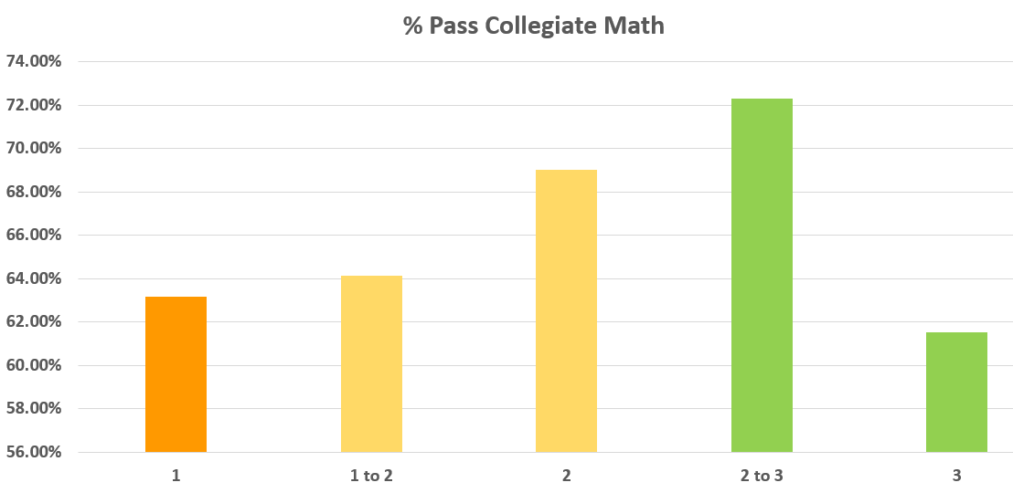

Alternatively, institutions that do not wish to offer Learning Support sections for different amounts of credit may still establish different preparation criteria as prerequisites for different Corequisite Learning Support sections (with the same amount of credit) so that instructors can tailor instruction appropriate to specific groups of students.

**10.** **Special Considerations for Corequisite Instruction in English**

ENGL 0999, Support for English Composition, will serve the dual purpose of supporting and developing the skills and concepts of ENGL 1101 English Composition I while also providing instruction for students to strengthen both reading and writing competencies in which they have deficiencies.

**Support Course Credit Hours**

Data from fall 2018 show that students pass ENGL 1101 at very significantly higher rates when the Corequisite Learning Support Course is offered at 2 or 3 credits, versus only 1 credit. Therefore, the recommendation is that ENGL 0999 be offered for 2 or 3 credits, and possibly at both levels so that instruction may be differentiated. (See Section 9 of this manual.)

**ENGL 0999 Credit Hours**

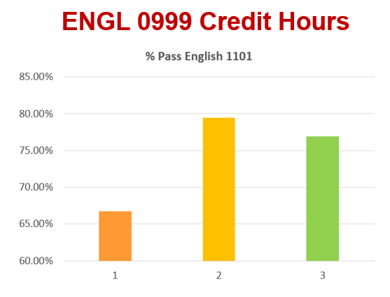

**Collegiate Course Composition**

The fall 2018 data show that students with Corequisite Learning Support requirements pass ENGL 1101 at higher rates when their ENGL 1101 sections are composed exclusively of students with Corequisite Learning Support requirements (cohort model). Restricting ENGL 1101 sections exclusively to students with Learning Support requirements may cause problems with class size, however, by forcing ENGL 1101 sections to be smaller than is usually the case or ENGL 0999 sections being larger than is ideal. See below (Class Size) and Section 13.

**ENGL 1101 Pass Rates**

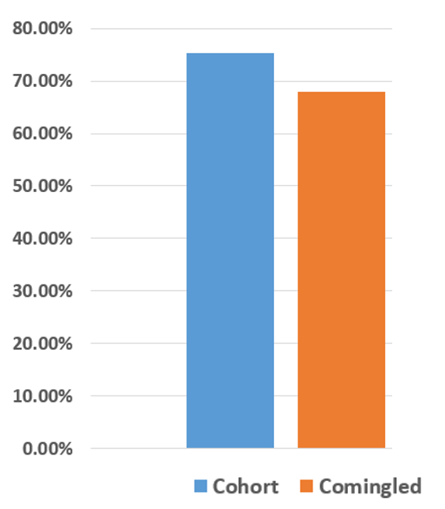

**Instructor Alignment**

Data from fall 2018 also indicate that students pass ENGL 1101 at higher rates when the same instructor teaches both the ENGL 1101 and ENGL 0999 sections. When this is not possible, the college-level and Corequisite Learning Support sections must still be carefully coordinated.

**ENGL 1101 Pass Rates Same vs. Not Always Same Instructor**

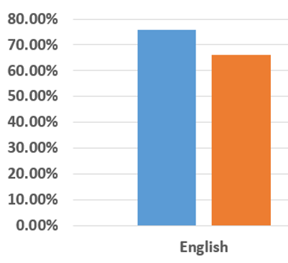



**Alignment Model**

In particular, the college-level and Corequisite Learning Support sections must cover the same topics in the same order at the same time. In practical terms, this may mean that institutions will have to specify the order and timing of topic coverage for ALL ENGL 0999 sections and ALL ENGL 1101 sections that include students with Learning Support requirements. Data from fall 2018 show that the lowest pass rates in ENGL 1101 are achieved at institutions where students with Corequisite requirements are allowed to enroll in any ENGL 0999 section, rather than being assigned to sections that are deliberately paired. Alignment models in the drawing below reflect the models discussed extensively in Section 12.

**ENGL 1101 Pass Rates by Alignment Model**

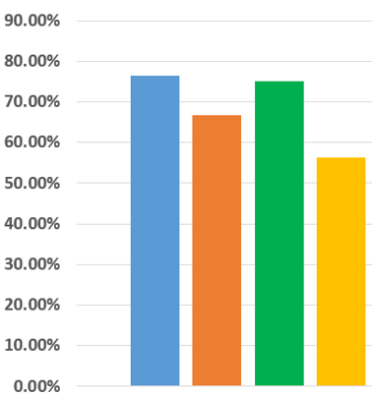



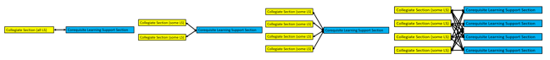

**Corequisite Section Size**

Data from fall 2018 suggest that the size of Corequisite Learning Support sections in English impacts the likelihood of student success, with students in smaller Corequisite Support sections passing ENGL 1101 at higher rates than students in larger Corequisite Support sections. Therefore, it is recommended that institutions make a concerted effort to restrict class sizes in English 0999 sections to no more than 20 students.

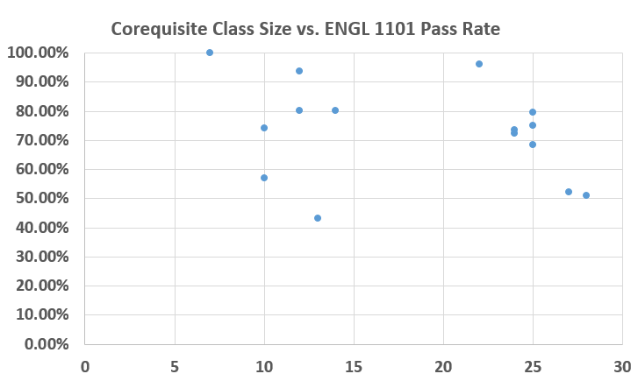

**r = -0.29462**

**11.** **Special Considerations for Corequisite Instruction in Mathematics**

The Corequisite Learning Support courses in mathematics will serve the dual purpose of supporting and developing the skills and concepts of the college-level courses while also providing instruction for students to strengthen mathematical competencies in which they have deficiencies.

**Support Course Credit Hours**

Data from fall 2018 show that students pass entry-level collegiate mathematics courses at significantly higher rates when the Corequisite Learning Support course is offered at 2 or 3 credits, versus only 1 credit. Therefore, the recommendation is that MATH/STAT 0996, MATH 0997, MATH 0998, and MATH 0999 be offered for 2 or 3 credits, and possibly at both levels so that instruction may be differentiated. (See Section 9 of this manual.)

**Corequisite Math Credit Hours**



**Collegiate Course Composition**

The fall 2018 data show that students with Corequisite Learning Support requirements pass their collegiate mathematics courses at slightly higher rates when their college math sections are composed of both students with and without Corequisite Learning Support requirements (comingled model).

**Collegiate Math Pass Rates**

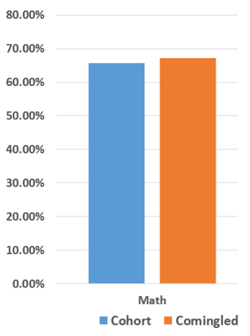

**Alignment Model**

Alignment of the content in the collegiate and Corequisite Learning Support sections is crucial. The college-level and Corequisite Learning Support sections must be carefully coordinated. In particular, the college-level and Corequisite Learning Support sections must cover the same topics in the same order at the same time. In practical terms, this may mean that institutions will have to specify the order and timing of topic coverage for ALL Corequisite Learning Support mathematics sections and ALL collegiate mathematics sections that include students with Learning Support requirements. Data from fall 2018 show that the lowest pass rates in collegiate mathematics sections are achieved at institutions where students with Corequisite requirements are allowed to enroll in any Corequisite Mathematics section, rather than being assigned to sections that are deliberately paired. Alignment models in the drawing below reflect the models discussed extensively in Section 12.

**Math Pass Rates by Alignment Model**

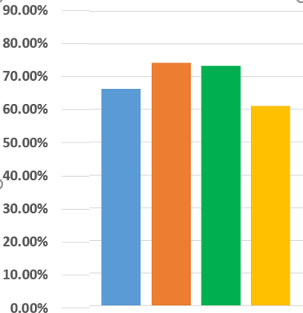





**Corequisite Section Size**

Analysis of Corequisite Support section size and success in collegiate mathematics courses at institutions serving students with Learning Support needs indicates a greater likelihood of success for students in Corequisite Support sections with fewer students. Therefore, it is recommended that institutions make a concerted effort to restrict class sizes in Corequisite mathematics sections small, probably no more than 25 students.

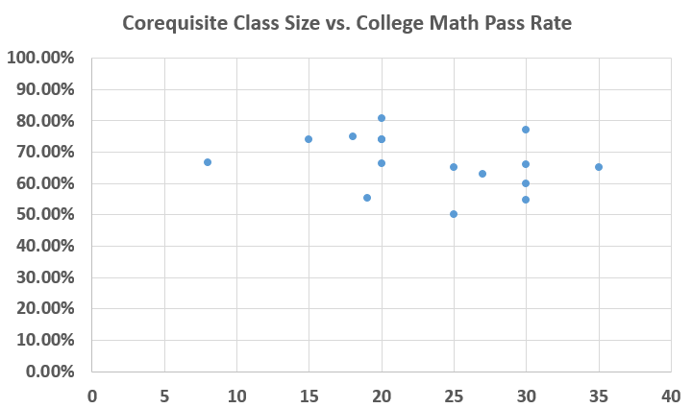

**r = -0.30112**

**12.** **Scheduling Considerations and Models**

Institutions have considerable latitude in developing models for scheduling Corequisite Learning Support sections.

There are several considerations:

Will the institution attempt to ensure that the same instructor teaches any collegiate and Corequisite Learning Support sections that are linked? (See sections above on “Special Considerations for Corequisite Instruction in English.”)

Does the institution believe that it is important for topics to be covered first in the Corequisite Learning Support section before they are discussed in the linked collegiate course, or after, or that it does not matter? This will, in part, dictate the temporal relationship between the scheduling of the Corequisite Learning Support section and the collegiate section. Obvious possibilities: the Corequisite Learning Support section may be scheduled either immediately before or after the collegiate section or the Corequisite Learning Support section may be scheduled at the same time, but alternating days with the collegiate section (e.g., collegiate section is on Tuesday and Thursday while the Corequisite Learning Support section is scheduled on Monday and Wednesday or Monday, Wednesday, and Friday).

There are a number of possible models for scheduling Corequisite Learning Support sections linked to collegiate sections.

**Model A Cohort Model**

The collegiate section contains only students who are also enrolled in Corequisite Learning Support (cohort model). All of the students in the collegiate section are enrolled in the same Corequisite Learning Support section.

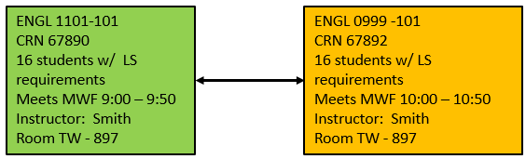

Advantage: Simplicity.

Disadvantages:

* Since there are no students without Corequisite Learning Support requirements in the collegiate section, there is a possibility that standards for the collegiate section would be affected.
* To maintain a smaller class size in the corequisite section, institutions must also limit the class size of the paired collegiate section. This will decrease revenue.

**Model B Comingled Model**

This model has two variants. In both variants, there are students with and without Corequisite Learning Support requirements in the same collegiate class (comingled model), and all students with Corequisite Learning Support requirements from the collegiate section are enrolled in the same Corequisite Learning Support Section. In one variation (B1) this is accomplished by scheduling two sections in one classroom with the same instructor. In the other variation (B2) students with and without Corequisite Learning Support requirements are enrolled in the same collegiate section, with some seats set aside for students with Corequisite Learning Support requirements using the “reserved seats” function in Banner.

**Model B1 – Two collegiate sections in the same room**

Two collegiate sections are scheduled in the same room at the same time with the same instructor. Students in one section all have Corequisite Learning Support requirements. None of the students in the other section have Learning Support requirements. All students from the collegiate section that have Corequisite Learning Support requirements are enrolled in the same Corequisite Learning Support section.

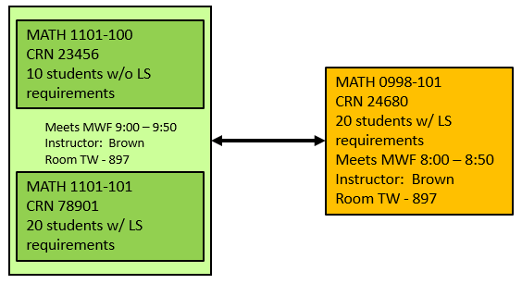

Advantages:

* Still a relatively simple solution.
* May allow institutions to maintain smaller class sizes in corequisite sections because these are partially offset by the additional students in the collegiate part of the class.
* Students with and without Learning Support requirements are taking collegiate courses side by side. This will help to ensure that collegiate standards are maintained.

Disadvantage: Slightly more complex to schedule than Model A.

**Model B2 – Students with and without Corequisite Learning Support requirements are enrolled in the same collegiate section.**

Students with and without Corequisite Learning Support requirements are enrolled in the same collegiate section, with some seats set aside for students with Corequisite Learning Support requirements using the “reserved seats” function in Banner. (Model suggested by Dr. German Vargas at the College of Coastal Georgia. Banner details explained in Appendix 2.)

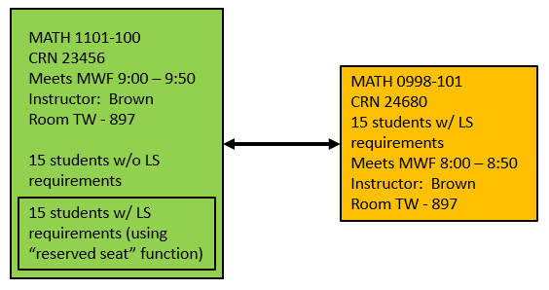

Advantages:

* Still a relatively simple solution.
* May allow institutions to maintain smaller class sizes in corequisite sections because these are partially offset by the additional students in the collegiate part of the class.
* Students with and without Learning Support requirements are taking collegiate courses side by side. This will help to ensure that collegiate standards are maintained.

Disadvantages:

* Slightly more complex to schedule than Model A.
* Reserved seats CANNOT be taken off once registration for the course begins.

**Model C Comingled Plus**

Some collegiate sections with students with Corequisite Learning Support requirements are co-scheduled with collegiate sections containing no students with Learning Support requirements (comingled model). Students with Learning Support requirements must also register for designated sections of corequisite support which may be taught by the instructor who teaches the collegiate section or by a different instructor.

Students with Corequisite Learning Support requirements from each of two collegiate sections are assigned to a single Learning Support section.

There are several potential variants of this configuration, but the common element is that the pairing of collegiate and corequisite Learning Support sections is not random. Specific collegiate sections are paired with specific Corequisite Learning Support sections.

A prototype for this arrangement is shown below.

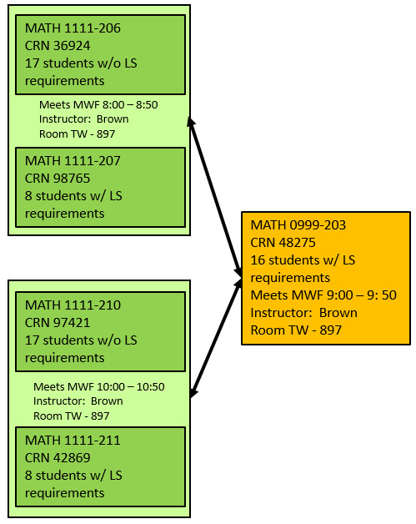

Advantages:

* May allow institutions to maintain smaller class sizes in corequisite sections because these are partially offset by the additional students in the collegiate parts of the classes.
* Students with and without Learning Support requirements are taking collegiate courses side by side. This will help to ensure that collegiate standards are maintained.

Disadvantage: Slightly more complex to schedule than Model B.

**Model D**

Students in any collegiate section designed for students with Corequisite Learning Support requirements can sign up for any Corequisite Learning Support section.

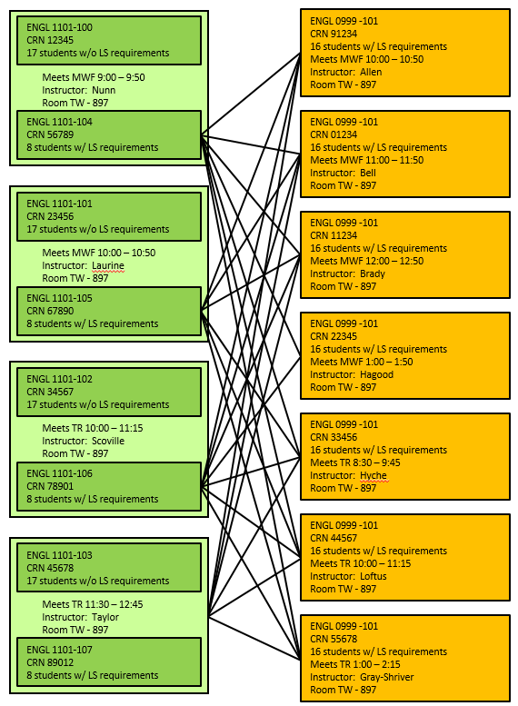

Advantage:

* Requires little institutional planning other than making sure that there are enough collegiate and corequisite Learning Support sections.

Disadvantages:

* Scheduling burden will be mainly on students.
* Corequisite Learning Support sections are supposed to provide “just in time” support for the skills and topics that students are covering in collegiate sections. If pairing between collegiate and Corequisite Learning Support sections is random, it will be nearly impossible for instructors in Corequisite Learning Support sections to know what is being covered in the collegiate sections for all of the students in their classes. Because of the difficulty in aligning content between collegiate and Corequisite Learning Support sections with this model, ***use of this model is strongly discouraged***. Data presented in Sections 10 and 11 show that students are less likely to succeed in collegiate courses (in English and mathematics) when this model is used.

**13.** **Class Sizes**

Corequisite Learning Support sections should be smaller than the size of the collegiate sections they support. Smaller Corequisite Learning Support class sizes will typically reduce the range of student preparation within a single section and allow instructors to be more effective in tailoring instruction to help students overcome deficiencies in preparation.

Most of the scheduling models discussed in the previous section would allow institutions to keep their collegiate sections at their target sizes while allowing smaller class sizes for Corequisite Learning Support sections. There is only one scheduling model that will not support this goal: Model A (see previous section) in which the collegiate section has only students with Corequisite Learning Support requirements and the same students are in the collegiate and corequisite sections.

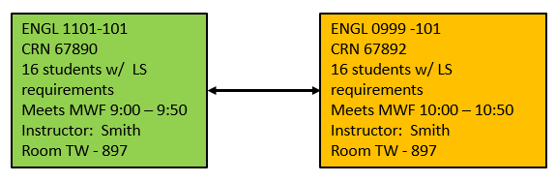

This model (above) requires small class sizes in the collegiate section to achieve small class sizes in the Corequisite Learning Support section. All other models (B1, B2, C, and D) offer more flexibility to adjust class sizes.

Institutions should establish target class sizes for Corequisite Learning Support sections and adopt scheduling models that are appropriate for achieving those class sizes.

Data from both English and mathematics suggests that smaller Corequisite sections are associated with higher success rates in the paired collegiate courses. Corequisite class sizes in English are discussed in Section 10; corequisite class sizes in math are discussed in Section 11. The preliminary recommendation based on fall 2018 data is that corequisite English sections should have 20 or fewer students; corequisite mathematics sections should have 25 or fewer students.

**14.** **Corequisite Course Setup in Banner**

The Ellucian Customer Center provides instructions on how to schedule corequisite sections in Banner as is commonly done with science lecture and lab sections.

You need an Ellucian Customer Center account to access this information. If you do not have an Ellucian Customer Center account, you may request one here: <https://clientapps.ellucian.com/SignUp>. Granting of access is not instantaneous; they will have to verify your employment, etc.

1. Once you have an account, you can Log into the Ellucian Customer Center via: <https://login.ellucian.com>.
2. From the Ellucian Customer Center landing page, select “Resources” from the top navigation bar, then choose the On-Demand Training app listed under Knowledge.
3. From the On-Demand Training landing page, select the On-Demand Training Menu (just beneath the top navigation bar), then “Banner” from the dropdown menu.
4. From the Banner On-Demand Training landing page, select the Student (see courses) blue link to see courses under Banner 9.
5. From the Banner Student courses landing page, scroll down to find the Managing the Class Schedule’ selections.
6. Select the ‘Defining Courses with Advanced Scheduling Configurations’ and click “View Course” to begin.
7. Click on start to view the course. This “course” is 26 minutes if you take all the modules.
8. You will have an opportunity to download the quick reference guide on “Defining Courses with Advanced scheduling Configurations,” which is recommended. The second page of this quick reference guide walks you through the steps to link courses.
9. The entire course may be useful to you. However, you also have the option to go directly to the “Linking Lecture and Lab Sections” in the right-hand navigation menu.
10. This demo shows you how to link one lecture section to one lab section, but states that the same process may be used to link multiple labs to a single section or vice versa.

**15.** **Other Banner Considerations**

1. **Next-Generation Accuplacer Test Scores**

**Business Practice for Entering Next-Generation Accuplacer Scores in Banner – from GeorgiaBEST**

This document explains how to create test codes for the two Next-Generation Accuplacer tests, how to enter student test scores, and how to translate test codes for the Academic Data Collection.

To accept Next-Generation Accuplacer test scores, the test codes for Quantitative Reasoning, Algebra, and Statistics (ACCNGM) and Reading (ACCNGR) must be established in Banner. These test codes must be created on the Test Code Validation page (STVTESC) prior to entering test scores on the Test Score Information page (SOATEST) for students. Note that the WritePlacer test code has not changed. The addition of new test codes on STVTEST will most likely be done by someone in your registrar’s office, but this may vary by institution.

Summary below.

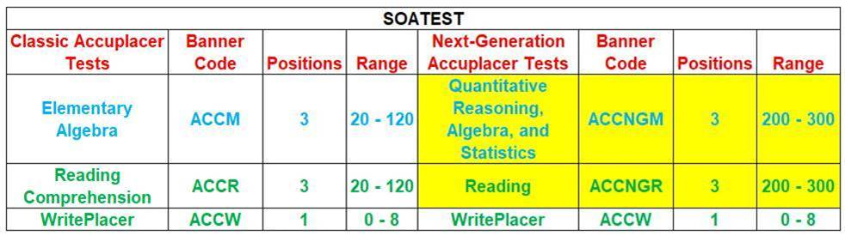

The complete GeorgiaBEST documentation is available on the GeorgiaBest website ([www.usg.edu/georgia_best/site/login](http://www.usg.edu/georgia_best/site/login)). A username and password is required to view the documents on the GeorgiaBEST side. If you do not already have these, please consult with your institution’s Banner Project Leader (<https://www.usg.edu/georgia_best/site/functional_leaders>).



|  |
| --- |
| Next-Generation Accuplacer Test Scores Business Practice **PURPOSE:** The Next-Generation Accuplacer Test Scores Business Practice provides guidelines for Banner set up and steps required to create the Next-Generation Accuplacer test scores.  Beginning with Spring 2019 Midterm, these test scores will be collected by the Academic Data Collection (ADC). This business practice includes instructions for translating the Banner values to the valid values collected by the ADC.  The Next-Generation Accuplacer Test Scores Business Practice document can be found on the [Business Processes page of the GeorgiaBEST website](https://www.usg.edu/georgia_best/application_development_and_support/business_processes). |

After you have logged into the GeorgiaBEST website, go to the Business Processes page.

It may be easier to enter the following URL after you have logged in to the GeorgiaBEST website:

<https://www.usg.edu/georgia_best/application_development_and_support/business_processes>

Scroll down to either the Data Collections or Student sections of the page. Then locate the link to the “Next-Generation Accuplacer Test Scores Business Practice.”

1. **Scheduling Two Sections in One Classroom**

Scheduling Models B1, C, and D call for scheduling two collegiate sections in one classroom: one for students with Corequisite Learning Support requirements, one for students without.

**Prerequisites:**

The collegiate section for students with Corequisite Learning Support Requirements should indicate as a prerequisite that the codes in SOATEST appropriate to the course are:

ENGL 1101 LSE = 2

MATH 1001 LSM2 = 2

MATH 1101 LSM2 = 2

MATH/STAT 1401 LSM2 = 2

MATH 1111 LSM1 = 2 AND LSM2 = 3

The collegiate section for students without Corequisite Learning Support Requirements should indicate as a prerequisite that the codes in SOATEST appropriate to the course are:

ENGL 1101 LSE = 3

MATH 1001 LSM2 = 3

MATH 1101 LSM2 = 3

MATH/STAT 1401 LSM2 = 3

MATH 1111 LSM1 = 3

Pages 17 – 19 of the “Georgia Enhancements 8.62 and 9.6 (Momentum Year) Workbook” have detailed information on “Baseline Prerequisite Checking for Corequisite Learning Support.”

To view the GeorgiaBEST document, go to the GeorgiaBest website (<https://www.usg.edu/georgia_best/site/login>). You will need a username and password to view documents on this site. If you do not already have these, please consult with your institution’s Banner Project Leader (<https://www.usg.edu/georgia_best/site/functional_leaders>).

Once you are logged in, you should be able to click on the link below or paste in the URL below to go directly to the workbook.

<https://www.usg.edu/georgia_best/user_docs/Momentum_Year_workbook.pdf>

**Corequisites:**

The section for students with Corequisite Learning Support Requirements should indicate a corequisite of a Corequisite Learning Support section. Depending on your model for scheduling corequisite sections, you could indicate a specific CRN or a requirement to enroll in a corequisite Learning Support section.

Appropriate collegiate and Corequisite Learning Support course pairs are listed below:

ENGL 1101 with ENGL 0999

MATH 1001 with MATH 0997

MATH 1101 with MATH 0998

MATH/STAT 1401 with MATH/STAT 0996

MATH 1111 with MATH 0999

The sections for students without Corequisite Learning Support Requirements should **not** indicate any corequisite.

See instructions in Section 14 of this manual on **“Corequisite Course Setup in Banner.”**

**Overrides:**

In order to schedule two sections in one classroom with one instructor, it will be necessary to do two overrides at the section level (in the second section you schedule):

* Override the room conflict (to allow two sections to be taught at the same time in the same room).
* Override the instructor conflict (to allow the instructor to teach two sections at the same time).

1. **Restricting Enrollment in Corequisite Learning Support Sections to Students with Corequisite Learning Support Requirements**

**Prerequisites:**

All Corequisite Learning Support sections should indicate as a prerequisite that the codes in SOATEST appropriate to the course are:

ENGL 0999 LSE = 2

MATH/STAT 0996 LSM2 = 2

MATH 0997 LSM2 = 2

MATH 0998 LSM2 = 2

MATH 0999 LSM1 = 2 AND LSM2 = 3

Pages 17 – 19 of the “Georgia Enhancements 8.62 and 9.6 (Momentum Year) Workbook” have detailed information on “Baseline Prerequisite Checking for Corequisite Learning Support.”

To view the GeorgiaBEST document, go to the GeorgiaBest website (<https://www.usg.edu/georgia_best/site/login>). You will need a username and password to view documents on this site. If you do not already have these, please consult with your institution’s Banner Project Leader (<https://www.usg.edu/georgia_best/site/functional_leaders>).

Once you are logged in, you should be able to click on the link below or paste in the URL below to go directly to the workbook.

<https://www.usg.edu/georgia_best/user_docs/Momentum_Year_workbook.pdf>

**Corequisites:**

All Corequisite Learning Support sections should require corequisite enrollment in a section of the appropriate collegiate course. Depending on your model for scheduling corequisite sections, you could indicate a specific CRN or a requirement to enroll in any appropriate collegiate section. Appropriate Corequisite Learning Support and collegiate course pairs are listed below:

ENGL 0999 with ENGL 1101

MATH/STAT 0996 with MATH/STAT 1401

MATH 0997 with MATH 1001

MATH 0998 with MATH 1101

MATH 0999 with MATH 1111

See instructions in Section 14 of this manual on **“Corequisite Course Setup in Banner.”**

**D.** **Corequisite Learning Support Rules, Placement, and Documentation in Banner**

All USG institutions are required to implement Georgia Enhancements 9.6, which will automate the process of determining Corequisite Learning Support status and exit from Corequisite Learning Support.

Pages 1 – 23 of the Georgia Enhancements 8.63 and 9.6 (Momentum Year) Workbook describe Banner setup and Banner functionality for evaluating and documenting student Corequisite Learning Support status.

Before you run the ZORCLSP “job” in Banner, you will have to select the population on which you will run it. (See page 12 of the Workbook.) You should select all undergraduates newly admitted for a particular term, excluding Dual Enrollment and transient students.

To view the GeorgiaBEST document, go to the GeorgiaBest website (<https://www.usg.edu/georgia_best/site/login>). You will need a username and password to view documents on this site. If you do not already have these, please consult with your institution’s Banner Project Leader (<https://www.usg.edu/georgia_best/site/functional_leaders>).

Once you are logged in, you should be able to click on the link below or paste in the URL below to go directly to the workbook.

<https://www.usg.edu/georgia_best/user_docs/Momentum_Year_workbook.pdf>

**E.** **Setting up Learning Support Sections in Banner**

In order to ensure the quality of data provided to the System Office via the Academic Data Collection, some specific steps are necessary when setting up the Corequisite Learning Support sections at the **catalog** level. These steps allow Corequisite Learning Support sections to be recognized as such by our research teams and your students with Learning Support requirements to be counted properly.

Learning Support Grade Modes

Each of the Corequisite Learning Support courses (MATH/STAT 0996, MATH 0997, MATH 0998, MATH 0999, ENGL 0999) should be set up with an appropriate grade mode code on the course schedule for the term. Learning Support courses for English are recommended to have a grade mode code of 6 and Learning Support courses for mathematics are recommended to have a grade mode code of 7.

|  |  |
| --- | --- |
| 6 | Grade mode code Corequisite Learning Support English |
| 7 | Grade mode code Corequisite Learning Support Mathematics |

These grade modes are established at the catalog level and display on the course section as well as on the student’s registration. To confirm settings, check the following locations in Banner:

* + Basic Course Information (SCACRSE) > Grading Mode section > Grade Mode field
  + Schedule (SSASECT) > Course Section Information > Grade Mode field
  + Student Course Registration (SFAREGS) > Registration section > Grade Mode field

NOTE: If your institution chose not to use the recommended values of 6 and/or 7 for Learning Support grade modes, the **institutional values must be translated to the recommended values** on the EDI Cross-Reference Rules (SOAXREF) using the RGTGMOD label.

Refer to the Course Grade Mode Code element (SCE005) in the Academic Data Collection data element dictionary (<https://www.usg.edu/research/reporting_resources>, then click on Data Element Dictionary with Valid Values ).

Instructional Level

Each of the Corequisite Learning Support courses (MATH 0997, MATH 0998, MATH 0999, ENGL 0999) in Banner should be identified with Classification code 10 (Learning Support). This instruction level must be established at the catalog level. To confirm settings, check the following location in Banner:

* Course Detail Information (SCADETL) > Supplemental Data tab > Classification field

Refer to the Instruction Level Code element (CRS005) in the Academic Data Collection data element dictionary (<https://www.usg.edu/research/reporting_resources>, then click on Data Element Dictionary with Valid Values ).

Course CIP Code

The course CIP code of all Learning Support courses in Banner should begin with the number “32”. Specifically, the CIP code for Learning Support English courses should be 32.0108 and the CIP code for Learning Support mathematics courses should be 32.0104. The course CIP code is established at the catalog level. To confirm settings, check the following location in Banner:

* Basic Course Information (SCACRSE) > Course Details section > CIP field

Refer to the Course CIP Code element (CRS004) in the Academic Data Collection data element dictionary (<https://www.usg.edu/research/reporting_resources>, then click on Data Element Dictionary with Valid Values ).

**F.** **Setting up Corequisite Learning Support Prerequisites for Collegiate Courses in Banner**

Enrollment in ENGL 1101, MATH 1001, MATH 1101, MATH/STAT 1401, or MATH 1111 requires students to exempt Corequisite Learning Support for the course or to enroll in Corequisite Learning Support. Information about how to set up the corequisite sections is covered in Section 14. Corequisite Course Setup in Banner. Rules for creating placement rules and Learning Support corequisites for these courses are covered in Section 15B. Scheduling Two Sections in One Classroom, Section 15C. Restricting Enrollment in Corequisite Learning Support Sections to Students with Corequisite Learning Support Requirements, and Section 15D. Corequisite Learning Support Rules, Placement, and Documentation in Banner.

Institutions may require exit or exemption from Corequisite Learning Support requirement as prerequisites to enrolling in other collegiate courses, as described in the [Academic and Student Affairs Handbook, section 2.9.1.4](https://www.usg.edu/academic_affairs_handbook/section2/C769/#p2.9.1_administrative_procedures_for_learning_support_programs). Learning Support prerequisites for these courses should be stated as:

* Completion or exemption from Corequisite Learning Support requirements in English.

OR

* Completion or exemption from Corequisite Learning Support requirements in mathematics [can specify MATH 1001, MATH 1101, MATH/STAT 1401, or MATH 1111].

OR

* Completion or exemption from Corequisite Learning Support requirements in English and mathematics.

Exemption from Corequisite Learning Support requirements could be indicated in Banner SOATEST as:

* LSE = 3 (for English)
* LSM1 = 3 (for MATH 1111)
* LSM2 = 3 (for MATH 1001, MATH 1101, and MATH/STAT 1401)

Institutions should not require exemption from Learning Support for MATH 1111 as a prerequisite to courses in programs that do not require students to take MATH 1111 (College Algebra).

Since Corequisite Learning Support requirements are satisfied by completion of the gateway collegiate course with a grade that satisfies the institutional minimum (usually a “C”), satisfaction of Corequisite Learning Support requirements will be reflected in an institutionally-defined passing grade in ENGL 1101, MATH 1001, MATH 1101, MATH/STAT 1401, or MATH 1111.

Course prerequisites reflecting “Completion or exemption from Corequisite Learning Support requirements . . .” can be achieved in Banner by referencing SOATEST scores that reflect exemption from the requirements OR completion of appropriate entry-level courses in English or mathematics.

**16.** **Data Collection**

Institutions must maintain test-score data and Corequisite Learning Support placement and exit information in the Banner Student Information System in a USG-approved format so that accurate data concerning Learning Support placement and completion is reported via the USG Academic Data Collection.

Implementation of Georgia Enhancements 9.6 (as described in Section 15 D of this manual) is necessary to ensure that information on Corequisite Learning Support status for students is maintained in Banner in a USG-approved format.

The Learning Support placement functionality in Banner provided by Georgia Enhancements 9.6 will result in the update in Banner of the necessary information in the correct field for the ADC extraction of each student’s Learning Support Program Requirement Status.

The Learning Support Program Current Enrollment indicator will be derived in the extraction from a combination of the student’s Learning Support Requirement Indicator (NCRQ), the student’s actual course enrollments during the term, and the Learning Support requirement status field (NCST) in Banner.

The Learning Support Program Date of Completion field will be derived from a combination of the student’s Learning Support Requirement Indicator, the Learning Support Program Current Enrollment Indicator, and the activity date for when a student was coded as having satisfied exit requirements in the requirement status field.

If an institution makes changes to the GeorgiaBEST-delivered functionality around Learning Support Placement, the institution is responsible for ensuring that the same information is produced and populated in the same Banner location as the GeorgiaBEST process.

All students enrolled in Learning Support courses will be reported in the USG Academic Data Collection as having System or Institutional Learning Support requirements or enrolling as Volunteers. Students not enrolled in Learning Support courses will be reported as being Exempt or as having a System or Institutional Learning Support Requirement.

Students with **System Requirements** have not met the System-defined minimum criteria to exempt placement in Corequisite Learning Support.

Students with **Institutional Requirements** have not met the institutionally-defined minimum criteria to exempt placement in Corequisite Learning Support. This only applies when institutions have defined criteria to exempt placement in Corequisite Learning Support that exceed the System minimums.

Students are classified as **Volunteers** if they enroll in Corequisite Learning Support courses despite having met or exceeded System and Institutional Requirements to exempt placement in Corequisite Learning Support.

In setting up Corequisite Learning Support sections in Banner at the catalog level, institutions must follow the specified USG conventions so that the USG can readily identify these sections and the students enrolled in them as meeting Corequisite Learning Support requirements. See Section 15 E, Setting up Learning Support Sections in Banner, for details on section set-up.

**17.** **USG Policy on Learning Support**

**Board of Regents Policy Manual**

In order to avoid conflicts with official USG policy, the policies will not be restated here, but links to the relevant policies are provided below.

[**3.3.7 Learning Support Programs**](https://www.usg.edu/policymanual/section3/C338/#p3.3.7_learning_support_programs)

This section describes the requirement for USG institutions to offer Learning Support programs.

### [**3.5.1.2 Cumulative Grade Point Average**](https://www.usg.edu/policymanual/section3/C340/#p3.5.1_grade_point_average)

This section states that institutional credit (which is what Learning Support courses offer) cannot affect students’ grade point averages.

**18.** **Academic and Student Affairs Handbook Guidelines on Learning Support**

**Academic and Student Affairs Handbook**

In order to avoid conflicts with the guidelines in the Academic and Student Affairs Handbook, the guidelines will not be restated here, but links to the relevant sections of the Academic and Student Affairs Handbook are provided below.

[**2.4.4 Details Regarding Areas A-F**](https://www.usg.edu/academic_affairs_handbook/section2/C738/#p2.4.4_details_regarding_areas_af) This section states the “30 hour” rule (requiring students to complete Area A within their first 30 collegiate credit hours) at the bottom of the information on A1 and A2.

[**2.9 Learning Support**](https://www.usg.edu/academic_affairs_handbook/section2/C769) (view all sections)

[**2.9.1 Administrative Procedures for Learning Support Programs**](https://www.usg.edu/academic_affairs_handbook/section2/C769/#p2.9.1_administrative_procedures_for_learning_support_programs)

Covers:

* Organization and staff
* Evaluation for Learning Support placement
* Rules regarding Learning Support program operation
* Rules for students in Learning Support

[**2.9.2 Numbering of Learning Support Courses**](https://www.usg.edu/academic_affairs_handbook/section2/C769/#p2.9.2_numbering_of_learning_support_courses)

[**2.9.3 Reporting and Recording Learning Support Status**](https://www.usg.edu/academic_affairs_handbook/section2/C769/#p2.9.3_reporting_and_recording_learning_support_status)

**19.** **USG Policy on Students with Disabilities**

**Board of Regents Policy Manual**

## In order to avoid conflicts with official USG policy, the policy will not be restated here, but a link to the relevant policy is provided below.

## [4.1.5 Students with Disabilities](https://www.usg.edu/policymanual/section4/C327/#p4.1.5_students_with_disabilities)

**20.** **Academic and Student Affairs Handbook Guidelines on Students with Disabilities**

**Academic and Student Affairs Handbook**

In order to avoid conflicts with the guidelines in the Academic and Student Affairs Handbook, the guidelines will not be restated here, but links to the relevant sections of the Academic and Student Affairs Handbook are provided below.

## [3.3.1 Regents’ Centers for Learning Disorders](https://www.usg.edu/academic_affairs_handbook/section3/C679/#p3.3.1_regents_centers_for_learning_disorders)

**See the section on: USG Accommodations for Students With Learning Disorders**

[**3.3.5 Learning Support Considerations**](https://www.usg.edu/academic_affairs_handbook/section3/C679/#p3.3.5_learning_support_considerations)

[**3.3.6 Core Mathematics Course Substitutions**](https://www.usg.edu/academic_affairs_handbook/section3/C679/#p3.3.6_core_mathematic_course_substitutions)

**Appendix 1.**

**University System of Georgia**

Fundamental Features of

Corequisite Learning Support

**Note:** This is not an admissions document. All guidelines and statements below are intended for students who have already been admitted to USG institutions, not as conditions for admission.

**General Requirements for Learning Support Programs**

* Institutions that admit students with high school grade point averages (HSGPA) or standardized test scores indicating that they will require additional support to succeed in collegiate English or mathematics courses must offer Corequisite Learning Support courses in these areas.
* The “default placement” for all students will be in an entry-level collegiate course with Corequisite Learning Support UNLESS students meet exemption criteria (for support) as outlined below in the sections on English and mathematics.
  + Students who do not meet any exemption criteria may waive placement testing if they are willing to accept placement in Corequisite Learning Support at the highest level of credit intensity offered at the institution.
  + All students must be made aware that they have the OPTION to take placement tests, which may place them directly into collegiate courses or in less credit-intensive levels of Corequisite Learning Support. Students interested in taking placement tests should not be discouraged from doing so.
  + Exception: students wishing to enroll in MATH 1111 College Algebra, (with or without Corequisite Learning Support), must take the mathematics placement test unless they have already met the criteria for direct placement into MATH 1111 or MATH 1111 with Corequisite Learning Support (see below).
* Institutions that admit students requiring Corequisite Learning Support in English or mathematics must designate a Learning Support Coordinator whose duties must include (but are not limited to):
  + Ensuring that appropriate Corequisite Learning Support courses are provided for all admitted students requiring Learning Support.
  + Coordinating with institutional admissions, the testing center, and academic departments as needed regarding placement, and ensuring that all students are appropriately placed.
  + Ensuring that Corequisite Learning Support placement and progress are accurately flagged and tracked in Banner.
  + Ensuring that the fundamental features of Corequisite Learning Support are fully implemented at the institution.
  + Ensuring that Corequisite Learning Support courses are carefully and appropriately coordinated with the college level courses they are intended to support.
  + Providing or coordinating training of institutional faculty, staff, and administrators as needed to ensure appropriate implementation of the Corequisite Learning Support model.
* Learning Support courses are to be offered exclusively in “corequisite” format. The corequisite format means that students requiring Learning Support will enroll in both a collegiate course (ENGL 1101, MATH 1001, MATH 1101, MATH/STAT 1401, or MATH 1111) and a Corequisite Learning Support course that is designed to support mastery of the skills and concepts needed to pass the collegiate course in a “just-in-time” manner.
* Each Corequisite Learning Support course will be a required course that is aligned with and offered alongside the appropriate college-level course and should be designed specifically to help students master the skills and knowledge required for success in the linked college-level course.
* The college-level and Corequisite Learning Support sections must be carefully coordinated. In particular, the college-level and Corequisite Learning Support sections must cover the same topics in the same order at the same time. In practical terms, this may mean that institutions will have to specify the order and timing of topic coverage for ALL Corequisite Learning Support sections and ALL college-level sections that include students with Learning Support requirements.
* Institutions must use the standard prefixes, numbers, titles, and course descriptions as listed below for the Corequisite Learning Support courses.
* Different sections of Corequisite Learning Support courses may be tailored for particular groups and offered for different amounts of credit (up to 3 hours of institutional credit), and tuition may be charged accordingly. Sections at different levels of support should be distinct (i.e., students requiring a three-credit corequisite course should not be enrolled in the same Learning Support class as students requiring a one-credit corequisite course). At institutions offering Corequisite Learning Support courses at multiple levels of credit intensity, course number suffixes A, B, and C will be used to designate courses with different credit hours. Examples:

|  |  |
| --- | --- |
| **Corequisite Support for**  **ENGL 1101 – English Composition I** | **Corequisite Support for**  **MATH 1001 – Quantitative Reasoning** |
| ENGL 0999A – 3 credit hours  ENGL 0999B – 2 credit hours  ENGL 0999C – 1 credit hour | MATH 0997A – 3 credit hours  MATH 0997B – 2 credit hours  MATH 0997C – 1 credit hour |
|  | **Corequisite Support for**  **MATH 1101 – Introduction to Mathematical Modeling** |
|  | MATH 0998A – 3 credit hours  MATH 0998B – 2 credit hours  MATH 0998C – 1 credit hour |
|  | **Corequisite Support for MATH/STAT 1401 – Elementary Statistics** |
|  | MATH 0996A – 3 credit hours  MATH 0996B – 2 credit hours  MATH 0996C – 1 credit hour |
|  | **Corequisite Support for**  **MATH 1111 – College Algebra** |
|  | MATH 0999A – 3 credit hours  MATH 0999B – 2 credit hours  MATH 0999C – 1 credit hour |

* Institutions offering only one level of Corequisite Learning Support do not need to use the identifier suffixes described above.
* Students will exit Learning Support (LS) requirements in English and/or mathematics by passing the college-level course in the LS area with a grade that meets the minimum grade requirement for the collegiate course at that institution (typically a “C” or higher). Students must enroll in both the Corequisite Learning Support course and the collegiate course every semester until they pass the collegiate course, even if they have passed the Corequisite Learning Support course one or more times.
* There are no limits on the number of “attempts” students may have to satisfy LS requirements.
* Paired college-level course sections may have only students with LS requirements (cohort model) or a mix of students with and without LS requirements (comingled model). When a college-level course section contains only students with LS requirements, care should be taken to ensure that the section adheres to the same academic standards as sections containing a mix of students with and without LS requirements or sections containing only students without LS students requirements.
* Institutions must establish consistent standards for sections of ENGL 1101, MATH 1001, MATH 1101, MATH/STAT 1401, and MATH 1111. The college-level course sections that students with LS requirements enroll in must be identical to those taken by students who do not have LS requirements. No elements of the Corequisite Learning Support experience will contribute to the grade earned in the college-level course.
* Although exit from LS requirements is determined by the grade in the collegiate course, institutions should make every effort to ensure that students attend the Corequisite Learning Support course and take the work of the Corequisite Learning Support course seriously.
* Institutions must use A, B, C, F grading in the Corequisite Learning Support courses.
* Students wishing to drop or withdraw from either the Corequisite Learning Support or linked college-level courses will be required to withdraw from BOTH courses.
* Students requiring LS in both English and mathematics may defer enrollment in Corequisite Learning Support and the paired collegiate course in one or the other area, but must be continuously enrolled in one or both pairs until the college-level courses have been passed. In cases where students cannot take courses in both LS areas simultaneously, enrollment in ENGL 1101 with Corequisite Learning Support should take priority. All Area A requirements must be completed within the first 30 collegiate credit hours, including college-level and Corequisite Learning Support requirements in both English and mathematics.

**English**

**Placement**

All entering students will be enrolled in ENGL 1101 English Composition I and the Corequisite Learning Support course, ENGL 0999 Support for English Composition, unless they meet one of the exemption criteria listed below or are enrolled in a program for which ENGL 1101 is not required. If students enroll in programs that do not require ENGL 1101, but they choose to take this course, standard assessment and placement rules will apply.

The exemption criteria below apply to the requirement to enroll in the Corequisite Learning Support course, not to the ENGL 1101 course requirement. Institutions may set higher exemption criteria.

Students meeting any of the criteria on the list below may enroll in ENGL 1101 without the Corequisite Learning Support course, ENGL 0999:

* Student already has credit for an Area A English course (must meet the minimum grade requirement for the course at the institution – which may be a “C” or higher).
* Student has an English Placement Index of 4230 or higher. *
* Student has a final high school GPA (HSGPA – this is the same HSGPA that is used in calculation of the Freshman Index) of 3.1 or higher and has completed the Required High School Curriculum (RHSC) in English. If the RHSC in English has not been completed, HSGPA may not be used to exempt this requirement.
* Student has an ACT English or Reading score of 17 or higher.
* Student has an SAT Verbal/Critical Reading score of 430 or higher on the “old” SAT.
* Student has an Evidence-Based Reading and Writing (EBRW) score of 480 or higher on the “new” SAT. **
* Student has a Classic Accuplacer Reading Comprehension score of 61 or higher AND an Accuplacer WritePlacer score of 4 or higher.
* Student has an Accuplacer Next-Generation Reading score of 237** or higher AND an Accuplacer WritePlacer score of 4 or higher.

* At the institution’s option, the English Placement Index (EPI) may continue to be used for students who have at least two of the following: 1) High school grade point average, 2) (Old) SAT or ACT scores, 3) Classic Accuplacer scores.

** “New” SAT scores and Next-Generation Accuplacer Reading test scores may not be used to calculate the English Placement Index.

**English Learning Support Course Prefix, Number, and Description**

**ENGL 0999 Support for English Composition (1-3 institutional credit hours)**

**Prerequisites:** None

**Corequisite:** ENGL 1101 English Composition I

**Description:** This Learning Support course provides corequisite support in reading and writing for students enrolled in ENGL 1101 – English Composition I. Topics will parallel those being studied in ENGL 1101 and the course will provide support for the essential reading and writing skills needed to be successful in ENGL 1101. Taken with ENGL 1101, this is a composition course focusing on skills required for effective writing in a variety of contexts, with emphasis on exposition, analysis, and argumentation, and also including introductory use of a variety of research skills.

**Course Design**

* ENGL 0999, Support for English Composition, will serve the dual purpose of supporting and illuminating the skills and concepts of ENGL 1101 English Composition I while also providing instruction for students to strengthen reading and writing competencies in which they have deficiencies.
* It is recommended that the same instructor teach the ENGL 1101 and ENGL 0999 sections. When this is not possible, the college-level and Corequisite Learning Support sections must still be carefully coordinated. In particular, the college-level and Corequisite Learning Support sections must cover the same topics in the same order at the same time. In practical terms, this may mean that institutions will have to specify the order and timing of topic coverage for ALL ENGL 0999 sections and ALL ENGL 1101 sections that include students with LS requirements.

**Mathematics**

**Aligned Mathematics Courses**

* For students who are **not** enrolled in a STEM or business program, or a field requiring an algebra-intensive course, the linked mathematics courses will be either:
* MATH/STAT 0996 Support for Elementary Statistics with MATH/STAT 1401 Elementary Statistics

OR

MATH 0997 Support for Quantitative Reasoning with MATH 1001 Quantitative Reasoning

OR

MATH 0998 Support for Mathematical Modeling with MATH 1101 Introduction to Mathematical Modeling.

Any student may enroll in these courses.

* For students enrolled in programs witha calculus or algebra-intensive mathematics requirement, the linked mathematics courses will be:

MATH 0999 Support for College Algebra with MATH 1111 College Algebra.

**Special requirements for MATH 1111:** Students must meet placement criteria (outlined below) for direct placement into MATH 1111 or placement into MATH 1111 with corequisite support.

**Placement**

All entering students will be enrolled in one of four standard Area A college-level credit-bearing mathematics courses (MATH 1001 Quantitative Reasoning, MATH 1101 Introduction to Mathematical Modeling, MATH/STAT 1401 Elementary Statistics, or MATH 1111 College Algebra) and a Corequisite Learning Support course unless they meet one of the exemption criteria listed below or are enrolled in a program for which a mathematics course is not required. Note that MATH 1111 has higher placement and exemption criteria than MATH 1001, MATH 1101, and MATH/STAT 1401. If students enroll in programs that do not require a mathematics course, but they choose to take a mathematics course, standard assessment and placement rules will apply.

The exemption criteria below apply to the requirement to enroll in a Corequisite Learning Support course, not to the college-level mathematics course requirement. Institutions may set higher exemption criteria.

**MATH 1001 Quantitative Reasoning and**

**MATH 1101 Introduction to Mathematical Modeling and**

**MATH/STAT 1401 Elementary Statistics**

Students meeting any of the criteria on the list below may enroll in MATH 1001,MATH 1101, or MATH/STAT 1401 without the Corequisite Learning Support courses, MATH/STAT 0996, MATH 0997 or MATH 0998:

* Student already has credit for an Area A mathematics course (must meet the minimum grade requirement for the course at the institution – which may be a “C” or higher).
* Student has a Mathematics Placement Index of 1165 or higher. *
* Student has placed in Pre-Calculus or a higher mathematics course (e.g., College Trigonometry or some form of calculus).
* Student has a high school GPA (HSGPA – this is the same HSGPA that is used in calculation of the Freshman Index) of 3.2 or higher and has completed the Required High School Curriculum (RHSC) in mathematics. If the RHSC in mathematics has not been completed, HSGPA may not be used to exempt this requirement.
* Student has an ACT Mathematics score of 17 or higher.
* Student has an SAT Mathematics score of 400 or higher on the “old” SAT.
* Student has an SAT Math section score of 440 or higher on the “new” SAT. **
* Student has a Classic Accuplacer Elementary Algebra score of 67 or higher.
* Student has an Accuplacer Next-Generation Quantitative Reasoning, Algebra, and Statistics score of 258** or higher.

* At the institution’s option, the Mathematics Placement Index (MPI) may continue to be used for students who have at least two of the following: 1) High school grade point average, 2) (Old) SAT or ACT scores, 3) Classic Accuplacer scores.

** “New” SAT scores and Next-Generation Accuplacer scores may not be used to calculate Mathematics Placement Indices (MPI).

**MATH 1111 College Algebra**

***Students who do not qualify for initial enrollment in MATH 1111 (with or without corequisite Learning Support) may enroll in MATH 1001 or MATH 1101 (with or without corequisite support), and may later enroll in MATH 1111 after successfully completing MATH 1001 or MATH 1101***.

**Criteria for Placement into MATH 1111 with Corequisite Learning Support:** Students meeting any of the criteria on the list below may enroll in MATH 1111 with corequisite support, MATH 0999. (Institutions may set higher requirements to enroll in MATH 1111 with corequisite support.)

* Student already has credit for MATH 1001 Quantitative Reasoning, MATH 1101 Introduction to Mathematical Modeling, or MATH/STAT 1401 Elementary Statistics (must meet the minimum grade requirement for the course at the institution – which may be a “C” or higher).
* Student has a Mathematics Placement Index of 1165 or higher. *
* Student has a high school GPA (HSGPA – this is the same HSGPA that is used in calculation of the Freshman Index) of 3.2 or higher and has completed the Required High School Curriculum (RHSC) in mathematics. If the RHSC in mathematics has not been completed, HSGPA may not be used to meet this requirement.
  + Student has an ACT Mathematics score of 17 or higher.
  + Student has an SAT Mathematics score of 400 or higher on the “old” SAT.
  + Student has an SAT Math section score of 440 or higher on the “new” SAT. **
  + Student has a Classic Accuplacer Elementary Algebra score of 67 or higher.
  + Student has an Accuplacer Next-Generation Quantitative Reasoning, Algebra, and Statistics score of 258** or higher.

**Criteria for Direct Placement into MATH 1111**: Students meeting any of the criteria on the list below may enroll in MATH 1111 without the Corequisite Learning Support course, MATH 0999. (Institutions may set higher requirements for direct enrollment in MATH 1111.)

* Student already has credit for MATH 1001 Quantitative Reasoning, MATH 1101 Introduction to Mathematical Modeling, or MATH/STAT 1401 Elementary Statistics (must meet the minimum grade requirement for the course at the institution – which may be a “C” or higher).
* Student has a Mathematics Placement Index of 1265 or higher. *
* Student has placed in pre-calculus or a higher mathematics course (e.g., College Trigonometry or some form of calculus).
* Student has a high school GPA (HSGPA – this is the same HSGPA that is used in calculation of the Freshman Index) of 3.4 or higher and has completed the Required High School Curriculum (RHSC) in mathematics. If the RHSC in mathematics has not been completed, HSGPA may not be used to exempt this requirement.
* Student has an ACT Mathematics score of 20 or higher.
* Student has an SAT Mathematics score of 470 or higher on the “old” SAT.
* Student has an SAT Math section score of 510 or higher on the “new” SAT. **
* Student has a Classic Accuplacer Elementary Algebra score of 79 or higher.
* Student has an Accuplacer Next-Generation Quantitative Reasoning, Algebra, and Statistics score of 266** or higher.

* At the institution’s option, the Mathematics Placement Index (MPI) may continue to be used for students who have at least two of the following: 1) High school grade point average, 2) (Old) SAT or ACT scores, 3) Classic Accuplacer scores.

** “New” SAT scores and Next-Generation Accuplacer scores may not be used to calculate Mathematics Placement Indices (MPI).

**Mathematics Learning Support Course Prefixes, Numbers, and Descriptions**

**MATH/STAT 0996** Support for Elementary Statistics (1-3 institutional credit hours)

**Prerequisites:** None

**Corequisite:** MATH/STAT 1401 Elementary Statistics

**Description:** This Learning Support course provides corequisite support for students enrolled in MATH/STAT 1401 – Elementary Statistics. Topics will parallel topics being studied in MATH/STAT 1401 and the course will provide support for the essential skills needed to be successful in MATH/STAT 1401. Taken with MATH/STAT 1401, topics to be covered will include descriptive statistics, probability theory, confidence intervals, hypothesis testing, and other selected statistics topics.

**MATH 0997 Support for Quantitative Reasoning (1-3 institutional credit hours)**

**Prerequisites:** None

**Corequisite:** MATH 1001 Quantitative Reasoning

**Description:** This Learning Support course provides corequisite support in mathematics for students enrolled in MATH 1001 – Quantitative Reasoning. Topics will parallel topics being studied in MATH 1001 and the course will provide support for the essential quantitative skills needed to be successful in MATH 1001. Taken with MATH 1001, topics to be covered will include logic, basic probability, data analysis and modeling from data.

**MATH 0998 Support for Mathematical Modeling (1-3 institutional credit hours)**

**Prerequisites:** None

**Corequisite:** MATH 1101 Introduction to Mathematical Modeling

**Description:** This Learning Support course provides corequisite support in mathematics for students enrolled in MATH 1101 – Introduction to Mathematical Modeling. Topics will parallel topics being studied in MATH 1101 and the course will provide support for essential quantitative skills needed to be successful in MATH 1101. Taken with MATH 1101, this course is an introduction to mathematical modeling using graphical, numerical, symbolic, and verbal techniques to describe and explore real-world data and phenomena. Emphasis is on the use of elementary functions to investigate and analyze applied problems and questions, supported by the use of appropriate technology, and on effective communication of quantitative concepts and results.

**MATH 0999 Support for College Algebra (1-3 institutional credit hours)**

**Prerequisites:** Credit for MATH 1001, MATH 1101, or MATH/STAT 1401 with a “passing” grade (as defined by institution, typically “C” or higher) OR high school GPA 3.2 or higher OR ACT Mathematics score of 17 or higher OR “old” SAT Mathematics score of 400 or higher OR “new” SAT Math section score of 440 or higher OR Accuplacer Elementary Algebra score of 67 or higher OR Accuplacer Next-Generation Quantitative Reasoning, Algebra, and Statistics score of 258 or higher. [Institutions may set higher prerequisites for enrollment in MATH 1111 with corequisite support.]

**Corequisite:** MATH 1111 College Algebra

**Description:** This Learning Support course provides corequisite support in mathematics for students enrolled in MATH 1111 – College Algebra. Topics will parallel topics being studied in MATH 1111 and the course will provide support for the essential quantitative skills needed to be successful in MATH 1111. Taken with MATH 1111, this course provides an in-depth study of the properties of algebraic, exponential and logarithmic functions as needed for calculus. Emphasis is on using algebraic and graphical techniques for solving problems involving linear, quadratic, piece-wise, defined, rational, polynomial, exponential and logarithmic functions.

**Course Design**

The corequisite mathematics courses will serve the dual purpose of supporting and illuminating the skills and concepts of the college-level mathematics courses while also providing instruction for students to strengthen mathematical competencies in which they have deficiencies

***Updated 6/02/21***

**Appendix 2.**

**Banner 9 Quick Guide for Corequisite Courses**

This guide was provided for sharing with other USG institutions by Dr. German Vargas at the College of Coastal Georgia.

Please use the guide with caution and note that if any errors or process inconsistencies are found, please contact Dr. Vargas at [gvargas@ccga.edu](mailto:gvargas@ccga.edu).

[Guide begins on next page.]



**BANNER 9 Quick Guide for Corequisite Courses**

**Introduction**

This guide was created at the College of Coastal Georgia to document internal processes, facilitate training for department coordinators and to support Corequisite implementations at other institutions that use Ellucian’s BANNER 9.

The guide will have a specific illustrative case (College Algebra paired with a Corequisite Support), but its content can be easily transferred to the implementation of corequisite support for various Math Pathways or simply corequisite support in other disciplines like English.

The guide will contain implementation guidelines for three specific BANNER 9 features, Reserved Seating, Corequisite at the Course level (SCADETL) and Corequisite at the section level (SSADETL).

*NOTE: If you find any error or process discrepancy in this document please contact German Vargas at* [*gvargas@ccga.edu*](mailto:gvargas@ccga.edu)

**Illustrative Example:**

* Gateway Course
  + Name: MATH 1111 College Algebra
  + Capacity: 30 Students
    - Reserved Seating
      * 15 students deemed “collegiate-ready”
      * 15 students needing corequisite support (via BANNER attribute)
  + Number of Credits: 3
  + Days and Times: MWF 9:00am - 9:50am
  + CRN: 80201
* Corequisite Support Course
  + Name: MATH 0999 Support for College Algebra
  + Capacity: 15 Students (Learning Support/Developmental Students)
  + Number of Credits: 2
  + Days and Times: T Th 9:00am - 9:50am
  + CRN: 80202
  + Corequisite Course Requirement: Registration in this course requires registration in MATH 1111
  + Corequisite Section Requirement: Registration in this course requires registration in CRN: 80201

**Implementing Reserved Seating**

Reserved seating is a feature in BANNER that will allow you to hold seats for groups of students that satisfy particular criteria. These criteria include Level (Undergraduate, Graduate), Campus, College, Degree, Program, Field of Study Code, Department, Curricula, Class, Attribute, Cohort, Admission Term, Matriculation Term, and Graduation Term. While many of these are very useful for a variety of cases, we will focus on Attribute as the way for us to identify what students have the Learning Support (Developmental) requirement.

*NOTE: Reserved seats CANNOT be taken off once registration begins in the course.*

Steps to implement Reserved Seating:

1. Create the Gateway Course with 30 seats
2. Create the Support Course with 15 seats
3. Open SSASECT
4. Click the Section Enrollment Information Tab

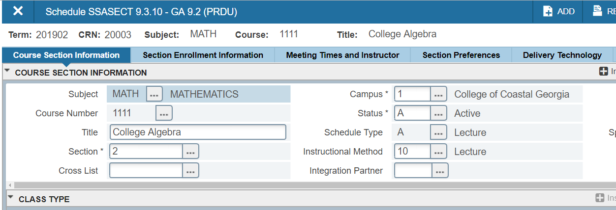

1. Click the Reserved Seats Subtab

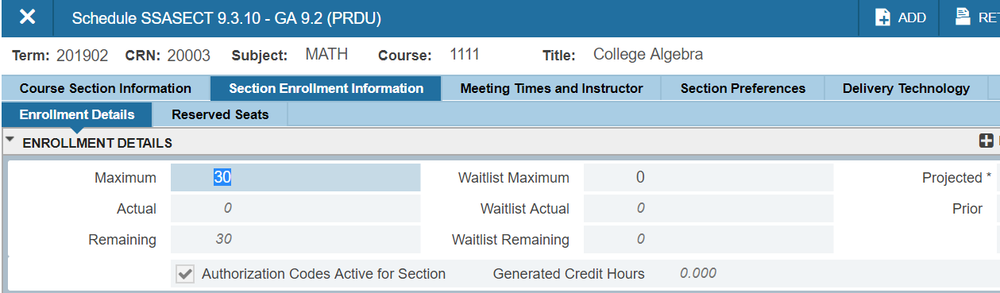

1. Click **+**Insert to add a row that corresponds to the reserved seating group

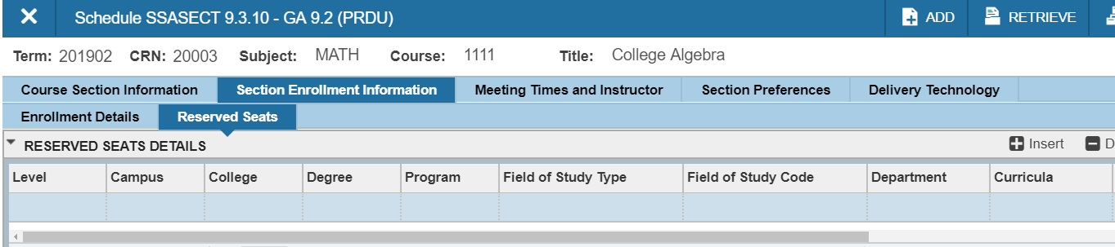

1. Insert the attribute that students will need to have in order to use the reserved seats. I this case, we are using the attribute LSA for student needing Learnings Support for Algebra. This attribute should be included in the **second row**, as the first row will correspond to the open seats that are not linked to any type of criteria.

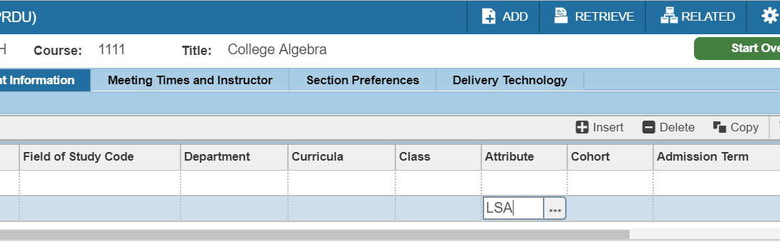

1. Update the number of seats that correspond to the open seats (first row) and the number of seats that will be reserved for the LSA attribute (second row)

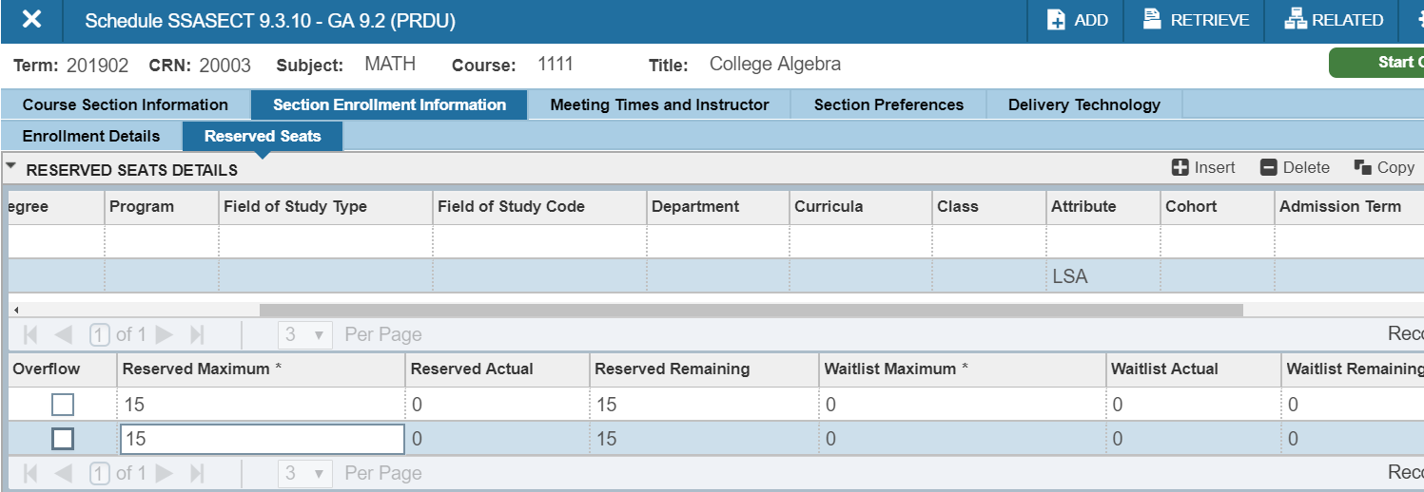

1. Click Save at the bottom right corner of the screen (or press F10)

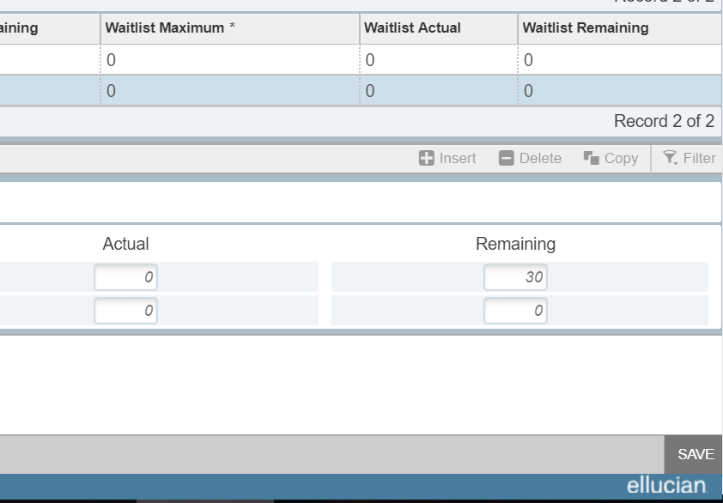

1. You may receive a warning that indicates that you are changing the maximum number of seats available. Click Yes.

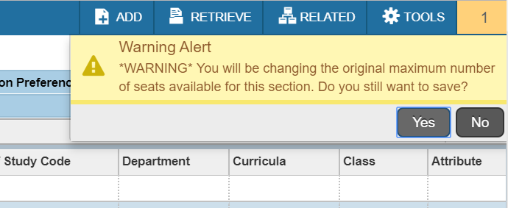

1. Reserved Seating feature is ready and you will be able to monitor the number of available seats for each row of criteria. In this case we just have one row for open seats and one row for students needing corequisite support.

**Implementing Corequisite at the Course Level**

In BANNER we can link the registration on the corequisite support course with registration in the Gateway course. The goal is that any attempt to register a student into MATH 0999 will require concurrent registration in MATH 1111. *Please note that this is a requirement that needs to be imposed in MATH 0999 but not vice versa, as a student can be registered in MATH 1111 without needing the support course. Also note that this needs to be done*

Steps to implement corequisite at the ***course*** level:

1. Create the Gateway Course
2. Create the Support Course
3. Open SCADETL
4. Type or search for Subject (MATH in this case)

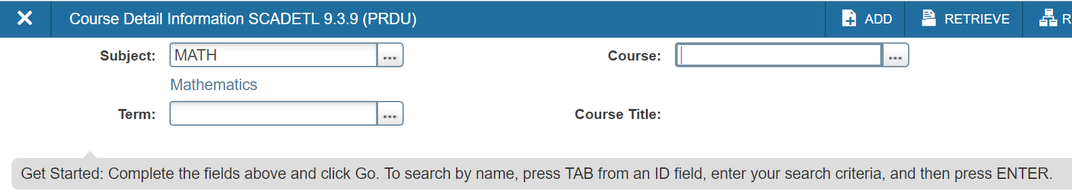

1. Type or search for Course (0999 in this case)

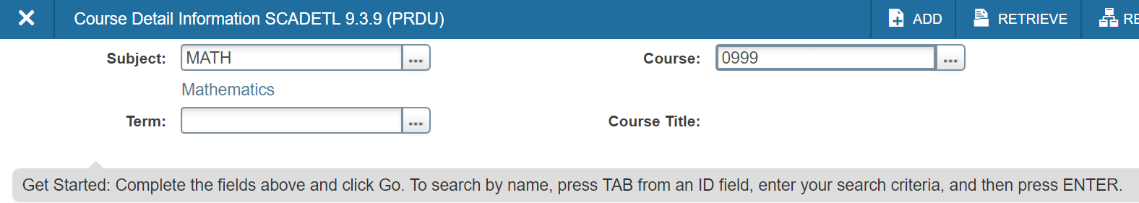

1. Type or search for the Term (Next registration term in this example is 201902 corresponding to spring 2019)

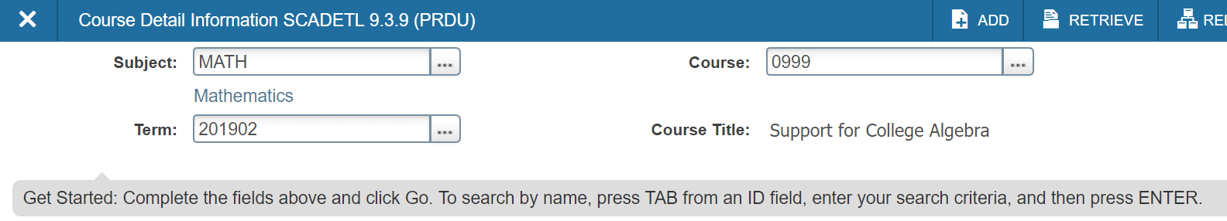

1. Click Go

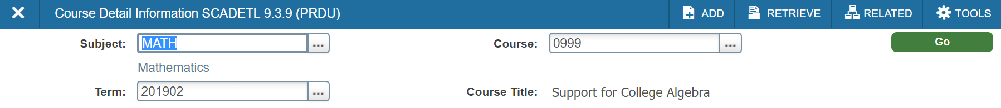

1. Under the Corequisites and Equivalents tab, select the “From Term” and “To Term” fields. Note that we will select the first term to be 201902 and this corequisite will be applicable indefinitely (denoted as Term 999999).

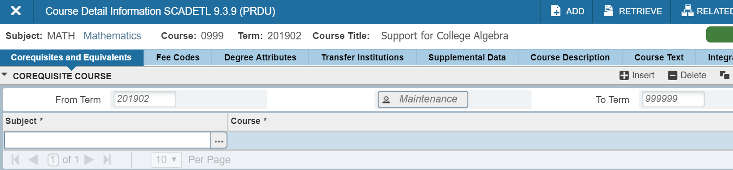

1. Type or search for Subject (MATH in this case)

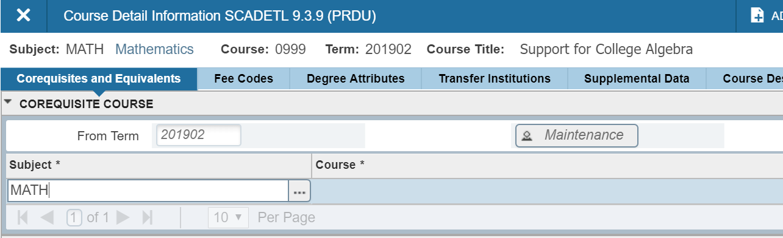

1. Press Tab on your keyboard or select the next field
2. Type or search for Course. Note that the selected course was MATH 0999 and this course must be linked to MATH 1111 so we must select 1111 in this field.

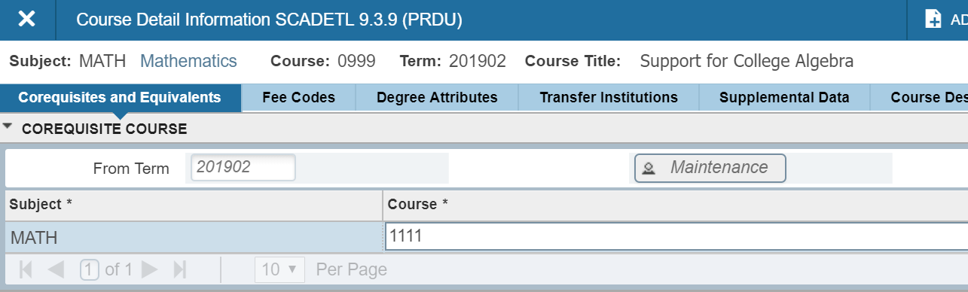

1. Click Save at the bottom right corner of the screen (or press F10)

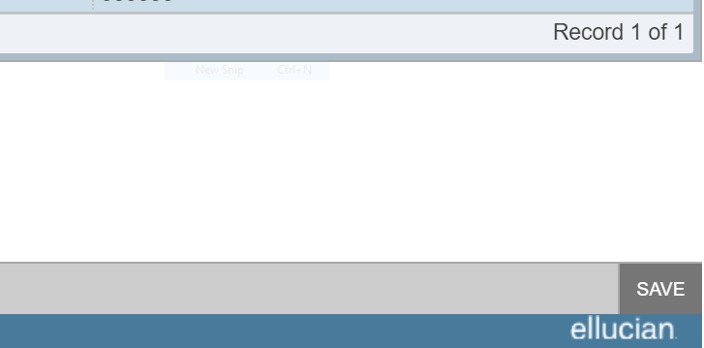

1. Corequisite at the course level has been successfully implemented. *Please note that this process needs to be performed only one time, as the course prerequisite will continue indefinitely as denoted by the term 999999. To eliminate the corequisite at the course level, you can do so by click the Maintenance button between the “From Term” and the “To Term” fields.*

**Implementing Corequisite at the SECTION Level**

Beyond the connection between courses we can use BANNER to link specific sections. This is an additional layer of connectivity for institutions in which the corequisite support course is specifically connected with a paired section of the gateway course that is traditionally taught by the same instructor. The goal is that any attempt to register a student into **CRN: 80202** MATH 0999 will require concurrent registration in **CRN: 80201** MATH 1111. *Please note that this is a requirement that needs to be imposed in MATH 0999 but not vice versa, as a student can be registered in MATH 1111 without needing the support course.*

Steps to implement corequisite at the ***section*** level:

1. Create the Gateway Course
2. Create the Support Course
3. Open SSADETL
4. Type or search the Term (Next registration term in this example is 201902 corresponding to spring 2019)

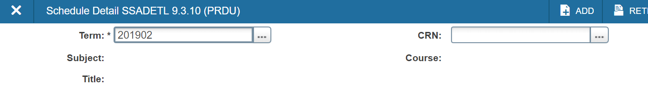

1. Type or search for the CRN of the corequisite support course (CRN: 80202 for MATH 0999)

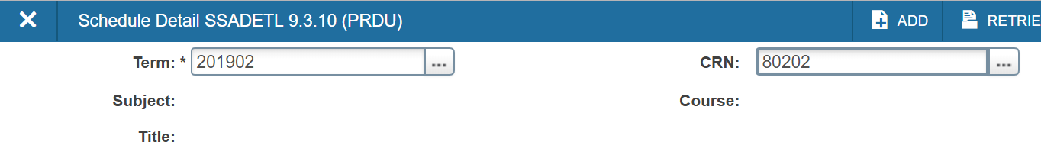

1. Click Go

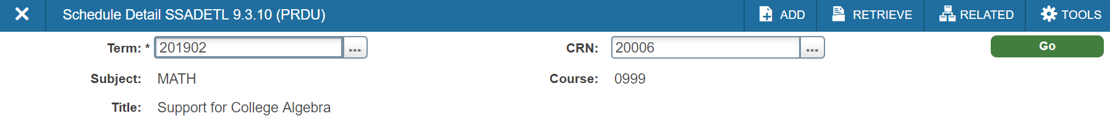

1. On the Section Link and Corequisites tab, skip the Link Connector Section and go to the Corequisites Section. Type the CRN of the MATH 1111 section that is paired with this support section

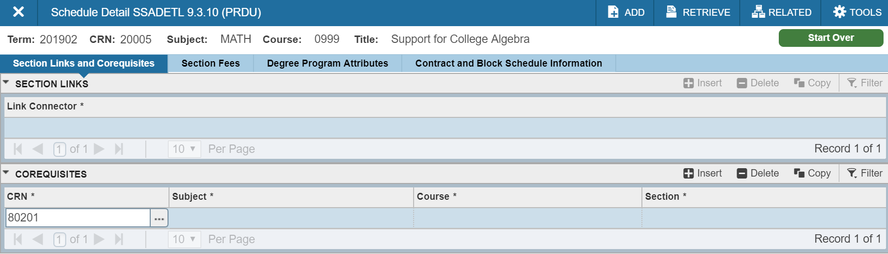

1. Press Tab, and then click Save

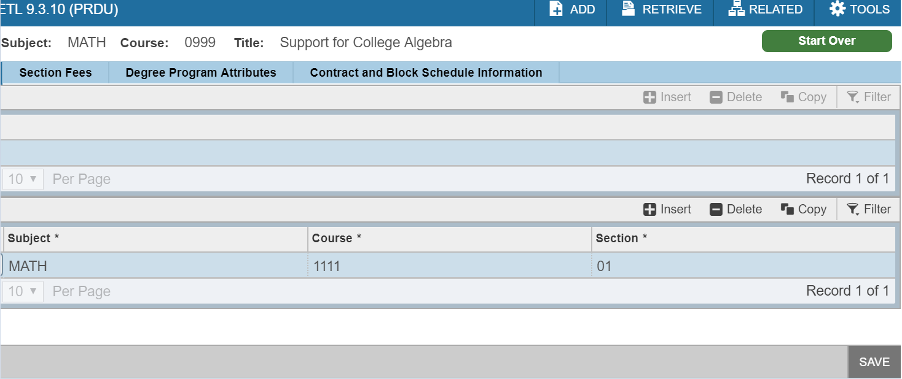

1. Corequisite at the section level has been successfully implemented. *Please remember that this process is only linking the section 80202 with the section 80201, and therefore, this process needs to be repeated for every corequisite section that we need to pair.*

**Updates and Corrections.**

May 30, 2019

* Section 1. Chained attrition – added total number of students lost between Foundations and Corequisite for English and mathematics
* Section 1. Success in Gateway Courses by Academic Preparation as Defined by ACT Scores – replaced English bar graph with correct graph. (Previously the mathematics score graph was posted for both English and mathematics.)
* Section 7. Updated placement criteria in English and Mathematics in light of new admissions criteria recently placed in BOR Policy Manual 4.2.1.1 (Freshman Requirements)
  + ACT English>=17 changed to ACT English or Reading>=17
  + SAT (new) Reading test>=24 changed to SAT (new) Evidence-Based Reading and Writing (EBRW) section>=480
  + SAT (new) Mathematics test>=22 changed to SAT (new) Mathematics section>=440 (for placement in MATH 1001 or 1101 without corequisite support or MATH 1111 with corequisite support)SAT (new) Mathematics test>=25.5 changed to SAT (new) Mathematics section>=450 (for placement in MATH 1001 or 1101 without corequisite support or MATH 1111 with corequisite support)
  + Placement Chart and Infographic updated to reflect these changes
  + Same changes made to the Fundamental Features of Corequisite Learning Support document (Appendix 1)

June 17, 2019

* Corrected error in new SAT Math Section score for direct placement in MATH 1111 College Algebra. The correct score on the new SAT math section is 510, not 450. This correction applies to
  + Section 7, direct placement in MATH 1111, as well as the chart and infographic at the end of this section.
  + Appendix 1. Section on direct placement into MATH 1111.

November 13, 2019

* Corrected legends in Section 1: Analysis of Student Success in “Follow-on” Courses.

May 14, 2020

* Throughout – Minor changes to wording to clarify meaning or correct grammatical or spelling errors.
* Throughout – Added references to MATH/STAT 1401 (which now can be offered in Area A2 and MATH/STAT 0996, which is the Corequisite Learning Support course designed to support MATH/STAT 1401.
* Cover Page – Changed title to “Corequisite” Learning Support Manual
* Section 1. Added subsections on “Move to Fully Corequisite Learning Support – Fall 2018” and “Equity.”
* Section 4. Added in terminology of “cohort” and “comingled” models.
* Section 4. Last paragraph, added in the word “collegiate” to clarify that students must complete Area A requirements by the time they have completed 30 ***collegiate*** credit hours.
* Section 5. Added course description for MATH/STAT 0996.
* Section 5. In MATH 0999 course description, converted “new” SAT Math test score to “new” SAT Math section score.
* Section 6. Added MATH/STAT 0996 and MATH/STAT 1401 as linked mathematics courses.
* Section 7. Under placement criteria for both English and mathematics, added statements that “If the RHSC in English/mathematics has not been completed, HSGPA may not be used to exempt this requirement.”
* Section 7. Under placement criteria for both English and math, added notes to clarify that “old” SAT scores may be used in calculating English and Mathematics Placement Indices and “new” SAT scores and scores on Next-Generation Accuplacer tests may not be used in calculating Placement Indices.
* Section 7. Exemption Criteria Table. Added Elementary Statistics to the listing.
* Section 7. Placement Infographic. Added MATH/STAT 1401.
* Section 9. Added new paragraph with data from fall 2018 on student success at institutions where corequisite instruction was differentiated by credit hours.
* Section 10. Added text and data on success rates in ENGL 1101 versus credit hours in ENGL 0999, use of cohort versus comingled models, same versus different instructor, alignment model, and class size.
* Section 11. Added text and data on success rates in college math versus credit hours in Learning Support math course, use of cohort versus comingled models, alignment model, and class size.
* Section 12. Added labels to Models A, B, and C as “Cohort Model,” “Comingled Model,” and “Comingled Plus Model.”
* Section 12. Added recommendation, based on fall 2018 data, against using Model D.
* Section 13, Added recommendations on class sizes for Corequisite Learning Support sections in English and mathematics.
* Section 15E. Added specific recommendations for CIP codes for Learning Support English and mathematics courses.
* Section 18. Added clarification for the 30 hour rule to clarify that it applies to 30 collegiate credit hours.
* Section 20. Renumbered references to the Academic and Student Affairs Handbook to reflect numbering changes in the Academic and Student Affairs Handbook.
* Appendix 1. General Requirements section: Added in terminology of “cohort” and “comingled” models.
* Appendix 1. General Requirements section: Added clarification for the 30 hour rule to clarify that it applies to 30 collegiate credit hours.
* Appendix 1. English section: Added statement that “If the RHSC in English has not been completed, HSGPA may not be used to exempt this requirement.”
* Appendix 1. English section: Added notes to clarify that “old” SAT scores may be used in calculating the English Placement Index and “new” SAT scores and scores on Next-Generation Accuplacer tests may not be used in calculating Placement Indices.
* Appendix 1. Mathematics section: Added statements that “If the RHSC in mathematics has not been completed, HSGPA may not be used to exempt this requirement.”
* Appendix 1. Mathematics section: Added notes to clarify that “old” SAT scores may be used in calculating the Mathematics Placement Index and “new” SAT scores and scores on Next-Generation Accuplacer tests may not be used in calculating Placement Indices.
* Appendix 1. Mathematics section. MATH 0999 Prerequisites: Converted “new” SAT Math test score to “new” SAT Math section score.

May 26, 2021

* Section 4. Corequisite Learning Support: Added the following clarification to the 4th paragraph “Students must enroll in both the corequisite Learning Support course and the collegiate course every semester until they pass the collegiate course, even if they have passed the corequisite Learning Support course one or more times.”

June 2, 2021

* Section 5. Numbering of Learning Support Courses: Added MATH/STAT 1401 as a possible qualifying course to get into MATH 0999, Support for College Algebra.
* Section 7. Placement: In “Criteria for Placement into MATH 1111 with Corequisite Learning Support:” added “Student already has credit for MATH 1001 Quantitative Reasoning, MATH 1101 Introduction to Mathematical Modeling, or MATH/STAT 1401 Elementary Statistics.”
* Section 7. Placement: In “Criteria for Direct Placement into MATH 1111:” Added MATH/STAT 1401 as course that will allow direct placement into MATH 1111 without corequisite support.
* Section 7. Placement: Placement Infographic: Added MATH/STAT 1401 to the list of courses where transferable credit will allow students to exempt placement in Corequisite Learning Support for MATH 1111.
* Section 15. Other Banner Considerations: F. Setting up Corequisite Learning Support Prerequisites for Collegiate Course in Banner. Added MATH/STAT 1401 to the LSM2 list.

July 13, 2021

* Section 5. Numbering of Learning Support Courses: Corrects Accuplacer Next-Generation Quantitative Reasoning, Algebra, and Statistics score to **258** or higher.

October 26, 2021

* Section 7. Placement: Updated all High School Grade Point Averages (HSGPA) in this section to reflect the COVID/Post-COVID minima currently in use. These COVID/Post-COVID HSGPA minimums will remain in place until further notice. These changes are summarized in the table below.

|  |  |  |
| --- | --- | --- |
|  | **COVID/Post-COVID minimums** | **Pre-COVID minimums** |
| **English** | **>= 2.5** | **>= 3.1** |
| **MATH 1001, MATH 1101, MATH/STAT 1401** | **>= 2.5** | **>= 3.2** |
| **MATH 1111 with Corequisite Support** | **>= 2.5** | **>= 3.2** |
| **MATH 1111** | **>= 2.8** | **>= 3.4** |

November 9, 2021

* Section 4. Corequisite Learning Support: Updated the statement (at the end of the section) about the “30-hour rule” to clarify that the “30 hours” refers to 30 collegiate credit hours; hours earned in Corequisite Learning Support courses are not counted toward the 30 hours.

March 28, 2023

* Section 7. Placement: Updated all High School Grade Point Averages (HSGPA) in this section to reflect the Post-Covid minima currently in use. These changes are summarized in the table below.

|  |  |  |  |
| --- | --- | --- | --- |
|  | **Pre-COVID minimums** | **COVID minimums** | **Post-COVID minimums** |
| **English** | **>= 3.1** | **>= 2.5** | **>= 2.7** |
| **MATH 1001, MATH 1101, MATH/STAT 1401** | **>= 3.2** | **>= 2.5** | **>= 3.1** |
| **MATH 1111 with Corequisite Support** | **>= 3.2** | **>= 2.5** | **>= 3.1** |
| **MATH 1111** | **>= 3.4** | **>= 2.8** | **>= 3.2** |

Also made changes to this section to clarify that students who do not meet any exemption criteria cannot be placed in MATH 1111, only in MATH 1001, 1101, or MATH/STAT 1401.

Placement infographic on page 30 has not yet been updated.

May 18, 2023

Updated the placement infographic on page 30 to show new HSGPA cut scores.