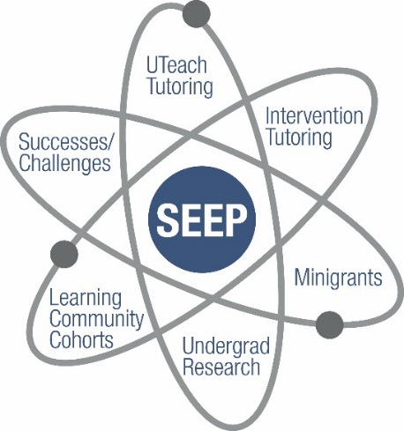

The University of West Georgia (UWG) Stem Education Enhancement Plan (SEEP) was designed to continue using the best practices from UWise (the previously funded USG STEM Initiative grant at UWG) while implementing new strategies that will continue to enhance student success:
* Intervention tutoring in Mathematics: This program started as part of a research experience in the scholarship of teaching under UWise. Students are tested at the beginning of the semester to categorize their risk of failure as high, moderate, or low. Moderate-risk students are directed to participate in SI (Supplemental Instruction) sessions run by our Center for Academic Success, while high-risk students receive individual tutoring.
* Faculty mini-grants: These grants are intended to support STEM faculty in improving course design and delivery. Proposals are evaluated by the SEEP committee in a competitive process. Projects supported thus far include a redesign of the analytical chemistry lab experience, concept mapping approaches to note taking in core biology courses, project-based instruction in physics, the use of supplemental videos and computer assignments in core math courses, and the development of an organic chemistry course for biology majors.
* Mentoring through undergraduate research: In this program, faculty receive funds for their research project and a student stipend for a freshman or sophomore who is mentored by an upper-level student with research experience. A poster presentation at the UWG Scholars Day Conference is required for assessment and dissemination. Seven projects have been supported thus far – three in Biology, two in Chemistry, one in Geosciences, and one in Physics.
* Uteach tutoring: UWG has been preparing STEM secondary education teachers preparation under the prestigious UTeach program since 2011 when UWG was selected as replication site for the program. Students in the UTeach program often need tutoring in specific upper-level STEM courses. One mathematics major and one chemistry major (minor in biology) were hired to tutor students for a couple of hours a week.
* Learning Community: Science of Sustainability: A learning community of STEM majors is being developed for the coming academic year. In the fall, 69 STEM freshmen will enroll in English, Mathematics, and an interdisciplinary core class on the science of sustainability. Several guest speakers will come to the UWG campus and offer extra-curricular activities. The English courses (developed under the support of the UWise program) are designed for STEM students and focus on science-related themes.

