The Lexile Framework and GALILEO
GALILEO Can Help You Find Books and Articles by Their Lexile Score

The Lexile Framework is a tool that links readers and text with a metric called Lexile. A Lexile is a standard score that matches a student’s reading ability with difficulty of reading material.

Look for Lexile scores in these GALILEO databases –
NoveList and NoveList K-8  Fiction titles listed in NoveList databases include their assigned Lexile score. You can find the Lexile for a specific book or you can search for books within a specified Lexile range that match the subject, author, series, or other terms of interest to the reader. NoveList folder function allows you to create and save book lists based on various criteria, including Lexile ranges and maturity level. | 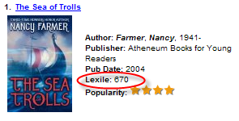
SIRS Databases  - SIRS Discoverer (elementary and middle)  - SIRS Researcher (high school)  In both databases, users can limit a search on any topic to a specific Lexile range using the Advanced Search feature. Once a set of results is retrieved, the results can be sorted by Lexile score. The citation for each article includes the Lexile indicator underlined for easy identification.  - Ppt for Lexiles and ProQuest  http://www.proquestk12.com/go/LexilesOverview | 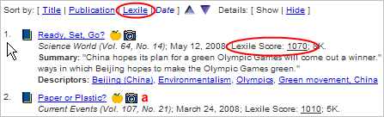
EBSCO Databases  - MASUltra  - Middle Search Plus  - Primary Search  - TOPICSearch  Portals that access the above databases include the Student Research Center for middle/high, and Kids Search for elementary/middle, and Searchasaurus for primary/ elementary. Students and teachers can search for topics within a specified Lexile range. Each citation in a results list specifies the Lexile indicator, which is hyperlinked to a Lexile rankings map. | 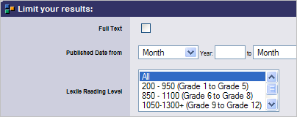

The Lexile Framework for Reading
From the Lexile.com website:

What is The Lexile Framework for Reading?
The Lexile Framework® for Reading is a scientific approach to reading and text measurement. It includes the Lexile® measure and the Lexile scale. The Lexile measure is a reading ability or text difficulty score followed by an “L” (e.g., “850L”). The Lexile scale is a developmental scale for reading ranging from below 200L for beginning-reader material to above 1700L for advanced text. All Lexile Framework products, tools and services rely on the Lexile measure and scale to match reader and text.

How is a text's Lexile measure determined?
Lexile measures are based on two well-established predictors of how difficult a text is to comprehend: semantic difficulty (word frequency) and syntactic complexity (sentence length). In order to Lexile a book or article, text is split into 125-word slices. Each slice is compared to the nearly 600-million word Lexile corpus – taken from a variety of sources and genres – and words in each sentence are counted. These calculations are put into the Lexile equation. Then, each slice’s resulting Lexile measure is applied to the Rasch psychometric model to determine the Lexile measure for the entire text.

For example, books like "Arthur and the Recess Rookie" (370L), "Arthur Goes to Camp" (380L) and "Arthur, Clean Your Room!" (370L) fall within the Lexile Range of a typical second grader. These books have shorter sentences and words appear frequently. Conversely, books in the "Harry Potter" series (which measure between 880L and 950L), "Little Women" (1300L) and "Don Quixote" (1410L) contain longer sentences and more complex words.

From the GaDOE website:
http://public.doe.k12.ga.us/lexile.aspx
The Lexile Framework is an educational tool that links text and readers under a common metric known as the Lexile.The Georgia Department of Education has worked with MetaMetrics, the developers of the Lexile Framework, to customize a "map" that provides a graphic representation of texts and titles matched to appropriate levels of reading ability.
To see the map, visit:
http://public.doe.k12.ga.us/DMGetDocument.aspx/GA-LexileMap-FINAL_2-27-06.pdf?p=39EF345AE192D900F620BFDE9C014CE65F48E7E4CC653240EBCFB76B1C2F47368CDB53B3758CEB56&Type=D



