GALILEO Express Links
Linking Your Patrons Directly to the Best of GALILEO

Instructions developed by Andy Spinks, Lead Librarian
Wheeler High School Library, Cobb County School System

What are Express Links?
Express Links are special URLs that point directly to individual resources within GALILEO. For example, http://www.galileo.usg.edu/express?link=zbmp is a link that goes directly to the MasterFILE Premier database, bypassing the GALILEO homepage.

Why use Express Links?
GALILEO is a wonderful collection of resources, available to every library patron in Georgia. However, most patrons only need a fraction of the resources that are available to them, and some patrons can get lost trying to find the best resources for their needs. This situation results in unsatisfied patrons and under-use of GALILEO.

Express Links allow library professionals to send patrons directly to the information they need, bypassing the one-size-fits-all interface.

How can I use Express Links?
Anything you can do with a regular URL, you can do with an Express Link:
- Make a favorite, a bookmark, or a shortcut.
- Set one as your browser’s default start page.
- Email them to patrons or a colleagues.
- Add them to your library web page
- Insert them in a Word, PowerPoint, or Acrobat document.

This flexibility allows for myriad applications:
- Customize your library computers with toolbar buttons, favorites, bookmarks, or desktop shortcuts to the best databases for your patrons.
- Create a custom GALILEO page for your library, or create individual custom pages for different patron groups or even for individual projects.
- Create an electronic research guide for a specific subject (i.e. current events, psychology, Georgia history) with direct links to the best databases for that subject.
- Answer an email query (i.e. Where can I find education journal articles?) with a direct link to the appropriate database(s).

How should I prepare to implement Express Links?
First, make a list of the distinct groups of patrons your library serves: elementary students, adults, business majors, teachers, historians, etc. Next, make a list of the GALILEO resources each group patron needs. For a complete list of databases available to you, go to the GALILEO home page (www.galileo.usg.edu) and click on “Databases A-Z”.

My Patron Groups

- HS students

- Teachers

Resources for HS Students

- MasterFILE
- MAS Ultra
- Academic Search
- CollegeSource

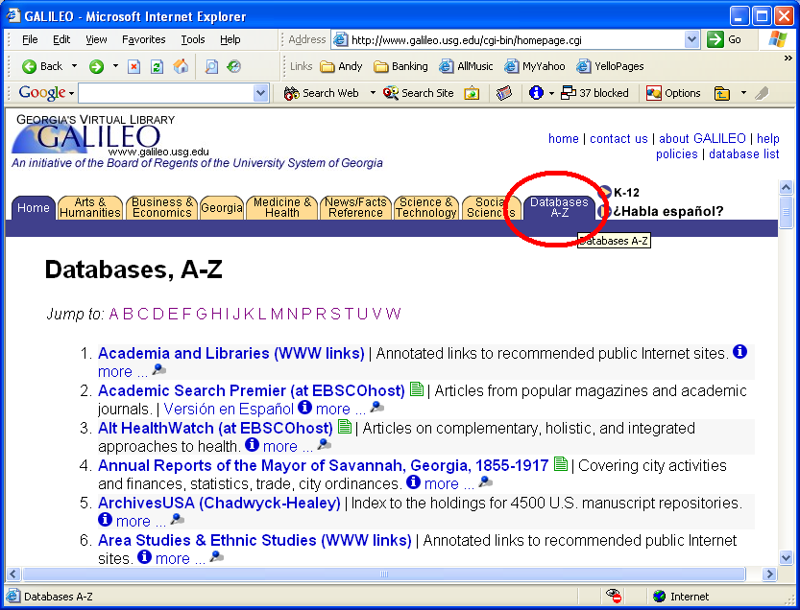

How do I find the Express Links for my resources?

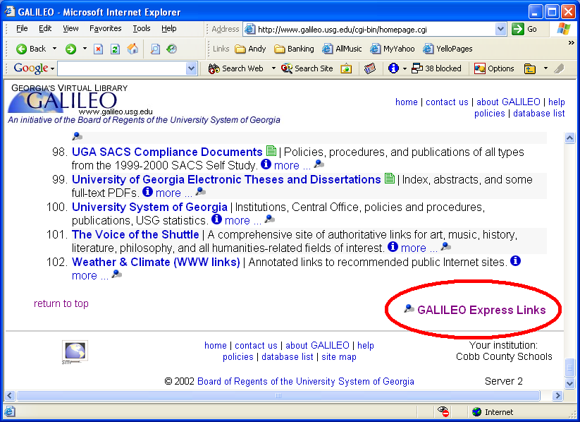
- On the Databases A-Z page, scroll to the bottom of the page.
- Click on “GALILEO Express Links” in the bottom right corner.
- This is the GALILEO Express Links page. Scroll down the page to the “Sitebuilding Options” section.
- Click on “Generate a formatted list of links for all databases for your institution.”
- The page that loads will be an A-Z list of Express Links for all the databases available to you.

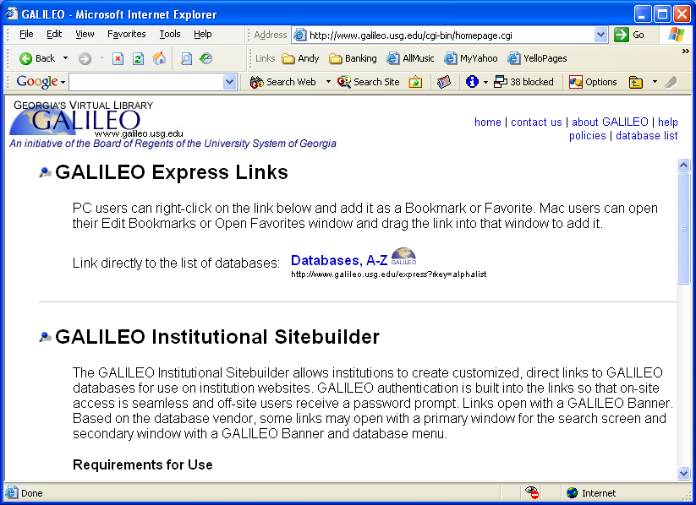
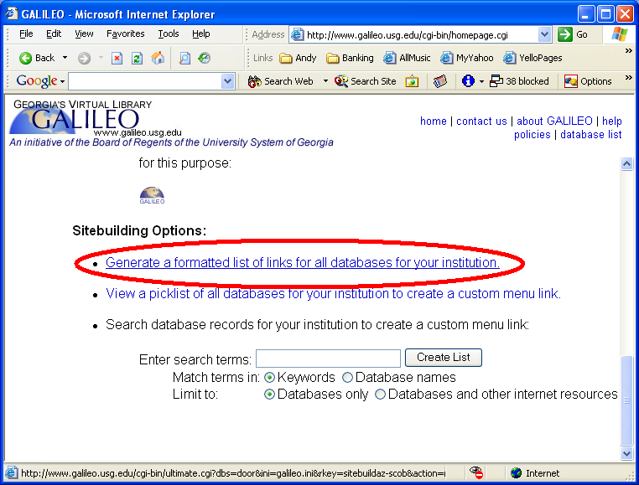
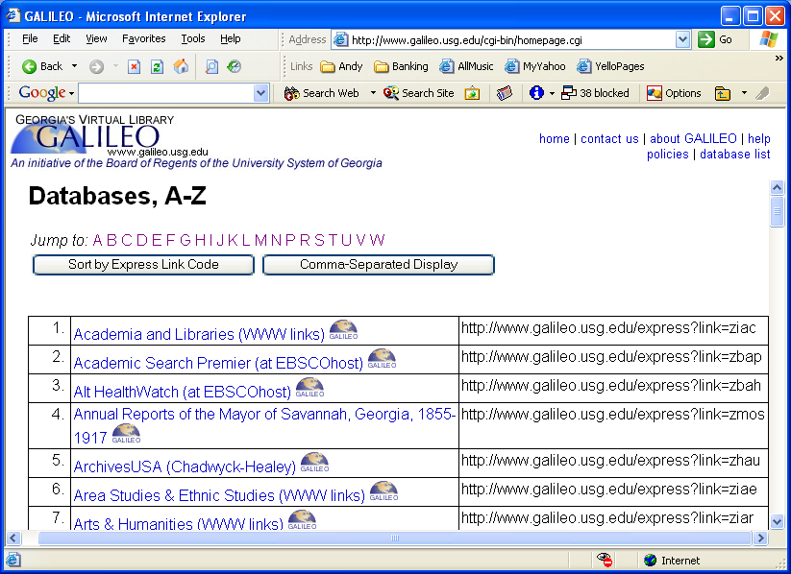

How do I use individual Express Links?
After locating the A-Z list of Express Links (see previous page), you can use the links on this page in a number of ways. Try these for starters:

- Grab one of the links (in the left column) with your mouse & drag it to the links toolbar or to the desktop as a shortcut.
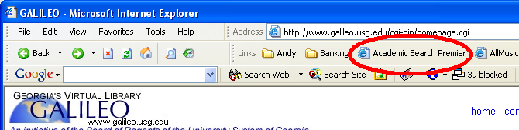

- Right-click on a link and choose “Add to Favorites.”
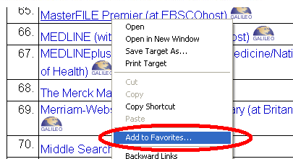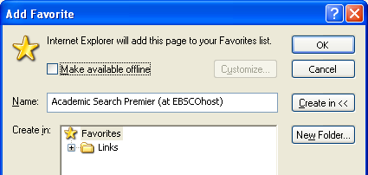

- Right-click on a link and choose “Copy Shortcut.” Paste the link into an email message.
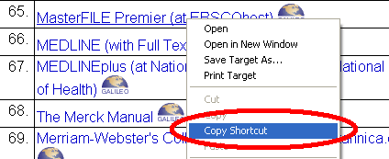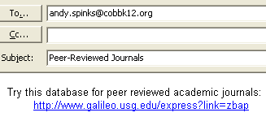

- Right-click on a link and choose “Copy Shortcut.” Then right-click on your desktop or an open folder and choose “Paste Shortcut.”
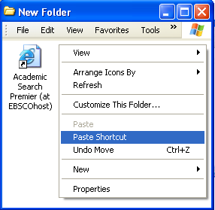

- Highlight the text of a link. Go to “Edit” menu and choose “Copy.” Open a document in Word, PowerPoint, FrontPage etc. Right-click where you want the link to go, then choose “Paste.”
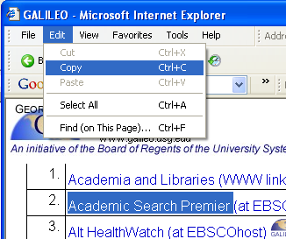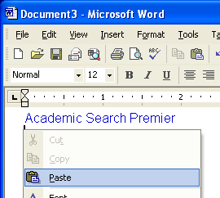

How do I create a custom GALILEO page?

Using the Express Links feature, you can also create a link to a list of databases that you select. You can use it to create a customized GALILEO homepage for your institution or to assemble a “bookcart” of appropriate databases for a group of patrons (psychology majors, middle school students, etc.)

- Begin by going back to the GALILEO Express Links page. (See “How do I find the Express Links for my resources?” above.)
- Scroll down the page to the “Sitebuilding Option” section and click on
“View a picklist of all databases for your institution to create a custom menu link.”
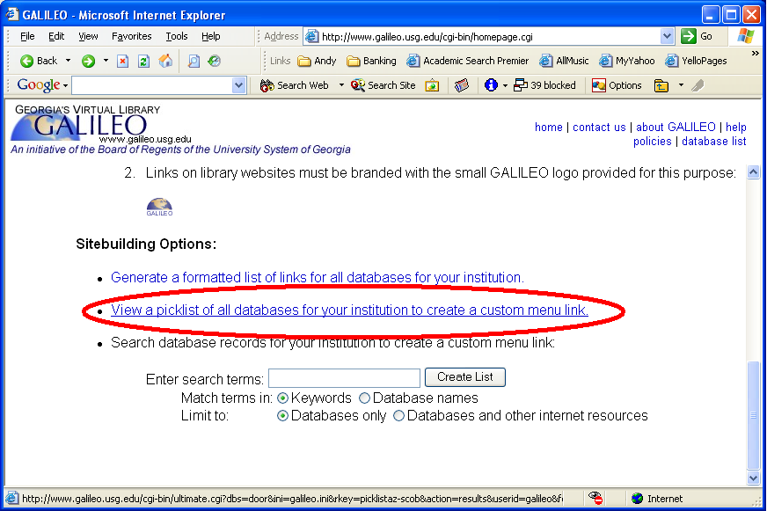

- Place a check in the box beside each of the desired resources, then click “Create List”
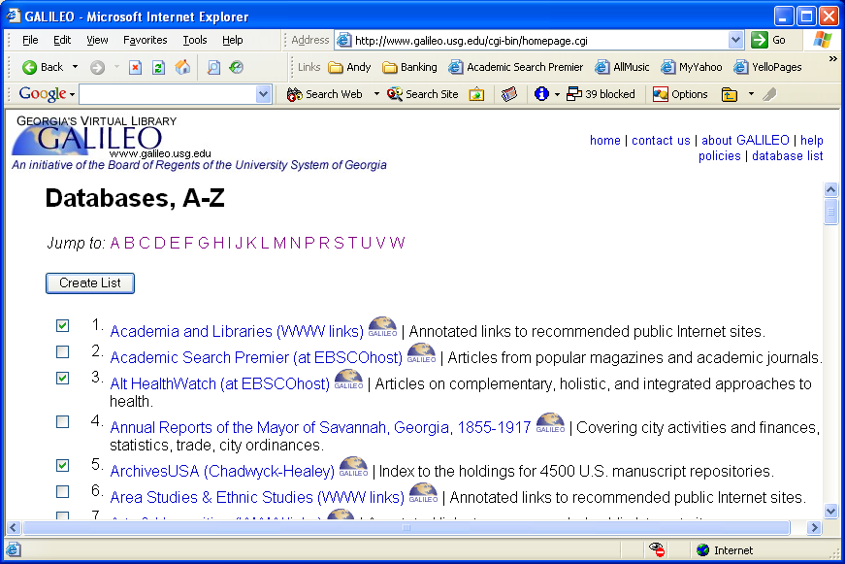

- This will create a preview of your list (AKA your “custom” GALILEO home page). In order to “save” your list, you simply create an Express Link to it. Click on “GALILEO Express Links” in the lower-right corner of the page.

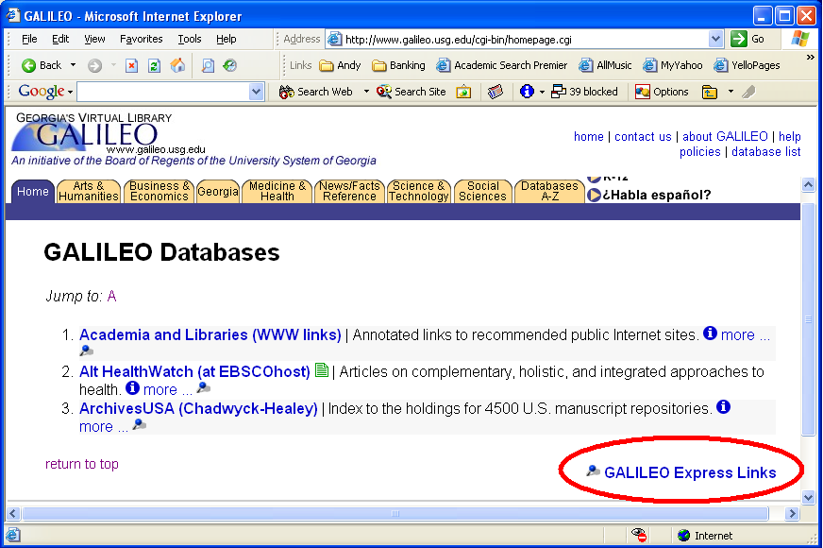

- This will generate a special link that instructs GALILEO how to build your custom list. Use the link called “GALILEO Databases” in the top center of the page to create favorites, shortcuts, etc. to your custom list. This link is the URL to your “custom” GALILEO page!

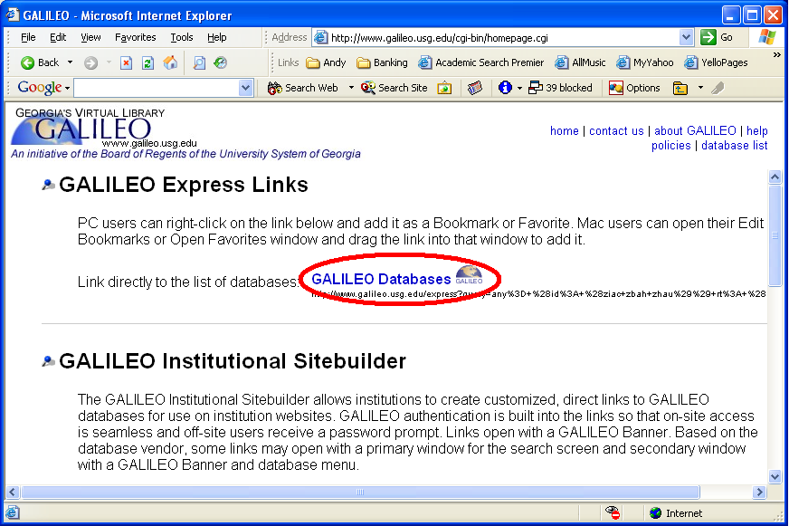

How do I integrate GALILEO databases with my other resources?
If you have other online resources (such as web sites or subscription databases) that you use alongside GALILEO, there are several options for integrating GALILEO with these resources.

Probably the most flexible option is to create a web page with links both to GALILEO databases and to the other online resources. Many libraries already have a page with links to their research sources, now they can replace the generic link to the GALILEO home page with Express Links to the best resources for their patrons!

One example of such a page is “Wheeler Research Central,” a custom research portal used at the Wheeler High School library in Cobb County. (Go to www.wheelerhigh.com , click on “Academics,” then “Library,” then “Wheeler Research Central.”) The site integrates GALILEO Express Links, local subscription databases, free internet sites, and local school content.

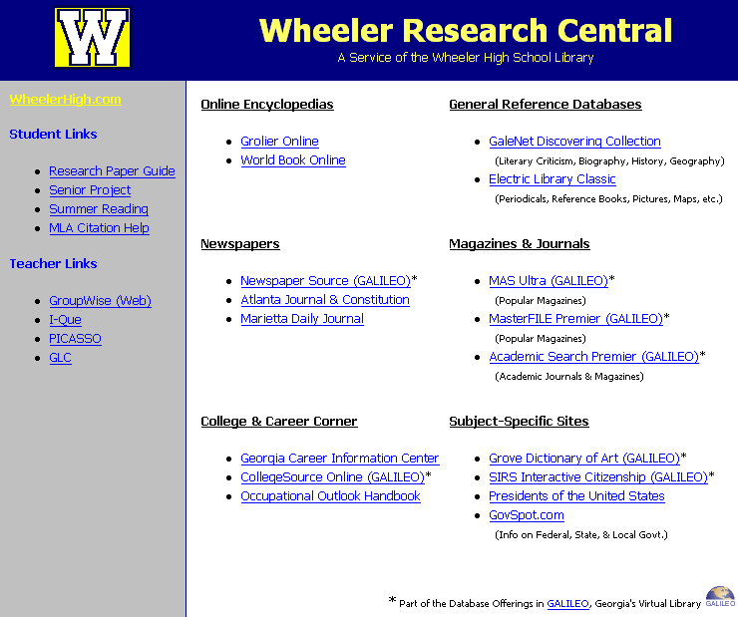

If you have the ability to create web pages and upload them to your library web site, you can build a site like Wheeler Research Central for your patrons.

- Use the Express Links feature to copy links to the desired databases & paste them into your web page editor. See “How do I use individual Express Links?” above for instructions.
- You must also add GALILEO branding to the Express Links on your page. You must add either the text “Part of the Database Offerings in GALILEO, Georgia's Virtual Library” or the small GALILEO image to your page. For more information, read the “GALILEO Institutional Sitebuilder” section on the Express Links page in GALILEO.
- When patrons use Express Links from off-campus computers, they will automatically be prompted for the current GALILEO password.

If you are the GALILEO administrator for your school system or library system, you also have a few additional options that allow you to integrate other resources into your GALILEO page.

- Start by adding a “Local Resources” button to your GALILEO interface. From the GALILEO home page, click on “About GALILEO,” then “Resources for GALILEO Librarians,” then “Local Resources Button.” This will give you all the information you need to get started.
- You can also add links to individual local resources with GLRI, GALILEO Local Resource Integration. However, you must participate in a full-day training session to use this feature.

