eProcurement and GeorgiaFIRST Marketplace
User’s Guide
for
Local Security Administrator

This page left blank for printing purposes.

Table of Contents
Table of Contents 3
Introduction 5
Chapter 1: eProcurement and GeorgiaFIRST Marketplace Overview 6
What is eProcurement? 6
What is the GeorgiaFIRST Marketplace? 6
Types of Requisitions 6
Benefits of ePro and the GeorgiaFIRST Marketplace 7
Types of Roles Involved 7
Process Flow 8
Chapter 2: eProcurement Approvals 9
How Do Approvals Work? 9
Approval Stages 9
Approval Time Limits 14
Chapter 3: Basic Security Functions 15
Adding a New User to the System 15
How To: Add a New User Profile 17
User Preferences 19
How To: Update User Preferences 20
Account Lockout 21
How To: Unlock a User Account 21
Reset Password 22
How To: Reset a User’s Password 22
Updating a User’s Email Address 22
How To: Update a User’s Email Address 23
Multi-Campus Approvers 23
Chapter 4: Shopper Setup 24
Shopper Security Roles 24
Shopper Setup as Requester in ePro 24
How To: Set Up a Shopper as a Requester in ePro 26
Chapter 5: Requester Setup 28
Requester Security Roles 28
Requester Setup 28
How To: Set Up a Requester 29
User Preferences for Requesters 30
Chapter 6: Buyer Setup 33
Buyer Security Roles 33
Buyer Setup 34
How To: Set Up a Buyer 34
User Preferences for a Buyer 35
How To: Add User Preferences for a Buyer 38
Chapter 7: ePro Administrator Setup 40
ePro Admin Security Roles 40
User Preferences for the ePro Admin 40
How To: Add User Preferences for an ePro Admin 41
Chapter 8: Approver Setup 42
Basic Approver Security Roles 42
Special Item Approver Security Roles 42
How To: Add User Preferences for an Approver 46
Chapter 9: Department and Project Manager Setup 47
Department Manager ID 47
How To: Update a Department Manager ID 47
Additional Department Managers 48
How To: Update Additional Department Managers 49
Project Manager ID 49

Introduction
This user guide is designed for Local Security Administrators who will be supporting the implementation and maintenance of the PeopleSoft Financials module eProcurement, or ePro, at their institution. Along with the implementation of ePro, the GeorgiaFIRST Marketplace is being implemented as well.
In this user’s guide, you will find an overview of what the eProcurement module does, as well as what the function of the GeorgiaFIRST Marketplace is. You will also learn the primary role that the Local Security Administrator plays in the entire process.
Topics Included in this User’s Guide:
- eProcurement and GeorgiaFIRST Marketplace overview
- How eProcurement approvals work
- Performance of basic security functions
- Setting up Shoppers
- Setting up Requesters
- Setting up Buyers
- Setting up ePro Administrators
- Setting up Approvers
- Department and Project Manager Setup
In addition to this user’s guide, there is a Security Job Aid that is available to help you set up ePro users. You can find this job aid at http://www.usg.edu/gafirst-fin/documentation/job_aids/category/security/.

Chapter 1: eProcurement and GeorgiaFIRST Marketplace Overview
What is eProcurement?
eProcurement (ePro) is a module in PeopleSoft Financials that has a primary function of creating electronic requisitions and routing them for approval. In this PSFIN module, ePro is used to create requisitions for goods and services. A requisition is simply an official request to purchase goods and services.
Previously, your institution may have used paper requisitions, or some other format, to request an item to be purchased. That hardcopy requisition then had to be routed for approval signatures, and then sent to the Purchasing Office. The Purchasing Office then had to rekey the information into the system to create a Purchase Order to send to the vendor.
With ePro, much of this is completely automated. A requisition is created within ePro and then electronically routed for approval. The approval chain is dependent on the Department charged and item type, among other things. Finally, after the last electronic approval is made, the requisition can be copied into, or sourced into an official Purchase Order that is dispatched to a vendor.
What is the GeorgiaFIRST Marketplace?
The GeorgiaFIRST Marketplace takes the use of ePro to another level. The GeorgiaFIRST Marketplace is an online shopping site that is accessed from PeopleSoft Financials. Through this online shopping site, users can shop online for contract items from a variety of state and institution approved vendors. Users can select items by placing them in an online shopping cart. They assign these shopping carts to a designated requester when ready, and the requester then turns their shopping cart into an ePro requisition.
Because users are shopping from approved vendors with contract prices, very little buyer intervention is required. After a requisition that is built from the GeorgiaFIRST Marketplace is approved, it is designed to be picked up for batch processing that will budget check it, source it into a purchase order, and then dispatch the purchase order. These batch processes are designed to run at different times throughout the day.
Types of Requisitions
With the implementation of the GeorgiaFIRST Marketplace into the eProcurement module, there are now two types of requisitions: GeorgiaFIRST Marketplace requisitions and Special Request Requisitions.
- GeorgiaFIRST Marketplace Requisition (CAT Origin requisition): Shoppers build a requisition from items in the GeorgiaFIRST marketplace.
- Special Request Requisition (ONL Origin requisition): Requesters build this type of requisition by manually entering items directly into the requisition. This type of requisition is not built from the contractually-approved items in the Marketplace.
Within ePro, users will not be able to combine items from the GeorgiaFIRST Marketplace with items from a Special Request Requisition into one requisition. Each requisition must be completely either from the Marketplace (CAT) or from a Special Request Requisition (ONL).
Benefits of ePro and the GeorgiaFIRST Marketplace
With this new system of online shopping and electronic requisitioning, you will see some immediate benefits, including:
- Reduction in paper forms routing through different offices
- Online browsing and shopping for items
- Comparison shopping
- You only need one login to shop from multiple vendors
- You can request goods from multiple vendors through one shopping cart
- All items in the GeorgiaFIRST Marketplace are contractually approved items
- Faster routing for approvals
- Ability to save items as ‘favorites’ in the GeorgiaFIRST Marketplace
- Automatic batch processing of approved requisitions
Types of Roles Involved
In order for the ePro and GeorgiaFIRST Marketplace functionality to work properly, users are set up with specific roles and responsibilities. They include:
- Marketplace Browser: User without any GeorgiaFIRST Marketplace roles assigned will default to a Marketplace Browser. A Browser can view items, contracts, and pricing in the Marketplace but cannot add items to a cart, or create requisitions.
- Shopper: User who can select items to purchase, add them to a cart, and assign that cart to a Requester for further processing. This type of user cannot create a requisition in PeopleSoft.
- Requester: User who can perform all functions that a Shopper can, with the added permissions to be able to create the actual requisition in PeopleSoft.
- Approver: User with the permissions and roles necessary to approve ePro requisitions.
- Buyer: User responsible for ensuring approved requisitions are sourced into a purchase order and dispatched to the supplier.
- Accounts Payable: The accounts payable department is responsible for building electronic invoices that are sent from GeorgiaFIRST Marketplace suppliers.
- ePro Administrator: This user monitors approval workflow to ensure requisitions are worked in a timely fashion.
- Local Security Administrator: This user is responsible for setting up other users with the appropriate roles, permissions, and user preferences.
As the Local Security Administrator, you are primarily responsible for setting up users with the proper roles and access. In addition, you will need to work with the ePro Administrator occasionally to perform maintenance on these users, such as updating email addresses. Since Workflow is such a critical piece of eProcurement, the user setup is very important.
Process Flow
Now that you know all of the roles involved, it is helpful to understand the eProcurement and GeorgiaFIRST Marketplace process flow beginning with Shoppers and ending with the Accounts Payable office.
Shoppers use the GeorgiaFIRST Marketplace to select goods they request to have purchased
Shoppers assign their completed shopping carts to their assigned Requester
The Requester is notified by email of this newly assigned cart
The Requester logs into the system and pulls the Shopper’s cart into a Requisition
The Requester finishes the requisition and submits it for approval
The Approvers (determined by various factors) either approve or deny the requisition lines
Once fully approved, the PeopleSoft Financials system automatically budget checks the requisition
Once the requisition has a valid budget check status, the PeopleSoft Financials system automatically sources the requisition into a purchase order and dispatches it to the vendor
The vendor fulfills the order and sends the item and invoice to the Institution
The institution receives the item; receipt is created in PSFIN
The AP Office pays the invoice
If the process involves a Special Request Requisition, then the shopper is eliminated from this process flow and the requester enters the items directly onto the requisition.

Chapter 2: eProcurement Approvals
A critical component to the whole eProcurement process is the ability to submit requisitions for approval electronically. Because approvals are handled online within the PeopleSoft Financials system, each institution can customize the approval process to their own specifications. In this chapter, we are going to outline the possible approval stages that your institution may choose to use.
How Do Approvals Work?
As mentioned earlier, a Requester creates a requisition in ePro. Each item on a requisition is placed on its own requisition line. Each distribution line on a requisition may be charged to a different set of ChartFields. Therefore, there may be different approval paths for each line on a requisition depending on a variety of elements.
Once the Requester submits the requisition for approval, each line has its own approval path. This approval path is determined by a number of factors. At a minimum, each requisition line will go to the Department Manager and Project Manager (if a Project is to be charged). These are the managers that are tied into the Department and Project ChartFields on that requisition line.
Depending on how your institution has set up approvals for eProcurement, the requisition line may go to many additional approvers as well. This includes approvers for assets, IT items, and items above a certain amount, if desired. Below is a summary of all of the approval stages and paths available for eProcurement. To determine which stages and paths your institution is currently using, check with your purchasing department or Local Security Administrator.
Approval Stages
Overall, there are five approval stages that can be used for eProcurement requisitions. They include:
- Stage 1: Department and Project Approval
- Stage 2: Fund Approvals (Agency, Grant, Technology Fee)
- Stage 3: Amount Approval (for requisitions built from the GeorgiaFIRST Marketplace)
- Stage 4: Item Type-Based Approvals
- Stage 5: Buyer Approval (for requisitions not built from the GeorgiaFIRST Marketplace)
Here is a summary of each stage:

Stage 1: Department and Project Approval
This is a mandatory approval stage for all requisition lines. Each requisition line must be charged to a Department. In addition, requisition lines can be charged to a Project. The requisition line is routed to the Department Manager (as entered in PeopleSoft) for approval. If the Project ChartField is used on the requisition line, the system also routes it to the Project Manager.
Stage 2: Fund Approval
This approval stage is optional.
Agency Fund Approval:
Agency Fund Approval is set up so that any requisition line charged to an Agency Fund Code must go to an individual specified for Agency Fund Approvals. Agency funds are used to account for resources held by an institution as custodian or fiscal agent for individual students, faculty, staff members, or other organizations. Agency Fund Codes include 60000, 61000, and 62000.
Grant Fund Approval:
Grant Fund Approval is set up so that any requisition line charged to fund 20000 must go to an individual specified for Grant Fund Approvals.
Tech Fee Fund Approval:
Tech Fee Fund Approval is set up so that any requisition line charged to fund 16000 must go to an individual specified for Tech Fee Fund Approvals.
If your institution chooses to employ the Fund Approval stage, there may be multiple Agency Fund Approvers, Grant Fund Approvers, and Tech Fee Fund Approvers. Each Agency Fund Approver will have the role BOR_AGENCY_FUND_APPR, each Grant Fund Approver will have the role BOR_GRANT_APPR, and each Tech Fee Fund Approver will have the role BOR_TECH_FEE_APPR. The institution will determine whether all fund approvers must approve the requisition or if only one from the group of multiple approvers has to approve it. If any of the above mentioned fund codes are not used on a requisition line, the system bypasses this approval stage.
Stage 3: Amount Approval
The Amount Approval stage is also an optional one. This stage is for all requisitions that were built from the GeorgiaFIRST Marketplace, although you may choose to have it implemented for your Special Request requisitions as well. Institutions have the following options when using Amount Approval and may select one of the options below:
- If the monetary amount is $10,000 or more per line, route to Amount Approver.
- If the total monetary amount of the requisition is $10,000 or more, route to Amount Approver and have a monetary amount of $10,000 or more per line.
Again, your institution may set up multiple approvers to serve as the Amount Approver. Each Amount Approver will have the role BOR_EP_CAT_AMOUNT_APPR. The institution will determine whether all amount approvers must approve the requisition or whether only one from a group of multiple approvers has to approve it. The institution does not have to use the $10,000 threshold and can edit this if needed.
If the requisition was not generated from the GeorgiaFIRST Marketplace, it will bypass this approval stage (this can be changed by the institution). If the requisition is below the set threshold and was generated from the GeorgiaFIRST Marketplace, it will also bypass this approval stage.
Stage 4: Item Type-Based Approvals
In Approval Stage 4, approvals are based upon the type of item being requested. Within this stage, there are seven potential approval paths. Each path is optional for the institutions.
- Stage 4, Path 1: Asset Approval
If the item on a Requisition line is an asset and charged to an Asset Account, it will be routed to the person set up as the Asset Approver. The accounts included in this path are 743200, 744200, and 800000 through 899999.

An Asset Approver must have the role “BOR_ASSET_APPR.” If your institution chooses to use the Asset Approver path, there can be multiple asset approvers. The institution will determine whether all asset approvers must approve the requisition or if only one from the group of multiple approvers has to approve it. In addition, institutions may identify additional account codes for asset approval, and they may add monetary amount criteria (i.e., asset item unit price greater than $5,000).

- Stage 4, Path 2: Audio Visual Approver
This is an optional approval path and is for any item on a requisition line that contains an NIGP code related to Audio Visual items or services. An NIGP code is the National Institute of Governmental Purchasing’s coding classification used primarily to classify products and services procured by state and local governments.

In PeopleSoft, the Category ID is tied into the NIGP Code. In the GeorgiaFIRST Marketplace, the NIGP code is already tied into items. For requisition line items not generated from the Marketplace, the Requester enters the proper Category ID. For those line items that have an NIGP Code related to Audio Visual items and services, the system will route the requisition line to the Audio Visual Approver.

An Audio Visual Approver must have the role “BOR_AUDIO_VIS_APPR”. If your institution chooses to use the Audio Visual (AV) Approver path, there can be multiple AV approvers. The institution will determine whether all AV approvers must approve the requisition or if only one from the group of multiple approvers has to approve it. In addition, institutions may identify additional NIGP codes for audio visual approval, and they may add monetary amount criteria (i.e., item has an NIGP code of 06400 and is greater than $1,000).
- Stage 4, Path 3: Chemical Approver
This path is also an optional one, and is for any requisition line with an NIGP code associated with chemicals. If the NIGP code for the requisition line is associated with a chemical purchase, the line will route to the Chemical Approver.

A Chemical Approver must have the role “BOR_CHEMICAL_APPR”. If your institution chooses to use the Chemical Approver path, there can be multiple Chemical Approvers. The institution will determine whether all chemical approvers must approve the requisition, or of only one from the group of approvers must approve it. In addition, institutions may identify additional NIGP codes for chemical approval, and they may add monetary amount criteria.

- Stage 4, Path 4: Facilities Planning and Design Approver
This optional path is for any requisition line with an NIGP code associated with facilities planning and design.

A Facilities Planning and Design Approver must have the role “BOR_FACILITIES_APPR”. If your institution chooses to use the Facilities Planning and Design Approver path, there can be multiple approvers in this path. The institution will determine whether all Facilities Planning and Design approvers must approve the requisition, or if only one from the group of approvers must approve it. In addition, institutions may identify additional NIGP codes for facilities planning and design approval, and they may add monetary amount criteria.

- Stage 4, Path 5: IT Approver
This approval path is for any IT hardware or software approvals, and is also optional. For any requisition line that is for a computer hardware or software purchase or service (based on NIGP code), the system routes the line to the IT Approver.

An IT Approver must have the role “BOR_IT_APPR”. If your institution chooses to use the IT Approver path, there can be multiple approvers in this path. The institution will determine whether all IT Approvers must approve the requisition, or if only one from the group of approvers must approve it. In addition, institutions may identify additional NIGP codes for IT approval, and they may add monetary amount criteria.

- Stage 4, Path 6: University Relations Approver
The sixth approval path in stage 4 is also optional and is for the University Relations Approver. For any requisition line that relates to media contact, logo use or copyright items (based on NIGP code), the system routes it to the University Relations Approver.

The University Relations Approver must have the role “BOR_UNIVREL_APPR”. If your institution chooses to use the University Relations Approver path, there can be multiple approvers in this path. The institution will determine whether all University Relations Approvers must approve the requisition, or if only one from the group of approvers must approve it. In addition, institutions may identify additional NIGP codes for University Relations approval, and they may add monetary amount criteria.
- Stage 4, Path 7: Default NIGP Code – 00000
The seventh approval path in stage 4 will route to a Buyer Approver in the event that a GeorgiaFIRST Marketplace Requisition line does not have an NIGP code. If the line item does not have an NIGP code, it will default to the “00000” NIGP code. This requisition line will automatically route to a Buyer Approver for correction.

- Stage 4, Path 8: Furniture Approver
This path is optional. The Furniture Approver must have the role “BOR_FURNITURE_APPR”. If your institution chooses to use the Furniture Approver path, there can be multiple approvers in this path. The institution will determine whether all Furniture Approvers must approve the requisition, or if only one from the group of approvers must approve it. In addition, institutions may identify additional NIGP codes for Furniture approval, and they may add monetary amount criteria.

- Stage 4, Path 9: Human Resource Approver
This path is optional. The Human Resource Approver must have the role “BOR_HR_APPR”. If your institution chooses to use the Human Resource Approver path, there can be multiple approvers in this path. The institution will determine whether all Human Resource Approvers must approve the requisition, or if only one from the group of approvers must approve it. In addition, institutions may identify additional NIGP codes for Human Resource approval, and they may add monetary amount criteria.

- Stage 4, Path 10: Pharmaceutical Drug Approver
This optional path is for any requisition line with an NIGP code associated with pharmaceutical drugs. The Pharmaceutical Drug Approver must have the role “BOR_PHARM_DRUG_APPR”. If your institution chooses to use the Pharmaceutical Drug Approver path, there can be multiple approvers in this path. The institution will determine whether all Pharmaceutical Drug Approvers must approve the requisition, or if only one from the group of approvers must approve it. In addition, institutions may identify additional NIGP codes for Pharmaceutical Drug approval, and they may add monetary amount criteria.
- Stage 4, Path 11: Budget Reference Approver
This optional path of approval will route to a Budget Reference approver for any requisition line where the Budget Reference does not equal the Fiscal Year. The Budget Reference approver must have the role “BOR_EP_BUD_REF_APPR”. If your institution chooses to use the Budget Reference Approver path, there can be multiple approvers in this path. The institution will determine whether all Budget Reference Approvers must approve the requisition, or if only one from the group of approvers must approve it.

Stage 5: Buyer Approval
In Approval Stage 5, the system will route all Special Request Requisitions (those requisitions not built from the GeorgiaFIRST Marketplace) to the person designated to give buyer approval. This stage is primarily used for Special Request Requisitions since they are not built from contract-approved catalogs. The Buyer Approver can then ensure the line item meets all procurement policies.
Institutions may choose to have multiple Buyer Approvers. In addition, the institution can choose whether all Buyer Approvers must approve the requisition or if only one needs to act on it. Finally, the institution may choose to inactivate this stage or include it for all requisitions.
Approval Time Limits
Within the system, there are built-in time limits that an Approver has to act on the requisition. This ensures that ePro requisitions do not sit around waiting for an Approver for an indefinite amount of time.
When a requisition is submitted for approval, the system sends it to the first Approver’s Worklist within PeopleSoft Financials. The Worklist is a queue which holds items waiting for approval. Once an Approver works a transaction, it is removed from the Worklist.
Once the requisition hits an Approver’s Worklist, that Approver has three days to either approve or deny it before they receive a reminder notification from the system. If the requisition sits in an Approver’s Worklist for four days without being approved or denied, the system removes the requisition from that Approver’s Worklist, and you as the ePro Administrator will need to reassign the transaction to another Approver. After the Approver has approved the requisition, the system automatically moves it onto the next Approver’s Worklist. If an Approver denies a requisition, the system returns it to the Requester. Denied requisition lines can be edited and resubmitted for approval.
If an Approver will be out of the office for an extended period of time and will be unable to work the requisitions in their Worklist, they have the ability to assign an alternate to serve in their place. This way, their Worklist does not build up while they are out of the office, and requisition approval is not delayed. As the ePro Administrator, you will also have this ability if you need to assign an alternate approver.
Each institution is able to customize the number of days as to when the system will send reminder emails and escalates a requisition.

Chapter 3: Basic Security Functions
In this chapter, we will cover the basic security functions that you need to perform for all users as they are added to the PeopleSoft system. If a user only needs access to Expenses Self-Service, then they can self-register. For all other users, including Shoppers who enter the system through self-service, you must add them to the system.
Adding a New User to the System
When you have a new user to add to the PeopleSoft system, much of the information first must come over from the ADP system. After the employee has been added to ADP, you can add that person to the PeopleSoft Financials system the following day. Each night, ADP sends new employee information, including name and Employee ID to PSFIN.
If the user is not an employee (i.e., consultant or contractor), then you would add them to PSFIN as a non-employee.
To begin, add the person’s User Profile. First, you must provide a unique user ID for this person. On the General tab, select the SYSADMIN1 symbolic ID. Then, you can enter a general password for the user. Passwords must contain two numerical digits and a minimum of eight characters. Since this is a new user, ensure that the “Password Expired?” checkbox is selected. This will force the user to change this general password upon initial login.
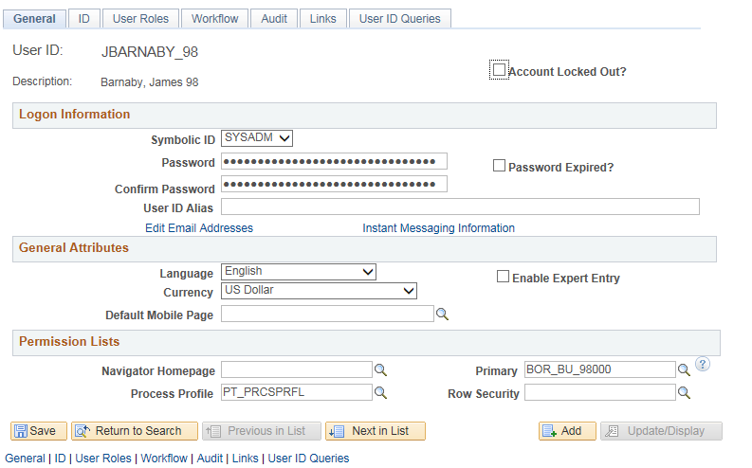
Through the Edit Email Addresses link, add the user’s primary email address. This is an important step for users of eProcurement, since many notifications concerning requisition approvals are sent using this email address.
In the Permission Lists section, add the Process Profile. The Process Profile permission list enables what features of Process Monitor operations the user will have. For all users, select the standard Process Profile of PT_PRCSPRFL.
In the Primary Permission List field, you need to enter your institution’s permission list (i.e., BOR_BU_71000). If the user will be required to process Banner student payments in Accounts Payable, consider selecting the “B” permission list instead. For any user who needs to add, maintain, or process payments for Banner students, their Primary Permission List should be the “BOR_BU_XXXXB”.
On the ID tab, employees should have an ID Type of “Employee.” For anyone else, the ID Type should be set to None. If selected as an employee, you need to link the User Profile to the Employee ID in the Attribute Value field. This is the employee’s ADP employee ID.
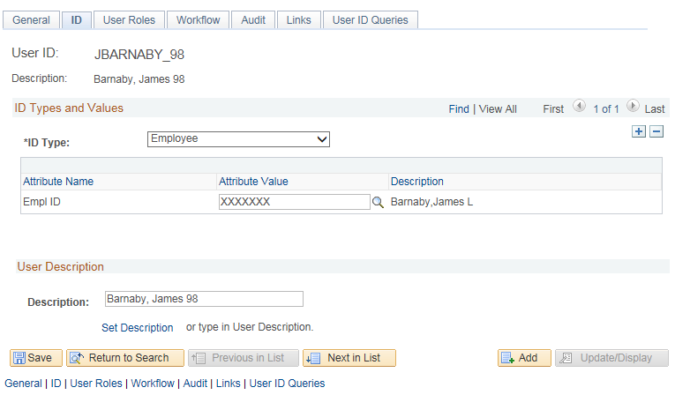
On the User Roles tab, begin adding the roles this person will need. The roles enable each user to navigate to processes and reports according to the business process requirements. Each User Profile will have one to many roles attached on this page. Some will be business functional roles and others will be system roles (i.e., Query, Report Manager). Each user should have the BOR_PeopleSoft User base role.
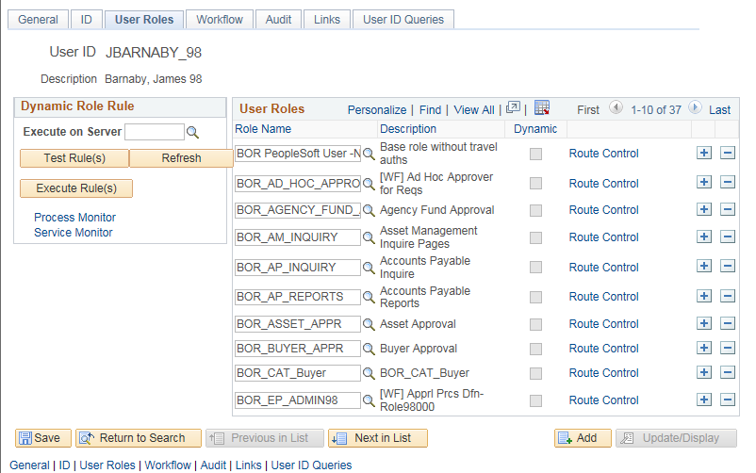
For assistance determining which roles a user may need, consult the security form for the user. In addition, there is a job aid that you can use which will list the roles needed by each business function. This job aid is located on the GeorgiaFIRST website. We will discuss the roles that you need to add for ePro users in the upcoming chapters.
Once the appropriate roles are attached, you must save this page. The User Profile has now been added to the system.
The user will need to sign into PeopleSoft and change their password.
How To: Add a New User Profile
- In the menu, select PeopleTools.
- Select Security.
- Select User Profiles.
- Select Distributed User Profiles.
- Select the Add a New Value tab.
- Enter a unique User ID.
- Click the Add button.
- In the Symbolic ID drop down list, select SYSADM1.
- In the Password field, enter a generic password.
- In the Confirm Password field, enter the same password.
- Ensure that the Password Expired? checkbox is selected.
- Select the Edit Email Addresses link.
- Select the Primary Email Account checkbox.
- Select the Email Type (Business or Home).
- Enter the user’s email address.
- Click OK.
- Select the Process Profile look up icon.
- Select the PT_PRCSPRFL process profile.
- Select the Primary look up icon.
- Select the Primary Permission List for your institution (BOR_BU_XXXXX). If the user processes Banner payments, select the “B” selection.
- Select the ID tab.
- For all employees, select Employee in the ID Type drop down list. For all non-employees, select None.
- For employees, enter the user’s ADP employee ID.
- In the Description field, enter the user’s name.
- Select the User Roles tab.
- Select the Role Name look up icon.
- Select BOR_PeopleSoft User.
- Click the Add a New Row button.
- Continue to use the Role Name look up icon and insert a new row button to select the additional security roles.
- Click the Save button.

User Preferences
In addition to attaching the appropriate roles, you will need to most likely add User Preferences for each user. User Preferences are additional business rules based on module functionality. Overall Preference need to be set up for all users, and each module will have additional documentation for their specific preferences.
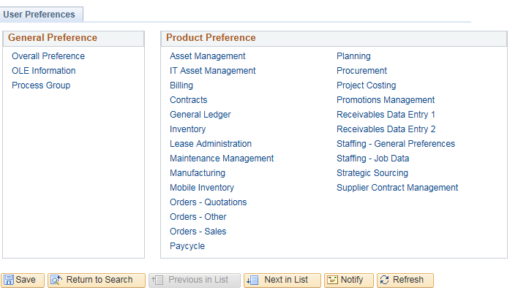
When adding User Preferences for a user, you first need to go through Overall Preference under General Preference. Here, you can add the user’s name. You must select your Business Unit and SetID on this page. Once done, you can save the page. This needs to be done for all users included in Workflow.
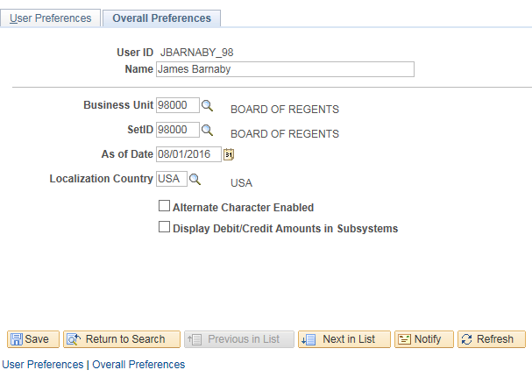

You can then go to the User Preferences tab to set up the specific user preferences under each applicable module. The Security Job Aid will indicate if a security role has corresponding user preferences that need to be set up. Below are the business processes for setting up user preferences by module:
- Accounts Payable: AP.010.010 – Adding and Updating AP User Preferences
- Accounts Receivable: AR.010.005 – AR User Preferences
- Purchasing: PO.010.020 – Setting Up User Preferences
- General Ledger: GL.010.027 – Setting Up and Maintaining GL User Preferences
How To: Update User Preferences
- In the menu, select Set Up Financials/Supply Chain.
- Select Common Definitions.
- Select User Preferences.
- Select Define User Preferences.
- Enter/Select the User ID of the person you are updating.
- Click the Search button.
- In the General Preference box, select the Overall Preference link.
- Enter the user’s name in the Name field.
- Enter/Select your institution’s Business Unit and SetID.
- Click the Save button.
- Select the User Preferences tab.
- Select the module you need to set preferences form, according to the Security job aid. When finished with each module, select the User Preferences tab.
- When finished, click the Save button.

Account Lockout
If a user attempts to login to PeopleSoft Financials more than five times unsuccessfully, the system will lock that user’s account. When this happens, you will need to unlock that person’s account. This is done on the Distributed User Profiles page.
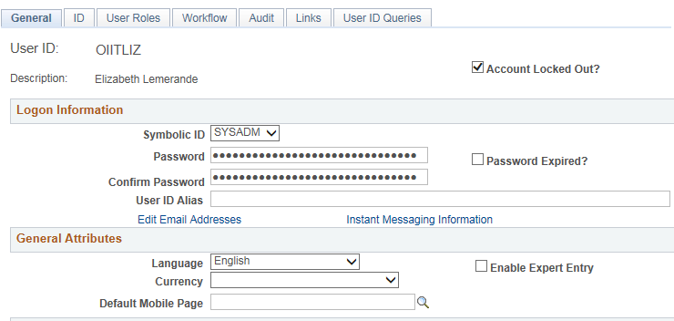
At the top of the General page, there is a checkbox indicating whether an account has been locked. To unlock the account, you need to deselect this checkbox. It is also recommended that you change the password and select the Password Expired? checkbox to force the user to create a new one.
How To: Unlock a User Account
- In the menu, select PeopleTools.
- Select Security.
- Select User Profiles.
- Select Distributed User Profiles.
- On the Find an Existing Value tab, enter the User ID.
- Click the Search button.
- On the General tab, deselect the Account Locked Out? checkbox.
- Enter a new generic password.
- Reenter the generic password.
- Select the Password Expired? checkbox.
- Click the Save button.

Reset Password
If you need to reset a password, you can do so through the Distributed User Profiles page. When resetting a password for a user, it is recommended that you input a generic password and force the user to change it upon logging in for the first time.
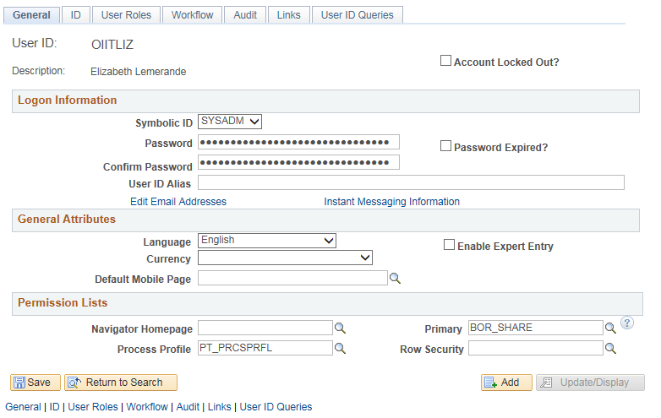
How To: Reset a User’s Password
- In the menu, select PeopleTools.
- Select Security.
- Select User Profiles.
- Select Distributed User Profiles.
- On the Find an Existing Value tab, enter the User’s ID.
- Click the Search button.
- Enter a new generic password.
- Reenter the generic password.
- Select the Password Expired? checkbox.
- Click the Save button.
Updating a User’s Email Address
A user’s email address in the system is very important for eProcurement and Expense users. This is due to the fact that Workflow relies on those emails to send various notifications. This includes when a user needs to approve something, or if a transaction has been denied. You can verify and update a user’s email address through the Distributed User Profile pages. You can also add multiple email addresses for a user. However, one must be selected as a primary address. The system sends notifications to the primary email address.
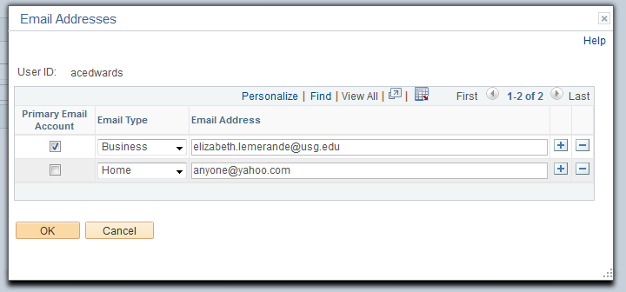
How To: Update a User’s Email Address
- In the menu, select PeopleTools.
- Select Security.
- Select User Profiles.
- Select Distributed User Profiles.
- On the Find an Existing Value tab, enter the User’s ID.
- Click the Search button.
- On the General tab, select the Edit Email Addresses link.
- Make any necessary updates to the existing email address.
- To add another email address, click the Add a new row button.
  - Select the email type.
  - Enter the email address.
- Ensure the Primary Email Account is selected.
- Click the OK button.
- Click the Save button.

Multi-Campus Approvers
There may be occasions when you have an approver that you need to add to the system, and that approver also works for another institution. If that person is employed at more than one institution and will need to be an approver at each institution, please submit a ticket to the ITS Helpdesk for additional instructions.

Chapter 4: Shopper Setup
Because ePro and the GeorgiaFIRST Marketplace depend on users being set up with the correct roles to perform their necessary tasks, the Local Security Administrator is responsible for ensuring their users are set up properly. During the implementation of this project, much of this set up work was done before going live. However, it will be the responsibility of the Local Security Administrator to maintain the ePro users in the system, as users need to be added, removed, or edited.
When performing setup, there is a specific order to follow.
- First, add the User Profile to the system.
- Next, add all of the security roles to the user.
- Then, make that user a Requester or Buyer in the system, if necessary.
- Finally, set up that User Preferences for that user.
Each role type has specific setup instructions.
Shopper Security Roles
The Shopper role is for the user who will need access to the PeopleSoft Financials system via the Self Service portal, so that they can shop in the GeorgiaFIRST Marketplace. For most shoppers, they will need the following roles:
Role Name | Purpose
BOR PeopleSoft User | Basic PeopleSoft User access
BOR_CAT_MktShopper* | Gives the Shopper access to the GeorgiaFIRST Marketplace
BOR_EP_REQUESTER | Enables the Shopper to have their name appear on a requisition

*If the shopper will also be a Requester, give them the BOR_CAT_Requester role instead. Users should not have multiple “BOR_CAT” roles.
Shopper Setup as Requester in ePro
After setting up the security roles for a Shopper, you must then set that Shopper up as a Requester in the system. By doing this, the Shopper’s name can appear on the actual requisition created from their shopping carts. In addition, they will receive the necessary notifications when their requisition is approved. To set up a shopper as a Requester in the system, you need to be on the Requester Setup page.

On the Requester Setup page, you will indicate the following defaults:
- Ship To SetID and Location
- Location SetID and Location
- PO Origin SetID = SHARE
- Origin = ONL
- Currency, Phone, and Fax
The Requisition Status should be set to Pending Approval.
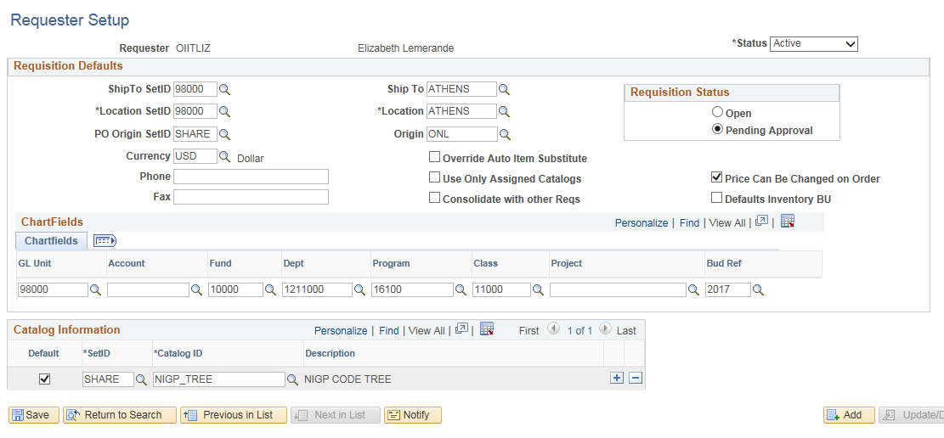
In addition, the following ChartFields may be set up for each person. This is optional, but most users choose to have defaults set up here. By setting up the default ChartFields for a Shopper, when their name is added to a requisition as the official requester, these ChartFields default on to the requisition. This Chartstring determines the first Approver the requisition will go to. The ChartFields include:
- GL Unit
- Fund
- Department
- Program
- Class
- Project
- Budget Reference
You do not want to enter an Account default. The Account for each requisition line will default from that item’s NIGP code.

In the Catalog Information section, select a value for the Catalog ID under the SHARE SetID as the default. There will be two choices: NIGP_TREE and NIGP_SHORT_TREE. The NIGP_TREE contains over 9,000 options. The NIGP_SHORT_TREE is a list of only the most used categories. Choose only one option here.
Once you have saved your Requester Setup page for your Shopper, that Shopper is now ready to begin working in ePro and the GeorgiaFIRST Marketplace.
How To: Set Up a Shopper as a Requester in ePro
- In the menu, select Set Up Financials/Supply Chain.
- Select Product Related.
- Select Procurement Options.
- Select Purchasing.
- Select Requester Setup.
- Select the Add a New Value tab.
- Enter the shopper’s User ID in the Requester field.
- Click the Add button.
- Ensure the status is set to Active.
- In the ShipTo SetID field, enter your institution’s SetID.
- In the ShipTo field, enter/select the default Ship To address for this shopper.
- In the Location SetID field, enter your institution’s SetID.
- In the Location field, enter/select the default Location for the shopper.
- In the PO Origin SetID field, enter SHARE.
- In the Origin field, enter ONL.
- In the Currency field, enter USD.
- Enter a phone and fax number if desired.
- Select the Pending Approval option in the Requisition Status box.
- In the GL Unit field, enter your institution’s business unit.
- In the Fund field, enter this Shopper’s default Fund.
- In the Dept field, enter this Shopper’s default Department.
- In the Program field, enter this Shopper’s default Program.
- In the Class field, enter this Shopper’s default Class Field.
- In the Project field, enter this Shopper’s default Project ID (if any).
- In the Bud Ref field, enter the current budget year.
- Leave the Account field blank.
- In the Catalog Information section, select the Default checkbox.
- In the SetID field, enter SHARE.
- In the Catalog ID field, enter NIGP_TREE or NIGP_SHORT_TREE.
- Save the page.

Chapter 5: Requester Setup
Requesters are individuals who will be creating ePro Requisitions either from Special Request Requisitions or from shopping carts from within the GeorgiaFIRST Marketplace.
Requester Security Roles
The Requester position (as well as many additional roles for ePro) requires the proper ‘maintain’ role to maintain requisitions. The role that you choose is dependent on whether or not your institution is implementing the GeorgiaFIRST Marketplace. The BOR_EP_MAINT_REQ and BOR_EP_MAINT_REQ_SCI roles are the same, except the BOR_EP_MAINT_REQ_SCI role has access to the “Web” tab for access to the GeorgiaFIRST Marketplace. The BOR_EP_MAINT_REQ role will not have access to the Web tab to enter and maintain Marketplace requisitions.
Role Name | Purpose
BOR PeopleSoft User | Basic PeopleSoft User access
BOR_CAT_Requester* | Enables the Requester to create requisitions from GeorgiaFIRST Marketplace shopping carts, as well as create their own shopping carts (this role is not needed if the institution is not implementing the GeorgiaFIRST Marketplace)
BOR_EP_REQUESTER | Enables the Requester to be set up as a Requester in the system
BOR_AD_HOC_APPROVE | Enables the Requester to insert additional approvers in the approval Workflow when needed
BOR_EP_MAINT_REQ or BOR_EP_MAINT_REQ_SCI | Enables the Requester to edit and track requisitions in the system.  If your institution is implementing the GeorgiaFIRST Marketplace, use BOR_EP_MAINT_REQ_SCI.  If your institution is not implementing the GeorgiaFIRST Marketplace, use BOR_EP_MAINT_REQ.

*If the requester will also be a Shopper, give them the BOR_CAT_Requester role only. Users should not have multiple “BOR_CAT” roles.
Requester Setup
After setting up the security roles for a Requester, you also must set up the individual as a Requester. You will follow the same steps as outlined for the Shopper Setup in ePro (see page 25 – 28).
How To: Set Up a Requester
- In the menu, select Set Up Financials/Supply Chain.
- Select Product Related.
- Select Procurement Options.
- Select Purchasing.
- Select Requester Setup.
- Select the Add a New Value tab.
- Enter the requester’s User ID in the Requester field.
- Click the Add button.
- Ensure the status is set to Active.
- In the ShipTo SetID field, enter your institution’s SetID.
- In the ShipTo field, enter/select the default Ship To address for this Requester.
- In the Location SetID field, enter your institution’s SetID.
- In the Location field, enter/select the default Location for the Requester.
- In the PO Origin SetID field, enter/select SHARE.
- In the Origin field, select ONL.
- In the Currency field, enter/select USD.
- Enter a phone and fax number if desired.
- Select the Pending option in the Requisition Status box.
- In the GL Unit field, enter/select your institution’s business unit.
- In the Fund field, enter/select this Requester’s Default Fund Code.
- In the Dept field, enter/select this Requester’s default Department.
- In the Program field, enter/select this Requester’s default Program Code.
- In the Class field, enter this Requester’s default Class Field.
- In the Project field, enter this Requester’s default Project ID (if any).
- In the Bud Ref, enter the current budget year.
- Leave the Account field blank.
- In the Catalog Information section, select the Default checkbox.
- In the SetID field, enter SHARE.
- In the Catalog ID field, enter NIGP_TREE or NIGP_SHORT_TREE.
- Save the page.
User Preferences for Requesters
After setting up the Requester in the system, you must then set up the User Preferences for the Requester. After setting up the Overall Preferences, you can select the Procurement link on the User Preferences tab. On the Procurement tab, input the Requester’s Location, Origin, Department, and Ship To Location. In the Requester field, input that Requester’s name.
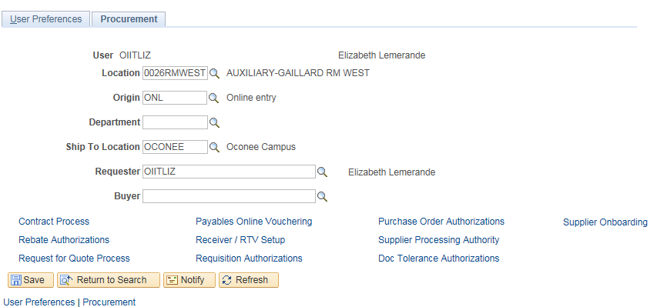
Your next step will be to select the Requisition Authorizations link at the bottom of the screen. Once on the Requisition Authorizations page, indicate what requisition actions the Requester is allowed to make. This includes approving, canceling, deleting, closing, and reopening a requisition. The other selections include:
- Can Work Approved Req’s: Enables a user to change a requisition that has already been approved.
- Full Auth for All Requesters: Gives the Requester authority to work all requisitions from all Requesters under your business unit (including add, update, cancel, delete, close, and reopen). If you do not choose this selection, you can add individual Requesters in the section below.
- Override Preferred Supplier: Enables a user to change the default supplier on a requisition line. If this authority is not selected, the user is unable to manually suggest a supplier.
- Override RFQ Required Flag: Enables a user to override the RFQ (Request for Quote) Required Rule option previously specified for a requisition in the requisition component.
- View/Override VAT Details: Enables the user to view and override VAT details within the requisition component. This selection does not apply to GeorgiaFIRST institutions.
- Override Non-Qualified Requisitions for Close: Enables the user to override requisitions that are not qualified to close on the Requester’s Workbench. Typically, only Buyers should have this permission setting.
- Can Send Approval Reminder: Enables the user to send an ad hoc notification to approvers with whom a requisition is pending. Typically, only Buyers should have this permission setting.
In the Requesters User Authorization area, you may specify the other Requesters for whom this user can work requisitions. For each Requester you add, you can enable the user to add, update, cancel, delete, close, and reopen requisitions as appropriate.
Typically, only Buyers should have the authority to reopen requisitions.
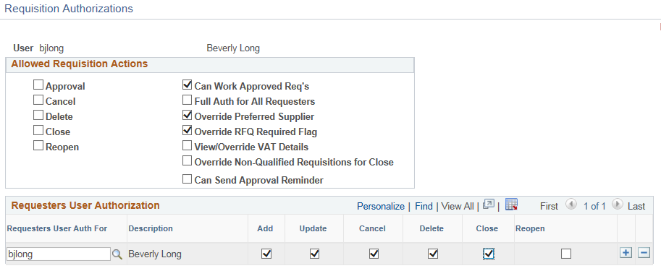
At a minimum, each Shopper who can assign a shopping cart in the GeorgiaFIRST Marketplace to the Requester should be listed in this section.
If a Requester does not have the 'Full Auth for All Requesters' selected, then that Requester’s own userid will need to be listed in the Requesters User Authorization section. If the Requester should also have authorization to perform work on another Requesters requisitions, then you would also need to add that Requesters userid in the Requesters User Authorization section and check the type of authorization needed (Add, Update, Close, etc). You can list as many userids as desired in this section.
If a Requester should have Full Auth for All Requesters, then the Requesters User Authorization section would not need to be completed. Also, the Cancel, Delete, and Close options would need to be checked in the Allowed Requisition Actions box.
How To: Adding User Preferences for Requesters
- In the menu, select Set Up Financials/Supply Chain.
- Select Common Definitions.
- Select User Preferences.
- Select Define User Preferences.
- Enter/Select the User ID of the Requester.
- Click the Search button.
- In the General Preference box, select the Overall Preference link.
- Enter the Requester’s name in the Name field.
- Enter/Select your institution’s Business Unit and SetID.
- Click the Save button.
- Select the User Preferences tab.
- Select the Procurement link.
- Enter the Requester’s Location.
- In the Origin field, enter ONL.
- In the Department field, enter the Requester’s default Department.
- In the Ship to Location field, enter the Requester’s default Ship To address code.
- In the Requester field, enter the Requester’s User ID.
- Select the Requisitions Authorizations link.
- In the Allowed Requisition Actions group box, select the actions this Requester is authorized to take.
- In the Requesters User Authorization section, enter each Shopper/Requester this Requester is authorized to work requisitions for, INCLUDING that Requester’s own ID. Insert additional rows as necessary. Ensure that the allowable actions include Add, Update, Cancel, Delete, and Reopen.
- Click the OK button.
- Click the Save button.

Chapter 6: Buyer Setup
Buyers are individuals who, in addition to creating their own requisitions, process requisitions from others and perform purchasing-related maintenance tasks. They are also responsible for sourcing requisitions into purchase orders, processing purchasing transactions, running purchasing-related reports, and maintaining purchasing-related configurations.
Buyer Security Roles
Role Name | Purpose
BOR PeopleSoft User | Basic PeopleSoft User access
BOR_AD_HOC_APPROVE | Enables the Buyer to insert additional approvals into the Workflow when necessary
BOR_EP_REQUESTER | Enables the Buyer to create requisitions
BOR_EP_BUYER_CENTER | Enables the Buyer to access the Buyer Center in order to expedite requisitions
BOR_EP_INQUIRY | Enables the Buyer to run inquiries on requisitions
BOR_EP_PROCESSES | Enables the Buyer to run requisition processes
BOR_EP_REQ_APPROVE | Enables the Buyer the ability to approve requisitions that are assigned to him/her
BOR_PO_INQUIRY | Enables the Buyer to run inquiries on purchase orders
BOR_PO_MAINTAIN | Enables the Buyer to perform maintenance on existing POs
BOR_PO_PROCESS | Enables the Buyer to run purchasing processes
BOR_PO_REPORTS | Enables the Buyer to run purchasing reports
BOR_PO_REQ_MAINT | Enables the Buyer to maintain requisitions
BOR_PO_REQ_PROCESS | Enables the Buyer to process requisitions through core Purchasing
BOR_PO_SETUP_CONFIG | Enables the Buyer to configure the system for purchasing
BOR_PO_VENDOR_MAINT | Enables the Buyer to maintain existing vendors in the system
BOR_EP_MAINT_REQ or BOR_EP_MAINT_REQ_SCI | Enables the Requester to edit/track requisitions in the system.  If your institution is implementing the GeorgiaFIRST Marketplace, use BOR_EP_MAINT_REQ_SCI.  If your institution is not implementing the GeorgiaFIRST Marketplace, use BOR_EP_MAINT_REQ.
BOR_BUYER_APPR | Enables the Buyer to approve requisitions, update the requisitions, and not restart Workflow
BOR_CAT_Requester | Enables the Buyer to shop and create requisitions in the GeorgiaFIRST Marketplace

Buyer Setup
Much like a Requester must be set up in the system, you must also set up your Buyers in the system after you have added their security roles. After setting up a user as a Buyer, you will then be able to add user preferences.
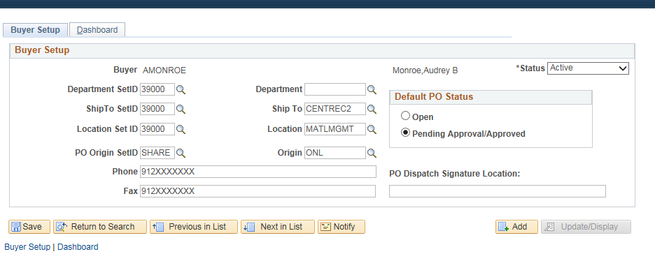
How To: Set Up a Buyer
- In the menu, select Set Up Financials/Supply Chain.
- Select Product Related.
- Select Procurement Options.
- Select Purchasing.
- Select Buyer Setup.
- Select the Add a New Value tab.
- Enter the User ID in the Buyer field.
- Click the Add button.
- Ensure the status is set to Active.
- In the Department SetID field, enter your institution’s business unit.
- If the Buyer only processes transactions for one department, you can enter that department in the Department field. However, if the Buyer processes transactions for multiple departments, leave this field blank.
- In the ShipTo SetID field, enter your institution’s business unit.
- In the Ship To field, enter this Buyer’s default Ship To location.
- In the Location Set ID field, enter your institution’s business unit.
- In the Location field, enter this Buyer’s primary location.
- In the PO Origin SetID field, enter SHARE.
- In the Origin field, enter ONL.
- If desired, enter a phone and fax number.
- Set the Default PO Status to Pending Approval/Approved.
- Click the Save button.
*Note: If the Buyer will also be creating requisitions, they must be set up on the Requester Setup Page also. See chapter 5.
User Preferences for a Buyer
Now that you have set up the user as a Buyer in the system, you can now set up their User Preferences. In the Overall Preferences for a Buyer, you must enter your institution’s Business Unit and SetID, along with the Buyer’s name. After setting the Overall Preferences, you can select the Procurement link on the User Preferences tab. Here, input the Buyer’s Location, Origin, and Ship To Location. Leave the Department field blank if the Buyer works on transactions from more than one department. Finally, enter the Buyer’s User ID in the Buyer field. If this Buyer will also be responsible for creating requisitions, enter the Buyer’s User ID in the Requester field as well.
After setting up the overall Procurement preferences, you can select the Document Tolerance Authorizations hyperlink. If this user will have the authority to override document tolerance exceptions between requisitions and purchase orders, select that radio button.
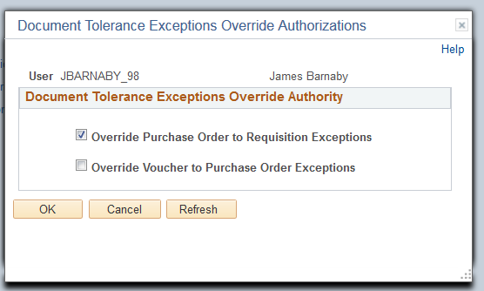
After returning to the overall Procurement preferences, select the Receiver/RTV Setup hyperlink. Here, you can indicate your business unit. It is here that you can also setup the default Receipt Quantity options for a buyer. Through these options, you can specify how the receipt quantity appears for the Buyer when they are entering a receipt. The options include:
- No Order Quantity: Select this option to signify that the receiver must enter the actual quantity received. This selection requires a live count of the items prior to receipt in the system. If selected, the copy function does not transfer order quantities to the receipt. The Buyer will need to manually enter all receipt quantities.
- Ordered Quantity: Select this option to automatically make the received quantity the purchase order quantity. This selection changes the purchase order quantity regardless of any prior receipt quantity.
- PO Remaining Quantity: Select this option to have the receipt display the numeric difference between the quantity ordered and the current quantity received. Selecting this option replaces the received quantity with the quantity that has not yet been received.
The field for Days +/- Today allows you to insert a default for the Buyer as to the time frame to look for purchase orders when creating receipts. For example, if you enter 30, when the Buyer searches for purchase orders to create a receipt, the system will look 30 days from the current date. The Buyer can change this field in their search parameters as well.
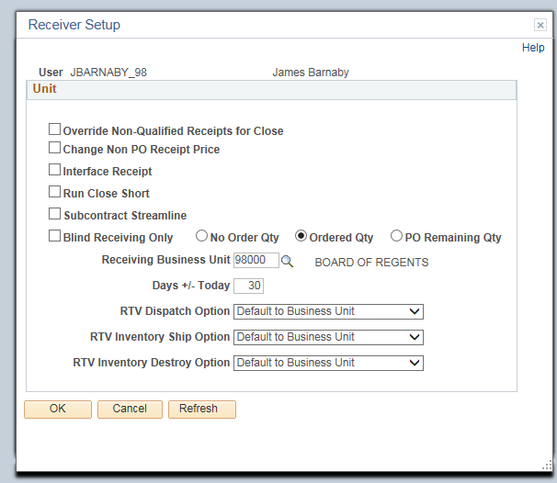
Through the Purchase Order Authorizations hyperlink, you can set the authorized actions the Buyer can take for their own purchase orders, as well as the purchase orders created by others. If you do not select the Full Authority for All Buyers selection, you will need to populate the other users for whom this Buyer is authorized to work purchase orders.
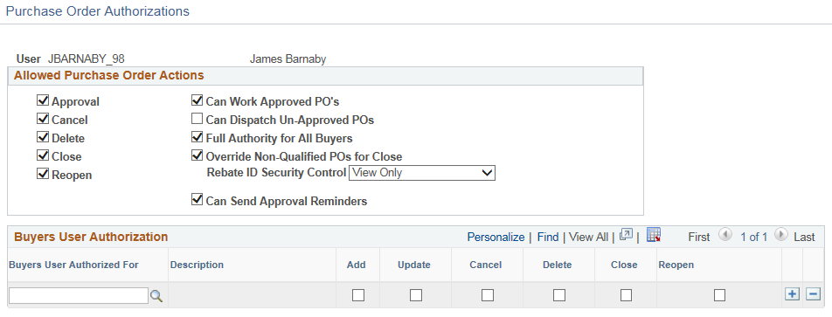
In addition, if the Buyer is responsible for entering or maintaining requisitions, you will need to set up this information through the Requisition Authorizations hyperlink. Here, you can specify the allowed actions a Buyer can take on their own requisitions, as well as the action they can take on requisitions created by others. If you do not select the Full Authority for All Requesters selection, you will need to populate the other users for whom this Buyer is authorized to work requisitions.
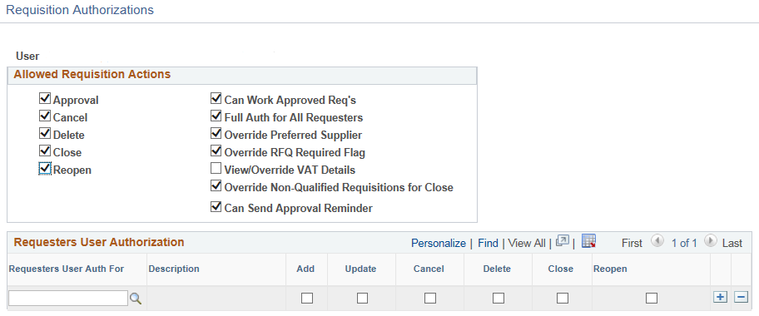
Finally, if the Buyer will be responsible for either entering suppliers or approving suppliers, you will need to select the Supplier Processing Authority hyperlink. Here, you may specify whether the Buyer can enter new suppliers or approve suppliers. A Buyer should not have the authority to do both. The Supplier Processing Authority does not apply to SHARE suppliers. SHARE suppliers are only able to be entered and edited by the Shared Services Center.
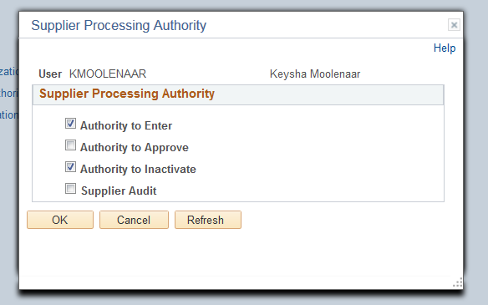
How To: Add User Preferences for a Buyer
- In the menu, select Set Up Financials/Supply Chain.
- Select Common Definitions.
- Select User Preferences.
- Select Define User Preferences.
- Enter/Select the User ID of the Buyer.
- Click the Search button.
- In the General Preference box, select the Overall Preference link.
- Enter the Buyer’s name in the Name field.
- In the Business Unit field, enter/select your institution’s Business Unit.
- In the SetID field, enter/select your institution’s SetID.
- Select the User Preferences tab.
- Select the Procurement hyperlink.
- In the Location field, enter/select the Buyer’s location.
- In the Origin field, enter/select ONL.
- In the Ship To Location field, enter the Buyer’s default Ship To Location.
- If the Buyer will be creating requisitions, enter/select the Buyer’s User ID in the Requester field.
- In the Buyer field, enter/select the Buyer’s User ID.
- Select the Document Tolerance Authorizations hyperlink.
- If this Buyer will have the authority to override document tolerance exceptions between Purchase Orders and Requisitions, select that checkbox.
- Click the OK button.
- Select the Receiver/RTV Setup hyperlink.
- Select the appropriate Receipt Quantity option for this buyer (No Order Qty, Ordered Qty, or PO Remaining Qty).
- Enter/select your institution’s business unit in the Receiving Business Unit field.
- Click the OK button.
- Select the Purchase Order Authorizations hyperlink.
- Select the actions the Buyer is authorized for regarding their Purchase Orders (Approve, Cancel, Delete, and Close).
- If the Buyer has the authority to work approved purchase orders, select that checkbox.
- If the Buyer has the authority to work purchase orders from all other Buyers, select the “Full Authority for All Buyers” checkbox.
- If the Buyer does not have the authority to work purchase orders from all other Buyers, but can work purchase orders from select Buyers, enter/select that additional Buyer’s User ID in the Buyers User Authorized For field. Then, select the authorized actions (Add, Update, Cancel, Delete, Close). For each additional Buyer, add a row and repeat this step.
- Click the OK button.
- Select the Requisition Authorizations hyperlink.
- Select the actions the Buyer is authorized regarding Requisitions (Approve, Cancel, Delete, Close).
- If the Buyer has the authority to work approved requisitions, select that checkbox.
- If the Buyer has the authority to work requisitions from all other Requesters, select the Full Auth for All Requesters checkbox.
- If the Buyer does not have the authority to work requisitions from all other Requesters, but can work requisitions from select Requesters, enter/select that additional Requester’s User ID in the “Requesters User Auth For” field. Then, select the authorized actions (Add, Update, Cancel, Delete, Close, Reopen). For each additional Requester, add a row and repeat this step.
- Click the OK button.
- Select the Supplier Processing Authority hyperlink.
- Select either the Authority to Enter or Authority to Approve checkbox.
- Select the Authority to Inactivate checkbox if desired.
- Click the OK button.
- Click the Save button.

Chapter 7: ePro Administrator Setup
ePro Administrators must also be set up in the system with the correct security roles. This enables the ePro Admin to set up eProcurement components, including:
- Approver Setup
- Requester Setup
- Reassigning Worklist Items
- Assignment of Alternate Users
The ePro Admin is also responsible for working with the Security Administrator to understand the necessary user security needs relative to security roles, role actions, and routing controls.
ePro Admin Security Roles
Role Name | Purpose
BOR PeopleSoft User | Basic PeopleSoft User access
BOR_EP_ADMINXX | Enables the ePro Admin to manage ePro Workflow; the “XX” is the institution’s first two digits in their SetID
BOR_EP_CONFIG_SETUP | Enables the ePro Admin to configure the system for eProcurement
BOR_EP_REASSIGN | Enables the ePro Admin to reassign requisitions that are routed to them due to escalation or Workflow errors

User Preferences for the ePro Admin
For the ePro Admin, you only need to setup the Overall Preferences. This includes the Business Unit, SetID, and name of the admin.
How To: Add User Preferences for an ePro Admin
- In the menu, select Set Up Financials/Supply Chain.
- Select Common Definitions.
- Select User Preferences.
- Select Define User Preferences.
- Enter/Select the User ID of the ePro Admin.
- Click the Search button.
- In the General Preference box, select the Overall Preference link.
- Enter the ePro Admin’s name in the Name field.
- In the Business Unit field, enter/select your institution’s Business Unit.
- In the SetID field, enter/select your institution’s SetID.
- Click the Save button.

Chapter 8: Approver Setup
All ePro Approvers must also be setup with specific security roles. In addition, depending on the type of approver they are, they will need to have a specific security role to match their approver type. For example, Department and Project approvers simply need the basic security roles for an approver. Special Item Category approvers need the basic security roles, along with their specialized approver role (i.e., BOR_IT_APPR for your institution’s IT approvers).
Basic Approver Security Roles
Role Name | Purpose
BOR PeopleSoft User | Basic PeopleSoft User access
BOR_AD_HOC_APPROVE | Enables the Approver to insert additional approvals into the Workflow when necessary
BOR_EP_REQ_APPROVE | Enables the Approver to approve/deny requisitions
BOR_EP_MAINT_REQ or BOR_EP_MAINT_REQ_SCI | Enables the Requester to edit and track requisitions in the system.  If your institution is implementing the GeorgiaFIRST Marketplace, use BOR_EP_MAINT_REQ_SCI.  If your institution is not implementing the GeorgiaFIRST Marketplace, use BOR_EP_MAINT_REQ.

Special Item Approver Security Roles
In addition to the security roles above, special Approvers will need one or more of the following roles:
Role Name | Purpose
BOR_AGENCY_FUND_APPR | For Agency Fund Approvers
BOR_EP_CAT_AMOUNT_APPR | For Amount Approvers
BOR_GRANT_APPR | For Grant Approvers
BOR_ASSET_APPR | For Asset Approvers
BOR_EP_BUD_REF_APPR | For Budget Reference Approvers
BOR_AUDIO_VIS_APPR | For Audio Visual Approvers
BOR_IT_APPR | For IT Approvers
BOR_CHEMICAL_APPR | For Chemical Approvers
BOR_UNIVREL_APPR | For University Relations Approvers
BOR_FACILITIES_APPR | For Facilities Approvers
BOR_BUYER_APPR | For Buyers who Approve
BOR_TECH_FEE_APPR | For Tech Fee Approvers
BOR_FURNITURE_APPR | For Furniture Approvers
BOR_HR_APPR | For Human Resources Approvers
BOR_PHARM_DRUG_APPR | For Pharmacological Approvers

The BOR_ASSET_APPR security role contains the role action of “Can Change Distrib” and “Can Change Schedule.” This allows the approver to change any field on the requisition distribution or schedule without restarting the approval process on requisitions that are not fully approved.
The BOR_BUYER_APPR security role contains the role action of “Can Change All.” This allows the approver to change any field on the requisition, including quantity and price, without restarting the approval process on requisitions that are not fully approved.
If any other approver needs a role action, you can assign these role actions the individual users. These role actions are also added under the Distribution User Profile > User Roles tab.
Role Name | Purpose
BOR_EP_RA_CHANGEALL | Allows the Approver to update any portion of the requisition without restarting Workflow on requisitions that are not fully approved. If the Requisition has been approved and the approver makes a change, the requisition will re-route back through Workflow.
BOR_EP_RA_CHANGEDISTRIB | Allows the Approver to update the distribution of the requisition without restarting Workflow on requisitions that are not fully approved. If the Requisition has been approved, and the approver makes a change, the requisition will re-route back through Workflow.
BOR_EP_RA_CHANGEHDR | Allows the Approver to update the header of the requisition without restarting Workflow on requisitions that are no fully approved. If the Requisition has been approved and the Approver makes a change, the Requisition will re-route back through Workflow.
BOR_EP_RA_CHANGELINE | Allows the Approver to update the line of the requisition without restarting workflow on requisitions that are not fully approved. If the Requisition has been approved and the approver makes a change, the requisition will re-route back through Workflow.
BOR_EP_RA_CHANGESCHED | Allows the approver to update the schedule of the requisition without restarting Workflow on requisitions that are not fully approved. If the Requisition has been approved and the approver makes a change, the requisition will re-route back through Workflow.

Without any of the above role action roles assigned, if an approver updates information on the requisition, such as ChartField information, the requisition will have to be re-routed back through the approval levels.

Approver User Preferences
In addition to security roles, you must set up your Approvers’ User Preferences. While the security roles give you access to the appropriate pages, the user preferences actually give you the ability to take certain actions. If the approver is also a requester, you will need to set them up as a requester in the system first.
In the Overall Preferences, you need to set up each approver with their name and Business Unit. Through the Procurement link, you will need to setup some information if the Approver is also a Requester. This information includes Location, Origin, Ship To Location, and User ID in the Requester field.
For all Approvers, you will need to go through the Requisition Authorizations hyperlink to indicate what authority the Approver has. In the Allowed Requisition Actions, you must select Approval at a minimum. If the Approver is also a Requester, then you will need to specify what other actions he/she can take. You also need to indicate whether the Approver has full authority for all requesters or just specific requesters that can be listed in the Requesters User Auth For group box.
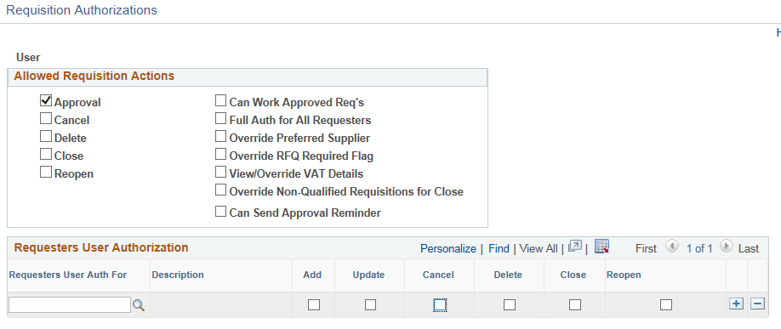

Through the Purchase Order Authorizations hyperlink, set the permission for the Approver to be able to approve a purchase order.
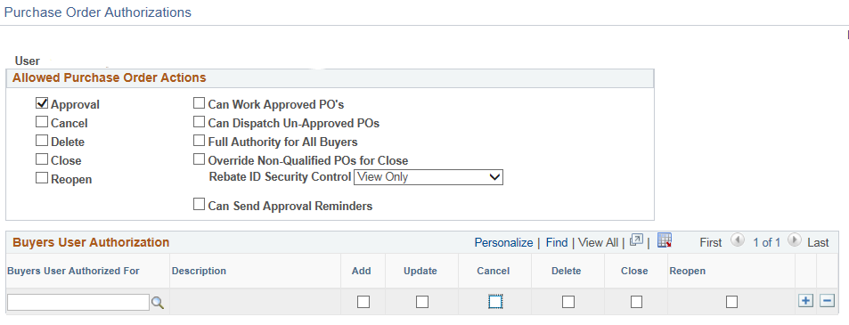

How To: Add User Preferences for an Approver
- In the menu, select Set Up Financials/Supply Chain.
- Select Common Definitions.
- Select User Preferences.
- Select Define User Preferences.
- Enter/Select the User ID of the Approver.
- Click the Search button.
- In the General Preference box, select the Overall Preference link.
- Enter the Approver’s name in the Name field.
- In the Business Unit field, enter your institution’s Business Unit.
- In the SetID field, enter institution’s SetID.
- Select the User Preferences tab.
- Select the Procurement link.
- In the Location field, enter/select the Approver’s location.
- In the Origin field, enter ONL.
- In the Ship To Location field, enter the Approver’s Ship To Location.
- If the Approver is also a Requester, enter the Approver’s user ID in the Requester field.
- Select the Requisition Authorizations link.
- Select the Allowed Requisition Actions for the Approver.
- If the Approver has the authority to work requisitions from all other Requesters, select the Full Auth for All Requesters checkbox.
- If the Approver does not have the authority to work requisitions from all other Requesters, but can work requisitions from select Requesters, enter/select that additional Requester’s User ID in the Requesters User Auth For field. Then, select the authorized actions (Add, Update, Cancel, Delete, Close, Reopen). For each additional Requester, add a row and repeat this step.
- Click the OK button.
- Select the Purchase Order Authorizations link.
- Select the Allowed Purchase Order Actions that will pertain to that user.
- Click the Save button.

Chapter 9: Department and Project Manager Setup
For your Department and Project Managers, in addition to setting up their security roles and user preferences, you also need to setup the Department and Project ChartFields with the correct manager User ID.
Department Manager ID
In the Department ChartField, indicate who the Department Manager is. This field is what Workflow uses for requisitions. When a requisition is charged to a particular department, Workflow is designed to route that requisition to the manager listed on the ChartField definition.
When updating the Department ChartField, make sure that the Department’s status is Active. Also, you must be in Correct History mode. Once you complete the Manager ID field, the Manager Name field should populate as well, once you tab out of the field.
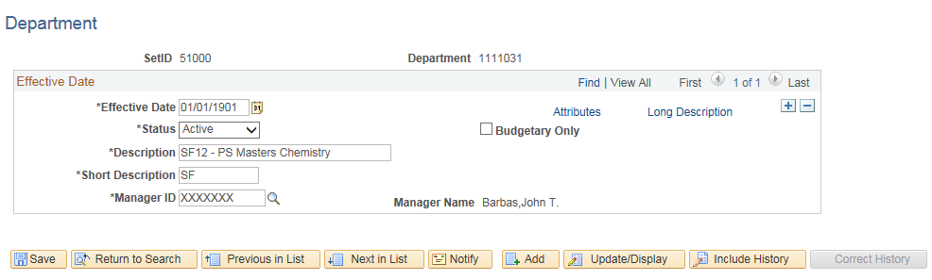
How To: Update a Department Manager ID
- In the menu, select Set Up Financials/Supply Chain.
- Select Common Definitions.
- Select Design ChartFields.
- Select Define Values.
- Select ChartField Values.
- Select Department.
- On the Find an Existing Value page, enter the Department ID in the Department field.
- Click the Search button.
- Select the Department you want to update.
- Ensure the Department status is Active.
- Click the Correct History button.
- Select the Manager ID look up icon.
- Enter the last name of the Department Manager in the Last Name field.
- Click the Look Up button.
- Select the correct User ID for the Department Manager.
- Click the Save button.
Additional Department Managers
The way Workflow is initially setup, there is only one User ID that you can specify for your Department Manager. If your institution wishes to have multiple department approvers, you can use the Department Approver page to specify additional Department managers. These additional Department Managers must also have their security roles and user preferences completed for them.
Important Note: Before using this page for the first time, contact ITS to make a change to your institution’s Workflow configuration.
On the Department Approver page, you can add multiple approvers for multiple departments. The first time you add multiple approvers, you need to select the Add a New Value tab and add the value using your institution’s SetID. After adding your institution the first time, you can add additional approvers through the Find an Existing Value tab (using your SetID).
For each additional approver, you first need to specify the department. Then, you select the User ID of the additional approver. To add additional approvers, you can select the Add a New Row button, and continue to add the additional approvers for the necessary departments.
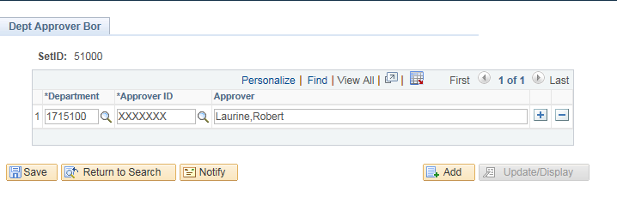

How To: Update Additional Department Managers
- In the menu, select Set Up Financials/Supply Chain.
- Select Common Definitions.
- Select Design ChartFields.
- Select Define Values.
- Select Department Approver.
- If this is the first time you are adding an additional Department Manager for your institution, select the Add a New Value tab. If this is not the first time, select the Find an Existing Value tab.
- Enter/select your institution’s SetID and click Add or Search.
- On a blank row, enter/select the Department ID for the Department you want to add an additional approver for.
- Enter/select the additional Approver’s UserID in the Approver ID field. Tab out of the field to populate the Approver field.
- To insert additional approvers, select the Add a New Row button and repeat steps 8 & 9.
- Click the Save button.
Project Manager ID
In the Project ChartField, you need to indicate who the Project Manager is. This field is what Workflow uses for requisitions. When a requisition is charged to a particular project, Workflow is designed to route that requisition to the manager listed on the ChartField definition.
When updating the Project ChartField, you need to make sure that the Project’s Status is Active. Also, you need to be in Correct History mode. Once you complete the Manager Id field, the Manager Name should populate as well, once you tab out of the field.
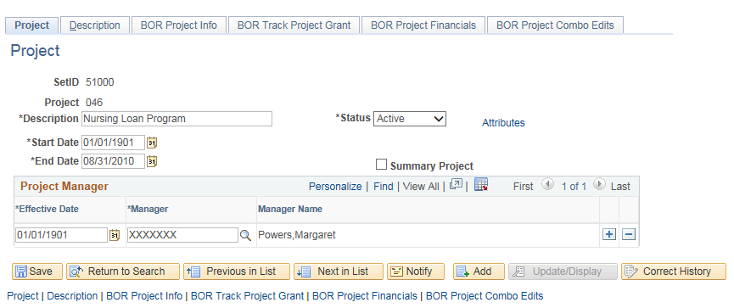
How To: Update a Project Manager ID
- In the menu, select Set Up Financials/Supply Chain.
- Select Common Definitions.
- Select Design ChartFields.
- Select Define Values.
- Select ChartField Values.
- Select Project.
- On the Find an Existing Value page, enter the Project ID in the Project field.
- Click the Search button.
- Select the Project you want to update.
- Ensure the Project status is Active.
- Click the Correct History button.
- Select the Manager ID look up icon.
- Enter the last name of the Project Manager in the Last Name field.
- Click the Look Up button.
- Select the correct User ID for the Project Manager.
- Click the Save button.

