eProcurement and GeorgiaFIRST Marketplace

User’s Guide
for
GeorgiaFIRST Marketplace Shoppers

Information Technology Services
Version 1.2
Last Updated: 01/08/2014

Table of Contents
Table of Contents 2
Introduction 6
Chapter 1: eProcurement and GeorgiaFIRST Marketplace Overview 7
What are eProcurement and the GeorgiaFIRST Marketplace? 7
Benefits of ePro and the GeorgiaFIRST Marketplace 7
Types of Roles Involved 8
Process Flow 9
How does PSFIN pass along user information to GeorgiaFIRST Marketplace? 9
How Do Approvals Work? 10
Chapter 2: Accessing and Navigating the GeorgiaFIRST Marketplace 12
Logging into PeopleSoft Financials Self Service 12
How To: Accessing GeorgiaFIRST Marketplace through PeopleSoft Financials Self Service 12
Logging in through PeopleSoft Financials Core System 14
How To: Accessing GeorgiaFIRST Marketplace through PeopleSoft Financials Core System 14
GeorgiaFIRST Marketplace Home Page 17
Leaving the GeorgiaFIRST Marketplace 19
Chapter 3: Contract Types 20
Chapter 4: Searching for Items in the GeorgiaFIRST Marketplace 21
Using Simple (Basic) Search 22
How To: Perform a Simple Search 24
Using Advanced Search 25
How To: Perform an Advanced Search 28
Search Result Details 29
Filtering Results 31
Searching from the Purchasing Showcase 33
How To: Search from a Showcased Supplier 33
Browse by Supplier 35
How To: Browse for Items by Supplier 35
Browse by Category 37
How To: Browse for Items by Category 37
Using Product Comparison 38
How To: Compare Products Side-by-Side 38
Searching from Punch-Out Suppliers 40
How To: Search from Punch-Out Suppliers 40
Chapter 5: Shopping for Items in the GeorgiaFIRST Marketplace 42
Active vs. Draft Carts 42
Adding an Item to a Cart 42
How To: Add Items to your Shopping Cart from the Product Search Results Page 43
How To: Add Items to your Shopping Cart from the Product Description Pop-Up 44
How To: Add Items to your Shopping Cart from Product Comparison 45
How To: Add Items from a Punch-Out Supplier 45
Shopping Cart Page 46
Shopping Cart Name 46
How To: Rename Your Shopping Cart 47
Removing Items from the Cart 48
How To: Remove Selected Items from a Cart 48
How To: Remove All Items from a Shopping Cart 49
Updating the Quantity of Items in a Cart 49
How To: Update Quantity of Items in a Cart 49
Selecting the Applicable Contract for an Item 50
How To: Select a Contract for an Item 50
Selecting Fulfillment Addresses (applies only to fax or email suppliers) 50
How To: Select Fulfillment Address 51
Deleting a Shopping Cart 52
How To: Delete a Shopping Cart 52
More about Draft Carts 53
How To: Create a New Cart 54
Adding Items to a Draft Cart 55
Reviewing Line Item History 57
How To: Review Line Item History 57
Chapter 6: Assigning a Cart to a Requester 58
Specifying a Default Requester 58
How To: Specifying a Default Requester 59
Shopper Chartfield Defaults 59
Assigning a Cart 61
How To: Assign a Cart 61
Un-assigning a Cart 63
How To: Un-Assign a Cart 63
Reviewing Cart History 64
How To: Review the History for a Cart 64
Creating a New Cart from a Previous Cart 65
How To: Create a New Cart from a Previous Cart 65
Chapter 7: Shopper Notifications 66
Notification #1: Shopping Cart Has Been Pulled into a Requisition 66
Notification #2: Your Requisition Has Been Approved 66
Notification #3: Your Requisition has Failed Budget Checking 67
Notification #4: Your Requisition Items Need to be Received 68
Chapter 8: GeorgiaFIRST Marketplace Favorites 69
Favorites 69
Creating Favorites Folders 69
How To: Create a Personal Folder or Sub-Folder 70
Adding Items as Favorites 71
How To: Add an Item as a Personal Favorite 71
Adding Favorite Items to Your Cart 73
How To: Adding Favorite Items to Your Cart using the Favorites Link 73
Moving and Copying Items Between Folders 74
How To: Move and Copy Items Between Folders 74
Editing Favorite Items 75
How To: Editing Favorite Items 75
Deleting Favorite Items and Folders 76
How To: Delete an Item from Favorites 76
How To: Delete a Folder from Favorites 77
Chapter 9: User Profile in GeorgiaFIRST Marketplace 78
User Information and Settings 78
How To: Update Color Theme to Match School Logo 78
Chapter 10: Desktop Receiving 80
Desktop Receiving 80
How To: Create a Desktop Receipt 82

Introduction
This User’s Guide is designed for Shoppers in the GeorgiaFIRST Marketplace. In this User’s Guide, you will find an overview of what the eProcurement module does, as well as what the function of the GeorgiaFIRST Marketplace is. You will also learn how to use the GeorgiaFIRST Marketplace to create a shopping cart of items you want purchased, how your requested goods are approved, and how to customize your experience in the marketplace.
Topics covered in this user’s guide:
- Overview of eProcurement and the GeorgiaFIRST Marketplace
- Accessing and Navigating the GeorgiaFIRST Marketplace
- Basic Procurement Policies
- Searching for Items in the GeorgiaFIRST Marketplace
- Shopping for Items in the GeorgiaFIRST Marketplace
- Assigning a Shopping Cart to a Requester
- Shopper Notifications
- Desktop Receiving
- GeorgiaFIRST Marketplace Folders and Favorites
- GeorgiaFIRST Marketplace User Profile

Chapter 1: eProcurement and GeorgiaFIRST Marketplace Overview
What are eProcurement and the GeorgiaFIRST Marketplace?
eProcurement (ePro) is a module in PeopleSoft Financials that has a primary function of creating electronic requisitions and routing them for approval. In this PSFIN module, ePro is used to create requisitions for goods and services. A requisition is simply an official request to purchase goods and services.
Previously, you may have used paper requisitions, or some other form, to request an item to be purchased. That hardcopy requisition then had to be routed for approval signatures, and then sent to the Purchasing Office. The Purchasing Office then rekeyed the information into the system to create a Purchase Order to send to the vendor.
With ePro, much of this is completely automated. A requisition is created within ePro and then electronically routed for approval. The approval chain is dependent on the Department charged and item type, among other things. Finally, after the last electronic approval is made, the requisition can be copied into, or sourced into an official Purchase Order that is dispatched to a vendor.
The GeorgiaFIRST Marketplace takes the use of ePro to another level. The GeorgiaFIRST Marketplace is an online shopping site that is accessed from PeopleSoft Financials. Through this online shopping site, users can shop online for contract items from a variety of state and institution approved vendors. Users can select items by placing them in an online shopping cart. They assign these shopping carts to a designated requester when ready, and the requester then turns their shopping cart into an ePro requisition.
Benefits of ePro and the GeorgiaFIRST Marketplace
With this new system of online shopping and electronic requisitioning, you will see some immediate benefits, including:
- Reduction in paper forms routing through different offices
- Online browsing and shopping for items
- Comparison shopping
- You only need one login to shop from multiple vendors
- You can request goods from multiple vendors through one shopping cart
- All items in the GeorgiaFIRST Marketplace are contractually approved items
- Faster routing for approvals
- Ability to save items as ‘favorites’ in the GeorgiaFIRST Marketplace
Types of Roles Involved
In order for the ePro and GeorgiaFIRST Marketplace functionality to work properly, users are set up with specific roles and responsibilities. They include:
- Shoppers: These users are the ones who select items in the GeorgiaFIRST Marketplace and place into shopping carts for their assigned Requesters.
- Browsers: Users without any GeorgiaFIRST Marketplace roles assigned will default to a Marketplace Browser. Browsers can view the items, contracts, and prices in the Marketplace but cannot shop or create requisitions.
- Requesters: These users take the shopping carts created by Shoppers and turn them into ePro Requisitions. Requesters can also build their own shopping carts, just like Shoppers.
- Approvers: These users are set up to approve ePro Requisitions.
- Buyers: These users are responsible for ensuring approved requisitions are sourced into a Purchase Order and dispatched to the vendor.
- AP Personnel: The AP office processes the resulting invoice from the vendor.
- ePro Administrator: This user monitors the approval workflow, to make sure requisitions are worked in a timely fashion
- Local Security Administrator: This user is responsible for setting up others users in their appropriate roles.
As a Shopper, you are responsible for using the GeorgiaFIRST Marketplace to request goods and services that will be turned into requisitions.

Process Flow
Now that you know all of the roles involved, below is the process flow beginning with Shoppers and ending with the Accounts Payable office.
Shoppers use the GeorgiaFIRST Marketplace to select goods they request to have purchased
Shoppers assign their completed shopping carts to their assigned Requester
The Requester is notified by email of this newly assigned cart
The Requester logs into the system and pulls the Shopper’s cart into a Requisition
The Requester finishes the requisition and submits it for approval
The Approvers (determined by various factors) either approve or deny the requisition lines
Once fully approved, the PeopleSoft Financials system automatically budget checks the requisition
Once the requisition has a valid budget check status, the PeopleSoft Financials system automatically sources the requisition into a purchase order and dispatches it to the vendor
The vendor fulfills the order and sends the item and invoice to the Institution
The institution receives the item/Receipt is created in PSFIN
The AP Office pays the invoice
How does PSFIN pass along user information to GeorgiaFIRST Marketplace?
In order for you to begin using the GeorgiaFIRST Marketplace, your local security administrator first sets you up in the PeopleSoft Financials system, with the correct user access. By using your PeopleSoft User ID and Password, you can access the PeopleSoft system. Once in PeopleSoft, you simply proceed to the GeorgiaFIRST Marketplace through a hyperlink.
By logging in through PeopleSoft, the system sends your user information to the GeorgiaFIRST Marketplace, allowing you to log in only once and shop from multiple vendors. In addition, your PeopleSoft User ID is used to store the Chartfields that should be charged for your requested goods, via the Requester Setup page in PeopleSoft.
How Do Approvals Work?
As mentioned earlier, once the Requester builds the requisition in ePro from your shopping cart, that Requester submits it for approval. In ePro, approvals are completed through Workflow. The ePro module looks at certain things in the requisition and automatically routes it to the necessary approvers. Approvals are based on the individual lines in a requisition. Below is a quick summary of how approvals flow for requisitions created from the GeorgiaFIRST Marketplace:
- First, all requisitions are routed to a Department Manager for approval. The correct Department Manager is determined by the Department Chartfield used on the requisition line.
- If a Project or Grant is indicated on the requisition line also, then the line is routed to the correct Project Manager for approval as well.
- The following approval steps are customizable by institution. Therefore, not all of these steps will apply to your requisition line. Check with your institution for exact approval setup.
  - Agency Fund Approval: If an agency fund is entered on a requisition line, that line will be routed to the approver responsible for approving agency fund transactions.
  - Amount Approval: If a requisition line is over a certain amount (i.e., $10,000 or greater), it will be routed to a special approver responsible for approving these high-amount lines.
  - Item Type Approvals: These approvals are determined by the type of item being requested through either the requisition line account number or NIGP code. The special item types include:
    - Assets
    - Audio Visual Equipment
    - Chemical Goods
    - Facilities Planning and Design
    - IT Hardware and Software
    - University Relations (i.e., anything for media contact, logo use, or copyright items)
Once your requested items have been placed on a requisition and are routed for approvals, there are time limits in place in which an approver has to act on the requisition. This ensures that your requisition does not sit around waiting for an approver for an indefinite amount of time.
When a requisition is submitted for approval, the system sends it to the first approver’s Worklist, within PeopleSoft Financials. The Worklist is a queue which holds items waiting for approval. Once an approver works a transaction, it is removed from their Worklist.
Once the requisition hits an Approver’s Worklist, that approver has 3 days to either approve or deny it, before they get a reminder notification from the system. If the requisition sits in an Approver’s Worklist for 4 days without being approved or denied, the system removes the requisition from that Approver’s Worklist, and the ePro Administrator reassigns the transaction to another approver. After the Approver has approved the requisition, the system automatically moves it onto the next Approver’s Worklist. If an Approver denies a requisition, the system returns it to the Requester. Denied requisition lines can be edited and resubmitted for approval.
If an approver will be out of the office for an extended period of time and will be unable to work the requisitions in their Worklist, they have the ability to assign an alternate to serve in their place. This way, their Worklist does not build up while they are out of the office, and requisition approval is not delayed.
A Requisition cannot be sourced into a Purchase Order until all requisition lines are approved. Therefore, if you need an item quickly, it may be best to order it on its own one-line requisition. This is particularly true if other requisition lines may require additional special approvals, such as asset approval or IT approval.

Chapter 2: Accessing and Navigating the GeorgiaFIRST Marketplace
As mentioned earlier, Shoppers access the GeorgiaFIRST Marketplace through the PeopleSoft Financials system. Once you have your PeopleSoft User ID and password, as well as the Self Service URL, you are ready to log into the PeopleSoft Self Service site.
Logging into PeopleSoft Financials Self Service
Most Shoppers will access the GeorgiaFIRST Marketplace via Self Service. There may be some Shoppers who will log into the main PeopleSoft Financials database. These Shoppers will also have additional roles, requiring them to have access to the core system. The URL that your local Security Administrator provides you will take you to the correct location.
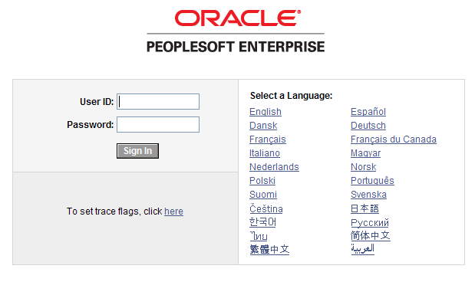
How To: Accessing GeorgiaFIRST Marketplace through PeopleSoft Financials Self Service
- Above is the PeopleSoft Financials log in page.
- Enter your User ID and Password. Remember, both of these items are case sensitive. If you try to log in more than five times with an incorrect User ID and/or password, the system will lock you out.
- Click the Sign In button.
- Depending on your institution, your screen may vary slightly from the one picture above. You may see your institution’s logo and welcome message. However, the menu should look familiar. To access the GeorgiaFIRST Marketplace, select the GeorgiaFIRST Marketplace link in the menu.
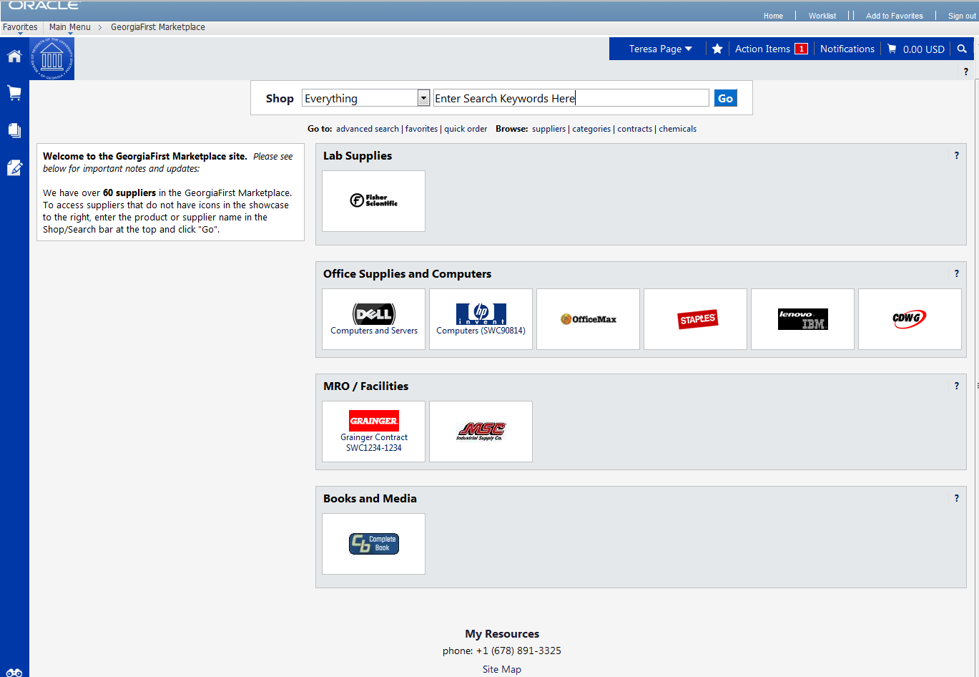
- Notice that the GeorgiaFIRST Marketplace is now displayed in your main window. You are now able to start navigating through the marketplace.
Logging in through PeopleSoft Financials Core System
For those Shoppers that have access to the core system, the access to the GeorgiaFIRST Marketplace is slightly different.
How To: Accessing GeorgiaFIRST Marketplace through PeopleSoft Financials Core System
- Above is the PeopleSoft Financials log in page.
- Enter your User ID and Password. Remember, both of these items are case sensitive. If you try to log in more than five times with an incorrect User ID and/or password, the system will lock you out.
- Click the Sign In button.
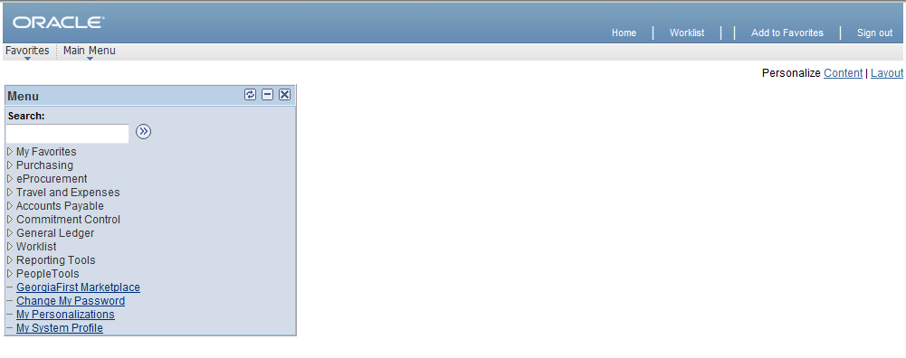
- Depending on your set up, you may have different menu options. However, you will have a link towards the bottom of the menu for the GeorgiaFIRST Marketplace. Select the GeorgiaFIRST Marketplace link to enter the marketplace.
- Notice that the GeorgiaFIRST Marketplace is now displayed in your main window. You are now able to start navigating through the marketplace. You should see your institution logo in the top left corner of the GeorgiaFIRST Marketplace.

GeorgiaFIRST Marketplace Home Page
The first step in using the GeorgiaFIRST Marketplace is knowing where things are located, and how to navigate the home page. Whenever you wish to return to the home page, simply click on the Home icon. You can also click on your institution’s logo in the upper left corner to return to the home page.
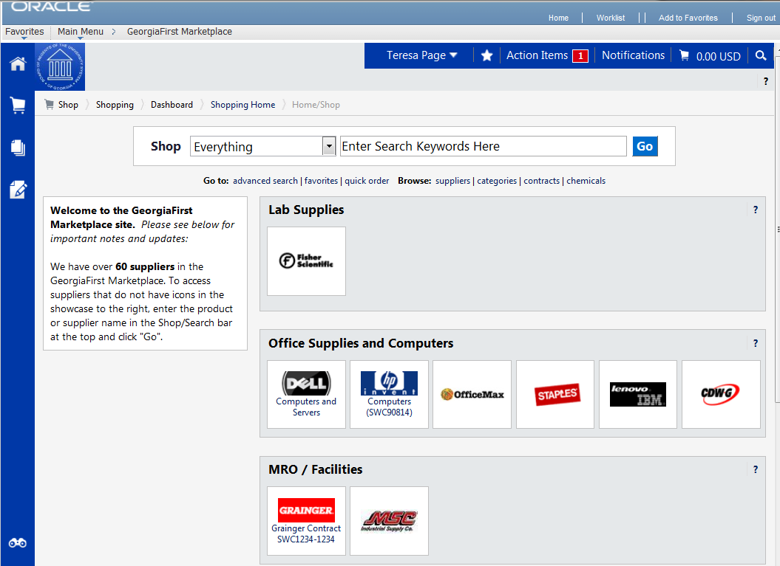User Information: In the upper middle section of the GeorgiaFIRST Marketplace, you will find your User Information. In this area is the user name and a link to the user profile.
89
7
11
10
99
6
4, 5
3
2
1
- Navigation Breadcrumbs and Screen Title: The screen title indicates the title of the current page that you are on.
- Cart Summary: The upper right corner displays a summary of your shopping cart. Included is the cart name, the number of items in the cart, and the total cart amount. You can click on this shortcut to go directly to the cart page to review, update, and process your shopping cart.
- Quick Search: This quick search feature allows for a variety of searches to be executed anywhere in the marketplace.
- Navigation Icons: Down the left side of the GeorgiaFIRST Marketplace are the primary navigation icons. By clicking on an icon, the screen refreshes to display sub links for the topics or functions covered in that particular part of the Marketplace. The links that you see are dependent on your permissions.
  - Home: This icon will return you to the Home page from any other parts of the application.
  - Shopping Cart: This icon is used for shopping and provides quick access to other parts of the application. You can also View and modify the current shopping cart, create new carts, delete existing carts, and prepare the active cart for processing.
  - Orders & Documents: This icon will allow you to search for documents that you have created.
  - Catalogs and Contracts: Contains a repository of various documents within the application.
- Navigation Sub-Links: Once you select a link, additional sub-links may be available. If sub links are available, they will be located just beneath the primary navigation links.
- Shop at the Top/Shop Quick Search: You can access simple and advanced search from this feature. This is the primary area to perform item searches. We will cover search features later in this chapter.
- Action Items: Action Items are items that require some sort of action by the user logged in. The number of action items will be displayed in red to the right of the Action Item menu.
- Notifications: Certain action items will trigger Notification messages informing the user that action is needed. Notifications are clickable and take you to the appropriate area of the application, so that action can be taken. The number of notifications will be displayed in red to the right of the Notifications menu.
- Organization Message: This box is an important tool system administrators use to communicate with the GeorgiaFIRST Marketplace community. This message box is available to all users and is a common way to communicate important upcoming dates, information about new suppliers, links to training, and more.
- Punch-Out: A “punch-out” supplier is a site maintained by the actual suppliers. Catalogs in punch-out sites can still be customized for an individual institution. Punch-out suppliers can be accessed from this area of the screen.
- Online Help: Online Help is accessed by clicking on the question mark anywhere in the application or by clicking on hyperlink text. Text with associated Help is indicated by text that changes colors when mousing-over the text. Much of the text in the application can be selected and a secondary Help window displays.

Leaving the GeorgiaFIRST Marketplace
When you are ready to leave the GeorgiaFIRST Marketplace and go to another menu selection in PeopleSoft, you can simply select that menu selection. When you are ready to close PeopleSoft, select the Sign Out link in the top right corner. You do not have to log out of the GeorgiaFIRST Marketplace since you accessed it through PeopleSoft, which remains open while you are in the marketplace.
Remember, PeopleSoft will automatically log you out for security purposes after 60 minutes of inactivity.

Chapter 3: Contract Types
Even though the suppliers and items in the GeorgiaFIRST Marketplace are all contractually approved, it is helpful to know what the contract types are. There are six types of contracts in the GeorgiaFIRST Marketplace. These contract types are automatically mapped to a Purchase Order Type in PeopleSoft Financials.
If a single Purchase Order includes two contract types, the PO type is sent to “MUL” for multiple.
Contract Type | Custom Catalog Attribute | Order of Precedence | Purchase Order Type | Contract Number
Intergovernmental Agreement | Intergovernmental | 0 | IGA | Goes to the PO Line Item
Mandatory State Contract | Mandatory State Contract | 1 | SWCM | Goes to the PO Line Item
Agency Contract | Agency Contract | 2 | AC | Goes to the PO Line Item
Statutory Mandatory | Statutory Mandatory | 3 | MAN | Goes to the PO Line Item
Convenience State Contract | Convenience State Contract | 4a | SWCC | Goes to the PO Line Item
Statutory Preferred | Statutory Preferred | 4b | PRF | Goes to the PO Line Item

Chapter 4: Searching for Items in the GeorgiaFIRST Marketplace
Within the GeorgiaFIRST Marketplace, there are many ways that you can search or browse for items. In this chapter, we will review most of the search methods. However, after using the marketplace for a while, you will find the way that you are most comfortable.
Before we discuss what search options are available, let’s take a minute to review what is available to be searched. First, GeorgiaFIRST Marketplace has “hosted catalogs”. A hosted catalog is an online version of a supplier’s printed catalog. Hosted catalogs contain product data and details, along with pricing information for each item. When you perform a product search, the products in all of the hosted catalogs are searched.
Second, there are “punch-out catalogs”. Punch-out catalogs are integrated external links to a supplier’s web-based catalog. The Shopper enters the punch-out supplier’s website through the GeorgiaFIRST Marketplace to search and select products from that supplier’s web catalog (i.e., Dell’s Government Catalog). The shopper then returns the items to the GeorgiaFIRST Marketplace shopping cart. Punch-out catalogs still maintain items and pricing specific to the University System of Georgia. In some cases, items and pricing in a punch-out are also specific to each institution.
Third, there are “self-managed” catalogs. These catalogs function very similarly to hosted catalogs, but the items and pricing are managed by the institutions, the University System Office, and the System Admin.

Using Simple (Basic) Search
A simple search is similar to a “Google” search, where you enter a word, phrase, or keyword into a single text box for searching. By using a simple search, you can get results from hosted catalogs, self-managed catalogs, and contracts. Simple Search displays when you enter the GeorgiaFIRST Marketplace. With the Simple Search feature, you can search through everything or you can search by product category. By default, the search will occur across all product categories (“Everything”). All of the words that you enter in the keyword textbox must be found in the items displaying in the product search results. After entering the keywords, click the “Go” button or press “Enter” on your keyboard.
When performing a simple search, the system looks through many different things in order to find the most relevant search results. This includes looking through Keywords and Item information. GeorgiaFIRST Marketplace System Administrators enter keywords to help guide users to the correct contract, supplier and favorite items. Item Information includes the following:
- Product Description
- Product Category/Sub Category
- Supplier (Vendor)
- Manufacturer Name and Manufacturer Part Number
- Unit of Measure/Product Size
- System Packaging and Size
- Alternate Name and Alternate Part Number(s)
- Client Catalog #
- Color
- Common Name
- MDL Number
- Molecular Formula
- Radionuclide
- UPC
One way to narrow down your search results is to only search in a particular product category. Searching by category helps reduce the number of products from appearing in the search results by filtering out those not in the selected category. When shopping by category, the data being search is limited. Available categories may vary by institution depending on the suppliers and items enabled. The Product Categories that you may see include:
- Lab Supplies: Products used in various research environments (i.e., reagents, glassware, analytical equipment, etc.)
- Medical/Clinical Supplies: Includes medical, surgical, clinical and dental products (i.e., gauze, needles, dental equipment, etc.)
- Office: Office supplies and consumables (i.e., files and folders, desk supplies, writing instruments, etc.)
- MRO/Facilities: Products related to maintenance repair and operation (i.e., tools, hardware, janitorial supplies, etc.)
- Furniture: All furniture products (i.e., desks, chairs, shelving, etc.)
- Services: Service-related items (i.e., lab services, legal services, training services, etc.)
- Manufacturing/Engineering: Major equipment purchases (i.e., Construction equipment, HVAC equipment, Pharmaceutical equipment)
- Books and Publications: Hardcopy documentation spanning all topics and interests (i.e., Books, Manuals, Magazines, etc.)
- Electronics/IT/AV: All electronic or computer-related equipment (i.e., computer hardware/software, AV equipment/accessories, communication equipment/accessories, etc.)
- Specialty: Miscellaneous Products (i.e., Sporting equipment, Clothing materials, Musical instruments, etc.)
- Food/Food Equipment: All food-related items (i.e., Commercial food preparation, storage, and serving equipment, Food consumables and supplies, Kitchen equipment, etc.)
It is recommended that when searching for an item, you first search by product category. If you do not find what you are looking for, then search “Everything.”
Once your search results are retrieved, you can use the filter options to further refine your results. Primarily, you can use the filter options for “Custom Attributes” to see those items on a state contract, agency contract, etc.
How To: Perform a Simple Search
- Start from the GeorgiaFIRST Marketplace home/shop page.
- Select the appropriate Product Category (optional).
- Enter one or more keywords.
- Press the Go button.

Using Advanced Search
By using Advanced Search, you are able to enter additional criteria to generate more specific search results than with Simple Search. The search criteria available depends on the product category selected and includes custom catalog attributes to identify contract type. By default, once you open the Advanced Search function after entering the GeorgiaFIRST Marketplace, it will remain open for subsequent searches, for the remainder of the shopping session.
To access Advanced Search, select the Advanced Search link found below the Simple Search (Shop at the Top).
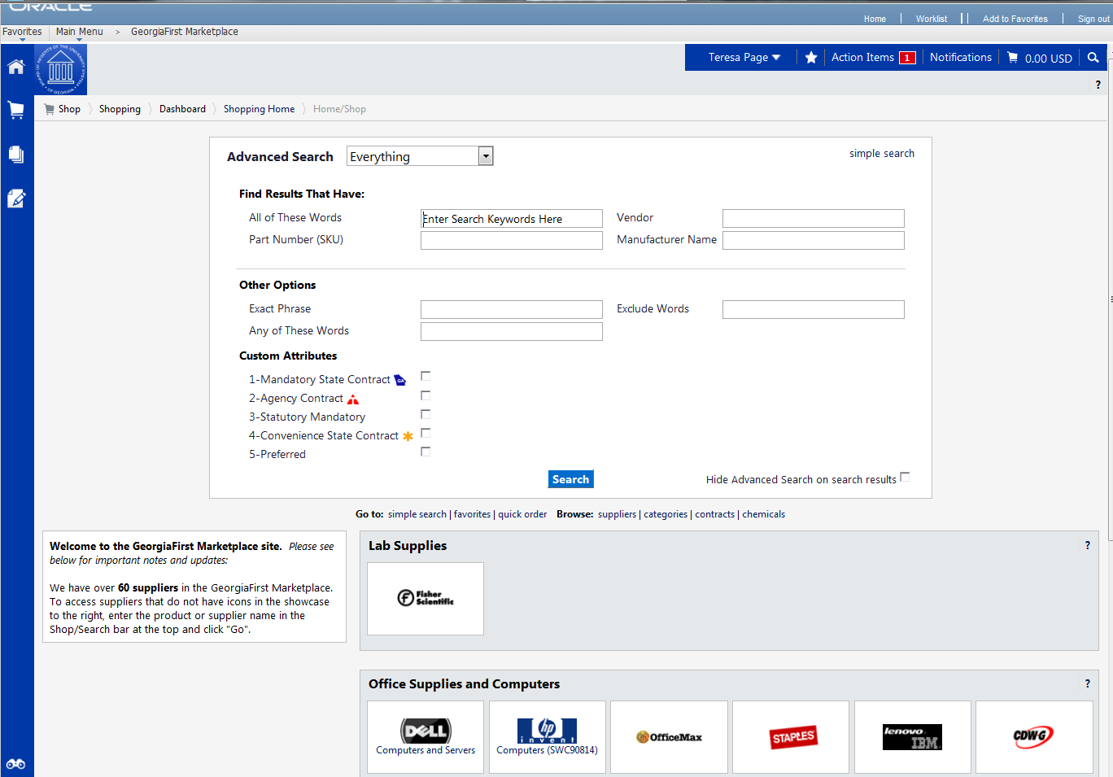
When using Advanced Search, proper usage of the search criteria fields makes a huge difference in terms of the quality of search results. Users should take the time to understand how each of these fields work. Keep in mind that the search criteria fields available in Advanced Search are dependent on the product category selected.
Search Criteria Field | Description
All of These Words | This field functions in the same way that Simple Search does. Only products containing ALL the word entered in this field are returned in search results. The words do not need to be in the same order as listed, but all words must be found in the item data or keyword data.
Part Number (SKU) | Enter the catalog number or SKU (Stock Keeping Unit) for the required product(s). This may be the distributor’s SKU or the manufacturer SKU.  For best results, the entire SKU should be entered. A partial match on part number returns the closest matching or similar results. This is a “begins with” match and at least four characters must be entered.  If multiple strings of text are entered (i.e., “123 456 798”), then all components of that string must be present in the part number for the item to be returned. For example, if “123 456 789” is entered into Product Search, the part numbers “123-456-789” and “123-456-789-000” would be returned, and “123-456” would not.  When the Part Number field is used as part of the search criteria, only those fields related to the Part Number for items are searched. This includes Supplier Part Number, Manufacturer Part Number, Alternate Part Number, Client Catalog Number, and Custom Catalog Number.
CAS No. | This search field is available in the Laboratory Supplies category only. CAS numbers can be entered in any format using numbers, brackets, braces, parentheses, and dashes (any other characters are stripped). The search engine will convert the entered value to the appropriate format to return only products with the entered CAS number. Enter multiple CAS numbers to find all chemicals with matching CAS numbers. Note: The entered CAS No. is checksum validated to reduce errors.
Product Class | This field is only available for Lab Supplies and provides a more detailed level of categorical search.
Product Size | Enter the units for the product size and select the dimension of the units from the pull-down menu. For example, enter “500” for units and select “mL” from the pull-down for a product size of 500mL. This is available only in the Lab Supplies category.
Supplier Name | Enter the beginning of a supplier’s entire name to find products from all suppliers that include the terms as part of their name, or begin typing and select from the drop-down list of suppliers to see products from a single specific supplier. When the Supplier Name field is used as part of the search criteria, only the supplier name is searched.
Manufacturer Name | To find products from a specific manufacturer, enter the name of that manufacturer here. Search Results will include products from all suppliers who have identified the manufacturer in the product information provided to the GeorgiaFIRST Marketplace. Enter multiple manufacturer names to limit results to a set of certain manufacturers.  Only the manufacturer field is searched for matches.
Exact Phrase | Products containing the exact words in the ordered entered are returned. This is a very powerful search strategy if you know the precise way in which a supplier presents its information. If you are unsure – and looking for results from multiple suppliers – it is recommended that you use “All of These Words” option instead.
Exclude Words | Products including any of the words entered in this field are excluded from Search Results. Another search field must be used when using the exclude function. For example, you may be looking for all glove options that are not small or medium. You could enter “latex gloves” in the “must include the words” field and “small medium” in the “exclude the words” field.
Any of These Words | Search results will include products containing any of the words entered in this field. Products containing more than one word appear higher in search results than products with only one. Keep in mind, the search results will not be as targeted as using the “must include the words” field.

You can also narrow down your results by using the Custom Attributes. These Attributes include:
- Mandatory State Contract
- Agency Contract
- Statutory Mandatory
- Convenience State Contract
- Statutory Preferred
Once your search results are retrieved, you can use the filter options to further refine your results. Primarily, you can use the filter options for “Custom Attributes” to see those items on a state contract, agency contract, etc.
When executing your search, select the “Hide Advanced Search on search results” checkbox if you would like the advanced search box to collapse and show the Simple Search after displaying results. To go back to using Simple Search, select the “simple search…” link.
How To: Perform an Advanced Search
- On the GeorgiaFIRST Marketplace home/shop page, select the advanced search link.
- Select a Product Category in the Advanced Search drop down list.
- In the Find Results That Have: section, use one or more of the following options:
  - All of These Words
  - Supplier
  - Part Number (SKU)
  - Manufacturer Name
  - CAS No. (Laboratory Supplies Category only)
  - Product Class (Laboratory Supplies Category only)
  - Product Size (Laboratory Supplies Category only)
- In the Other Options: section, use these additional fields as necessary:
  - Exact Phrase
  - Exclude Words
  - Any of the Words
- To search for items for a particular contract type, select the checkbox next to the appropriate custom attribute/contract type.
  - For example, initially perform the search with Mandatory State Contract selected. If the search does not return the required item, repeat the search with Agency Contract selected.
- Click the Search button

Search Result Details
Search results display below the Simple and Advanced Search.
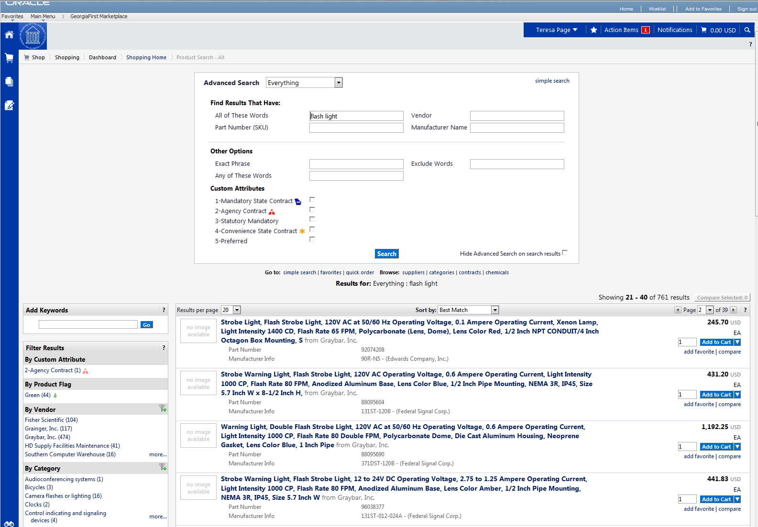
Here are the detailed explanations for the Search Results user interface:
Search Results | Description
Search Listing | By default, items and recommended services, suppliers, etc., are presented in the Best Match “Order”. Hosted products are displayed with an image (if available), along with product description and product detail information.
Showing | After the search is performed, you can see how many items are displayed from the overall total of results.
Sort By | After the search is performed, you can choose to re-sort the data by part number, product description, price, etc.,
Refining the Search through Keywords | GeorgiaFIRST Marketplace allows you to filter the search results by adding additional keywords into the “Add Keywords” field, found on the left side of the screen.
Refining the Search through Filters | GeorgiaFIRST Marketplace allows you to filter the search results by selecting specific suppliers, product categories, supplier classes, manufacturers, units of measure, product flags, or custom attributes (contract type). These filter options are found on the left side of the screen.
Icon Definitions | Custom Attributes (used for contract type, supplier classes, and product attributes are identified with icons below the product description. An item-specific legend is provided for product flags and supplier classes in the appendix.
Comparing Items in Search Results | From the search results, product details can be compared to determine which one should be ordered. This function is explained more in depth in the next chapter.
Access Additional Pages and Changing Items per Page | To change the number of items displaying per page, select the appropriate option from the “Items per page” drop-down at the top or bottom of the search results. To view items on a different page, use the arrow buttons or select a specific page number. This information is displayed above and below the search results.

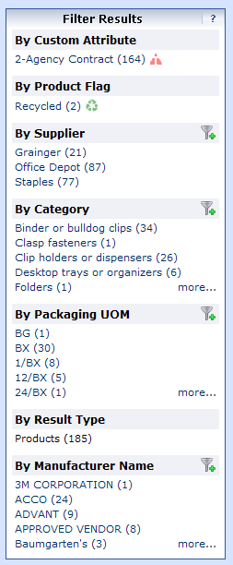
Filtering Results
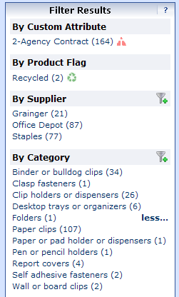
Once you have searched for an item, you can use the Filter Results section on the Search Results page to further narrow down your results. After performing a search, you will see the Filter Results section appear, where you can filter by Custom Attribute (contract type), Product Flag, Supplier, Category, Packaging UOM, Result Type, and Manufacturer Name.
To apply a single filter, simply click on the option. To see additional options under a filter, select the more… link.

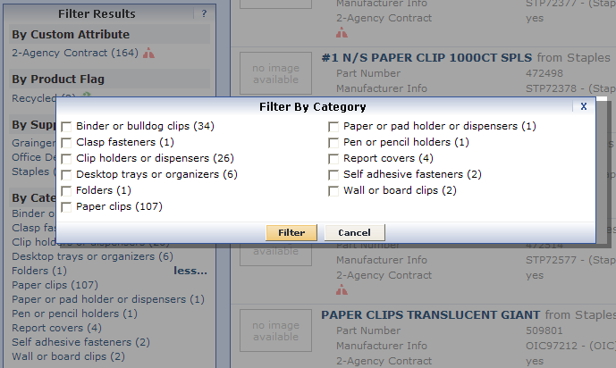
In addition, you can apply multiple filters under one filter option by selecting the add filter… icon (funnel with green plus sign). By selecting the add filter…icon, you can choose more than one filter option. Simply select the options you want through their checkboxes and then click the Filter button.

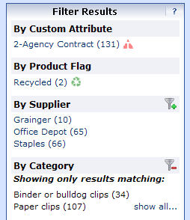
If you want to remove a filter, click the remove selected filter icon (funnel with red minus sign).

Over the next few pages, we will detail how to search using other methods.

Searching from the Purchasing Showcase
The Purchasing Showcase is an area where specific suppliers are highlighted. Suppliers listed in the Purchasing Showcase may or may not have an icon attached to their name. Additional, suppliers can have a caption indicating what the supplier offers or what special discounts they have or the contract number.
How To: Search from a Showcased Supplier
- From the GeorgiaFIRST Marketplace home/shop page, click on the Supplier name or icon in the Showcased Suppliers section. A pop-up displays that indicates how you can shop from the supplier. The options include a simple search. Depending on the system configuration, search by contract type may be available for some suppliers.
- Enter keywords in the Search field and click the Search button.
- The Search Results will appear and be formatted just how Simple Search and Advanced Search displays.
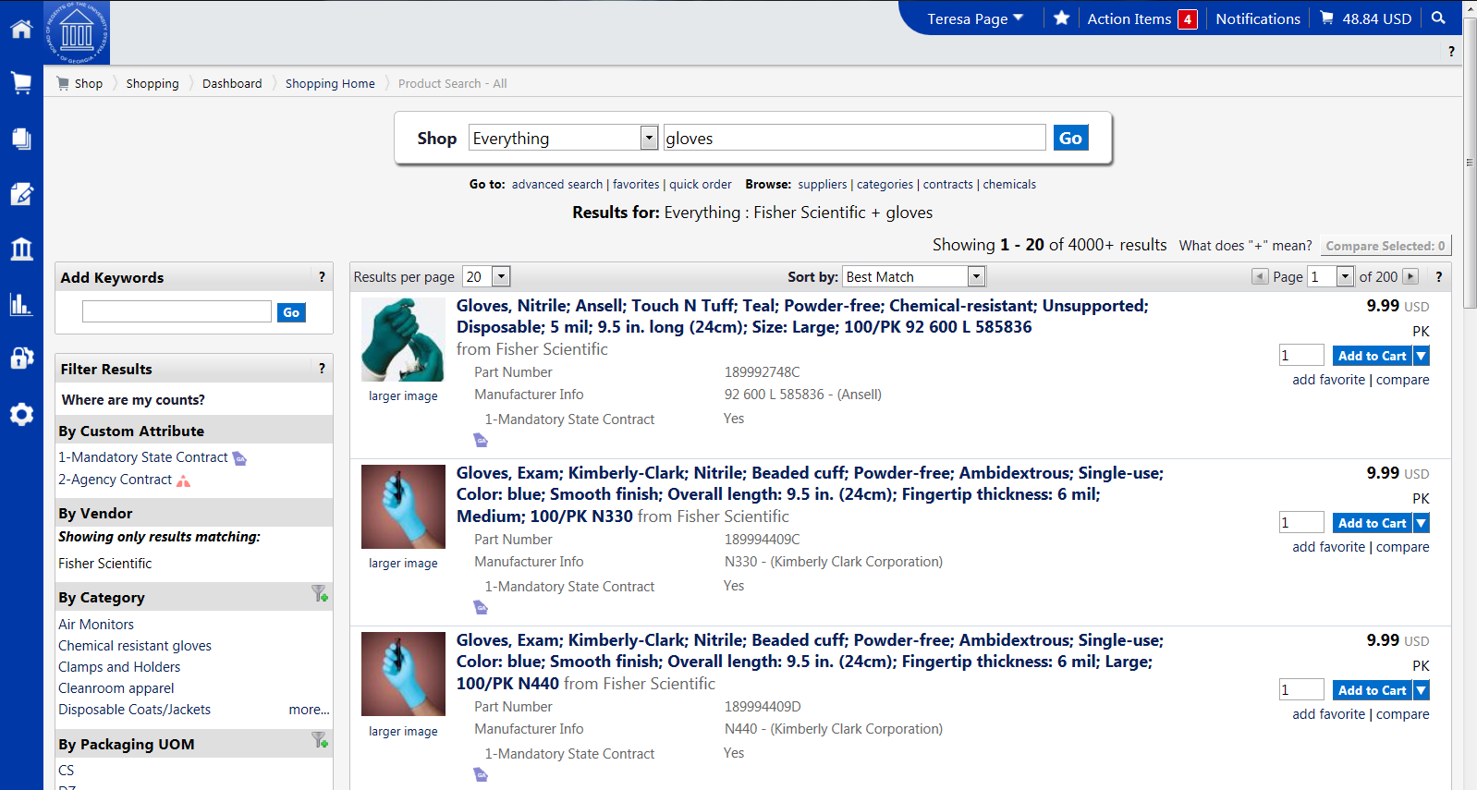
- From these search results, you can narrow down your results by using filter options, re-sorting the results, or adding additional keywords.

Browse by Supplier
The “Browse by Supplier” functionality is much like using a table of contents from a paper catalog. Once the desired chapter is found (product category), a single click takes you to all of the products provided by that supplier in that selected category. This functionality is different than selecting a specific supplier from the Showcase or through Punch-outs.
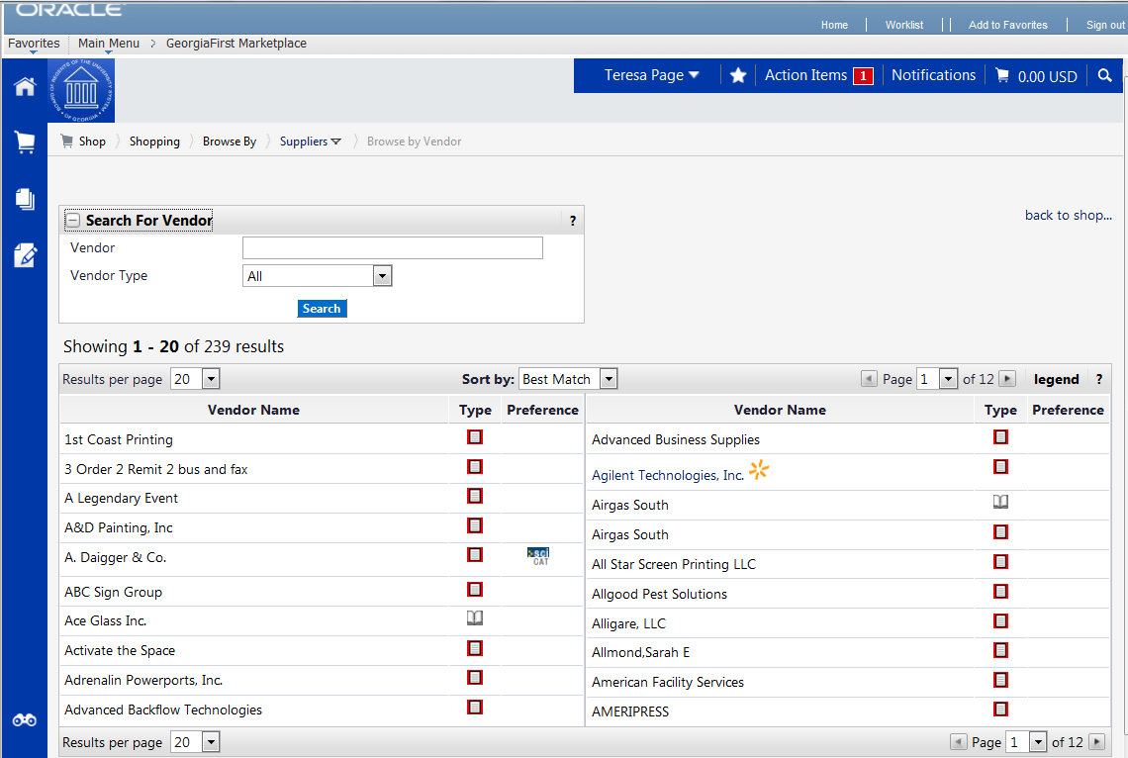
How To: Browse for Items by Supplier
- From the GeorgiaFIRST Marketplace home/shop page, select the Browse: suppliers link.
  - By default, all suppliers display. Suppliers are listed in alphabetical order with preference suppliers displaying first.
- To search for a specific supplier, click on the expand icon (+) to the left of “Click to expand Search for Supplier Filter.”
- To view all suppliers click the Search button.
- To search by supplier name or supplier information, enter the appropriate information in the Supplier Name field. The supplier search allows for a “contains” name search.
- From the Supplier Type drop down list, select to view Hosted Catalog Suppliers.
- Click the Search button.
- Select the supplier from the results by selecting the Supplier Name. The supplier information and categories display.
- From the supplier category page, select the desired product category by clicking on its name or the expand icon (+) next to its name.
- Continue drilling down into the categories until you locate the sub-category that you would like to view.
- Final sub-categories (with items) are indicated with the word “view” next to it. Click the view button to view the items for the supplier in that particular category. You will be taken to the Search Results page, which is formatted like all other Search Results pages.

Browse by Category
The “Browse by Category” functionality is similar to the “Browse by Supplier” functionality. The main difference is instead of viewing one supplier’s table of contents, all supplier tables of contents are shown. Using this functionality is equivalent to opening numerous paper catalogs from many suppliers to the same section.
Browse by Category provides a quick way to locate all item, across all suppliers, in a certain category.
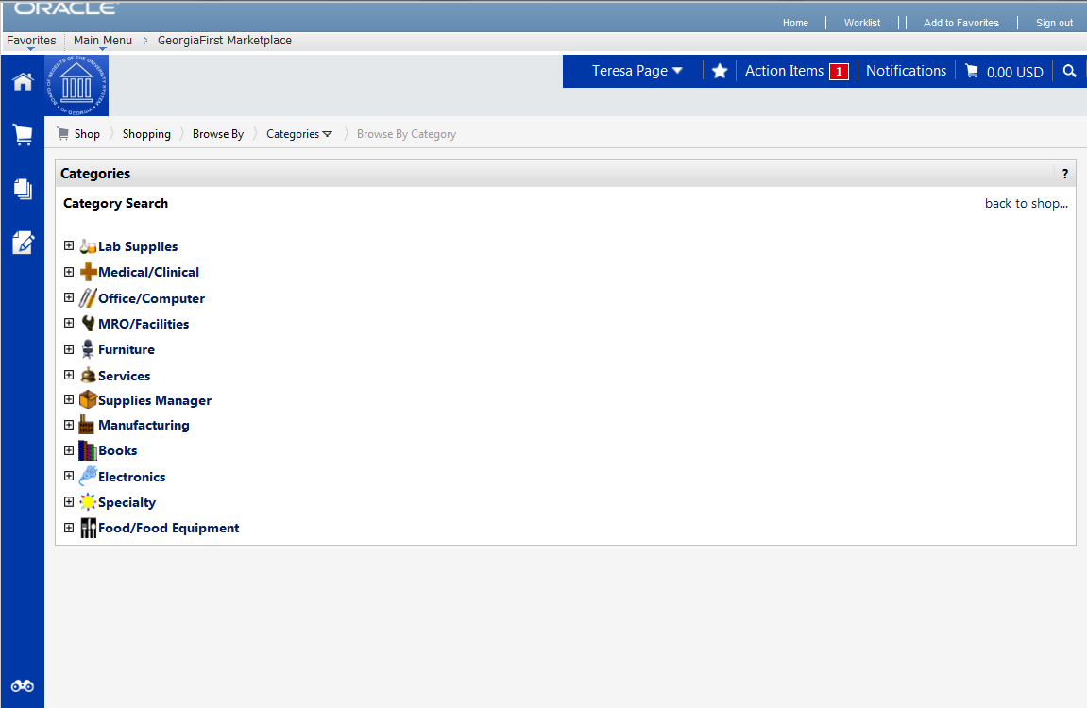
How To: Browse for Items by Category
- From the GeorgiaFIRST Marketplace home/shop page, select the Browse: categories link.
- A full list of available categories, across all hosted catalogs is presented. This represents your full table of contents.
- Use the expand (+) and collapse (-) buttons to drill down to the category of your choice.
- Final sub-categories (with items) are indicated with the word “view” next to it. Click the view button/link to view the items in that particular category. You will be taken to the Search Results page.
- On the Search Results page, all items in the selected category are displayed from all suppliers. Use the filter results to narrow your search results down even further.
Using Product Comparison
Side-by-side comparisons are a good way to determine which product is best suited for a particular need. The Compare function allows the selection of two or more products to do a direct side-by-side comparison of the product attributes of each. Products found across multiple pages of search results can now be compared to one another. Keep in mind that the product comparison feature can only be used to evaluate hosted catalog items. Items from punch-out suppliers do not display in the search results, and therefore cannot be part of the side-by-side comparison.
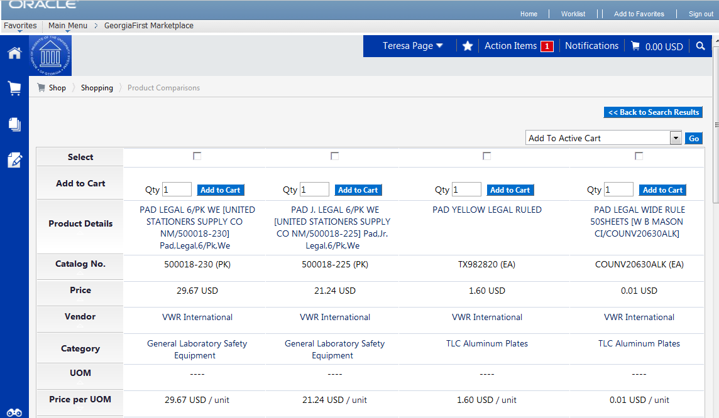
How To: Compare Products Side-by-Side
- From the GeorgiaFIRST Marketplace home/shop page, search for an item using your preferred search method.
- From the search results, click the compare hyperlink for each item you want to include in the comparison. To remove an item from comparison, while on the Search Results page, select the remove hyperlink.
- Note: Items across multiple pages can be selected. Once one or more items are selected, the Compare Selected button will activate.
- Continue to select items for comparison. Once all items are selected, click the Compare Selected button at the top of the search results.
- The Product Comparison page lists all of the products selected for comparison. Product attributes are shown on the left side of the page. Scroll down to review the information for each item/attribute.
- To remove a product from the Product Comparison page:
  - Click the check box at the top of the product
  - Select the Remove action from drop down list
  - Click the Go button
- Click on the supplier hyperlink for an item for more information about that supplier. Here you can see supplier and contract information.
- Click the more information URL to view a detailed product description.
- Click the Add to Cart icon to add the item directly to your shopping cart.
- Click the Back to Search Results button to go back to your original search results and cancel the product comparison. From here, additional products can be selected for comparison.

Searching from Punch-Out Suppliers
In addition to searching supplier-hosted catalogs that are loaded into the GeorgiaFIRST Marketplace, you can also search for items via punch-out suppliers. When accessing a punch-out supplier via the GeorgiaFIRST Marketplace, you are automatically authenticated to the supplier, so the supplier’s website knows which organization you are from. This enables the supplier to show the appropriate products and pricing.
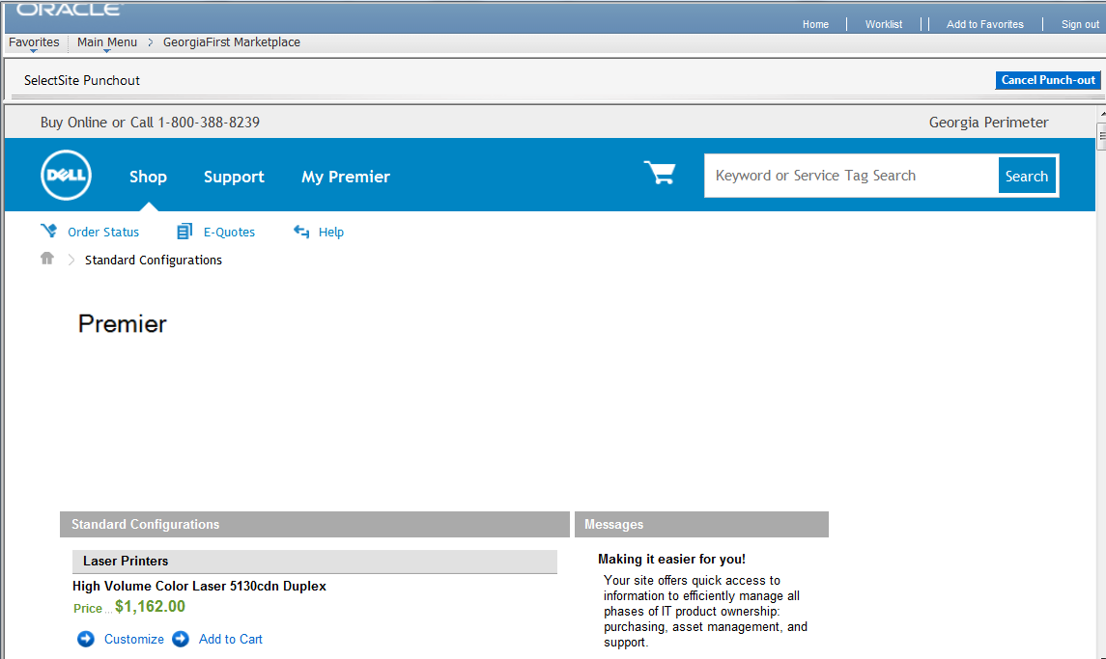
How To: Search from Punch-Out Suppliers
- From the GeorgiaFIRST Marketplace home/shop page, click on the Punch-Out supplier from the Punch-Out section.
- The system will redirect you to that supplier’s web-page.
- If you decide that you did not want to search from the punch-out supplier, select the Cancel Punch-out button in the upper right corner of the screen. This will take you back to the GeorgiaFIRST Marketplace.
- Search for your items through the Punch-out supplier’s website. The specific steps for searching and selecting items will be different for each punch-out supplier.
- Select your items using the punch-out supplier’s tools (i.e., “Add to Cart,” “Add Item,” etc.).
- After selecting your items, proceed to the punch-out supplier’s checkout. Check out of the punch out site. Checking out will be different for each supplier. For example, in the Dell punch-out site, when you are ready to pull your selected items into your GeorgiaFIRST Marketplace shopping cart, you select the “Create Order Requisition” button within the Dell punch-out site, and then choose “Submit Order Requisition”. This action places the items you selected into your GeorgiaFIRST Marketplace shopping cart. An order is NOT placed with the supplier when checking out of a punch-out site.
- After checking out of the punch-out supplier’s website, you are returned to the GeorgiaFIRST Marketplace where you can add additional products to your shopping cart from other punch out vendors, as well as hosted catalog vendors.

Chapter 5: Shopping for Items in the GeorgiaFIRST Marketplace
Now that you know how to search for items, you are ready to begin building your shopping cart in the GeorgiaFIRST Marketplace.
The process that you will follow is the following:
Search for Items
Place items in your Shopping Cart
Review and edit your Shopping Cart if needed
Assign your Shopping Cart to your Requester
Active vs. Draft Carts
There are two types of carts you can have in the GeorgiaFIRST Marketplace: Active Cart and Draft Cart. An Active Cart is the shopping cart you are currently working with or editing. A Draft Cart is a cart that you have created, but are not currently working with.
If you have started creating a cart, you can locate it within the Shopping Cart icon, then My Carts and Orders link, then Open My Active Shopping Cart link. You can locate all of your carts under the My Carts and Orders link, and then under the “View Draft Shopping Carts” sub-link. Even your active cart will be listed here. The current active cart will have a colored background with its shopping cart icon.
You can create new carts whenever necessary. Additionally, draft carts can be created for future use. Creating draft carts may be useful for setting up orders that are similar or that might be used later. Initially, we will only work with one cart. Later in this chapter, we will talk about working with additional draft carts. Remember, your active cart is the shopping cart you are actively working with by adding items and assigning to a requester.
Adding an Item to a Cart
Shopping carts represent items selected that you wish to purchase. Shopping carts contain line items that represent items, or products being requested through the GeorgiaFIRST Marketplace. There are multiple ways to add an item to your shopping cart depending on where you are in the Marketplace. You can add items to your shopping cart from the search results page, product description pop-up, product comparison, etc.
How To: Add Items to your Shopping Cart from the Product Search Results Page
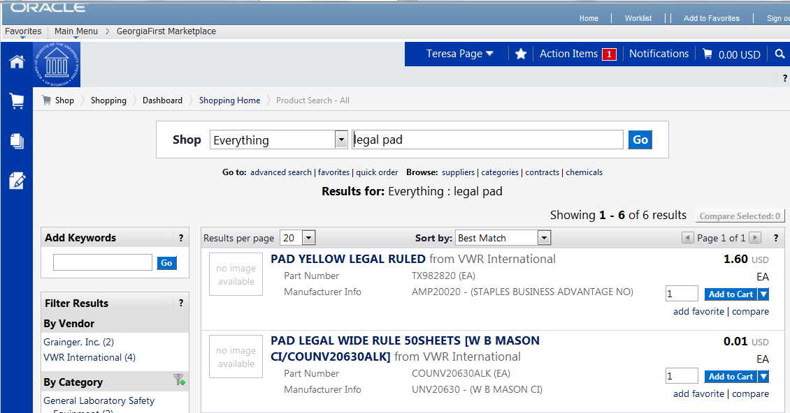
- From the GeorgiaFIRST Marketplace home/shop page, search for the item using your preferred search method.
- From the search results, locate the item you wish to add.
- For that item, enter the quantity you wish to request.
- Select that item’s Add to Cart button.

How To: Add Items to your Shopping Cart from the Product Description Pop-Up
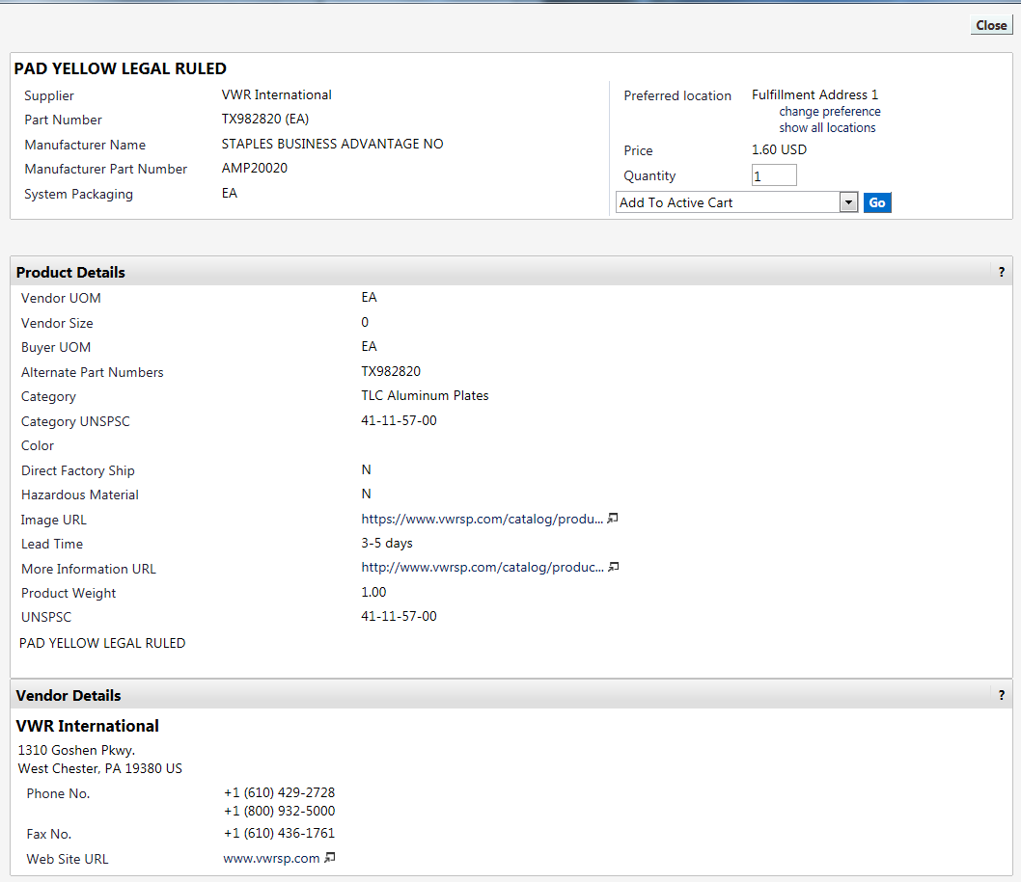
- From the GeorgiaFIRST Marketplace home/shop page, search for the item using your preferred search method.
- Click on an item’s product description (item description hyperlink) to open its Product Details Pop-Up.
- Enter the desired Quantity.
- In the drop down list, select Add to Active Cart and click the Go button.
- Click the Close button after receiving the “Added Successfully” message.

How To: Add Items to your Shopping Cart from Product Comparison
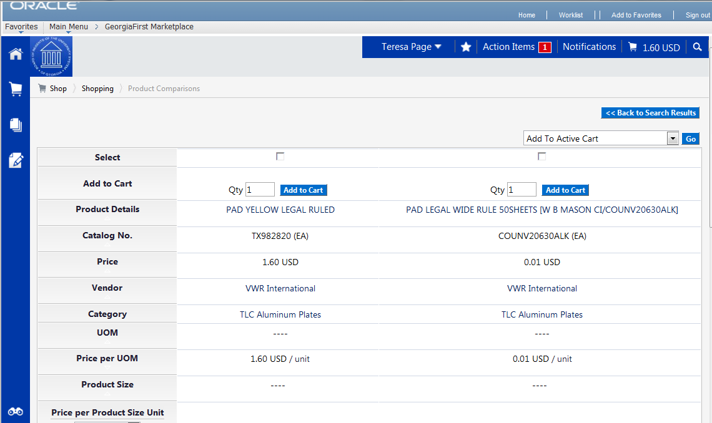
- After searching for items and selecting items for comparison, open the Product Comparison page by selecting the Compare Items button.
- From here, you can add items to your shopping cart in one of two ways:
  - Enter the Quantity and click the shopping cart icon, or
  - Place a check in the desired items Select checkboxes, and choose Add to Active Cart in the Action drop down list.
How To: Add Items from a Punch-Out Supplier
- From the GeorgiaFIRST Marketplace home/shop page, select the Punch-Out supplier by clicking on its name or icon in the Punch-out section.
- The Marketplace redirects you to the supplier’s punch-out site.
- Search for products and add products to the cart in the supplier’s punch-out (this process varies from punch-out to punch-out).
- Use the supplier’s mechanism to return products to the GeorgiaFIRST Marketplace (this process again varies from punch-out to punch-out).
- Upon returning to the GeorgiaFIRST Marketplace, the selected items will be in the active shopping cart and you will be on the Shopping Cart page.
Shopping Cart Page
From anywhere in the Marketplace, when you are ready to review your shopping cart, you can select the cart summary link in the upper right corner of the screen. You should see your active cart name (by default, this is your user name, the date, and sequential order number for the day), the number of items in the cart, and the total cart amount. Click this shortcut to go directly to the cart page where the cart details can be reviewed and updated.
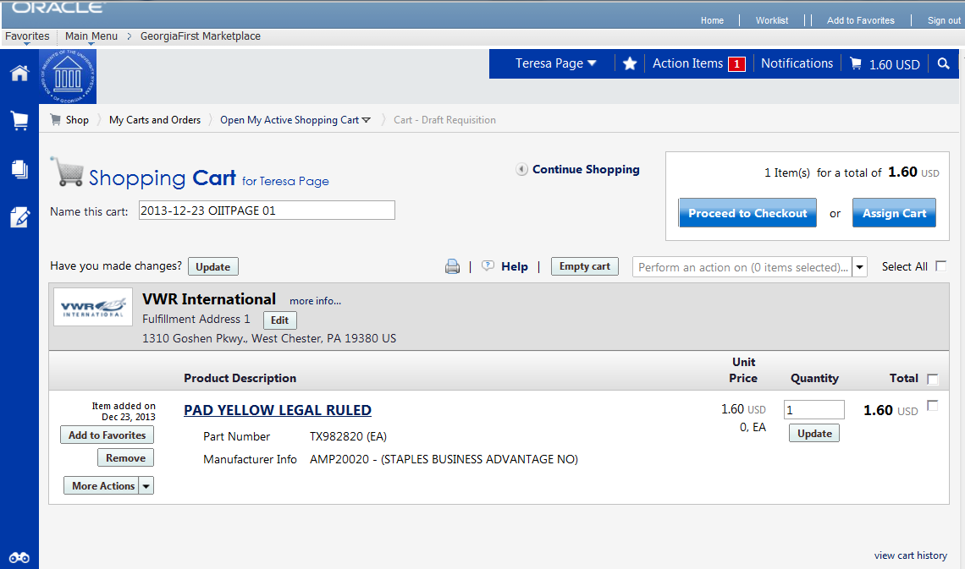
Shopping Cart Name
Once you begin adding items to your shopping cart, the system gives your shopping cart a default name. This default name is a combination of your user name, the date, and the sequential order number for that date. For example, a shopper with the user name of MJones, creates her first cart of the day on March 23, 2011. This cart is given a default name of “2011-03-23 MJones 01.” If this user creates another cart on March 23rd, then the second cart is named “2011-03-23 MJones 02.”
You can easily rename your cart though. To do so, simply retrieve your Shopping Cart.
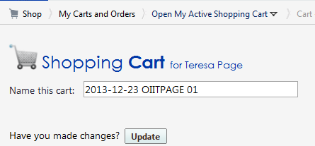

How To: Rename Your Shopping Cart
- Retrieve your shopping cart.
- Input your new shopping cart name in the ‘Name this cart’ box.
- Click the Update button directly below the cart name.

Removing Items from the Cart
You can remove items from a shopping cart either individually or all at once. GeorgiaFIRST Marketplace allows the removal of items from the cart, regardless if the item is from a punch-out supplier or hosted catalog item.
How To: Remove Selected Items from a Cart
- Go to the Shopping Cart.
- Option 1:
  - Select the Remove button on the product line.
- Option 2:
  - In the cart, select one or more items to remove by placing a checkmark in its Select checkbox.
  - Click in the action drop down list.
  - Select Remove Selected Items.
- The selected items are then removed from your shopping cart.

How To: Remove All Items from a Shopping Cart
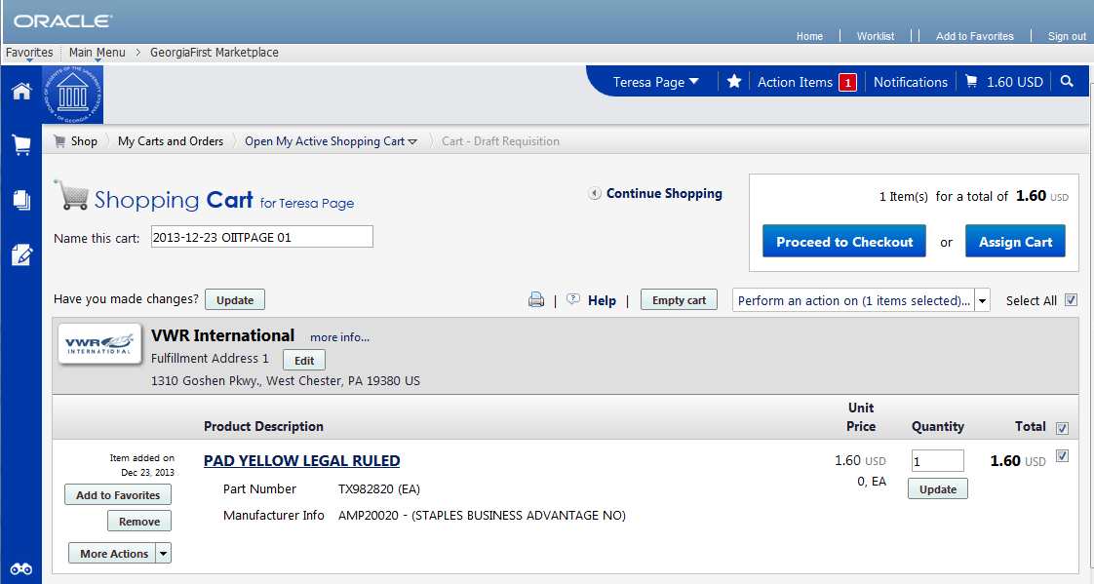
- Go to the Shopping Cart.
- Select the Empty Cart button.
- To remove all items, click the OK button to proceed.
- Your active shopping cart should now be empty.
Updating the Quantity of Items in a Cart
Once you have added items to your shopping cart, you may find it necessary to change the quantity requested. You can update the quantity when adding an item to your shopping cart or after the item has been added to your shopping cart.
How To: Update Quantity of Items in a Cart
- Go to the Shopping Cart.
- For the item you want to update, go to the Quantity field in that row.
- Enter the desired quantity.
- Click the Update button directly under the Quantity field.
- If you are making updates to more than one item, you can enter the desired quantity for all items and the select the update button directly below the Shopping cart name to update all quantities at one time.

Selecting the Applicable Contract for an Item
Some items that you select may be listed on multiple contracts. The Marketplace will always default to the lowest priced. If you wish to change to a different contract (for example, change from an Agency Contract to a Mandatory State Contract), you can select the appropriate contract while in the Shopping Cart. If you are ever unsure which contract to use, contact your institution’s Procurement Lead.
How To: Select a Contract for an Item
- Go to the Shopping Cart.
- For the item you want to select a different contract for, select the change… hyperlink next to the contract name.
- A pop-up box will appear with the contract choices. Select the appropriate contract by using the radio button.
- Click OK.
Selecting Fulfillment Addresses (applies only to fax or email suppliers)
In instances where a supplier has multiple fax numbers or email addresses, for example by region, the GeorgiaFIRST Marketplace will have multiple fulfillment addresses for that supplier. When an item from a supplier with multiple fulfillment addresses is added to the shopping cart, an edit button is displayed next to the current default fulfillment address.
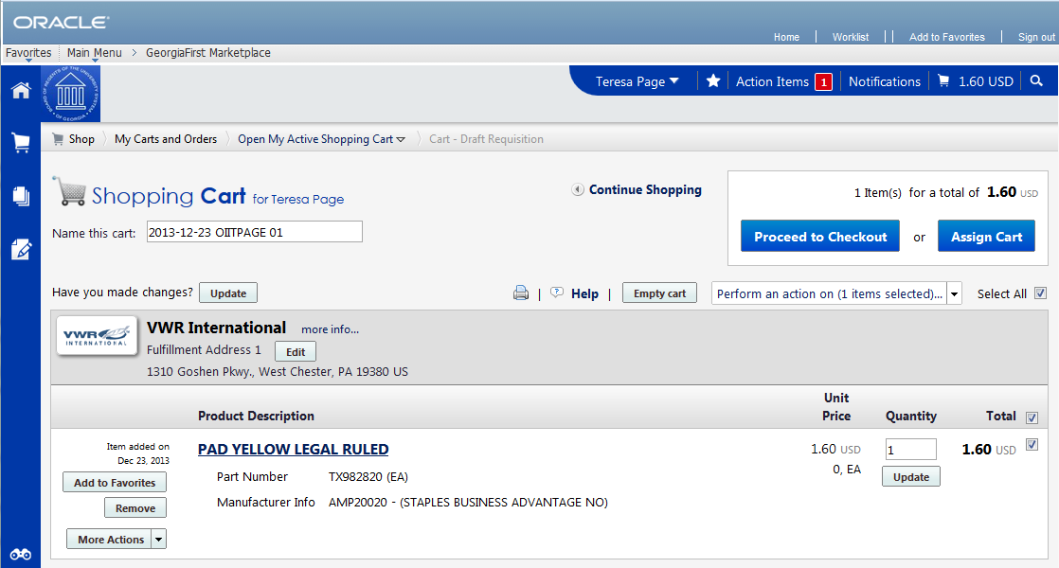
By clicking on the edit button, the user may select a different fulfillment address for this item. Note also that a user may click the save as my preferred checkbox to update this as the default fulfillment address.
How To: Select Fulfillment Address
- Go to the Shopping Cart.
  - Note: If a supplier has multiple fulfillment addresses, an edit button will appear below their name on the Shopping Cart. If there is no edit button, there is only one fulfillment address for the supplier.
- Select the edit button below the supplier name.
- Using the drop down list, select the fulfillment address you wish to use.
- To save the supplier’s fulfillment address as the preferred address you always want to use, select the save as my preferred checkbox.
- Click the Save button.

Deleting a Shopping Cart
On occasion, you may find it necessary to delete your shopping cart. You can delete entire shopping carts with one click. Once you delete a shopping cart, it is permanently removed.
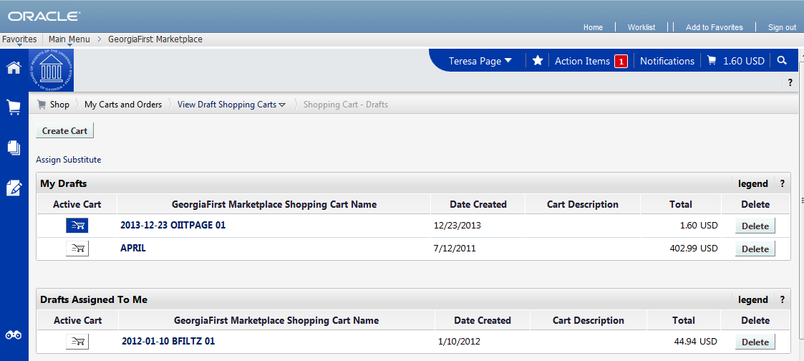
How To: Delete a Shopping Cart
- Select the Shopping Cart icon.
- Select the My Carts and Orders sub-link.
- Select the View Draft Shopping Carts sub link.
- Locate the cart you want to delete.
  - Your current (or active) cart will have an icon with a colored background.
  - Draft carts have an icon with a white background.
- Press the Delete button on the right side of the screen.
- After selecting Delete, the system deletes the cart immediately. Once a cart is deleted it is permanently removed and it cannot be restored.

More about Draft Carts
Earlier, we discussed the difference between an active cart and a draft cart. Remember, an active cart is the shopping cart you are actively working on. You can, however, create additional carts whenever necessary. Additionally, draft carts can be created for future use. Creating draft carts may be useful for setting up orders that are similar or that might be used later. For example, you can have draft carts for different standing orders.
Under the Shopping Cart icon, you will see a link for My Carts and Orders. Within that link you will see a link for Open My Active Shopping Cart and a link for View Draft Shopping Carts. Under the Active cart link will be the current shopping cart that you are working with. Under the Draft carts link are all of the carts you have created. The shopping cart that you are current working with, or your active cart, will have a colored background in its shopping cart icon. Draft carts will have a white background.
Let’s imagine that we have three draft carts – one for office supplies, one for furniture, and one for camera accessories.
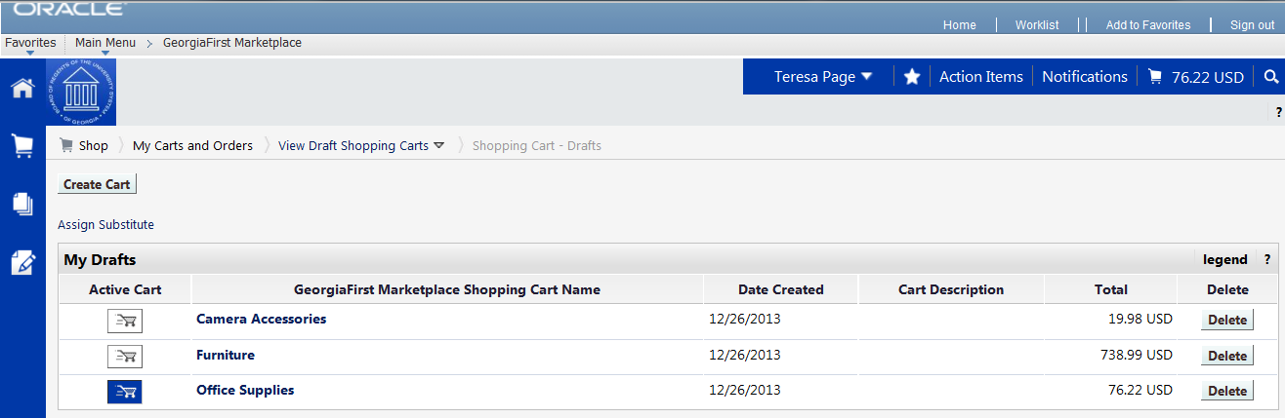
As you can see in the picture above, our current active cart is Office Supplies because its icon has a colored background. If we were to select the ‘Open My Active Shopping Cart’ link, we would see the Office Supplies cart.
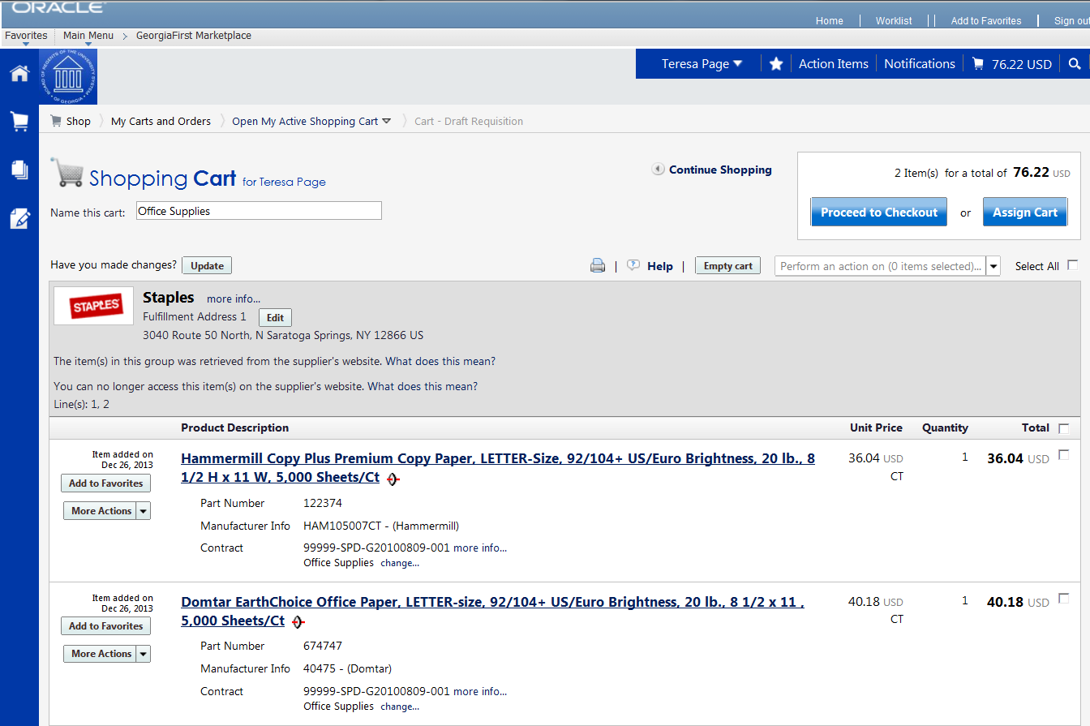
Whenever needed, you can create a new draft cart. To make a different draft cart active, simply click on that cart’s icon so that it has the colored background. Your active cart will always be listed in the Cart Summary in the upper right corner of the screen.
How To: Create a New Cart
- Select the Shopping Cart icon.
- Select the My Carts and Orders sub-link.
- Select the View Draft Shopping Carts sub-link.
- Select the Create Cart button.
- In the Name this cart field, you can replace the system default cart name with a different one if desired. Then click the Update button.

Adding Items to a Draft Cart
Generally, when you add an item to a cart as we explained earlier, that item is added to your active cart. If you want to add an item to a draft cart without making that cart active, you can do so.
- To add an item to a draft cart from the Product Search Results page, select the arrow next to the Add to Cart button. Choose “Add to Draft Cart”. You will then get a pop-up box asking which draft cart you want to add the item to. Select the appropriate cart by clicking its radio button. Then select the Add to Draft Cart button.
- Note: If your browser is set to block pop-ups, you will have to temporarily allow pop-ups to add to a draft cart.
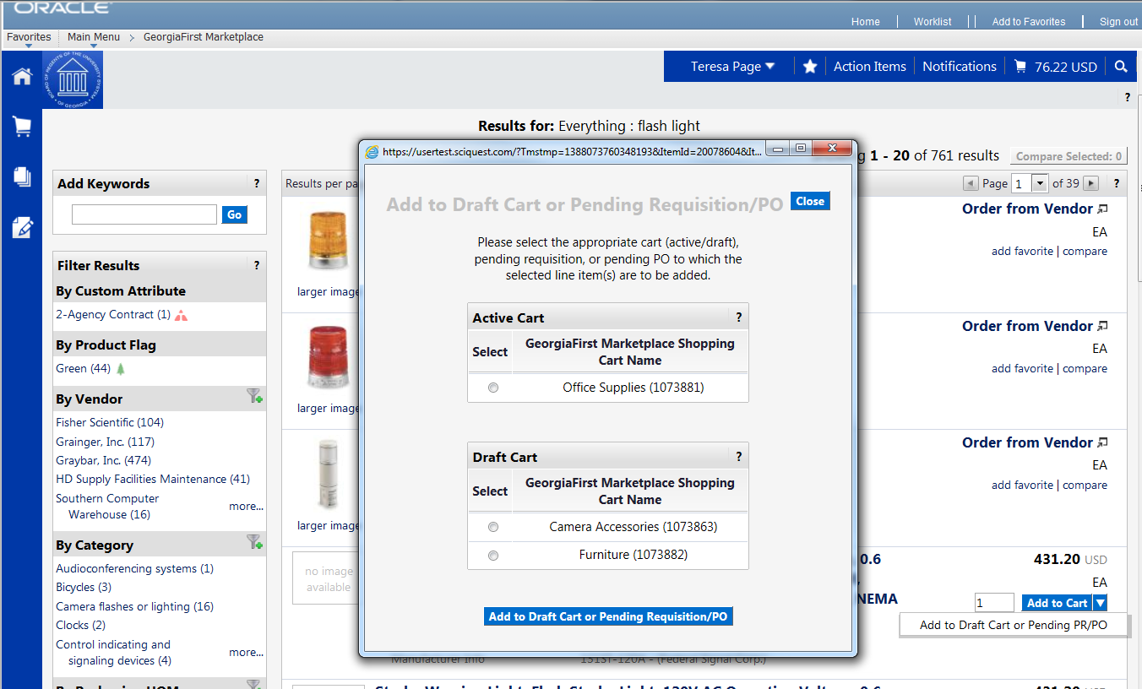
- You will then see an “Added Successfully” message. You have not changed which cart is currently active though.
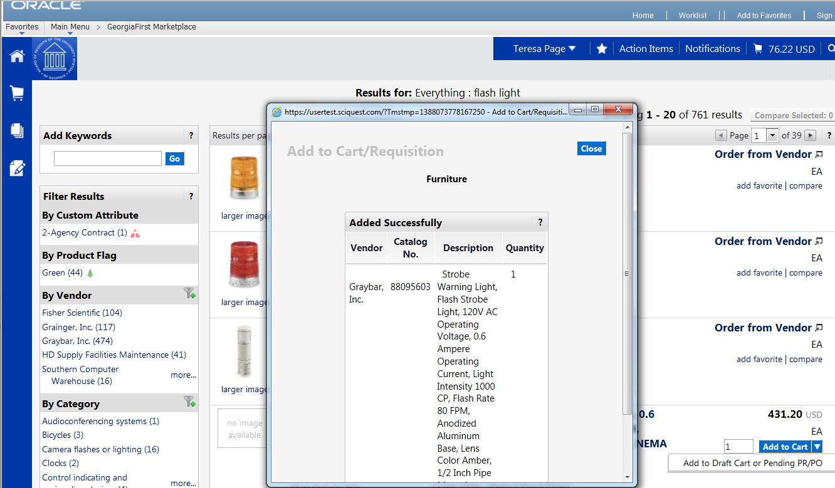
You will follow this same procedure whenever you want to add an item to a draft cart without making it your active cart. Wherever you add an item, there will be some sort of drop down allowing you to select “Add to Draft Cart”.

Reviewing Line Item History
The Line Item History feature allows users to view all purchases of the same item within a date range specified by the organization. Having the ability to see other recent purchases may prevent unnecessary external purchases. To perform this task, you must have the “View Line Item History” permission assigned.
How To: Review Line Item History
- In order to review line item history, you must first add the item to your cart.
- Access your shopping cart.
- For the item you want to review history for, select the More Actions drop down list.
- Select Line Item History.
- The Line Item History pop-up box appears.
  - Previous Purchases Found: An item having previous purchases that fall within the search criteria will display the item’s description and details regarding those previous purchases, including quantity, date, User ID, and User email address.
  - No Previous Purchases Found: An item having no previous purchases meeting the organization’s timeframe, department, and custom field criteria (if any) will display the item’s description and a message that no items were found.

Chapter 6: Assigning a Cart to a Requester
Now that you have searched for and added your items to your shopping cart, you can then assign your shopping cart to your Requester. By assigning your cart to a Requester, you are enabling that Requester to create a Requisition for your items and submit them for approval.
Specifying a Default Requester
One of your very first steps that you need to complete in the GeorgiaFIRST Marketplace is to identify who your requesters are. Your institution will provide you with who your Requesters are. You should have a Default Requester and a back-up Requester. Your back-up Requester should be used whenever you know that your default requester is unavailable (i.e., out on leave).
Before you can specify a default requester or assign a requisition to any requester, that requester must have logged into PeopleSoft and entered the GeorgiaFIRST Marketplace at least once. The first time a Requester logs into PeopleSoft and enters the Marketplace, all of their critical information is passed over to the Marketplace, which allows you to select them.
Your institution may set up your default requester for you. However, if they do not, we will list the steps below.
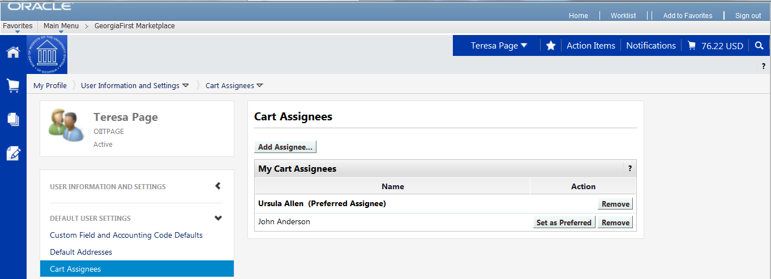

How To: Specifying a Default Requester
- Select the Down Arrow next to your name.
- Select View My Profile.
- Select the Show All link, within the User Information and Settings section.
- Select the Cart Assignees link.
- Click the Add Assignees button.
- Confirm your Business Unit appears in the Business Unit box.
- (Optional) In the Department drop down list, select your department.
- Click the Search button.
- Select your Requester by clicking on the Name.
- Repeat steps 4 – 9 to add additional Requesters.
- To specify your default Requester, select the Set as Preferred button.
- Your default Requester should be in bold.
Shopper Chartfield Defaults
As a shopper, you have a set of default Chartfields that will be charged when you request goods through the GeorgiaFIRST Marketplace. In other words, you have a defined default account code that is charged for the items that you request. This way, if you are a shopper for the Biology Department, the Biology Department is charged.
Your institution set these up for you in the PeopleSoft system when they added you as a Shopper. By doing this, you do not need to input your Chartfields each time you create a shopping cart. They are already tied into your Requester ID. (Every Shopper has a Requester ID in PeopleSoft where certain default information is stored.)
The Chartfields tied into your Requester ID are:
- Fund Code
- Department
- Program Code
- Class Field
- Project (if applicable)
The Account Code that will be charged will default based on the item. Each item in the GeorgiaFIRST Marketplace belongs to an NIGP code (or product category). For example, pencils belong to one category, while office furniture belongs to another. Therefore when you request office supplies through the GeorgiaFIRST Marketplace, the correct Account Code is charged.
When you assign your shopping cart to your Requester, you will have the ability to indicate if your default Chartfields should not be used for a specific item. When you are doing your final review of your Shopping Cart, you will have the ability to enter comments that are attached to your shopping cart. If you need to specify that a different Chartfield or set of Chartfields needs to be charged for an item, you do that within those comments.
Recommendation: Keep all items in one shopping cart assigned to one set of Chartfields. Comments are added per shopping cart and not per line.
When you have assigned your shopping cart to your Requester, the system automatically emails that Requester with a notification. In addition, whenever a Requester enters the GeorgiaFIRST Marketplace, they will be able to see any shopping carts assigned to them. Any comments that you apply to a Shopping Cart will be sent along with the email notification to the Requester.

Assigning a Cart
When you have finished adding items to your cart and you are ready to assign it to a Requester, you will first Proceed to Checkout. This step serves as a final review of your Shopping Cart. Through the comments tab, you can enter comments to be attached to your shopping cart. These comments are not, however, included in the email notification to the Requester. In the Final Review, you can also edit items if needed. After you have finished your final review, you then assign your cart to your Requester.
If you do not want your default Chartfields charged for these items, you should include instructions in the Note to Assignee section. The information you enter here before clicking the Assign button will be included in the email notification sent to the Requester.
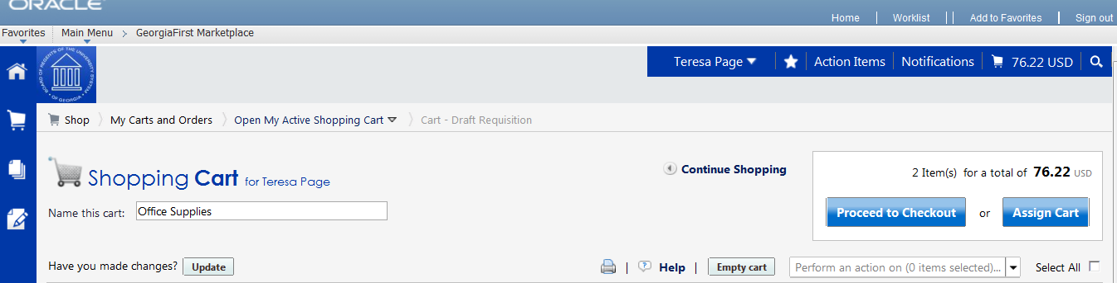
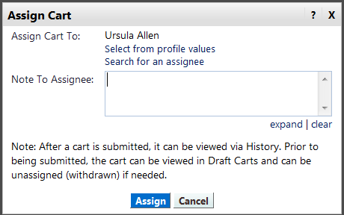
How To: Assign a Cart
- Pull up your shopping cart.
- Review your shopping cart to ensure that everything is correct. Make any necessary updates to the items in your cart.
- Select the Proceed to Checkout button.
- Here you perform a final review of your shopping cart. If you need to make any updates, you can select the appropriate edit button and make changes. You can also select the Return to shopping cart link in the upper right corner of the page.
- If you want to add any notes or comments, click the Comments tab.
  - Click the Add Comment button.
  - Enter your comment regarding the Chartfields. Keep in mind there is a 1000 character limit here.
  - Do not include any slashes (/) in your comments.
  - Click the Add Comment button.
  - Note: These comments are available to the Requester, but they are not included in the email notification.
- When you are ready to assign your cart, click the Assign Cart button.
- If you have a Default Requester in your profile, that Requester’s name should appear next to “Assign Cart To:”.
  - If you want to assign your cart to another Requester set up in your User Profile, select the “Search from profile values” link.
    - Using the drop down list, select the appropriate Requester.
  - If you do not have a Default Requester in your profile and need to search for your requester, select the “Search for an assignee” link.
    - In the User Search box, confirm your Business Unit appears in the Business Unit drop down list.
    - If you want to refine your search by department, select your Department in the drop down list.
    - Click the Search button.
    - Select the Requester you want to assign your shopping cart to and click the Choose Selected User button.
- In the Note to Assignee section, enter any instructions about charging Chartfields that are not your default. This note is included in the email notification to the Requester.
- Click the Assign button. A shopping cart notification displays. Your shopping cart has now been assigned to your Requester.

Un-assigning a Cart
On occasion, you may have a reason to unassign a shopping cart. For example, imagine that you have assigned a shopping cart to your Requester. After assigning it, you realize that you ordered the wrong item and wish to correct it. If your Requester has not pulled your shopping cart into a requisition yet (you will receive an email notification when this happens), then you can unassign your cart. If your shopping cart has already been pulled into a requisition, you will need to contact your Requester to determine the best corrective action.
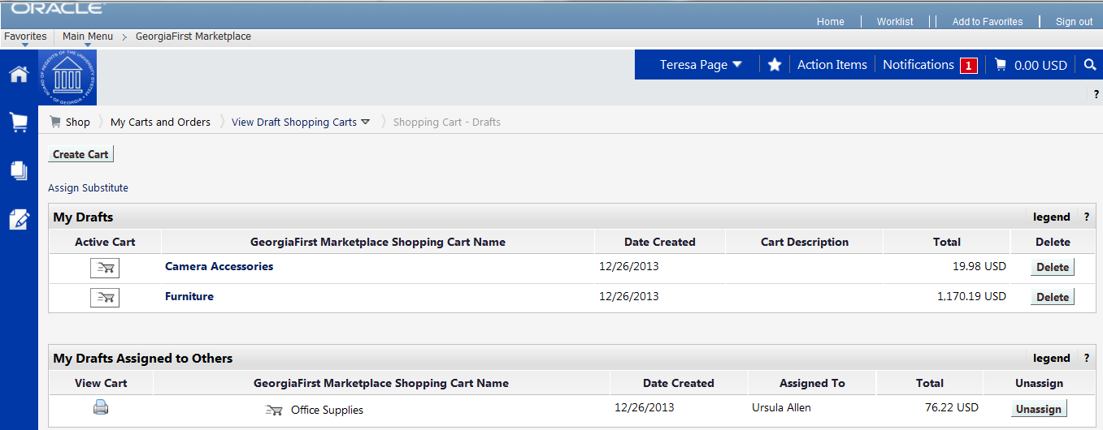
How To: Un-Assign a Cart
- From the GeorgiaFIRST Marketplace home page, select the Shopping Cart icon.
- Select the My Carts and Orders link.
- Select the View Draft Shopping Carts link.
- Locate the cart you want to un-assign under the section “My Drafts Assigned to Others” and click the Unassign button.
- Edit your cart as needed and then reassign it back to your Requester.

Reviewing Cart History
You can review your cart’s history after you have selected the “Proceed to Checkout” button to perform your final review of your shopping cart. The History tab is located right next to the Comments tab. The cart history provides a listing of the current line items in the cart. As items are added, a line in History is added, and as items are removed from the cart, the line is removed. A “delete” line is not created in the history. Cart history also indicates the following:
- If an item was selected from a favorite.
- Details about cart assignment, including what Requester was assigned the cart and when the assignment occurred.
- If the cart was created from a previous cart.
- When items were added and by who, the product name, and line number.
Once the cart is pulled into a requisition, the cart history is removed and a snapshot of the requisition at that point is taken.
How To: Review the History for a Cart
- Retrieve your Shopping Cart that already has items.
- Click the Proceed to Checkout button.
- Select the History sub-tab.
- Review the cart history. You can use the “Click to filter history” selection to filter your results by date or by action.
- To export the cart history to a csv file, click the Export CSV button.

Creating a New Cart from a Previous Cart
This function allows you to copy a cart you previously used into a new active cart. This is a convenient way to repeat an order. Items can be removed or additional products can be added to the copied cart if needed.
How To: Create a New Cart from a Previous Cart
- Select the Shopping Cart icon.
- Select My Carts and Orders.
- Select either View My Orders (Last 90 Days) or View My Orders (Last 5 Orders).
  - Tip: Use the Refine Search Results section to select different criteria.
- Locate the cart you want to copy and select it by clicking on the cart number. Use the Quick View icon to see a summary.
- Select the Cart Number link.
- In the Available Actions drop down list, select Copy to New Cart and select the Go button.
- A new active cart has now been created. You can now treat this new cart as you would any other active cart.

Chapter 7: Shopper Notifications
In order to help you manage your requests for goods, the eProcurement and GeorgiaFIRST Marketplace systems employ the use of automatic emails to provide notifications to you throughout the process.
Notification #1: Shopping Cart Has Been Pulled into a Requisition
The first notification that you may see is when the Requester that you assigned your cart to has pulled your cart into a requisition in the eProcurement system. When the Requester does this, the system will automatically send you an email notifying you of this step. This way, you are aware that your shopping cart has been picked up and is being processed by your Requester.
Notification #2: Your Requisition Has Been Approved
Once the Requester has pulled your shopping cart into a requisition, he/she submits the requisition for approval. Depending on your institutional setup for approvals, your requisition may be approved by one or more individuals. Once the last approver has approved your requisition, the system will notify you via email that your requisition has been fully approved.
Once your requisition has been approved, it will then be available for further automatic processing such as budget checking and sourcing into a purchase order. It is then dispatched to the vendor for order fulfillment.
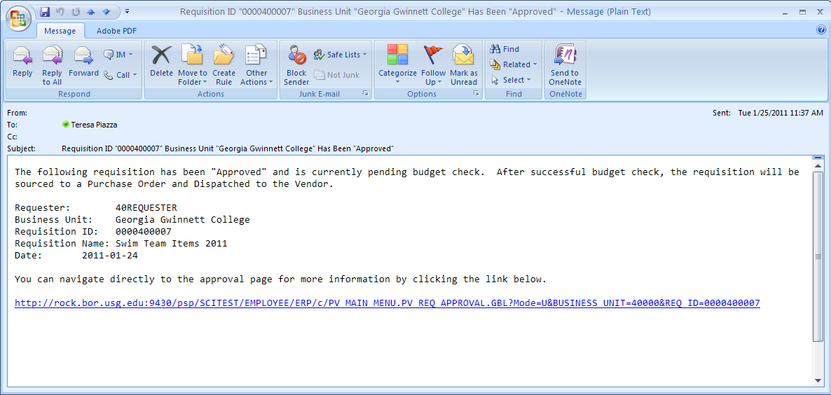
Likewise, if your requisition (or a requisition line) is denied, you will also receive an email indicating this. When you do, you should notify your Requester to determine the best course of action. We recommended that if you receive a “Denied Requisition” email that you forward it to your Requester. Only your Requester can go into the system and correct your requisition for resubmission.
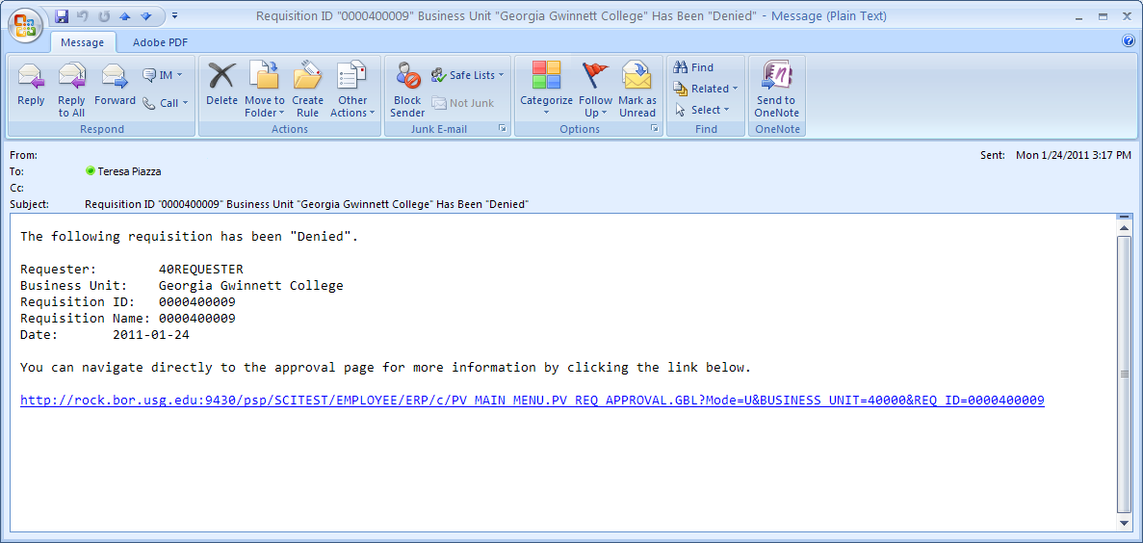
Notification #3: Your Requisition has Failed Budget Checking
Once your requisition is approved, the next step is for the system to verify if budget checking is required and if so, are funds available. If your requisition fails budget checking, an email is sent to the shopper. If you receive an email indicating your requisition has failed budget checking, you should contact your Department Manager responsible for that budget, or contact your default Requester to correct the requisition if an error was made in entering the budget/Chartfield information.
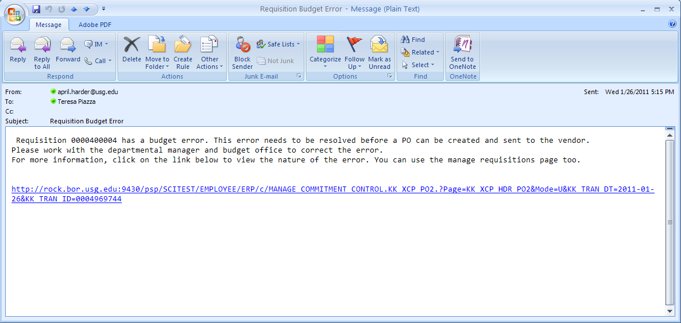
Notification #4: Your Requisition Items Need to be Received
Once your requisition has been turned into a purchase order and dispatched to the vendor, the vendor can then fill your order. In addition to sending you the purchased items, the vendor will send an invoice to your Accounts Payable department for these items. Before Accounts Payable can pay an invoice, it will check to see if the items you purchased require a receipt before payment can be made. If a receipt is required and has not been entered into the system yet, you may receive an email indicating that you need to “receive” your items in the system.
Please note: You should not “receive” an item in the system unless you have actually received it. Do not enter a receipt just because you get this email. This system is in place to ensure that the institution only pays for goods that it receives.

Chapter 8: GeorgiaFIRST Marketplace Favorites
As a Shopper, you can set up favorites in the GeorgiaFIRST Marketplace to easily retrieve items that you order frequently. By setting up favorites, you spend less time searching for items that you will order again in the future.
Favorites
There are two types of ‘favorites’ in the GeorgiaFIRST Marketplace. There are Personal Favorites and Shared Favorites. Personal favorites are those items that you identify as a favorite. Only you can see your personal favorites. With personal favorites, you create folders and sub-folders to manage these items. You have full control over the items in your personal favorites.
Shared favorites and folders are set up by administrators and can be set up for viewing and use for your institution or department. Shared favorites typically represent frequently ordered products or suggested products for purchase. Your institution will notify you of any shared favorites available for your use.
Each institution has a “Custom Configuration” shared favorites folder which can be used to highlight or specify particular items and configurations standard or recommended by the institution procurement department.
Recommendation: Only save items from hosted catalogs as favorites. Punch-out Items can be saved as a favorite, however, the pricing tied to the favorite will not be updated when the supplier updates that item’s price.
Creating Favorites Folders
Folders and sub-folders are used to house favorite items. There are two types of folders – personal and shared. Personal folders are only viewable by the user and are most commonly used. Shared folders are used to house favorite items to be used for the institution or department.

You can create any kind of folder structure. You can create a structure as simple as one folder named “favorites” to creating several folders to separate favorite item types. In order to save a favorite item, you will need to create at least one personal folder. Below is an example of a folder structure:
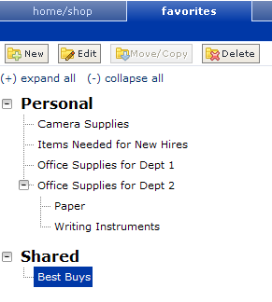
How To: Create a Personal Folder or Sub-Folder
- Select the Shopping Cart icon
- Select Shopping.
- Select View Favorites in the Go To section.
- On the left side of the window, the Personal and Shared headings display, as well as any existing folders. For new users, you should start by creating at least one Personal folder.
- To add a top-level folder, click the New button.
  - Select the option Top level personal folder
  - Enter a folder name and description.
  - Click Save.
- To add a sub-folder, select the top-level folder you want to add the sub-folder to by clicking on it.
  - Click the New button.
  - Select the option Subfolder of selected folder.
  - Enter a folder name and description.
  - Click Save.

Adding Items as Favorites
You can add personal favorites from the Product Search Results page or from a cart. Adding favorites is a fairly simple process. Once an item is saved as a favorite, it is identified in search results by a star icon.
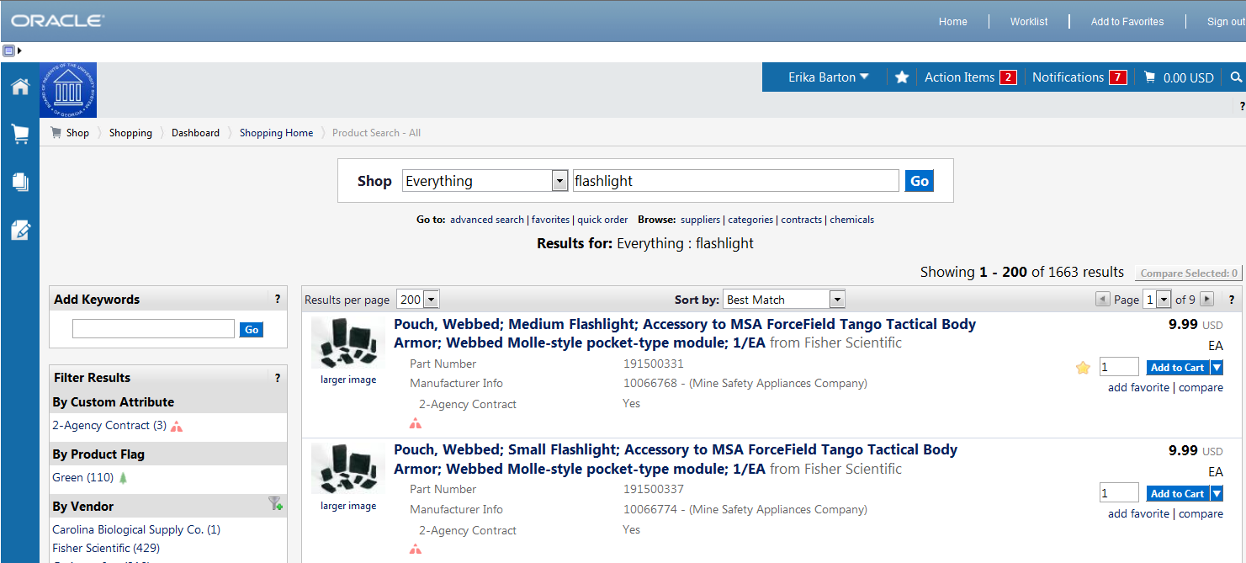
How To: Add an Item as a Personal Favorite
- Search for items using your preferred method in the GeorgiaFIRST Marketplace.
- From the search results, locate the item you want to add as a favorite.
- Directly under that item’s “Add to Cart” button, click on the add favorite hyperlink. The Add to Favorites popup displays.
- In the Item Nickname field, you can enter a name to reference the item. If you do not enter a nickname here, the supplier’s description will remain.
- In the Quantity field, you can enter the standard quantity that will be ordered for this item. Once you add a favorite item to your cart, the quantity can be updated there as well.
- Select the Destination Folder.
  - If you already have folders created, you will see your Personal Folders listed.
    - Select the folder you want to add your favorite item to, so that it is highlighted.
    - Click the Submit button.
    - Click the Close button.
  - If you do not have any Personal folders created, you will need to create at least one personal folder in order to save an item as a Favorite.
    - Click the New button.
    - Select the option Top level personal folder.
    - Enter a folder name and description. Click Save.
    - The new folder displays in the list and is automatically selected for the favorite item.
    - Click Submit to save the item.
    - Click Close.
- After an item is added as a favorite, it can be accessed via the favorites link.
- To add an item as a Favorite from a cart, select the Add to Favorites button on the item line within the cart.
  - Give the item a nickname and update the quantity if desired.
  - Select a folder.
  - Click Submit.
  - Click Close.

Adding Favorite Items to Your Cart
The Favorites functionality allows shoppers to store items that are referenced or ordered on a regular basis. Once items are added to Favorites, they can be added to a shopping cart from either of two places: from the Favorites page or from the Product Search results page (if favorite items are listed in the search results). Favorite items are designated with a star icon on the search results and can be added like any other item.
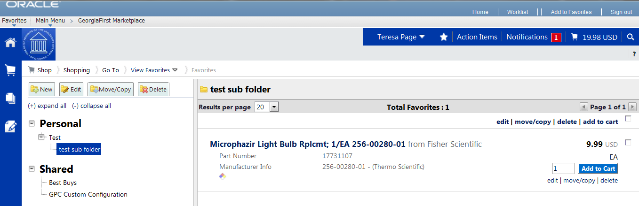
How To: Adding Favorite Items to Your Cart using the Favorites Link
- From the GeorgiaFIRST Marketplace, select the favorites link.
- Select the appropriate folder.
- The items for the selected folder will display on the right side of the screen.
- To add an individual item to your cart, select the Add to Cart button.
- To add multiple items to your cart, select the items with a checkmark, and then click add to cart at the top of the list.
- Your selected favorite items are now in your cart.

Moving and Copying Items Between Folders
Within GeorgiaFIRST Marketplace, you can move items from one folder to another, as well as copy items from one folder to another. These features may be useful if you create a sub-folder for a specific type of item and need to move favorites added earlier, or when creating “repeat” items for multiple folders.
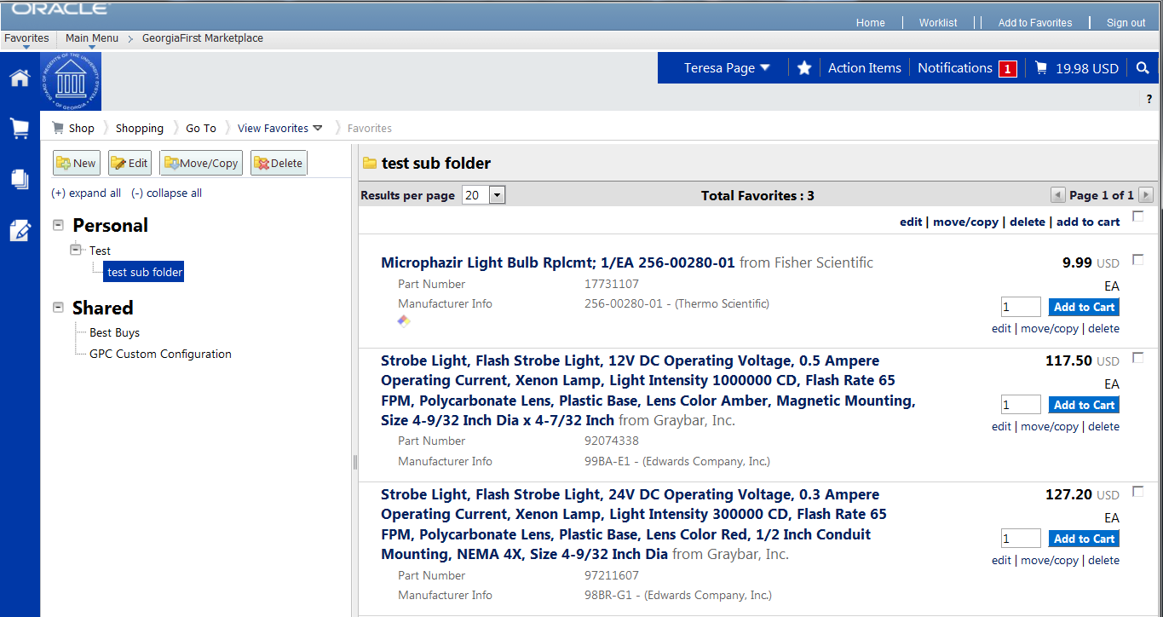
How To: Move and Copy Items Between Folders
- From the GeorgiaFIRST Marketplace, select the Favorites link.
- Select the appropriate folder from the left pane and locate the item(s) on the right pane.
- To move or copy one item to a different folder, click the move/copy link directly under its “Add to Cart” button.
  - Select the folder (so that it is highlighted) that you want to move or copy the item to.
  - Select either the move or the copy button.
  - Click Close in the confirmation window.
- To move or copy multiple items to a different folder, select the items with a checkmark.
  - Click the move/copy link at the top of the list.
  - Select the folder (so that it is highlighted) that you want to move or copy the items to.
  - Select either the move or the copy button.
  - Click Close in the confirmation window.

Editing Favorite Items
After adding a favorite item to a Personal Folder, you may need to update the item periodically. This includes the item’s nickname and quantity.
How To: Editing Favorite Items
- From the GeorgiaFIRST Marketplace, select the Favorites link.
- Select the appropriate folder from the left pane, and locate the item on the right pane.
- Click the edit link directly under the “Add to Cart” button.
- Make any necessary changes to the item and click the Submit button.
- Click the Close button.

Deleting Favorite Items and Folders
In Favorites, items and folders can be deleted as necessary. When you delete a folder, you delete those items saved in that folder as favorites also.
How To: Delete an Item from Favorites
- From the GeorgiaFIRST Marketplace, select the Favorites link.
- Select the appropriate folder from the left pane, and locate the item(s) in the right pane.
- To delete one item, click the delete hyperlink directly under its “Add to Cart” button.
  - Click the OK button to confirm the deletion.
- To delete multiple items, select the items with a checkmark.
  - Click the delete link at the top of the list.
  - Click the OK button to confirm the deletion.

How To: Delete a Folder from Favorites
- From the GeorgiaFIRST Marketplace, select the Favorites link.
- Select the appropriate folder from the left pane.
- Click the Delete button at the top of the folder list.
- Click OK to confirm the deletion.

Chapter 9: User Profile in GeorgiaFIRST Marketplace
Your User Profile in the GeorgiaFIRST Marketplace includes identification, purchasing abilities, and site accessibility. Almost every item in your User Profile will be read-only. For those items that are editable, you want to be very careful before making any changes to your user profile. Changing your settings may have a direct impact on receiving notifications, access to certain catalogs, and access to view contracts.
It is through your User Profile that you select your Requesters (see page 53). Therefore, you will need to access your profile on occasion. Below are some brief descriptions of what makes up your User Profile.
User Information and Settings
In the User Information and Settings section, you can see how your individual information is set up (i.e., name, phone number, email address, etc.).
When you enter the GeorgiaFIRST Marketplace for the first time, you may notice that the color scheme in the Marketplace doesn’t match your institution’s logo. You can change this by going through the Profile – User Information and Settings – Language, Time Zone and Display Settings. To change the color, select your institution in the Color Theme drop down list.
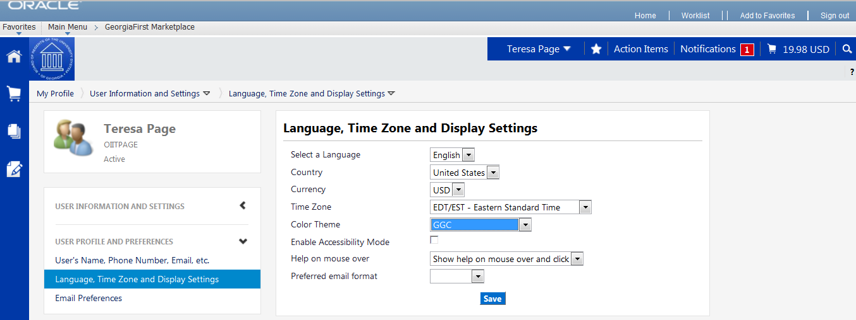
How To: Update Color Theme to Match School Logo
- In the GeorgiaFIRST Marketplace, click on your Name, found in the banner at the top of the page.
- Under the User Information and Settings section, select the Language, Time Zone and Display Settings link.
- Select your institution in the Color Theme drop down list.
- Click the Save button.
It is also in the User Information and Settings section that you can set up your default requester. Select the Cart Assignees link from the Default User Settings sub-section to add or delete requesters and specify your default requester.

Chapter 10: Desktop Receiving
For many items that are purchased, a receipt will be required before payment is issued by your Accounts Payable department. The receiving requirement is set on the actual requisition that is approved and turned into a purchase order. By creating a receipt in the system, your Accounts Payable Department can be sure that they are issuing payment for goods that have been received.
Some shoppers will have the ability to perform their own Desktop Receiving, which is creating a receipt in the system. This receipt is tied into the Requisition, Purchase Order, and Invoice so that payment can be issued. Without the receipt, the payment cannot be issued.
Not all shoppers will have this responsibility. Check with your institution for your applicable business processes. If you do have the Desktop Receiving responsibility, continue with this chapter to learn how to create receipts in the PeopleSoft system.
Desktop Receiving
Desktop Receiving is a function within the eProcurement module. It is a simplified version of what your Central Receiving department does on campus. Your Central Receiving Department will still be responsible for creating receipts in the PeopleSoft system for assets and other items that need to be inventoried. However, this eProcurement Desktop Receiving function will enable you to receive many of the goods you order through the GeorgiaFIRST Marketplace. You will need the proper security setup to perform desktop receiving.
Desktop receiving is done through the PeopleSoft Core system. You cannot access it through the Self Service site. Once you have logged into the system, you can proceed to eProcurement and then to Receive Items.
On the Receive Items page, all of your requisitions that have not been fully received will be listed. Through the Receive Items page, you will be able to indicate whether you have received the full quantity requested, or just a partial quantity.
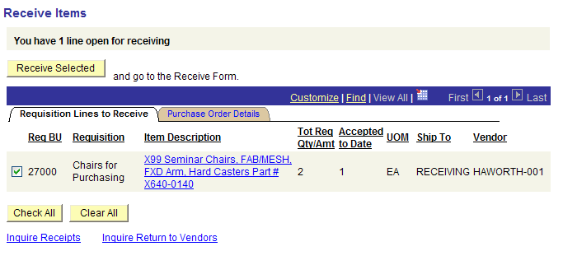
On the Receive Form, you will indicate the Receipt Date and how many you received.
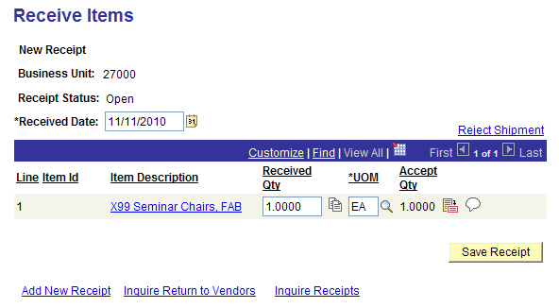
Once you save your receipt, the system will generate a Receipt Number. This Receipt Number will be tied into the Requisition number, Purchase Order number, and Voucher number.
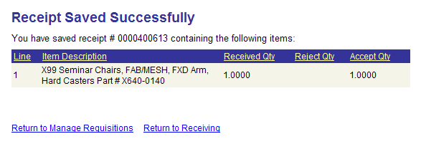

How To: Create a Desktop Receipt
- Log into the PeopleSoft Core system.
- Select eProcurement in the menu.
- Select Receive Items in the menu.
- Locate the Requisition Line Item you need to receive.
- Select the requisition by placing a checkmark in its select box (or to receive all line items, choose the Check All button).
- Select the Receive Selected button.
- If needed, change the Received Date. By default, the current date will be listed.
- In the Received Qty field, enter the quantity received.
- To review details about the actual purchase order, select the details… icon.
- To attach comments to the Receipt, select the comments icon.
  - Here you can indicate the condition and input a comment if needed.
  - Do not include any slashes (/) in your comments.
- Click the Save Receipt button.
- Your Receipt Number will be listed on the “Receipt Saved Successfully” page.
If you have a Requisition line item that you previously received a partial quantity for, you will still be able to go back to this same page and receive additional quantities.

