Setting up PeopleSoft trees for iStrategy
The use of PeopleSoft Trees in iStrategy
iStrategy is updated each business day with transactional data and tree information from PeopleSoft Financials. Trees are used to help group and organize the data into a format that will be the most meaningful to the users running the reports. The current trees that iStrategy pulls over from PeopleSoft are listed below. By updating the Institution Specific Trees, users can change the way a report is organized in iStrategy. For example, if an Institution’s Department Tree has all of their departments listed under “Office of the President” they may want to add a new node for “VP Finance and Administration” and shift some of the departments under that node of the tree to accurately reflect the departments that are the responsibility of the VP of Finance and Administration.
Shared Trees – same structure across all Institutions:
- Account
- Fund
- Program
- Class
Institution Specific Trees:
- Department – xxx_BI_DEPARTMENT
- Project – GRANT_ALLOC_TREE
Important Notes:
- Before beginning – Please do not copy existing trees and perform a ‘save as’ in PeopleSoft. It has caused issues in the past with the data not feeding over to iStrategy correctly. You will need to create a new iStrategy department for your Institution if the tree does not already exist.
- iStrategy currently uses the Grant_Alloc_Tree to pull in project information for each Institution. Should you wish to make updates to this tree, please coordinate with the Grant Allocations manager at your Institution. Modifying this tree could have allocation impacts in PeopleSoft.

Login to PeopleSoft and go to the tree manager. Create a new tree if the tree does not already exist. If the tree does already exist, please skip to page 5 for instructions on modifying the existing tree. 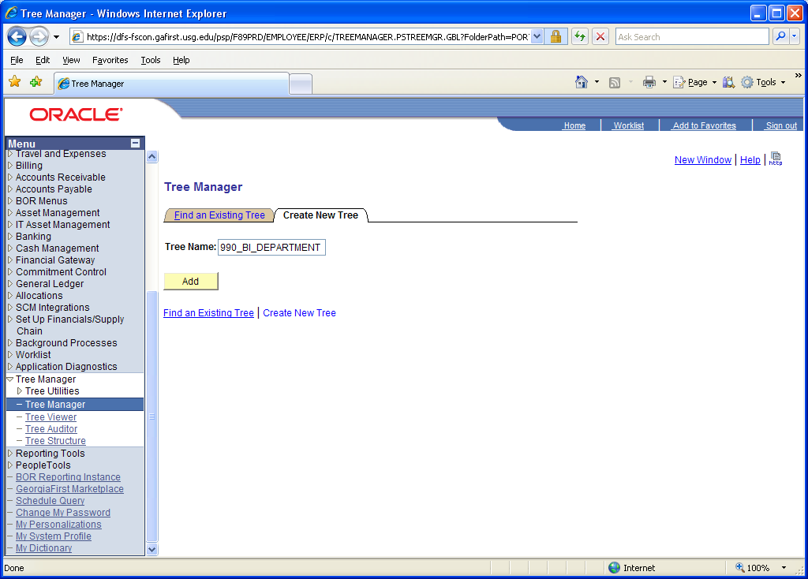
Click the add button and you will be directed to Tree Definition and Properties.
- Here you will Name the tree
- Enter the Structure ID based on the type of tree you are creating (for department tree use Structure ID DEPTID, for project tree use PROJECT_GL_BOR)
- Effective Date the tree (01/01/1901)
- Enter a Description for the tree
- Enter your Institution’s SetID for the tree.
- Leave the Category as DEFAULT.
- Currently, all iStrategy trees Use of Levels is set to “Strictly Enforced”
- In the Audits section, leave all boxes unchecked
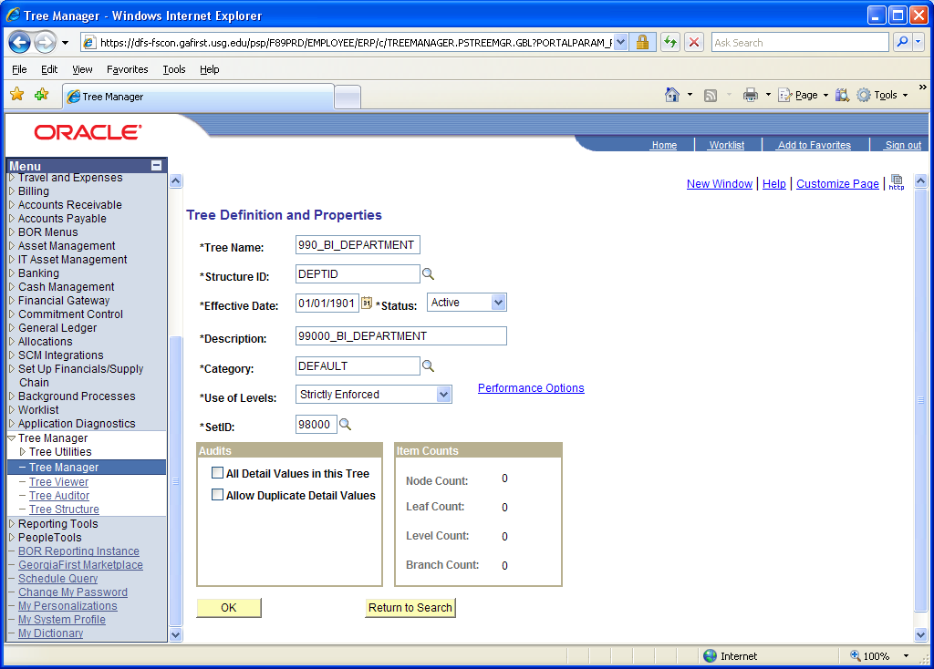
When everything is set up correctly, click ‘OK’. The system will then display the Set Up Tree Levels screen. 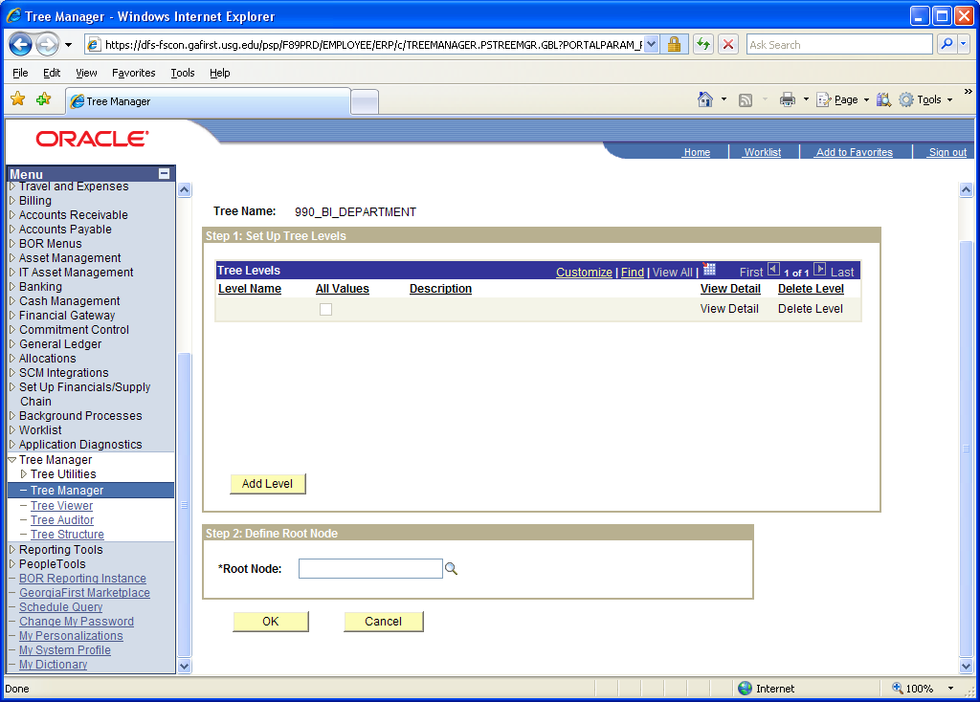
Select the Add Level button and then enter Level 1. You can also select Level 1 using the search tool. Repeat this process to add additional levels (level 2, level 3, etc.) as needed. All values for Level 1 by default will be checked. The other levels will be unchecked by default. The root node will be ALL_DEPARTMENTS for a department tree. The root node for a Project tree would be ALL_PROJ_GRANTS. 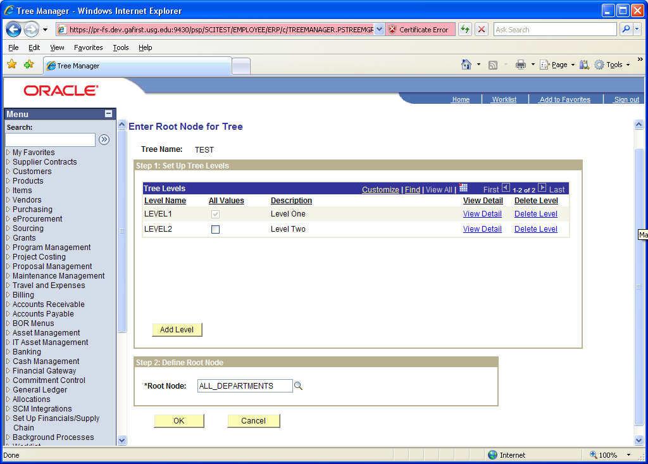
Select ‘OK’ when finished. User will be directed to the Tree Manager screen. 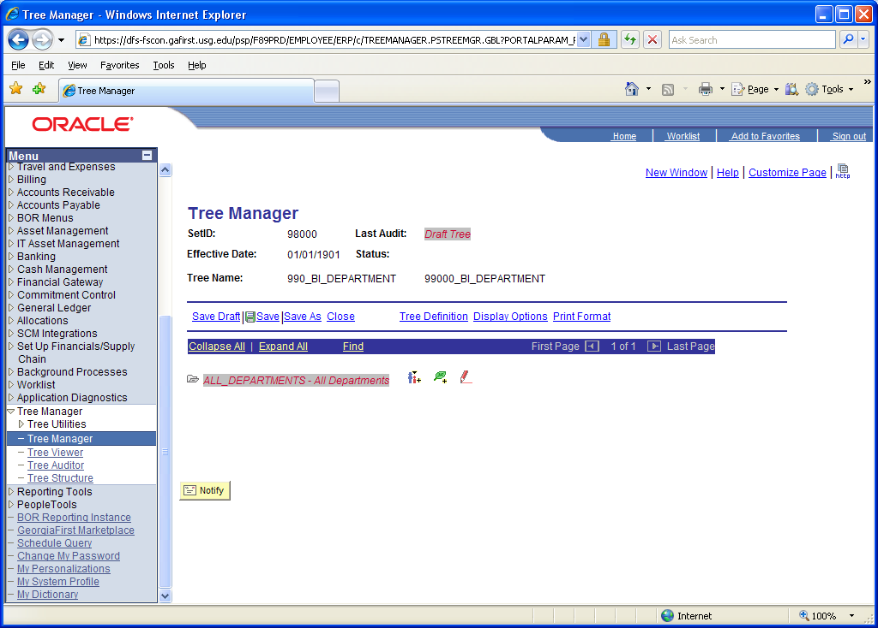
From here you will add the tree nodes by selecting the Insert Child Node icon - . Find your tree node in the search screen and click 'Add' to insert your tree node. 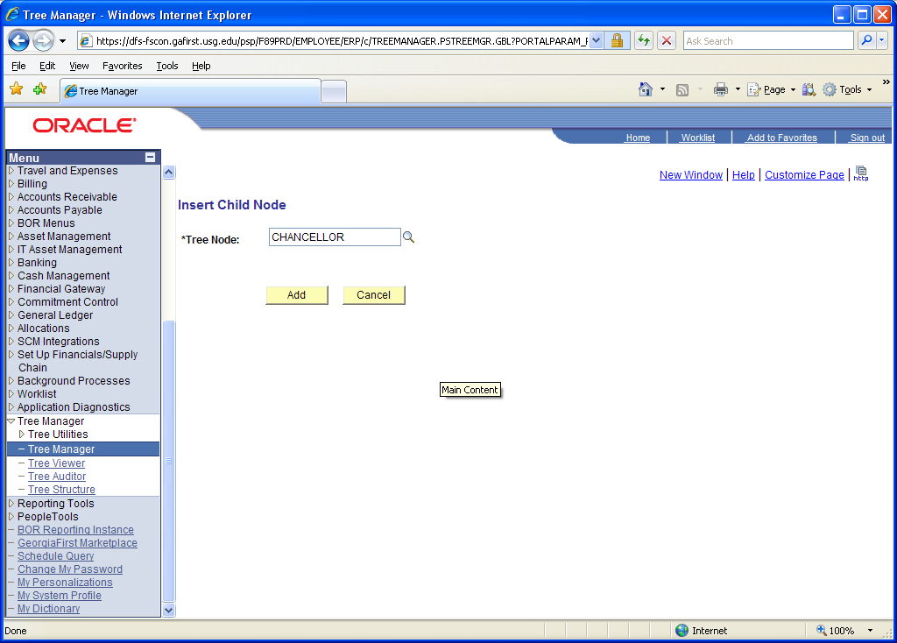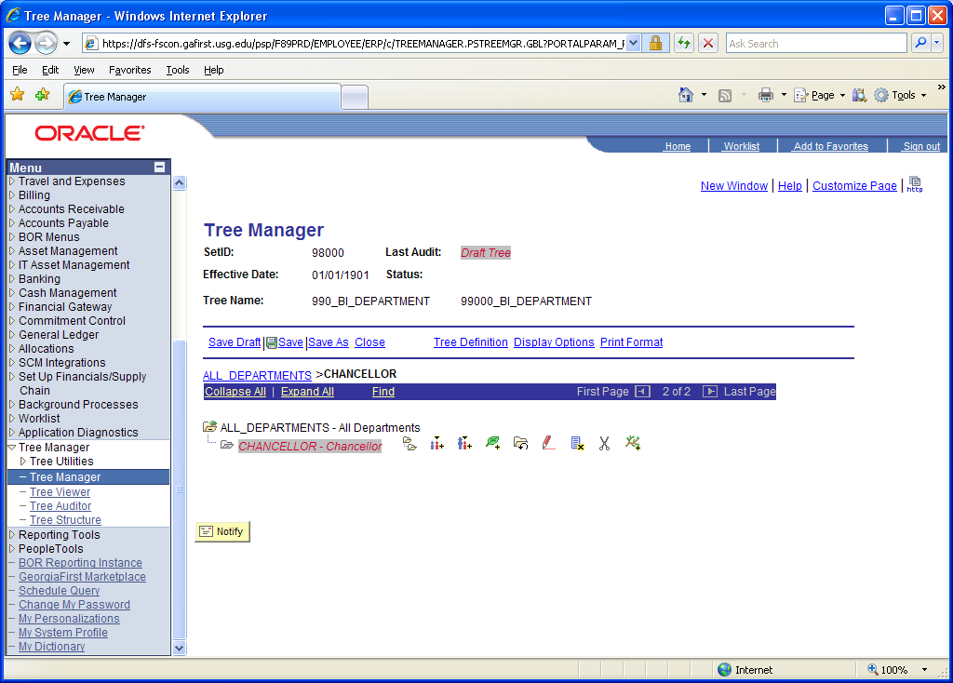
Once you are at the lowest level, to insert leaf values click on the Insert Detail icon - . Note – a leaf value consist of a Department ID (or a Project/Grant ID for project tree). You will then be directed to provide ranges for the leaf. You can insert one leaf value here or a range of values. 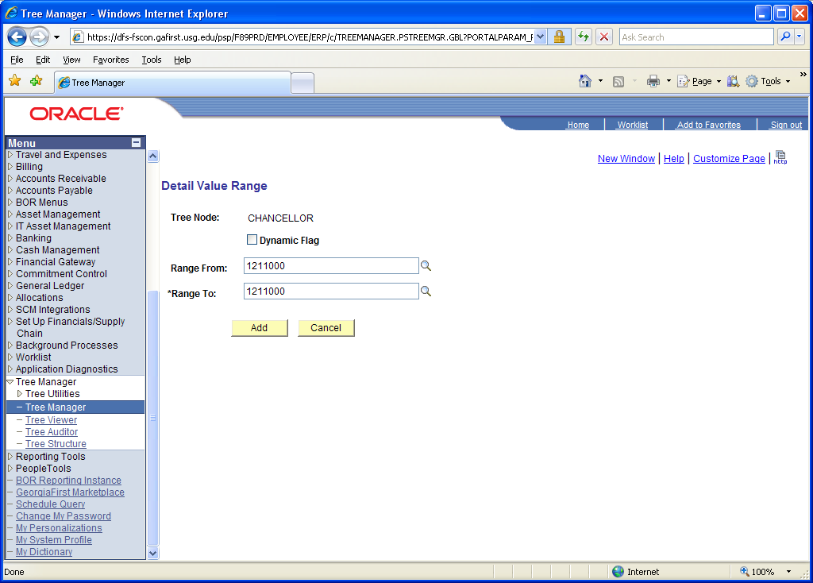
Click ‘Add’ to continue. If you need to insert more leaf values repeat the step above as needed. 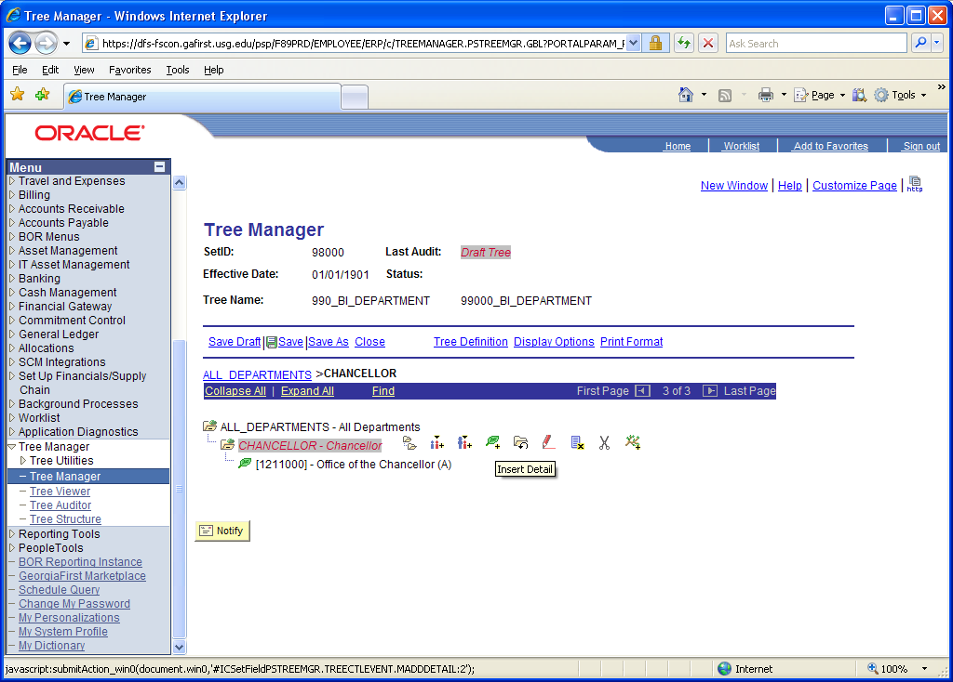
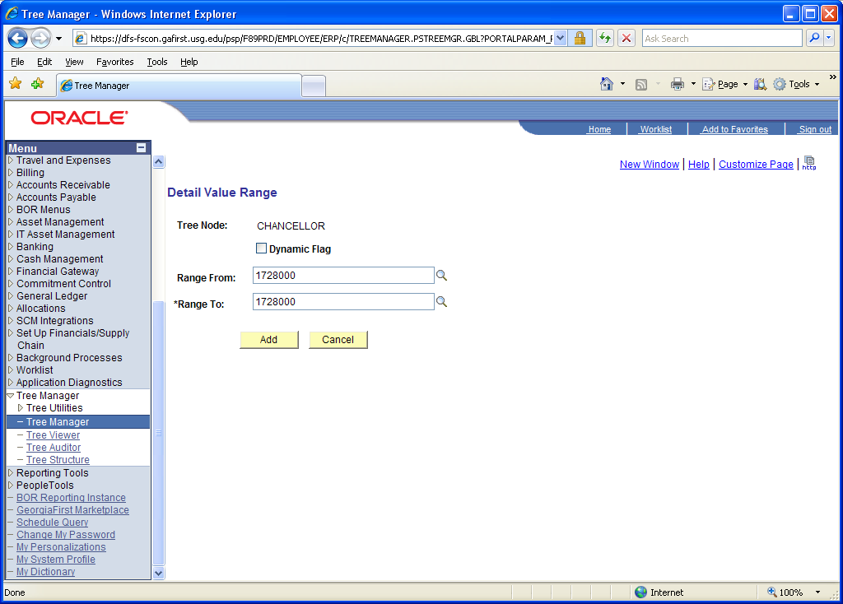
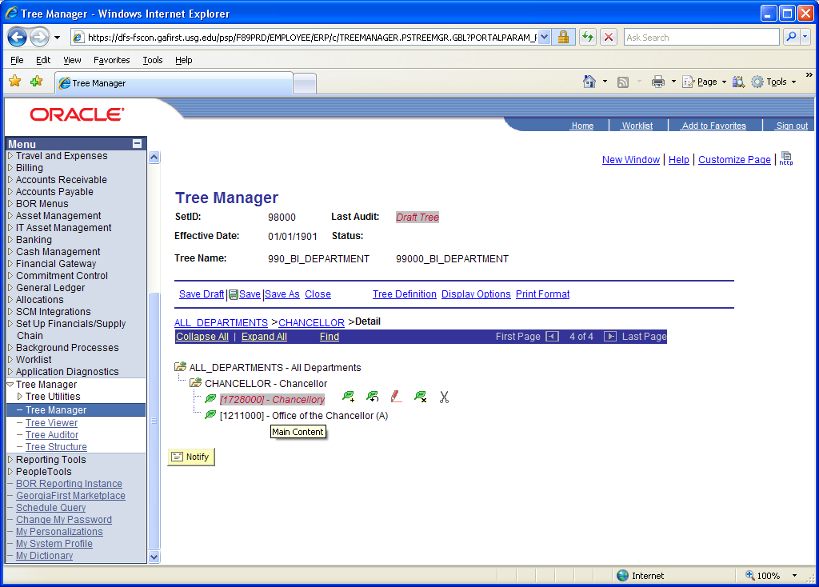
Note – you can drag and drop leaf values to a different order if you need to re-sort them. 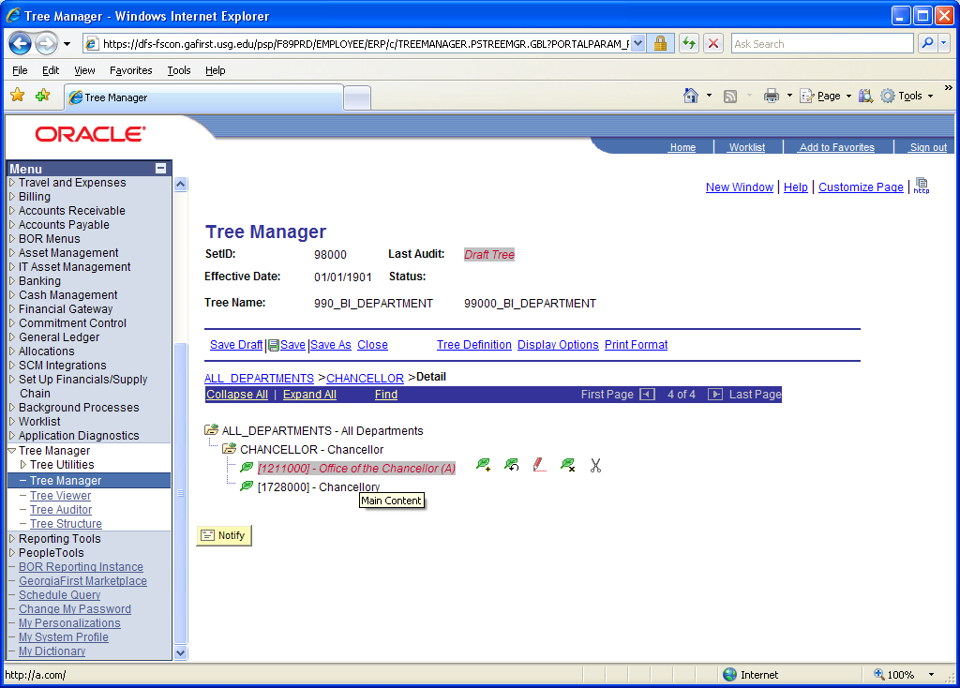
To add another Node at the same level as the Chancellor node, select all departments and then click the Insert Child Node icon - . Find your tree node in the search screen and click add to insert your tree node. 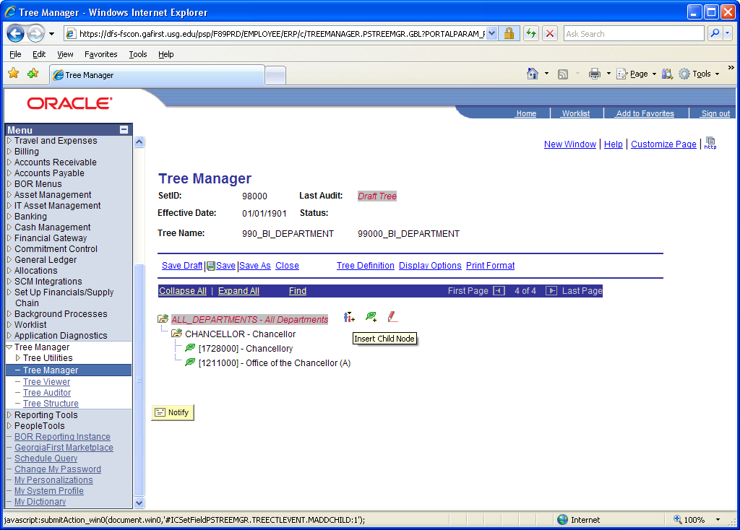
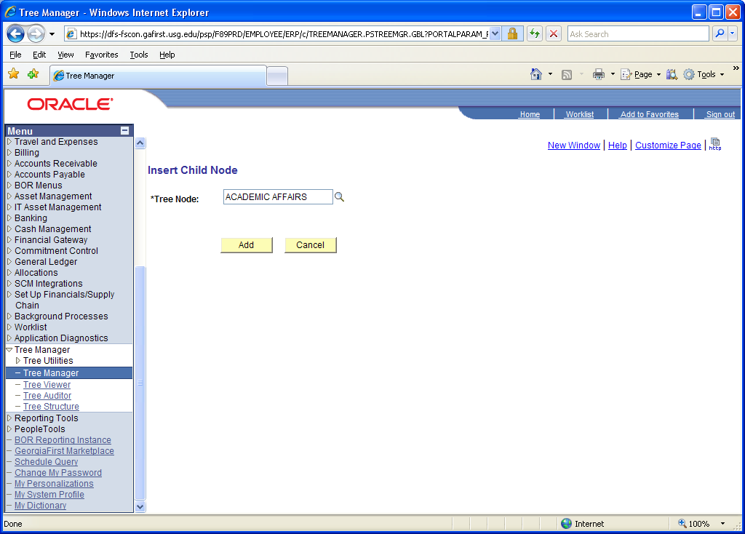
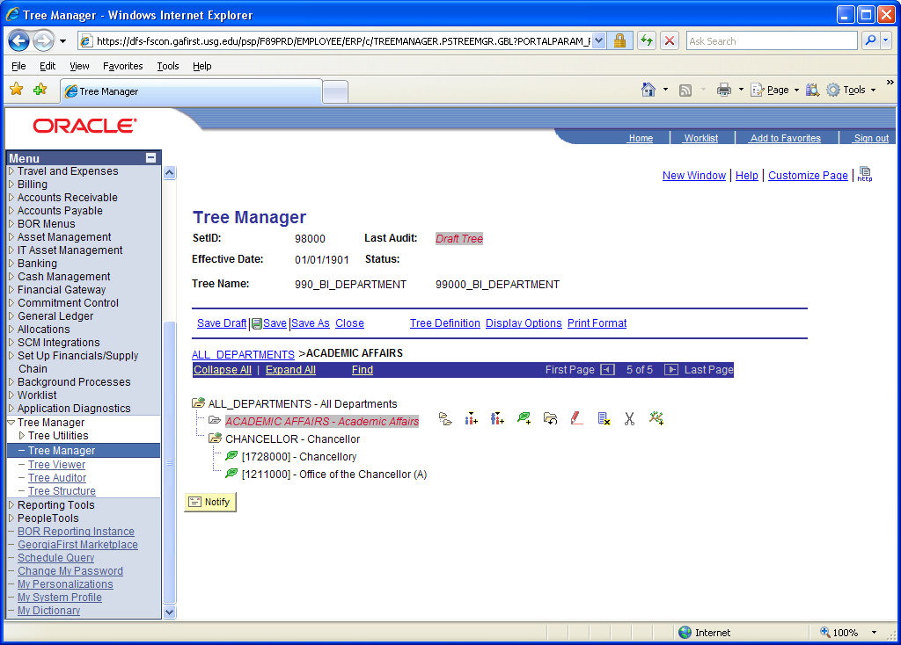
To add additional nodes at the same level as Academic Affairs and Chancellor, you may use the add sibling icon .
Note – you can drag and drop child values as needed also to re-sort them. 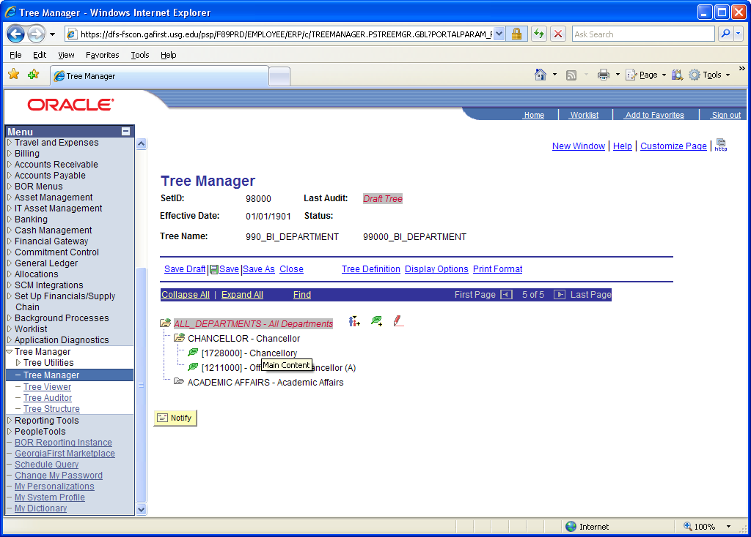
In this scenario, we want to see more child nodes before we list the department ranges. Click on ‘Academic Affairs’ and then select the ‘Add Child Node’ icon - . Find your tree node in the search screen and click add to insert your tree node. If you use a range of values then iStrategy will select all values in that range and assign them to the ‘Academic Affairs’ node. 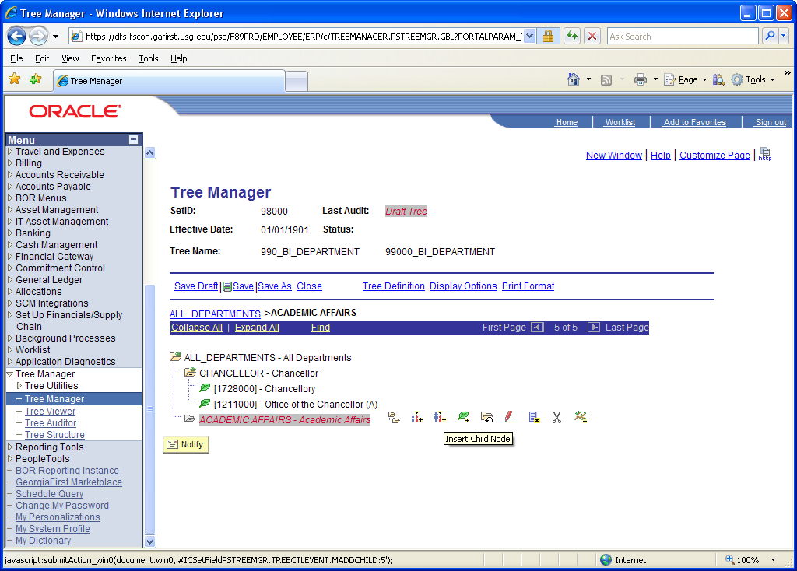
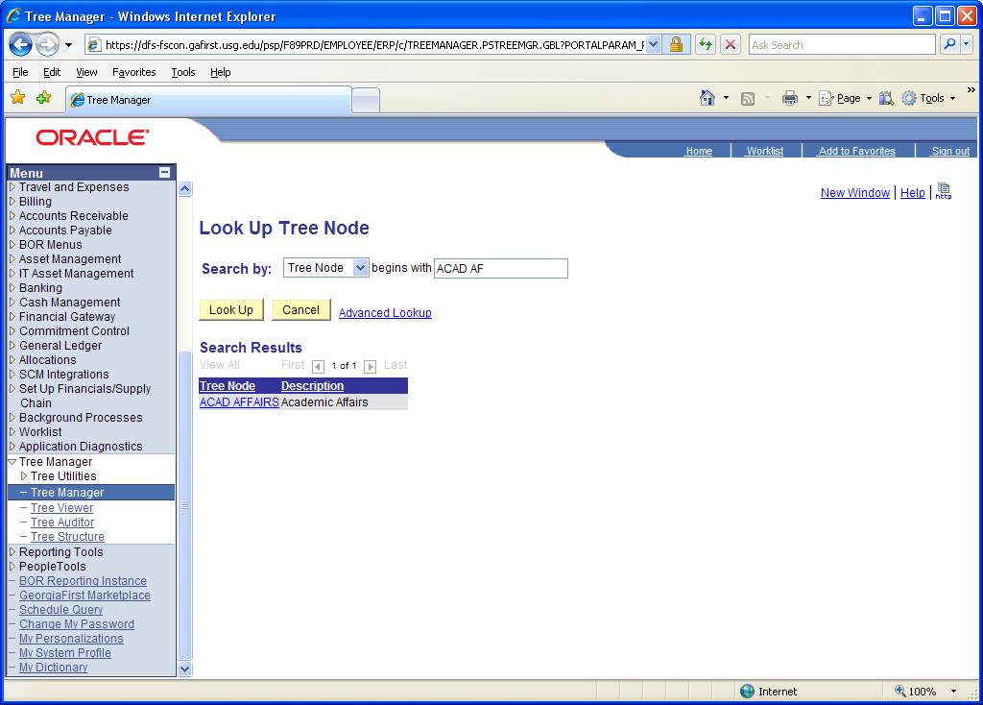
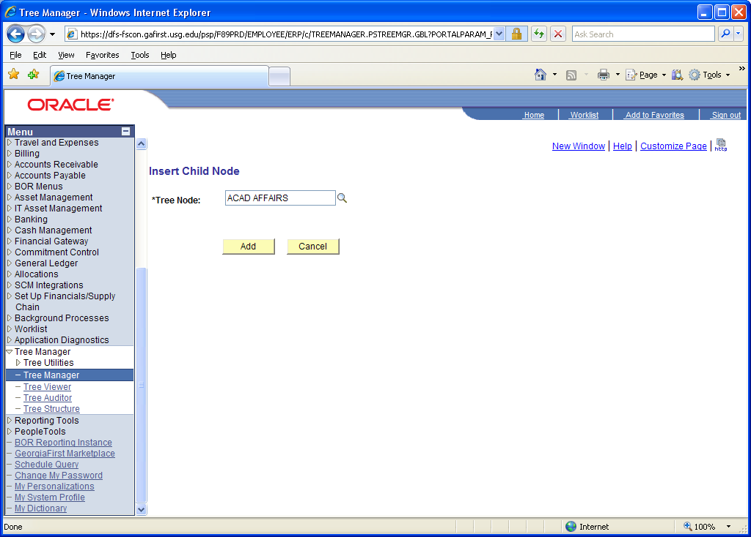
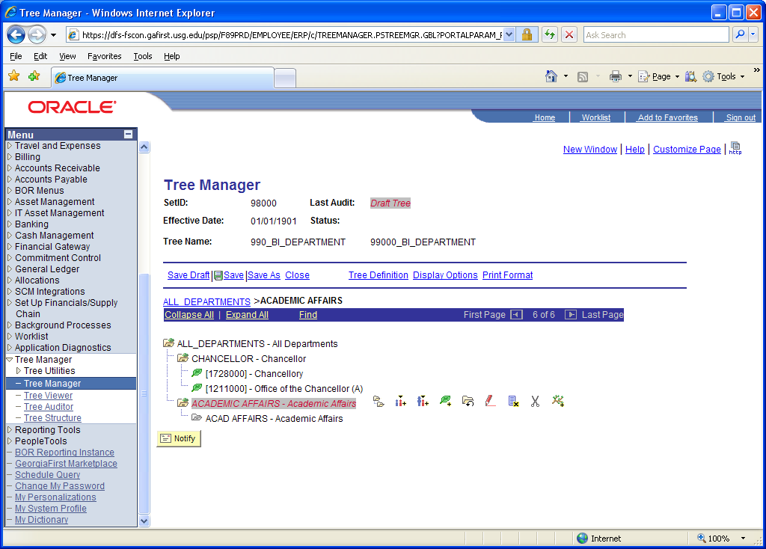
To add leaf values to ‘Acad Affairs’ click on the Insert Detail icon - . You will then be directed to provide ranges for the leaf. You can insert one leaf value here or a range of values. 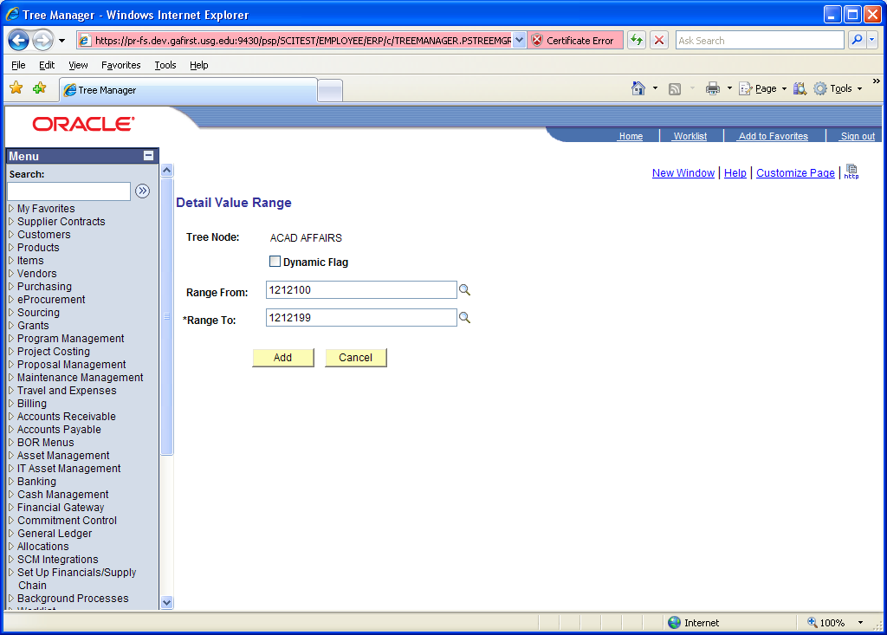
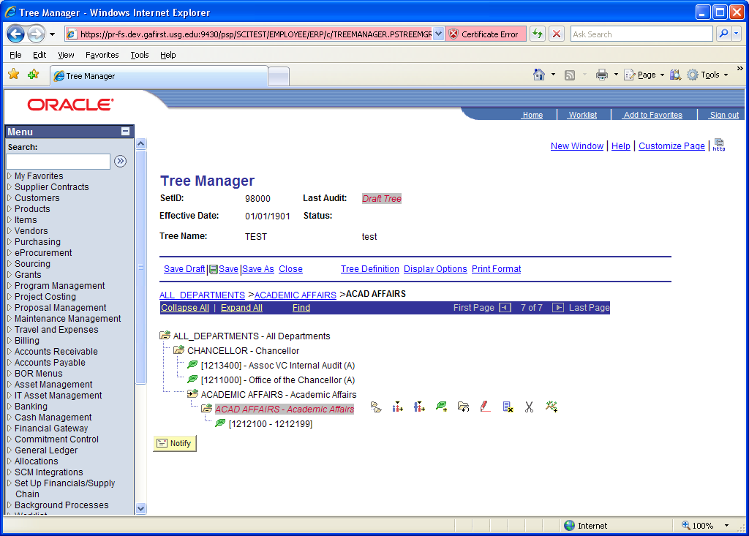
Continue adding child nodes and leaf values until the tree is complete. Click the save button to save the tree when finished. If you need to save an incomplete tree you can use the Save Draft button and then return to the tree at a later date/time. Note – PeopleSoft will not allow you to do a ‘Save’ if the tree is incomplete. An example of this is if there are nodes without leaf detail values. 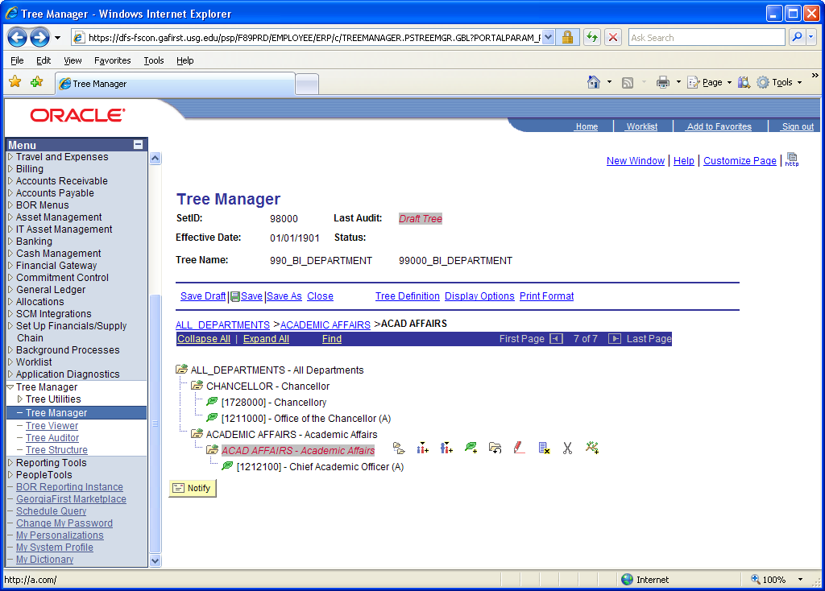
Notify the iStrategy team when the tree is complete providing them the tree name so they can then make sure iStrategy is updated to pull the tree values in the nightly ETL from PeopleSoft to iStrategy. The data will then feed over to iStrategy the next business day and your iStrategy reports using this tree will display the data based on the way that you set this tree up in PeopleSoft.
