Required Fields & Format for Locations
and Creating the Associated “Ship To Location” Code
This Job Aid details the required fields and format for all Locations that are referenced by a “Ship To Location” Code used on SciQuest Purchasing Documents. This job aid also covers how to create the associated “Ship To Location” code.
For more detailed instructions on adding and maintaining “Location” Codes and “Ship To Location” Codes, please see Business Process PO.020.800.
Required Fields and Format for Locations
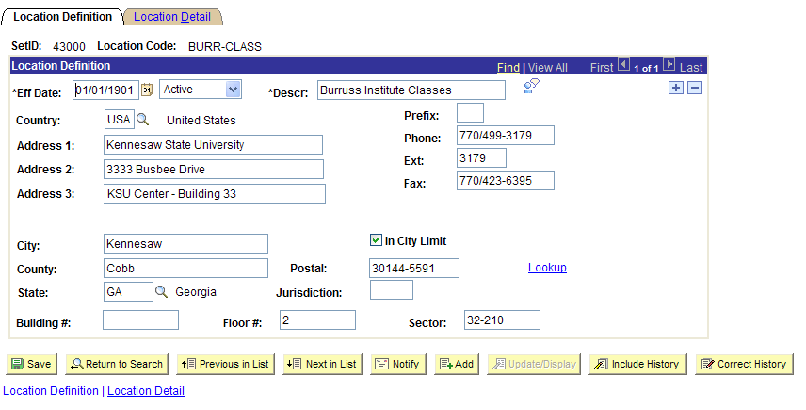
On the Location Definition tab:
- Address 1
  - Required Field
  - Populate this field with the University/College Name
- Address 2
  - Required Field
  - Populate this field with the Street Address of the delivery location
- Address 3
  - Required Field
  - Populate this field with any additional street address information for delivery
  - Use this field to identify street address information or to identify a building name/number
- City
  - Required Field
  - Populate this field with the name of the delivery city

- County
  - Required Field
  - Populate this field with either the County or Building Number
- State
  - Required Field
  - Populate this field with the appropriate state abbreviation
- Building #
  - Optional Field
  - Values in this field will not display on SciQuest related documents
  - To specify a building on SciQuest related documents, use either the “County/Bldg” field or the “Address 3” field.
- Floor
  - Required Field
  - Populate this field with the corresponding building number for the delivery address
- Sector
  - Required Field
  - Populate this field with the corresponding room number for the delivery address
- Postal
  - Required Field
  - Populate this field with the appropriate zip code for the delivery address
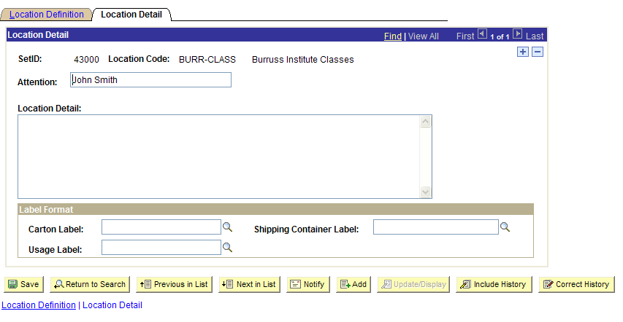
On the Location Detail tab:
- Attention
  - Required Field
  - Populate the Attention field with the Requester’s name or the name of the person responsible for receiving goods at this delivery address.
After creating the “Location” Code in the proper format, you can create the “Ship To Location” Code that is tied into that “Location” Code.

Creating the Associated “Ship To Location” Code
After creating the “Location” Code, you can then create the associated “Ship To Location” Code that is built from that Location Code.
Again, for more detailed instructions on adding and maintaining “Location” Codes and “Ship To Location” Codes, please see Business Process PO.020.800.
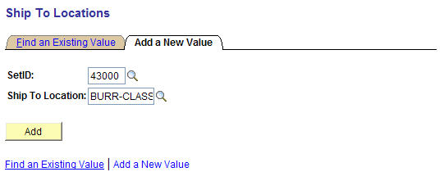
- When adding a new “Ship To Location” Code, use the “Add a New Value” option and select the “Location Code” you want to apply to the “Ship To Location” Code.
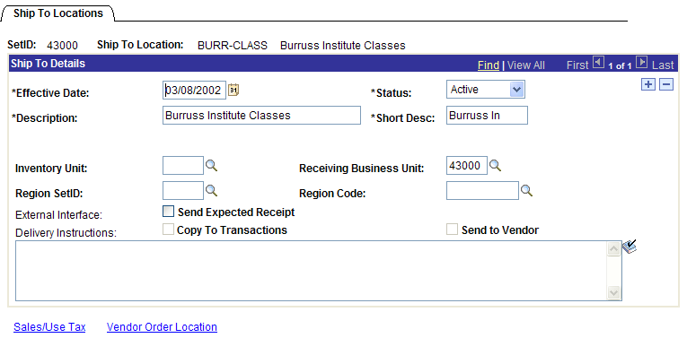
- Under “Ship To Details” on the Ship To Locations page, first verify that the Status is “Active.”
- Select the “Sales/Use Tax” link.
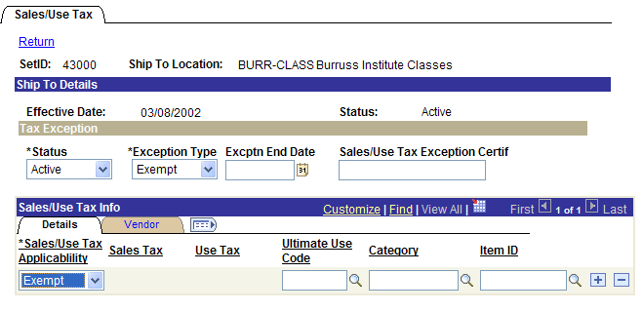
- For SciQuest “Ship To Location” Codes, the “Exception Type” in the Tax Exception area must be set to “Exempt.”
- Also, under Sales/Use Tax Info, the “Applicability” must be set to “Exempt.”
- Save the page.
- You may receive a warning regarding the Certificate ID or ending date. Click OK to clear the warning.

