Navigating in the GeorgiaFIRST Marketplace
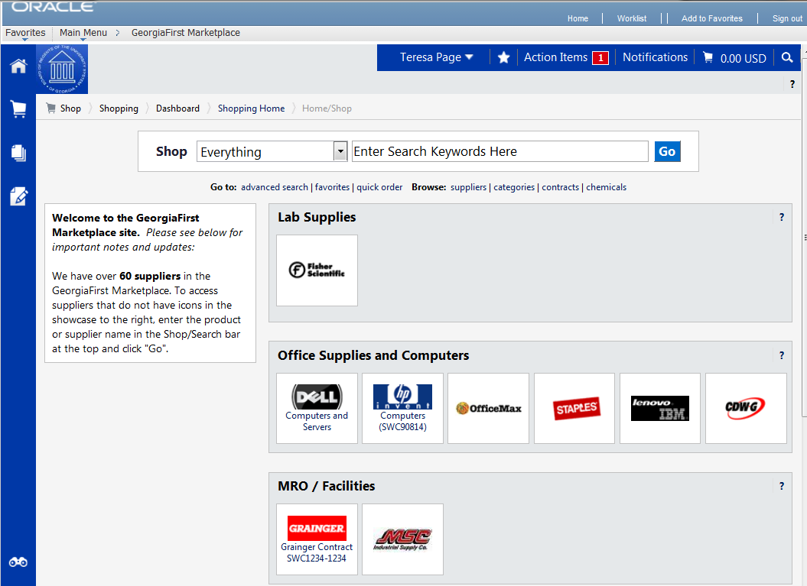
4
12
11
10
8
9
7
4
5, 6
3
2
1
The first step in using the GeorgiaFIRST Marketplace is knowing where things are located, and how to navigate the home page. Whenever you wish to return to the home page, simply click the home/shop tab and select the shop sub-tab. Or you can click your school logo in the upper left corner to return to the home page.

- User Information: In the upper middle section of the GeorgiaFIRST Marketplace, you will find your User Information. In this area is the user name and a link to the user profile.
- Navigation Breadcrumbs and Screen Title: The screen title indicates the title of the current page that you are on.
- Cart Summary: The upper right corner displays a summary of your shopping cart. Included is the cart name, the number of items in the cart, and the total cart amount. You can click on this shortcut to go directly to the cart page to review, update, and process your shopping cart.
- Quick Search: This quick search feature allows for a variety of searches to be executed anywhere in the marketplace.
- Navigation Icons: Down the left side of the GeorgiaFIRST Marketplace are the primary navigation icons. By clicking on an icon, the screen refreshes to display sub links for the topics or functions covered in that particular part of the Marketplace. The links that you see are dependent on your permissions.
  - Home: This icon will return you to the Home page from any other parts of the application.
  - Shopping Cart: This icon is used for shopping and provides quick access to other parts of the application. You can also View and modify the current shopping cart, create new carts, delete existing carts, and prepare the active cart for processing.
  - Orders & Documents: This icon will allow you to search for documents that you have created.
  - Catalogs and Contracts: Contains a repository of various documents within the application.
- Navigation Sub-Links: Once you select a link, additional sub-links may be available. If sub links are available, they will be located just beneath the primary navigation links.
- Shop at the Top/Shop Quick Search: You can access simple and advanced search from this feature. This is the primary area to perform item searches. We will cover search features later in this chapter.
- Action Items: Action Items are items that require some sort of action by the user logged in. The number of action items will be displayed in red to the right of the Action Item menu.
- Notifications: Certain action items will trigger Notification messages informing the user that action is needed. Notifications are clickable and take you to the appropriate area of the application, so that action can be taken. The number of notifications will be displayed in red to the right of the Notifications menu.
- Organization Message: This box is an important tool system administrators use to communicate with the GeorgiaFIRST Marketplace community. This message box is available to all users and is a common way to communicate important upcoming dates, information about new suppliers, links to training, and more.
- Punch-Out: A “punch-out” supplier is a site maintained by the actual suppliers. Catalogs in punch-out sites can still be customized for an individual institution. Punch-out suppliers can be accessed from this area of the screen.
- Online Help: Online Help is accessed by clicking on the question mark anywhere in the application or by clicking on hyperlink text. Text with associated Help is indicated by text that changes colors when mousing-over the text. Much of the text in the application can be selected and a secondary Help window displays.

