”) Plan Sponsor Portal – (PSP) Training and User Guide – Session 5



# R Agenda

# Meeting Highlights and Reminders

# Logging into PSP

* Features of the Tool

# Accessing Reports

# Running Adhoc reports

# Meeting Highlights and Reminders

# Introduction of Facilitators: Jennifer Kennington, Theresa Wood, Megan Lobe, Karthick G., Dorinda Ebert

# Please remember to mute your phones

# The session will be recorded and posted (along with the User Guide) to the OneUSG Smart Sheet

# Plan Sponsor Site (PSP) – Reporting Tool

**Function/Business Purpose:**

* The Plan Sponsor Portal is a web-based application that is accessed by a separate URL
* The Plan Sponsor Portal is used by USG Benefits Practitioners to access reports posted by Alight to USG
* Access is restricted to the institutional level
* The Plan Sponsor Portal is a ‘Pull’ delivery method
* The tool allows you to View, Contribute and Run reports. You cannot delete documents
* The data results are as of the end of the prior day. It is not real-time data

# Logging into the Plan Sponsor Portal

1. Access the to PSP by logging into the new OneUSG Faculty and Staff Portal:
2. URL: <http://www.usg.edu/oneusg_connect/>
3. Use the Path: Practitioner Services -> Benefits -> Select tool from accordion list

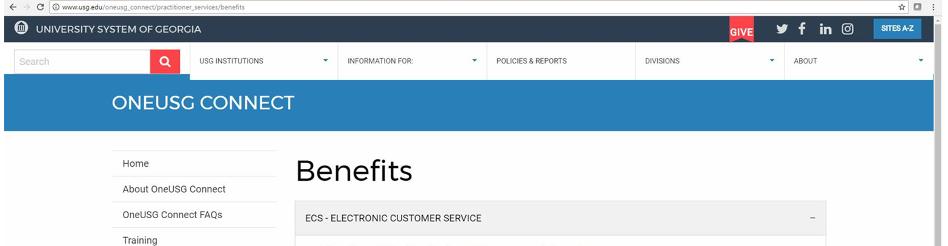

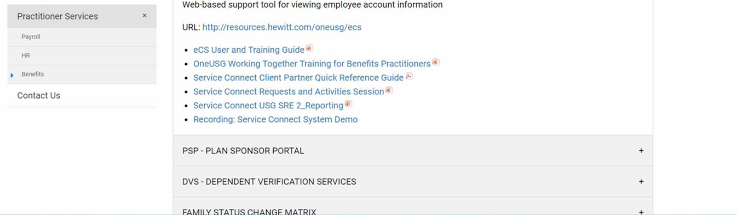

1. To access the PSP you will click the URL <http://www.hewitt.com/psp> and the below log on page will appear:
2. Enter your email address
3. Click ‘Forgot my Password

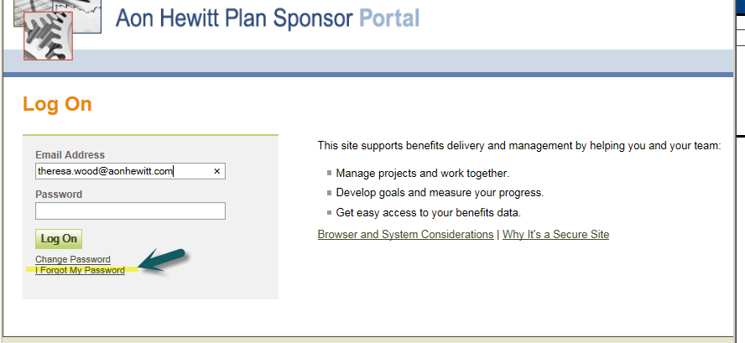

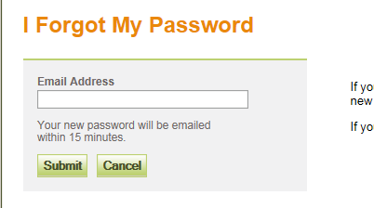

First time users may see this page – Click ‘I Agree’

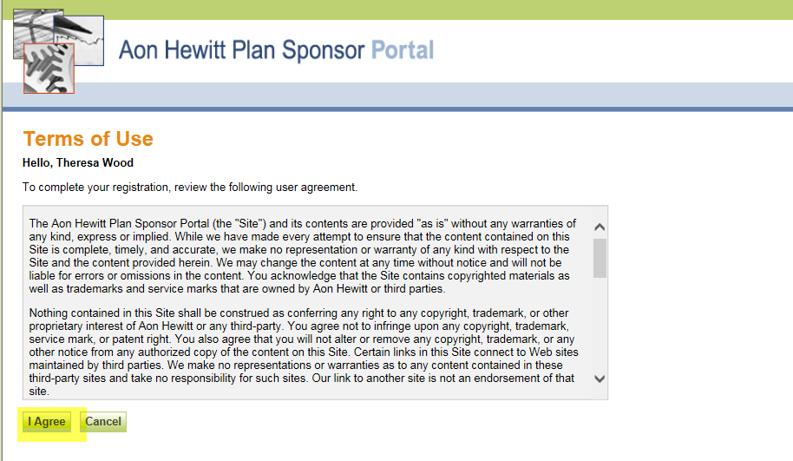

1. Once you are logged in, your home page should appear similar to the screen print below. The Home page provides you with Organizational level data at a glance (i.e. enrollment data). Use “personalize” to change your view. Other information that can be found in the home page includes:
2. The last 5 reports you reviewed
3. Key Results data (i.e. Call Center Wait times)

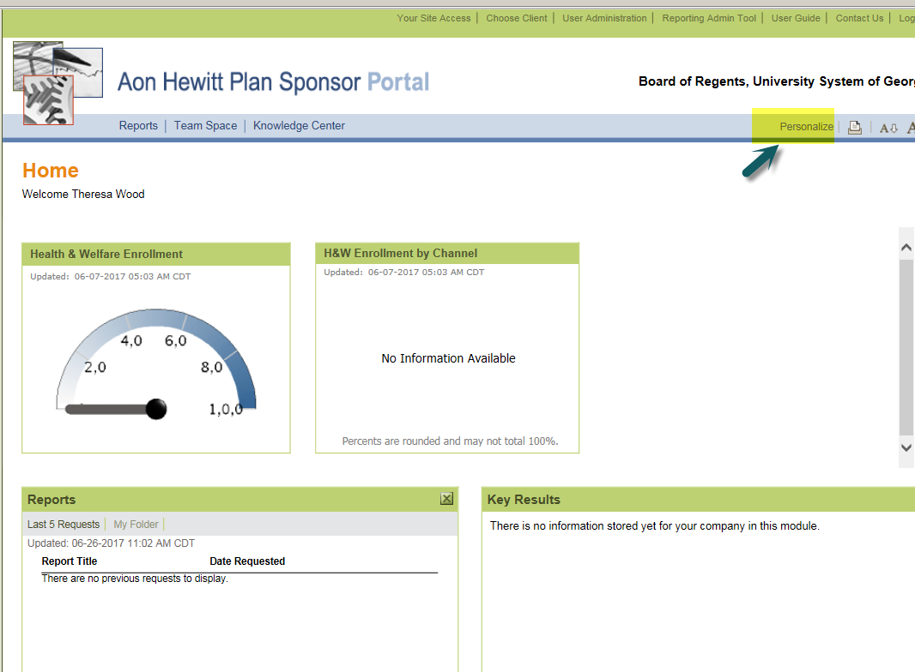

# Navigate the site using the menu bar located at the top of your screen

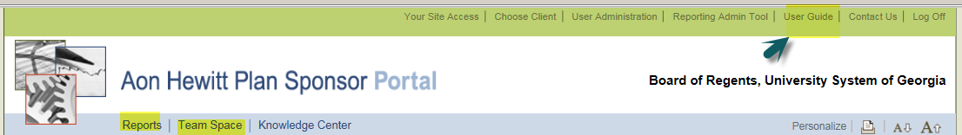

* 1. The User Guide is a helpful tool in providing you with very detailed information about the site
  2. Standard Pre-Defined Reports - The report model is based on the ‘pull’ method to access the reports. To access the pre-defined standard reports select >> “**Reports” where All of the folders will now appear.** Select the key folder(s) you wish to view (hover over the description for details):
     1. Health & Welfare – reports provide you with enrollment data for all Health plans, dental plans and FSA
     2. General – Data related to communication, events and population
     3. Delivery Measure – Channel methods for enrollment (benefits portal or Call Center)
     4. Shared – Reports that have been shared
  3. Automatic Reports* – Batch reports that do not require a QC process prior to posting and are automatically sent directly to the Plan Sponsor Portal. **To** **Access the Automatic report >>Reports>>TBA System Reports**
  4. User Defined Reports – Query Tools used to create your owner reports
  5. Data Dictionary – Search tool that will assist you with finding where data is stored
  6. Manual Reports** – Customer and Batch reports that will require a QC process prior to posting. These reports will be manually posted by the Alight Process owner once the QC process is completed. **To Access the reports >>Team Space>> Opens up share point>>Health and Benefits>>University System of Georgia>>Your Folder (see steps below**

**\*Note: You will not use the YSA folder**

**\*\*See Appendix A for Reports Inventory**

**Landing Page**

**Note: You will only see what you have access to**

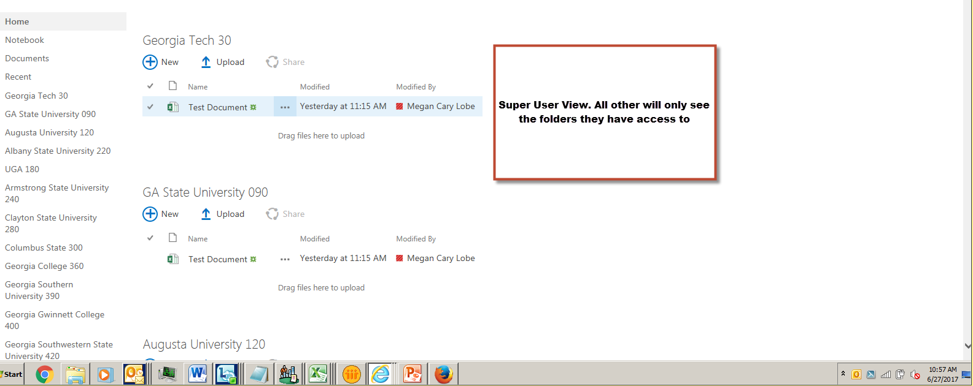

# Viewing/Downloading your Document/Reports

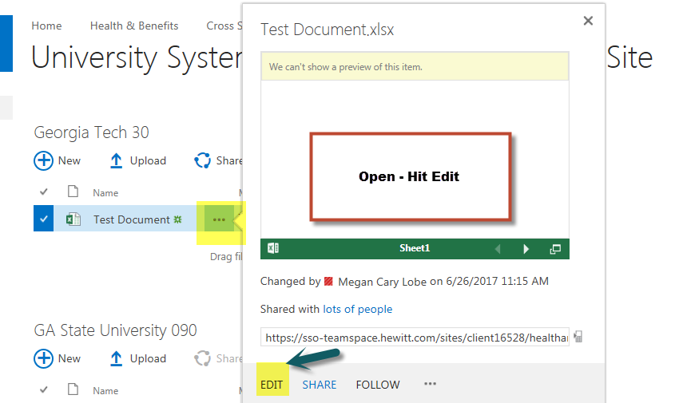

# Contributing – Uploading a Document/File

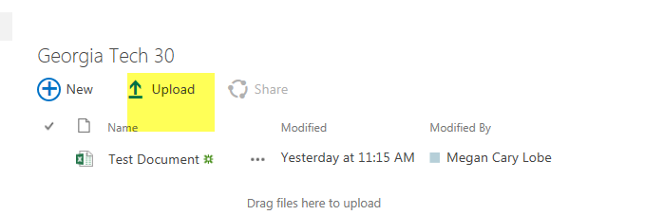

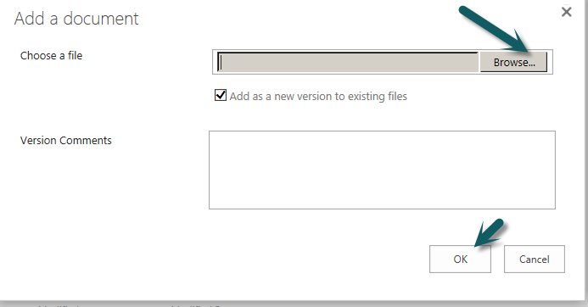

Or Drag and Drop

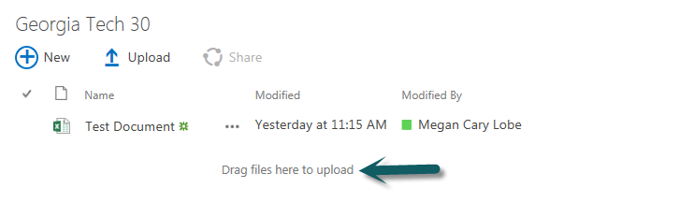

# Appendix A – Report Inventory

TBD

# Appendix B – Institution Index

| **Institution** | **Company Code** | **HR System Owner** |
| --- | --- | --- |
| The University of Georgia | 180 | UGA |
| Georgia Institute of Technology | 30 | GT |
| Augusta University | 120 | AU |
| Georgia State University | 90 | ADP |
| Armstrong State University | 240 | ADP |
| Clayton State | 280 | ADP |
| Columbus State University | 300 | OneUSG |
| Fort Valley State University | 330 | ADP |
| Georgia College & State University | 360 | OneUSG |
| Georgia Southern University | 390 | ADP |
| Georgia Gwinnett College | 400 | OneUSG |
| Georgia Southwestern State University | 420 | OneUSG |
| Kennesaw State University | 430 | ADP |
| Savannah State University | 480 | ADP |
| Valdosta State University | 510 | OneUSG |
| University of North Georgia | 530 | ADP |
| University of West Georgia | 540 | ADP |
| Abraham Baldwin Agricultural College | 570 | ADP |
| Atlanta Metropolitan State College | 610 | ADP |
| College of Coastal Georgia | 630 | ADP |
| Dalton State College | 690 | ADP |
| Darton State College | 220 | ADP |
| East Georgia State College | 720 | ADP |
| Georgia Highlands College | 730 | ADP |
| Gordon State College | 760 | ADP |
| Middle Georgia State College | 830 | ADP |
| South Georgia State College | 880 | ADP |
| Board of Regents of the University System of Georgia | 980 | OneUSG |
| Bainbridge State College | 620 | ADP |
| Albany State University | 220 | ADP |