The Excel to CI is a utility that’s used to import data. It enables you, as the user, to upload data into the PeopleSoft database from an Excel Spreadsheet. There are 6 tabs at the bottom in the spreadsheet, one for each worksheet. Each worksheet has a special function.

Below is a high-level description of the function of each tab.

Cover Sheet

The Coversheet provides a brief overview of the process flow and functionality of the tool.

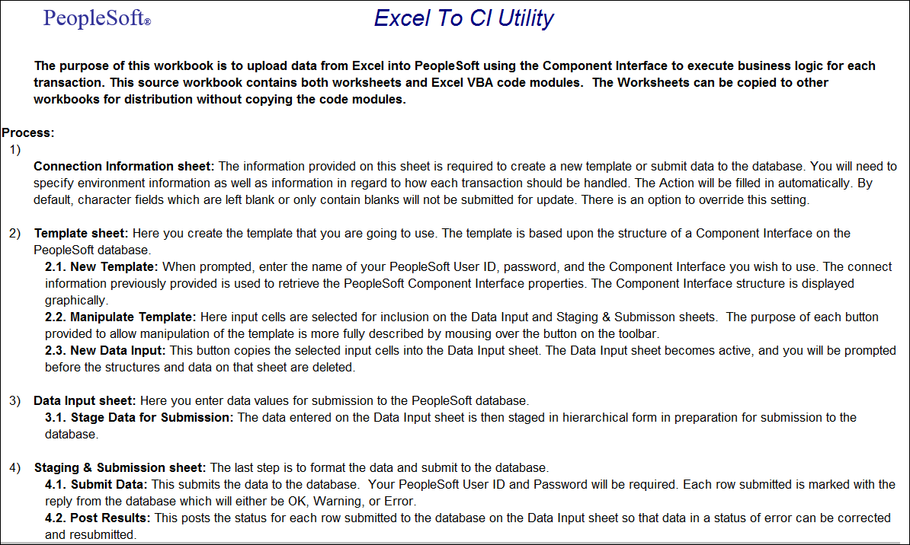

Connection
The Connect Information worksheet has the environment information to connect to the PeopleSoft database. This information will be setup by the System Administrator and this page should not be changed. If there are any connectivity issues please contact the System Administrator.

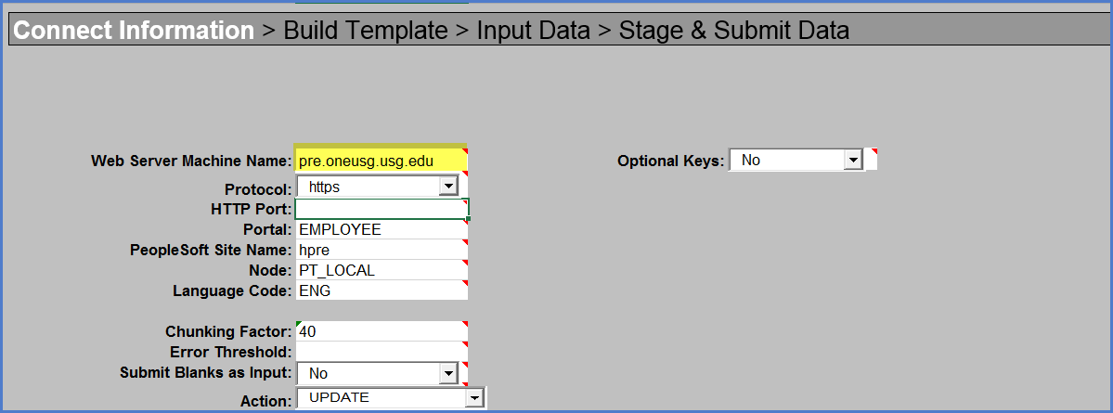

Template
Template is used to build the structure for the data that will sent to HCM. The data on the top of the workbook contains database details of the fields on the Additional Pay Data page.
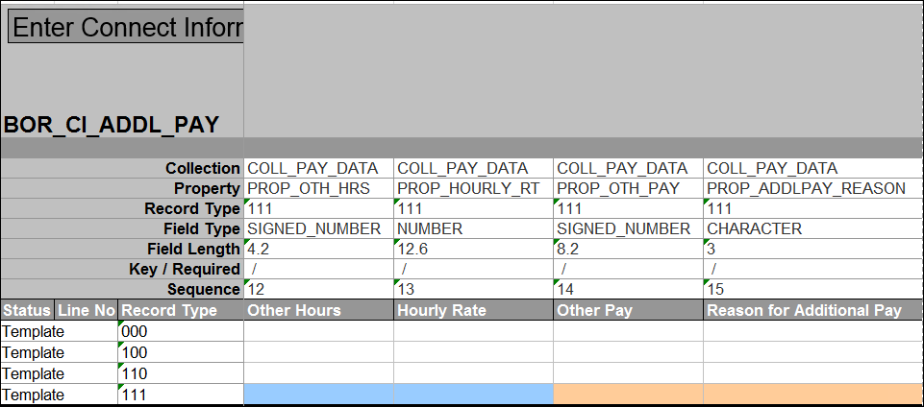

The Template worksheet has a toolbar at the top.
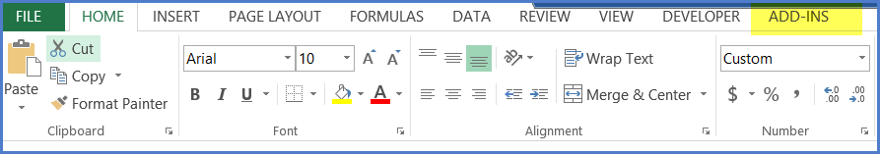
Click Add-Ins on the top menu bar to display a custom toolbar for the worksheet. The options available on this toolbar are used to build the template. Each tool bar option has help text that describes the purpose and use of each of the options when the cursor is placed over the option. Below is a description for each tool bar option.

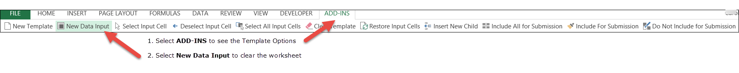
Data Input
Enter all the data which needs to be loaded in the ‘Data Input’ worksheet and click the ‘Stage Data for Submission’ option to load the information. When the option is selected the data values are loaded to ‘Staging & Submission’ worksheet in the structured format. The multiple roles will be displayed in the subsequent columns.
The Data Input sheet is also used to correct data to submit to the database. When errors that are flagged on the Staging and Submission Results worksheet are corrected the items marked in error can be staged again.
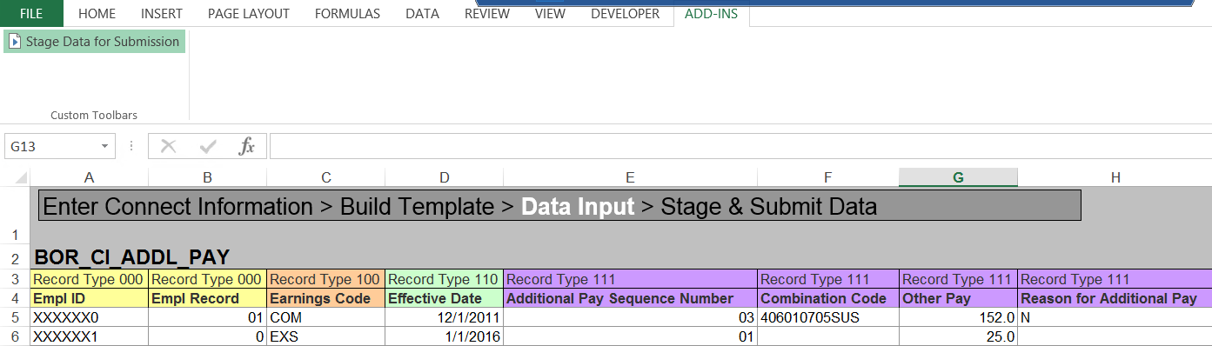

Staging & Submission
Staging & Submission worksheet displays the content in the structured format and provides the option to submit the information to the PeopleSoft environment.
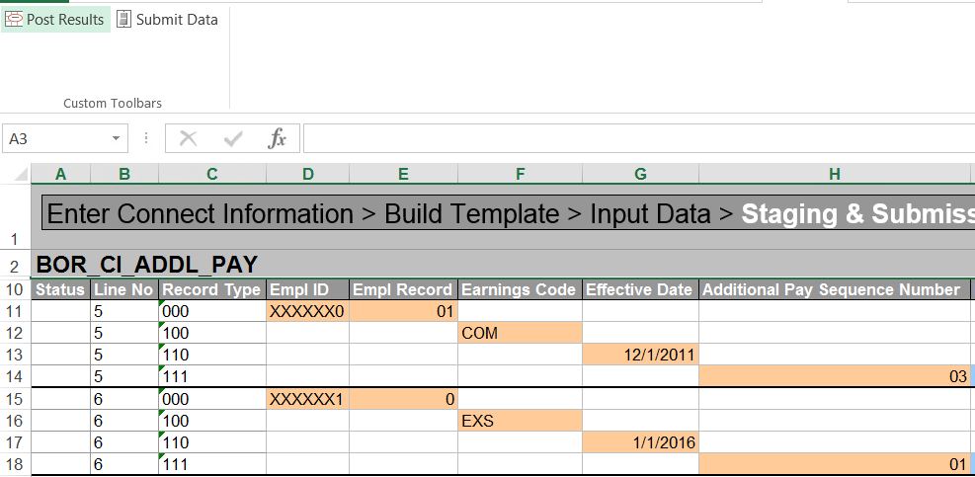
Once you select the Submit Data the login credentials are validated again and data values are loaded in to the HCM system. If the data was not successfully loaded in to the HCM environment the Status column was displayed with error.
Errors
Once results have been posted, you can view the status for each transactions.

Step A: Run the Excel to CI:
- In the appropriate folder, double click on the Excel to CI to open it.
- The Excel to CI will open up on the Tab that you last used.
- Click on the Options… button and then choose Enable this content.

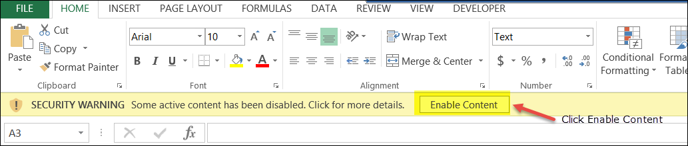

Step B: Verify the Connect Information Tab:
- Click on the Connect Information tab. Verify the Web Server Machine Name, PeopleSoft Site Name and Action is correct.
- Action should be set to ‘UPDATE’

Step C: Enter Data:
- Enter the data on the Data Input tab. You can copy and paste from another worksheet or key it in.
- If data already exists on the Data Input tab, delete all rows that contain data before copying and pasting any new data.
- Once the data is entered on the template, click on Add-Ins at the top of the worksheet and then click on Stage Data for Submission.
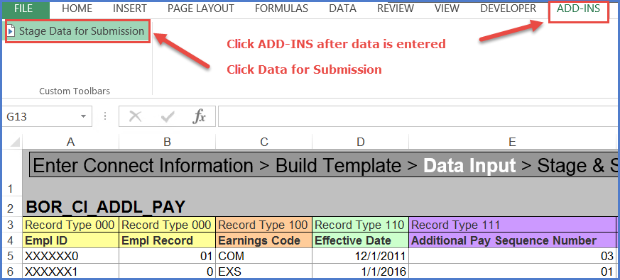

- You will be taken to the Staging and Submission tab. The data will automatically be populated. Depending on the amount of data and how many tables are being updated, this step could take a minute.
- Once the data is populated, click on Submit Data.
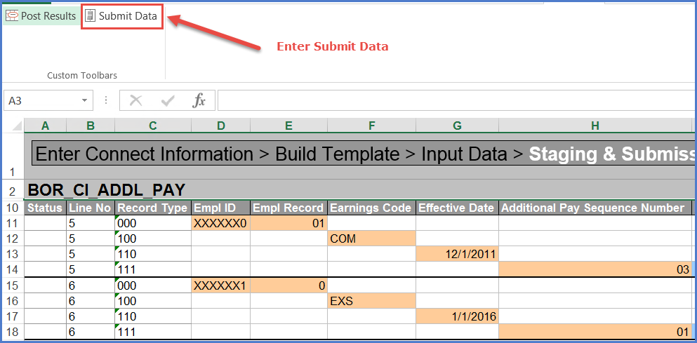

- The Login popup box will appear. Enter you login information based on the database you are loading this data into. Click OK. This step can take a minute or two depending on the amount of data and number of tables being updated.
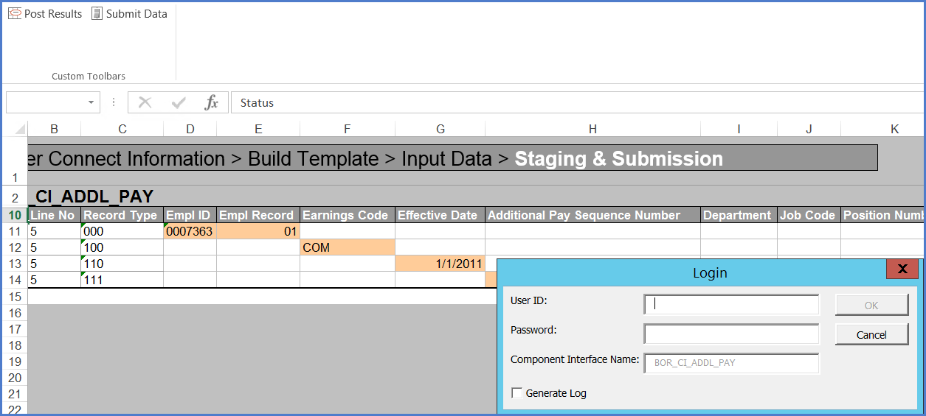
- The Status will automatically be populated on the Staging & Submission tab.

- Click on Post Results.
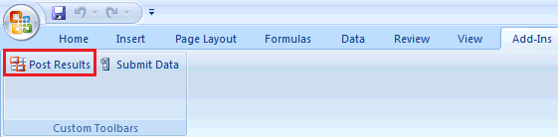

- Once the results are posted, you can sort the worksheet by the status to identify all the rows that loaded (OK or Warning) and all the rows that did not load (Error). You can delete the rows that loaded and correct those that did not load and then rerun.
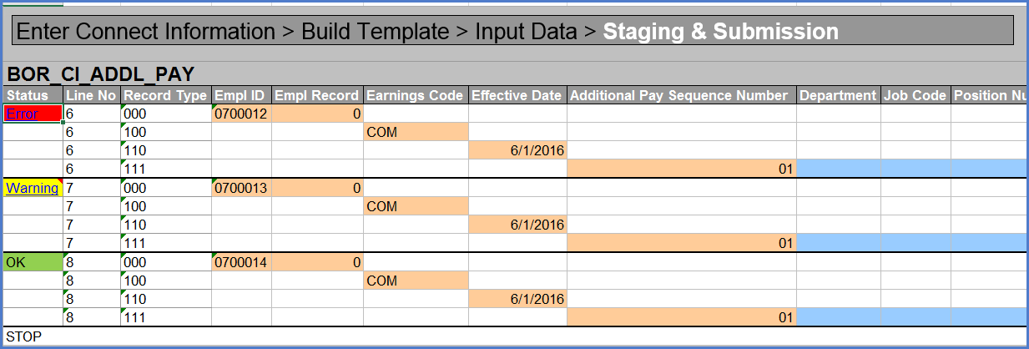
- If you place the cursor over the status, a popup box will appear containing the warning or error messages.

